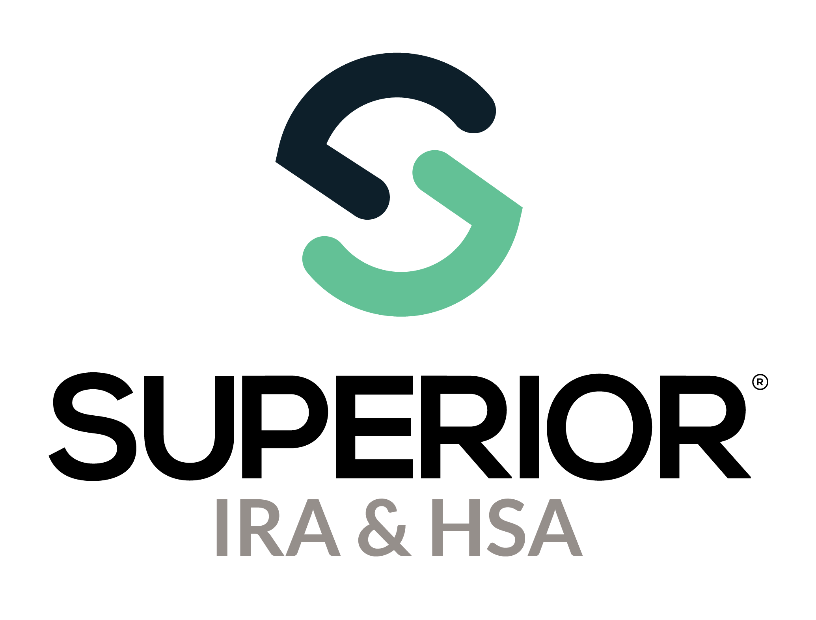
Users Page Training Guide

Superior IRA & HSA® and the Superior IRA & HSA logo are registered trademarks of Superior IRA & HSA, LLC.
Table of Contents
Users 3
Creating a New User 3
Editing an Existing User 6
Resetting a User’s Password 8
Deleting a User 8
Superior IRA & HSA Support 9
Chat 9
Call 9
Email 9
Help Center 9

Users
Users with a User Administrator role have access to the Users page of the Superior IRA & HSA® platform.
Select Users in the left navigation menu to view, add, edit, and delete users. (If you are not a User Administrator, you will not have Users as an option on the left navigation menu.)
You may also click Export Users to export a list of the users currently added to the platform.

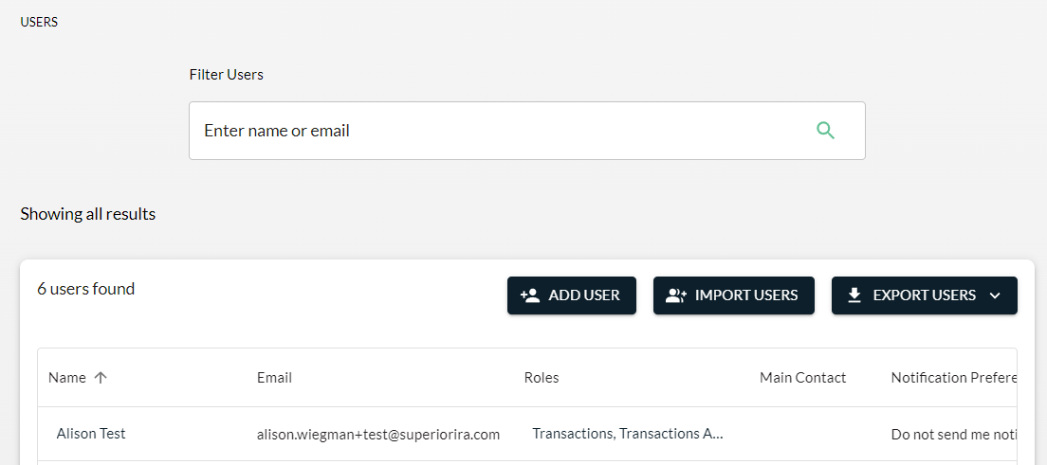

Creating a New User
To add a new user to the site, a User Administrator will follow these steps.
- Click Add User.
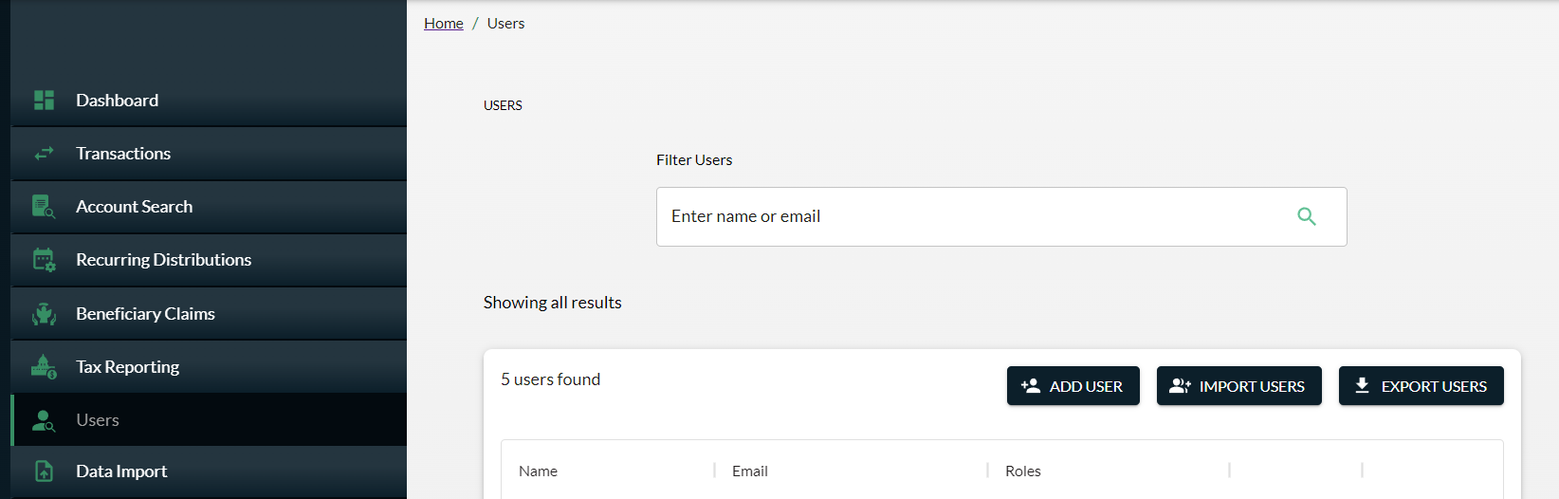

- Enter the First Name, Last Name, Phone Number, Email, and Job Title.
- Select the appropriate branch that corresponds with the user’s primary work location in the Branch field. (The branches displayed in the drop-down are based on the information entered by your organization’s Site Administrator under the Organization Settings tab.)
- Turn on Designate as Main Contact only if the user is the primary contact for your organization.
- Select one of the following preferences for the user to receive notifications from Superior IRA & HSA.
  - All notifications
  - Notifications based on my user roles
  - Do not send me notifications
- Click Continue to select the user’s Roles and Permissions.
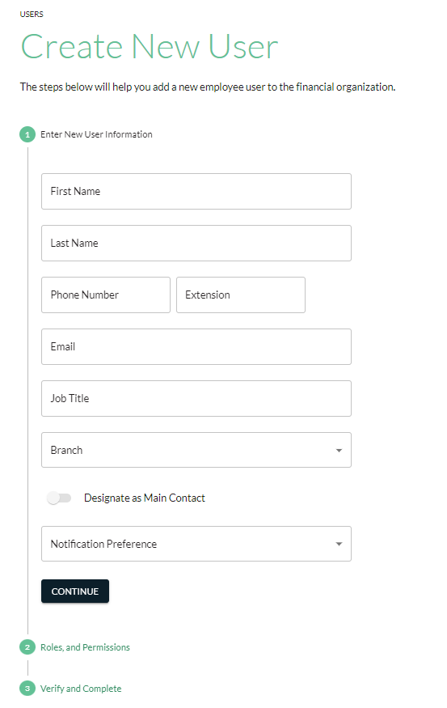

- Check the roles and permissions the user needs access to. The permissions are listed under each role type.
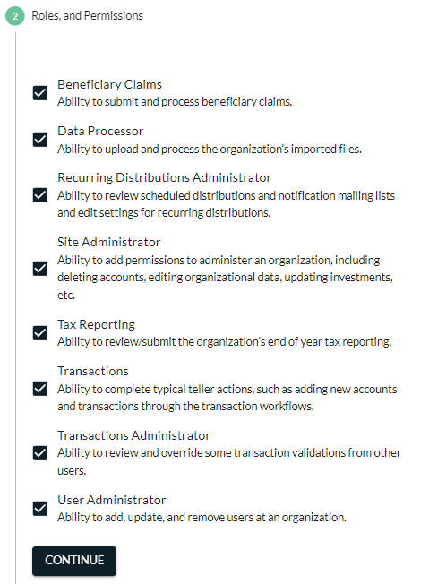
- Check the box to confirm the new user is authorized by the organization.
- Click Continue to save the user.

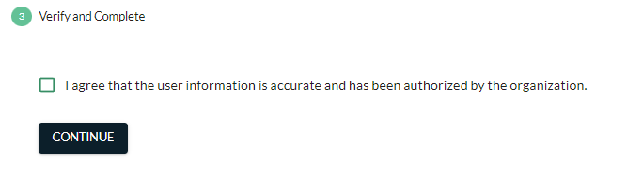
After adding a user to the system, that user will receive two emails from login@app.superiorira.com—one to verify their email address and the other to set up their password.

Editing an Existing User
User Administrators may edit any information for an existing user (including their own user roles) by following these steps.

- Click the specific user’s name from the Users tab.
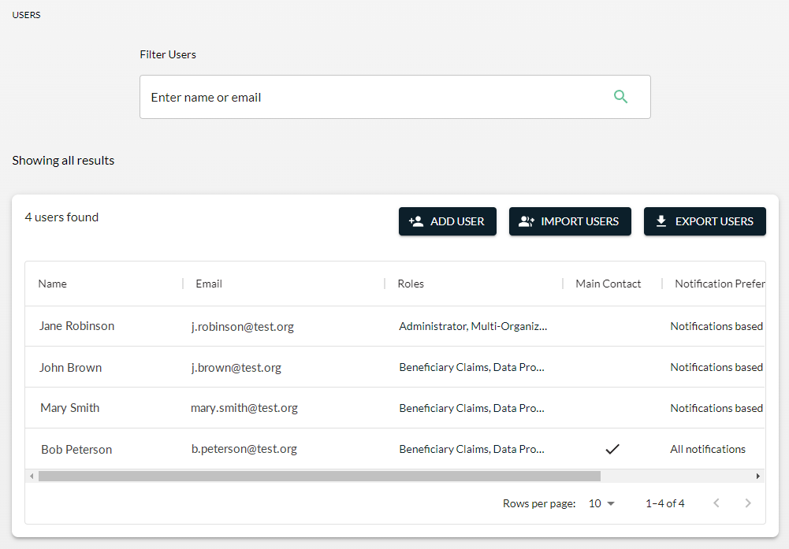

- Expand the User Information section and click Edit Details to edit a user’s first name, last name, phone number, job title, branch location, or notification preference.

Note: A user’s email address cannot be edited. If a user’s email address has changed, follow the steps in the Creating a New User section to establish an account with the new email address, then delete the account with the old email address using the steps provided in the Deleting a User section.
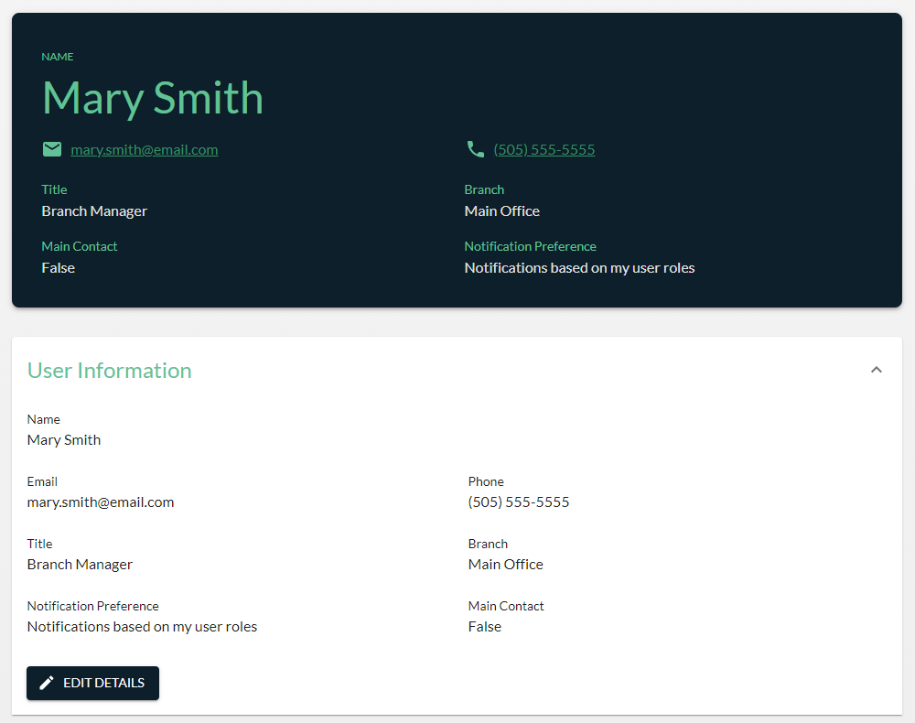
- Expand the Role & Permissions section and click on Edit Details to edit a user’s roles.
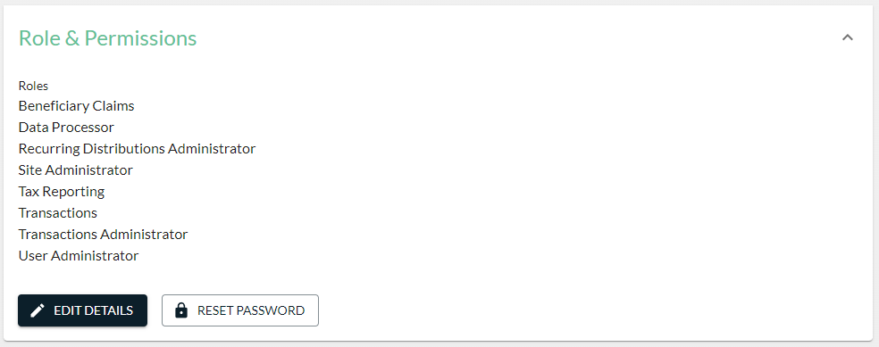

Resetting a User’s Password
User Administrators may reset a user’s password if the user is having trouble accessing the Forgot Password link on the login page.
- Click the user’s name from the Users tab.
- Expand the Roles & Permissions section for the user.
- Click Reset Password.

Deleting a User
User Administrators may delete a user’s access to the Superior platform if they no longer work in the IRA department, have left the organization, or their email address has changed.
- Find the user’s name in the table and scroll to the right.
- Click Delete.
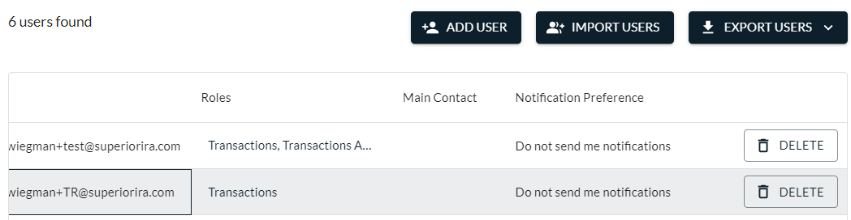

Superior IRA & HSA Support

Chat
Chat with us directly from the Superior IRA platform. The chat bubble appears in the lower right corner of every screen.


Call
Call us at 888-470-4542, Option 1.

Email
Email us at support@superiorira.com.

Help Center
Search for your answer directly from the chat bubble that appears in the lower right corner of every screen.
