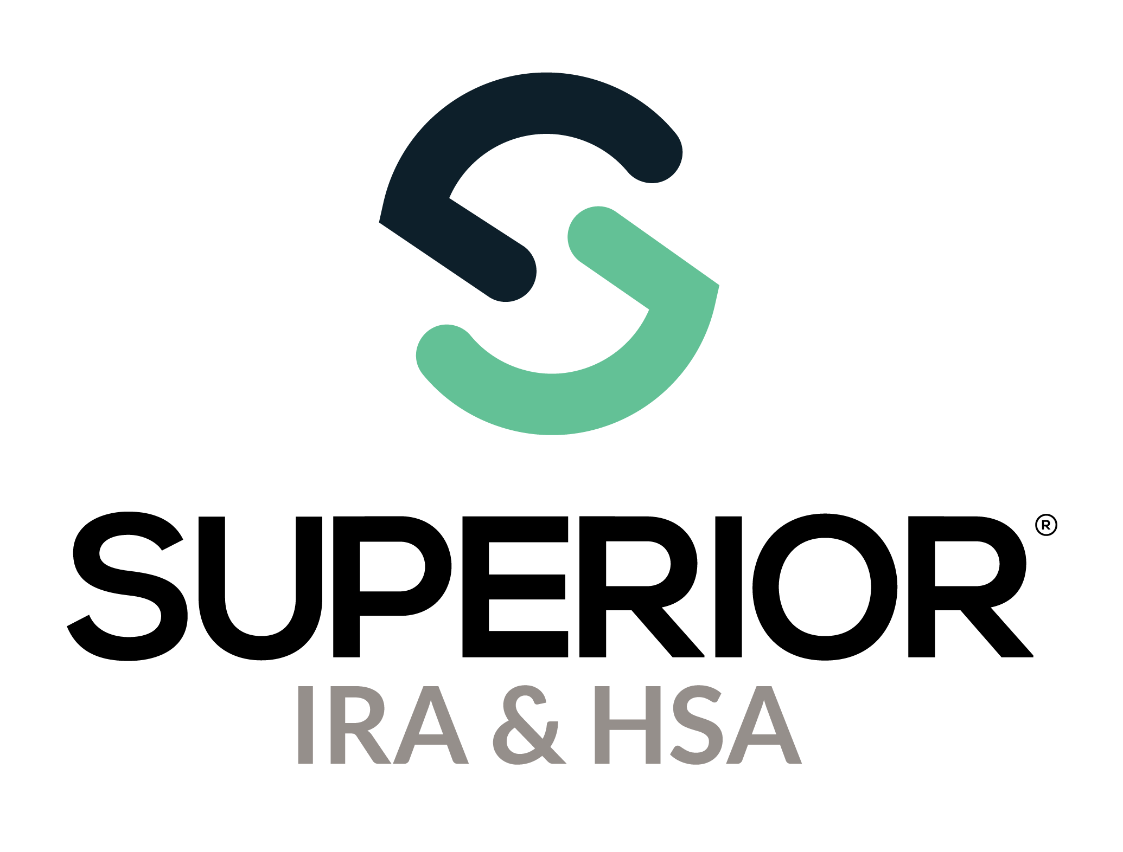
Transactions Page Training Guide

Superior IRA & HSA® and the Superior IRA & HSA logo are registered trademarks of Superior IRA & HSA, LLC.
Table of Contents
Transactions 3
Opening a New Account 4
Contributions and Distributions 6
Contributions to IRA or HSA 6
Distributions from an IRA 8
Add Recurring Distribution 11
Edit Recurring Distribution 13
Request a Rollover or Transfer 15
Transfer 15
Rollover 16
Update Beneficiaries 17
Electronic Signatures 18
Superior IRA & HSA Support 22
Chat 22
Call 22
Email 22
Help Center 22

Transactions
Users with a Transactions or Transactions Administrator role have access to this section. Select Transactions in the left navigation menu to access the transaction workflows.

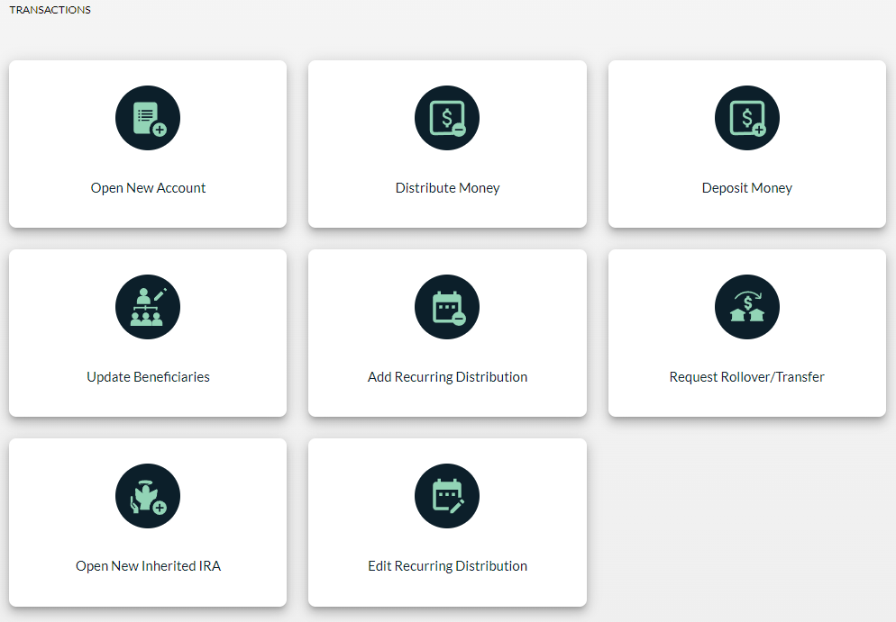

Opening a New Account
- Click the Transactions tab.
- Select Open New Account.
  - Enter the account owner’s name, SSN, or account number.
  - If no account owner is found, click + ADD ACCOUNT OWNER, complete each field, and click Continue.

  - If an account owner is found, select the account owner’s name, then click + ADD ACCOUNT. (Note: If the account owner has an existing IRA and is just opening a new IRA investment or their current IRA investment is renewing, you do not want to complete the Open New Account workflow.)

    - Validate the account owner’s details.
    - Update the phone number, email, and address as needed and click Continue.
  - Choose the Account Type and enter the Account Number and Open Date.
  - Make an initial deposit or skip this section if the owner is not contributing at the time the account is opened.
    - If skipped, you’ll move to the Name Primary Beneficiaries section. (Note: the platform will use your organization’s designated default investment loaded to the platform to complete the financial disclosure that will print at the end of the workflow with the rest of the application.)
    - If making a deposit, click Make Initial Deposit
      - Enter the deposit date, choose the method of deposit, and click Next.
      - Select the type of deposit, add any additional information if needed, and click Next.
      - Enter the amount of the deposit and click Continue.
    - Select the investment option by entering the amount allocated to each investment type and click Continue. This section will display all the IRA investments that have been built into the platform for your organization. If this section is skipped the platform will use your organization’s designated default investment loaded to the platform to complete the financial disclosure that will print at the end of the workflow with the rest of the application.
  - Click Name Primary Beneficiaries or Skip this section if the owner is not making a designation. (Skipping is not recommended, but if no beneficiary is designated, then at the time of death the owner’s spouse will become the default beneficiary. If there is no surviving spouse, the owner’s estate will become the default beneficiary.)

To name beneficiaries:
    - Click + Add Beneficiary.
    - Complete each field, gathering as much information as possible and click Continue. (Relationship, First Name, Last Name, Birth Date, and Percentage are required fields)
    - Click + Add Beneficiary to add additional PRIMARY beneficiaries, if needed.
    - Click Continue once all beneficiary information is added and 100% has been Designated.
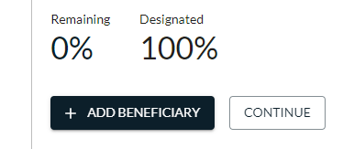

  - Click Name Contingent Beneficiaries or click Continue to skip this section if the owner is not making a designation at this time.

To name contingent beneficiaries:
    - Click + Add Beneficiary.
    - Complete each field, gathering as much information as possible and click Continue. (Relationship, First Name, Last Name, Birth Date, and Percentage are required fields)
    - Click + Add Beneficiary to add additional CONTINGENT beneficiaries if needed.
    - Click Continue once all beneficiary information is added and 100% has been Designated.
  - Click View PDF Document to view the form.
    - If obtaining a wet signature from the account owner, print the form, gather the required signatures, check the “Account Owner has reviewed and signed the document” box, and click Done to save the transaction.
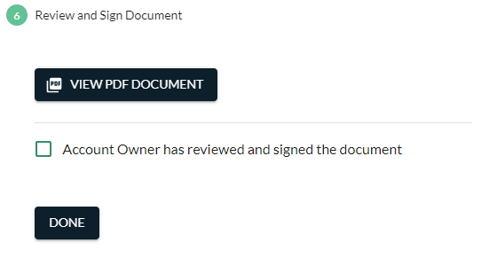

    - If enabled for your organization and obtaining an electronic signature from the account owner (e.g., using a signature pad), click Sign Electronically after you have clicked View PDF Document.
      - This will launch Kinective (formerly IMM) eSign in a new window.
      - Follow the steps in the Electronic Signatures section of this guide for details about the eSign process.
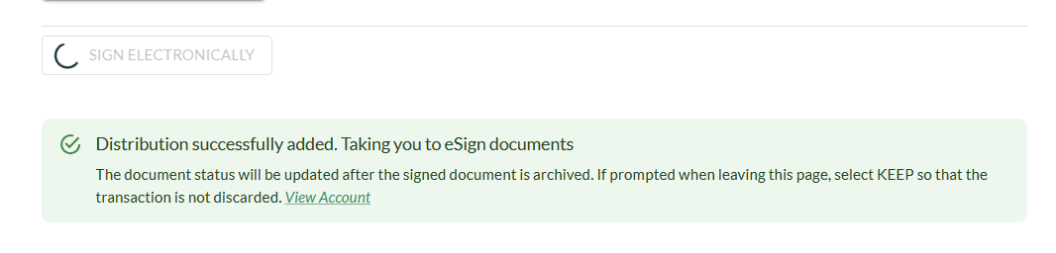

Contributions and Distributions
There are two ways to add a contribution to an account. You may navigate to the transaction workflow and select the appropriate icon—Deposit Money or Distribute Money. Or you may go to Account Search, find the account owner, select the account, and click the Add Deposit or Add Distribution icons to complete the workflow.

Contributions to IRA or HSA
- Click Deposit Money under the Transactions tab.
- Enter the account owner’s name, SSN, or account number.
- Select the account owner from the list.
- If the owner has more than one IRA or HSA, select the appropriate account for the contribution.
- Enter the deposit date, choose the method of deposit, and click Next. Depending on the selection, additional fields may appear (i.e., Check Payable To and Date on Check fields, Source of Assets).
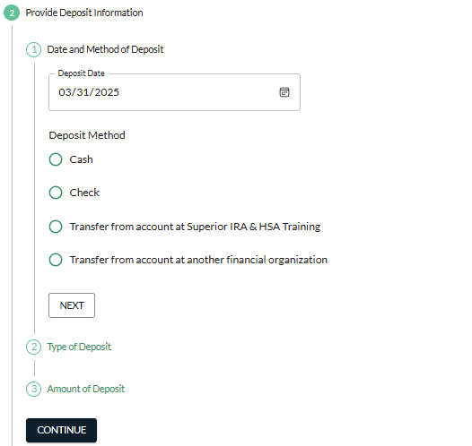

- Select the type of deposit and click Next. Depending on the selection, additional fields may appear.
- Enter the amount of the deposit and click Continue.
- Select the investment option by entering the amount allocated to each investment type and click Continue.
- Click View PDF Document to view the form.
  - If obtaining a wet signature from the account owner, print the form, gather the required signatures, check the “Account Owner has reviewed and signed the document” box, and click Done to save the transaction.
  - If enabled for your organization and obtaining an electronic signature from the account owner (e.g., using a signature pad), click Sign Electronically after you have clicked View PDF Document.
    - This will launch Kinective (formerly IMM) eSign in a new window.
    - Follow the steps in the Electronic Signatures section of this guide for details about the eSign process.

Distributions from an IRA
- Click Distribute Money under the Transactions tab.
- Enter the account owner’s name, SSN, or account number.
- Select the account owner from the list.
- If the owner has more than one IRA or HSA, select the appropriate account for the distribution.
- Select the distribution reason and click Continue. The most common selections are displayed automatically in the workflow. If the correct selection is not listed, click Show more reasons.
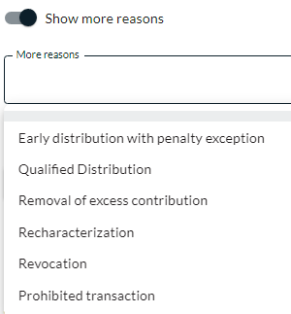

- Enter the amount of the distribution (total or net), any financial organization penalty/fee amounts, the distribution date, and click Next. (If the entire account is being distributed and will close the entire IRA plan, indicate as such in this section by clicking the Distribute the entire balance and close the account toggle.)
- Indicate the owner’s federal withholding election
  - based on the owner’s current election on file;
  - withholding at a different rate; or
  - waiving withholding.
- Provide state withholding elections, if applicable.
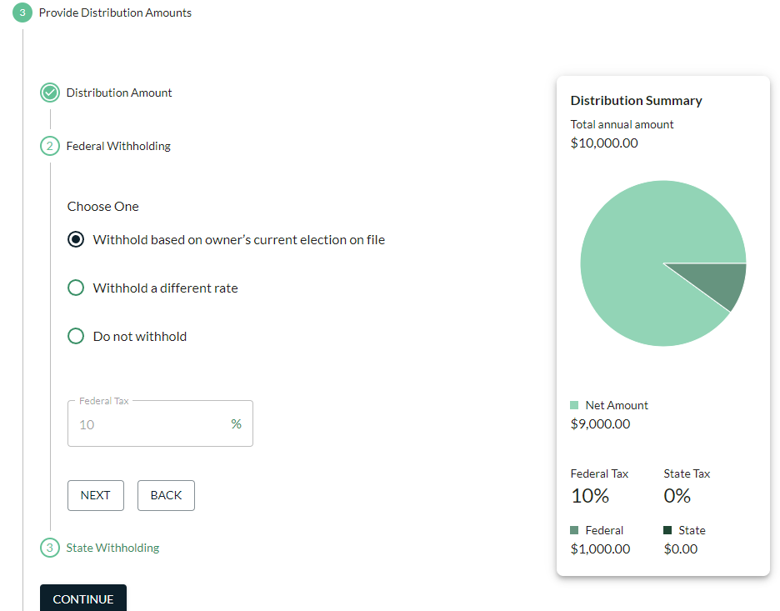

- Select the distribution method from the options provided. Depending on the selection, additional fields may appear. Then click Continue.
- Select the investments from which the assets will be taken by clicking Enter Assets (or choose to skip this option).

- Click View PDF Document to view the form.
  - If obtaining a wet signature from the account owner, print the form, gather the required signatures, check the “Account Owner has reviewed and signed the document” box, and click Done to save the transaction.
  - If enabled for your organization and obtaining an electronic signature from the account owner (e.g., using a signature pad), click Sign Electronically after you have clicked View PDF Document.
    - This will launch Kinective (formerly IMM) eSign in a new window.
    - Follow the steps in the Electronic Signatures section of this guide for details about the eSign process.

Add Recurring Distribution
- Click Add Recurring Distributions under the Transactions tab.
- Enter the account owner’s name, SSN, or account number and select the account owner/account from the list.
- Determine how the owner wants to receive these distributions. Depending on the owner’s age, the options may differ. Read each option and make the appropriate selection.
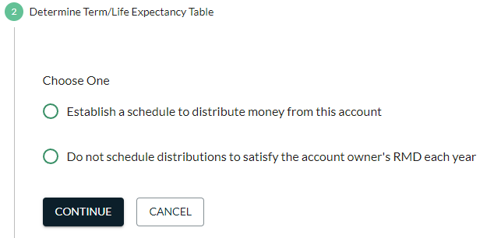
  - For owners age 73 and older: choose one of the following options to determine the term/life expectancy.
    - “Distributions over X years based on the account owner’s life expectancy” – this option will calculate the owner’s RMD based on the owner’s age and the Uniform Lifetime Table (this is the most common option if the owner wants only the RMD amount and nothing more)
    - “Distribute based on the joint life expectancy of the account owner and spouse” – this option can only be selected if all of the following apply.
      - The account owner is married,
      - The account owner’s spouse is the sole primary beneficiary for the entire year, and
      - The spouse beneficiary is more than 10 years younger than the account owner.
    - “Distributions for fewer than 12.2 years” – this will be selected if the account owner wants to receive distributions over a specific number of years that is less than the account owner’s life expectancy. (i.e. 15 years when their life expectancy is 26.5 years)
  - For owners under age 73: choose one of the options as appropriate based on the account owner’s request.
- Next provide the distribution amounts.
  - For owners age 73 and older: validate the 12/31 Fair Market Value and select the distribution amount—RMD or specific amount.
  - For owners under age 73: enter the distribution amount—this is the total amount for the YEAR.
- Enter any federal or state withholding elections.
- Select the distribution schedule.
  - Frequency: The system will divide the total yearly amount provided earlier by the frequency (see example below)
  - Start Date
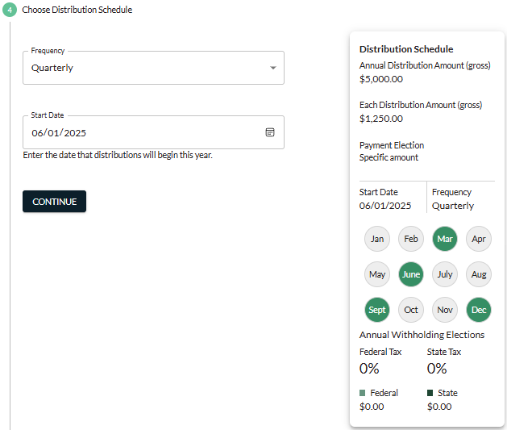
Chart colors the month when the owner will receive a distribution. Based on this selection, the owner will receive 1250.00 in June, September, December, and March.
- Select the distribution method, adding the Account Type if applicable, and click Continue.
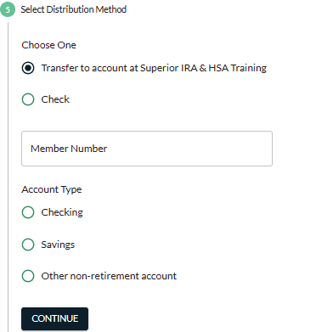
- Click View PDF Document to view the form.
  - If obtaining a wet signature from the account owner, print the form, gather the required signatures, check the “Account Owner has reviewed and signed the document” box, and click Done to save the transaction.
  - If enabled for your organization and obtaining an electronic signature from the account owner (e.g., using a signature pad), click Sign Electronically after you have clicked View PDF Document.
    - This will launch Kinective (formerly IMM) eSign in a new window.
    - Follow the steps in the Electronic Signatures section of this guide for details about the eSign process.

Edit Recurring Distribution
- Click Edit Recurring Distributions under the Transactions tab.
- Enter the account owner’s name, SSN, or account number and select the account owner/account from the list.
- Reconcile Distributions that the owner has already satisfied year to date that should be considered toward the annual amount the owner will receive. If the owner has distributions that were taken as a part of the scheduled payment or didn’t take the amounts displayed, add or delete the applicable withdrawals within this section.
- Determine how the owner wants to receive these distributions. Depending on the owner’s age, the options may differ. Read each option and make the appropriate selection.
- Determine how the owner wants to receive these distributions. Depending on the owner’s age, the options may differ. Read each option and make the appropriate selection.
  - For owners age 73 and older: choose one of the following options to determine the term/life expectancy.
    - “Distributions over X years based on the account owner’s life expectancy” – this option will calculate the owner’s RMD based on the owner’s age and the Uniform Lifetime Table (this is the most common option if the owner wants only the RMD amount and nothing more)
    - “Distribute based on the joint life expectancy of the account owner and spouse” – this option can only be selected if all of the following apply.
      - The account owner is married,
      - The account owner’s spouse is the sole primary beneficiary for the entire year, and
      - The spouse beneficiary is more than 10 years younger than the account owner.
    - “Distributions for fewer than 12.2 years” – this will be selected if the account owner wants to receive distributions over a specific number of years that is less than the account owner’s life expectancy. (i.e. 15 years when their life expectancy is 26.5 years)
  - For owners under age 73: choose one of the options as appropriate based on the account owner’s request.
- Next provide the distribution amounts.
  - For owners age 73 and older: validate the 12/31 Fair Market Value and select the distribution amount—RMD or specific amount.
  - For owners under age 73: enter the distribution amount—this is the total amount for the YEAR.
- Enter any federal or state withholding elections.
- Select the distribution schedule.
  - Frequency: The system will divide the total yearly amount provided earlier by the frequency (see example below)
  - Start Date
Chart colors the month when the owner will receive a distribution. Based on this selection, the owner will receive 1250.00 in June, September, December, and March.
- Select the distribution method, adding the Account Type if applicable, and click Continue.
- Click View PDF Document to view the form.
  - If obtaining a wet signature from the account owner, print the form, gather the required signatures, check the “Account Owner has reviewed and signed the document” box, and click Done to save the transaction.
  - If enabled for your organization and obtaining an electronic signature from the account owner (e.g., using a signature pad), click Sign Electronically after you have clicked View PDF Document.
    - This will launch Kinective (formerly IMM) eSign in a new window.
    - Follow the steps in the Electronic Signatures section of this guide for details about the eSign process.

Request a Rollover or Transfer
A transfer is when an account owner requests to move an IRA or HSA from another institution to the same account type at your financial organization. This is completed via a “transfer” of assets. A signed transfer form needs to be completed and mailed to the current IRA/HSA institution.
A rollover is for qualified plan assets to be rolled over to an IRA. This money can come from a 401k plan, 403b plan, a pension, etc. In most cases, the plan administrator will provide the owner/former employee with certain documentation to complete for the rollover to occur. In rarer cases, the financial organization would complete a rollover request to the former employer’s plan administrator.

Transfer
NOTE: If the owner does not already have the appropriate IRA (TRAD, ROTH or HSA) set up, a new account will need to be opened before completing the transfer request form.
- Click Request Rollover/Transfer under the Transactions tab.
- Enter the account owner’s name, SSN, or account number.
- Select the account owner from the list.
- Select the source of assets and provide information about where they are currently held.
- Select the current owner information and provide information in additional fields, if applicable.

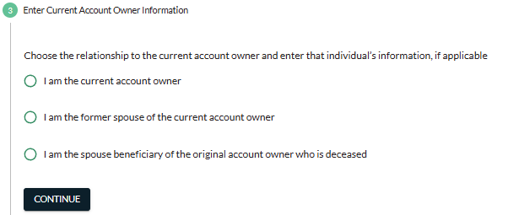

- Provide the transfer/rollover instructions, as shown below.
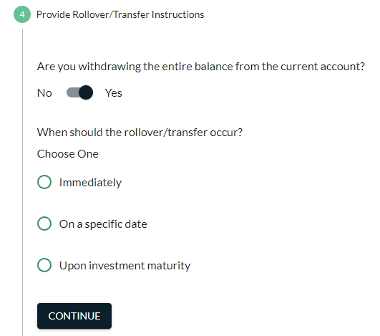
- Enter the amount allocated to each investment type and click Continue. This is how you document what investment the funds will be deposited into once the funds are received. Or click Skip, as appropriate.
- Click View PDF Document to view the form.
  - If obtaining a wet signature from the account owner, print the form, gather the required signatures, check the “Account Owner has reviewed and signed the document” box, and click Done to save the transaction.
  - If enabled for your organization and obtaining an electronic signature from the account owner (e.g., using a signature pad), click Sign Electronically after you have clicked View PDF Document.
    - This will launch Kinective (formerly IMM) eSign in a new window.
    - Follow the steps in the Electronic Signatures section of this guide for details about the eSign process.
- Send the signed request along with a recent statement of the investment to the current trustee/custodian of the plan.
REMEMBER: While you wait for the assets to arrive from the sending organization, the transfer/rollover request will appear on your dashboard under Awaiting Transfer. Once the check is received from the transfer or rollover request, follow the steps provided in the Awaiting Transfer section of this guide to add the transfer/rollover to the system.

Rollover
NOTE: If the owner does not already have the appropriate IRA (TRAD/ ROTH) set up, a new account will need to be opened before completing the rollover request form.
Follow the steps provided in the Transfer section, except select Employer-sponsored retirement plan. Complete the necessary fields based on the qualified retirement plan information.
REMEMBER: While you wait for the assets to arrive from the sending organization, the transfer/rollover request will appear on your dashboard under Awaiting Transfer. Once the check is received from the transfer or rollover request, follow the steps provided in the Awaiting Transfer section of this guide to add the transfer/rollover to the system.

Awaiting Transfer
Whenever you complete the Request Rollover/Transfer workflow under the Transactions tab, the transaction will go into the Awaiting Transfer queue, pending completion until the money is received from the other financial organization.

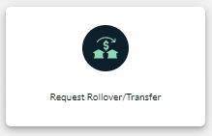

When you receive the money from the other organization, take these steps in the Awaiting Transfer section of the Superior Dashboard.
- Click Rollover/Transfer to open the specific transaction. (Only click the trash can icon if the transaction will no longer be completed.)
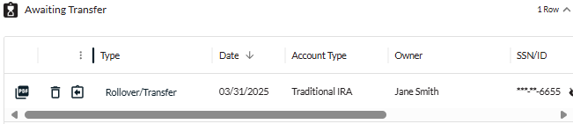
- Enter the amount of the rollover/transfer and the date assets were received. The account owner will not need to sign an additional document because a transfer/rollover request document was already signed, indicating which percentages to allocate to which investments.
- Click Submit to save the transaction. (It is not necessary to have the account owner sign a deposit form for this transaction, as the original rollover/transfer request form already has their signature.)
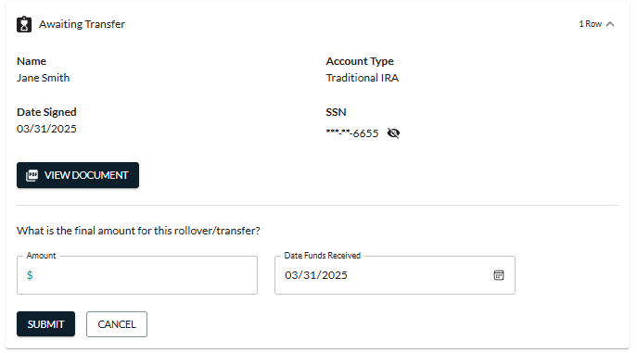

Update Beneficiaries
Beneficiaries can be updated two ways. Users may select Update Beneficiaries under the Transactions tab.
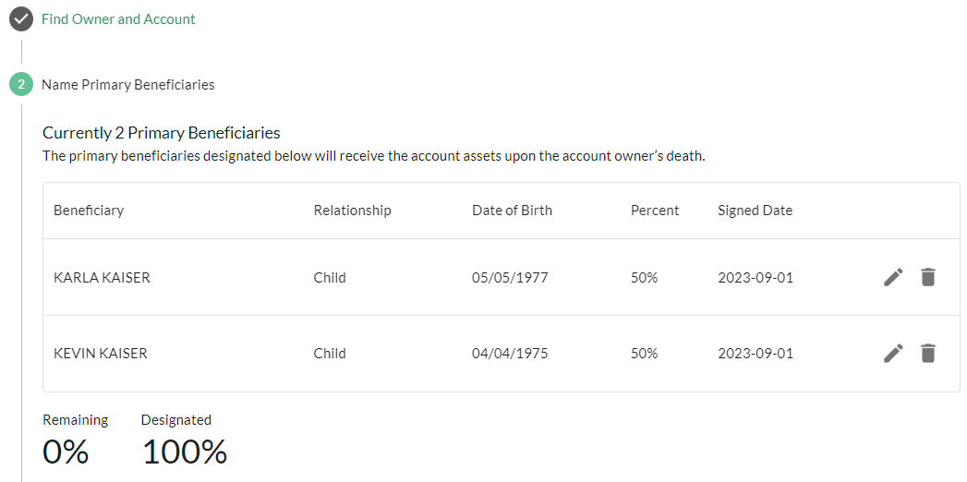
Edit and delete existing POD here
Or, users may update beneficiaries under the Account Search tab by entering in the owner’s name or SSN, selecting the account that needs to be updated, and selecting the Update Beneficiaries icon.
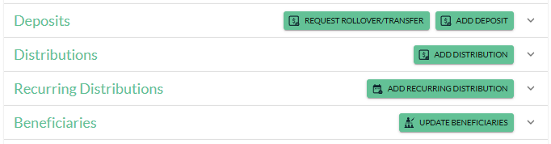

Electronic Signatures
If your organization has electronic signatures enabled within the Superior platform, follow the steps provided within this section upon clicking the Sign Electronically button at the end of the transaction workflow.
After clicking Sign Electronically, a new window with the signing session will open. If only in-person signing is enabled, you will only see a Sign button for each required signer. The screen below shows all the remote eSign options enabled.
- Click Sign next to a required signer’s name to capture the signature.
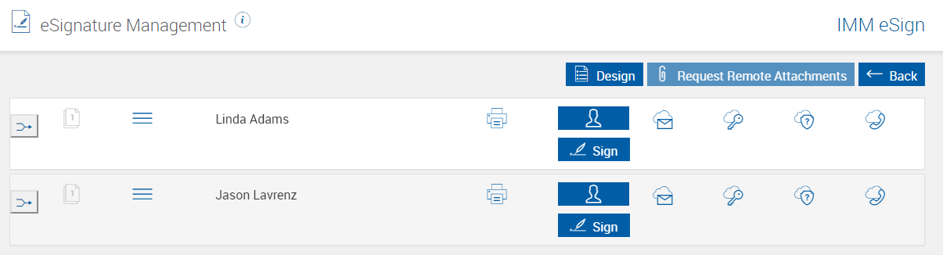
- Provide the consumer disclosure to the account owner by clicking the Consumer Disclosure link or the Print button. Check the box after the account owner has reviewed the consumer disclosure.
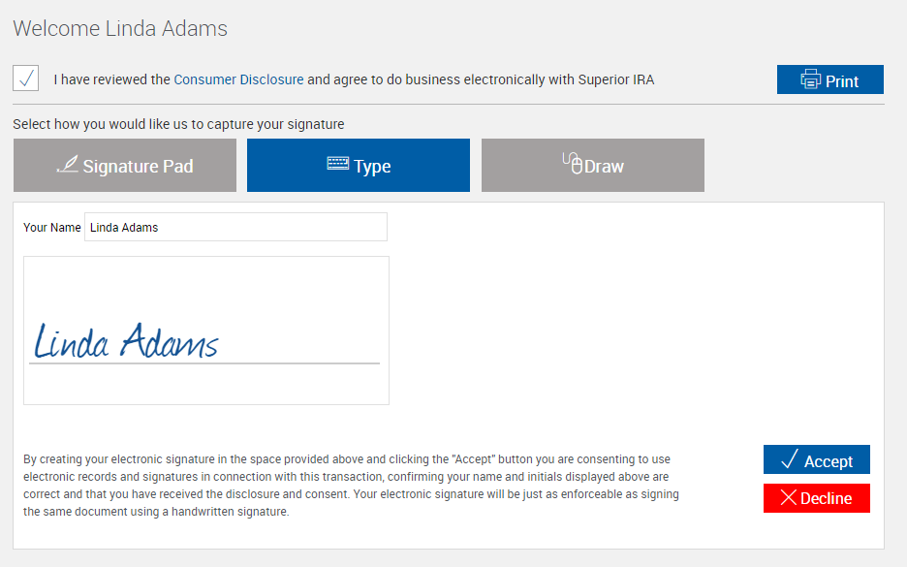
- Select a signature method, obtain a signature, then click Accept.

- Click Sign in each place where prompted on the form.
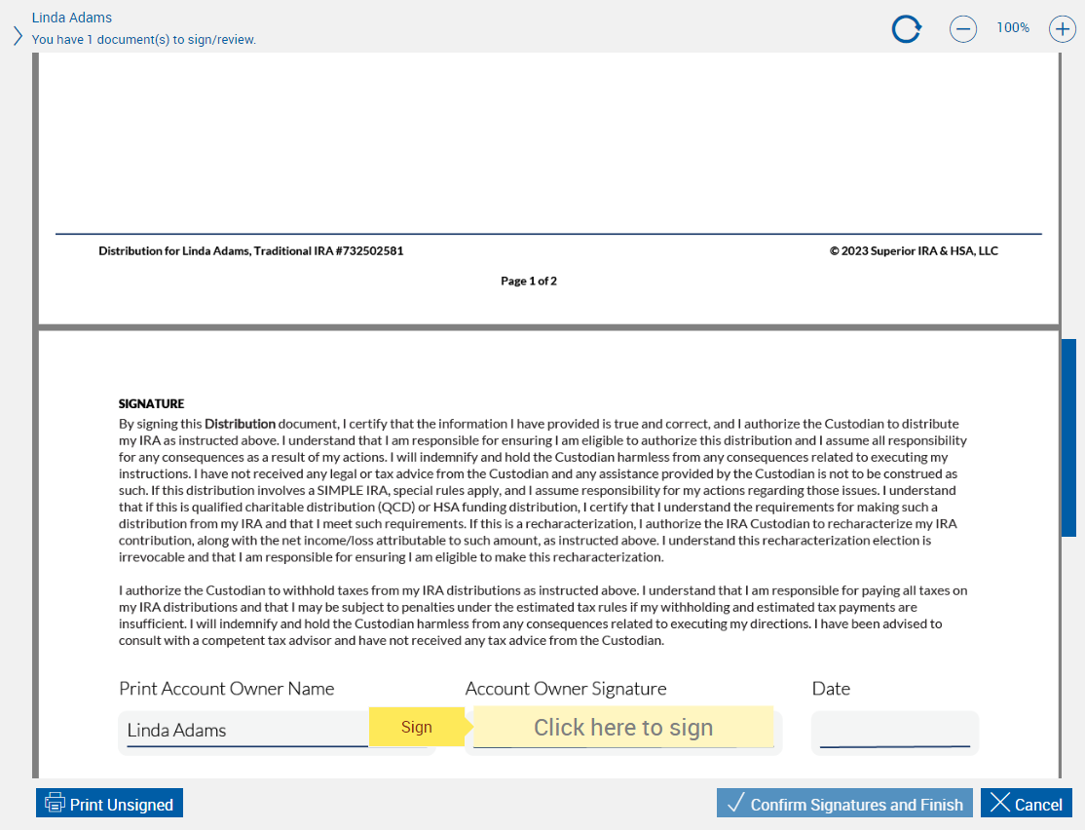
- Click Confirm Signatures and Finish after signing the last page.
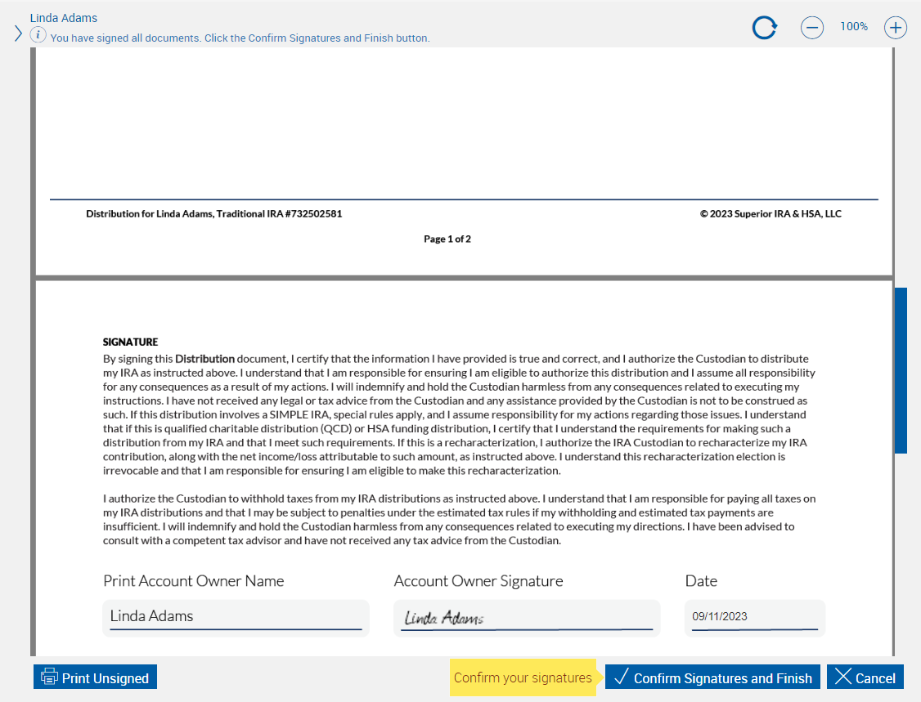
- Click Sign to begin the signing process for the next required signer.
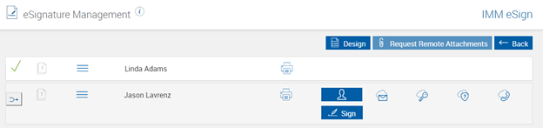
- After obtaining all signatures, a check mark will appear next to each individual’s name. Click Continue to go to the Session Details page.
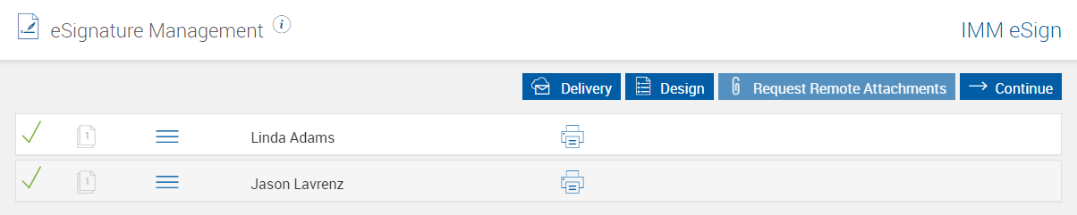
- Click Archive to finalize the transaction. (This button only appears after all signatures are obtained.)
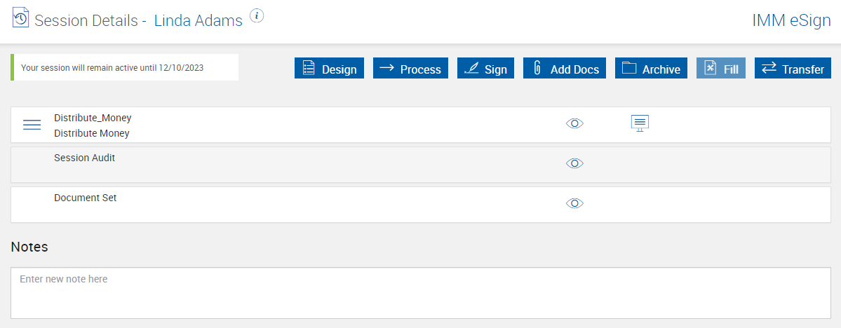

- After successfully archiving the document, close the window and return to the Superior platform.
  - Kinective will send a notification to Superior and the platform will download the signed document and update the transaction from Awaiting Signature to Pending Review (if completed by a user with the Transactions role) or will save the transaction to the platform (if completed by a user with the Transactions Administrator role).
  - If you return to the workflow and receive a pop-up message asking if you would like to delete the transaction, click Keep. (This message only appears if Superior has not yet received the notification back from Kinective, and the image will be stored in the Awaiting Signature section until received.)
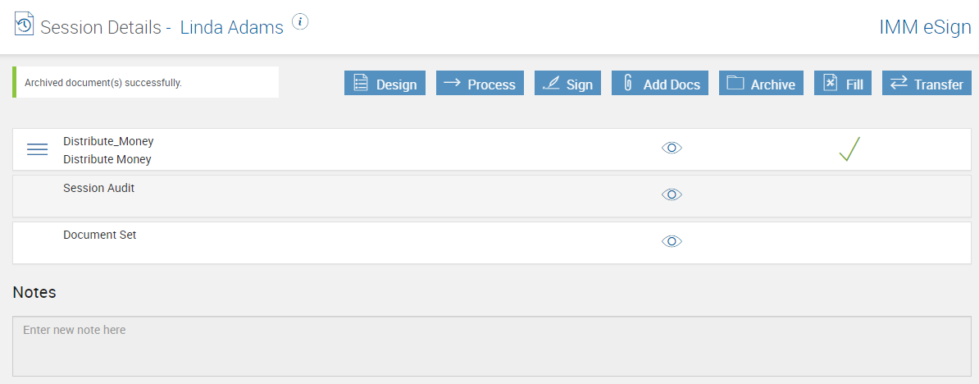

Superior IRA & HSA Support

Chat
Chat with us directly from the Superior IRA platform. The chat bubble appears in the lower right corner of every screen.


Call
Call us at 888-470-4542, Option 1.

Email
Email us at support@superiorira.com.

Help Center
Search for your answer directly from the chat bubble that appears in the lower right corner of every screen.
