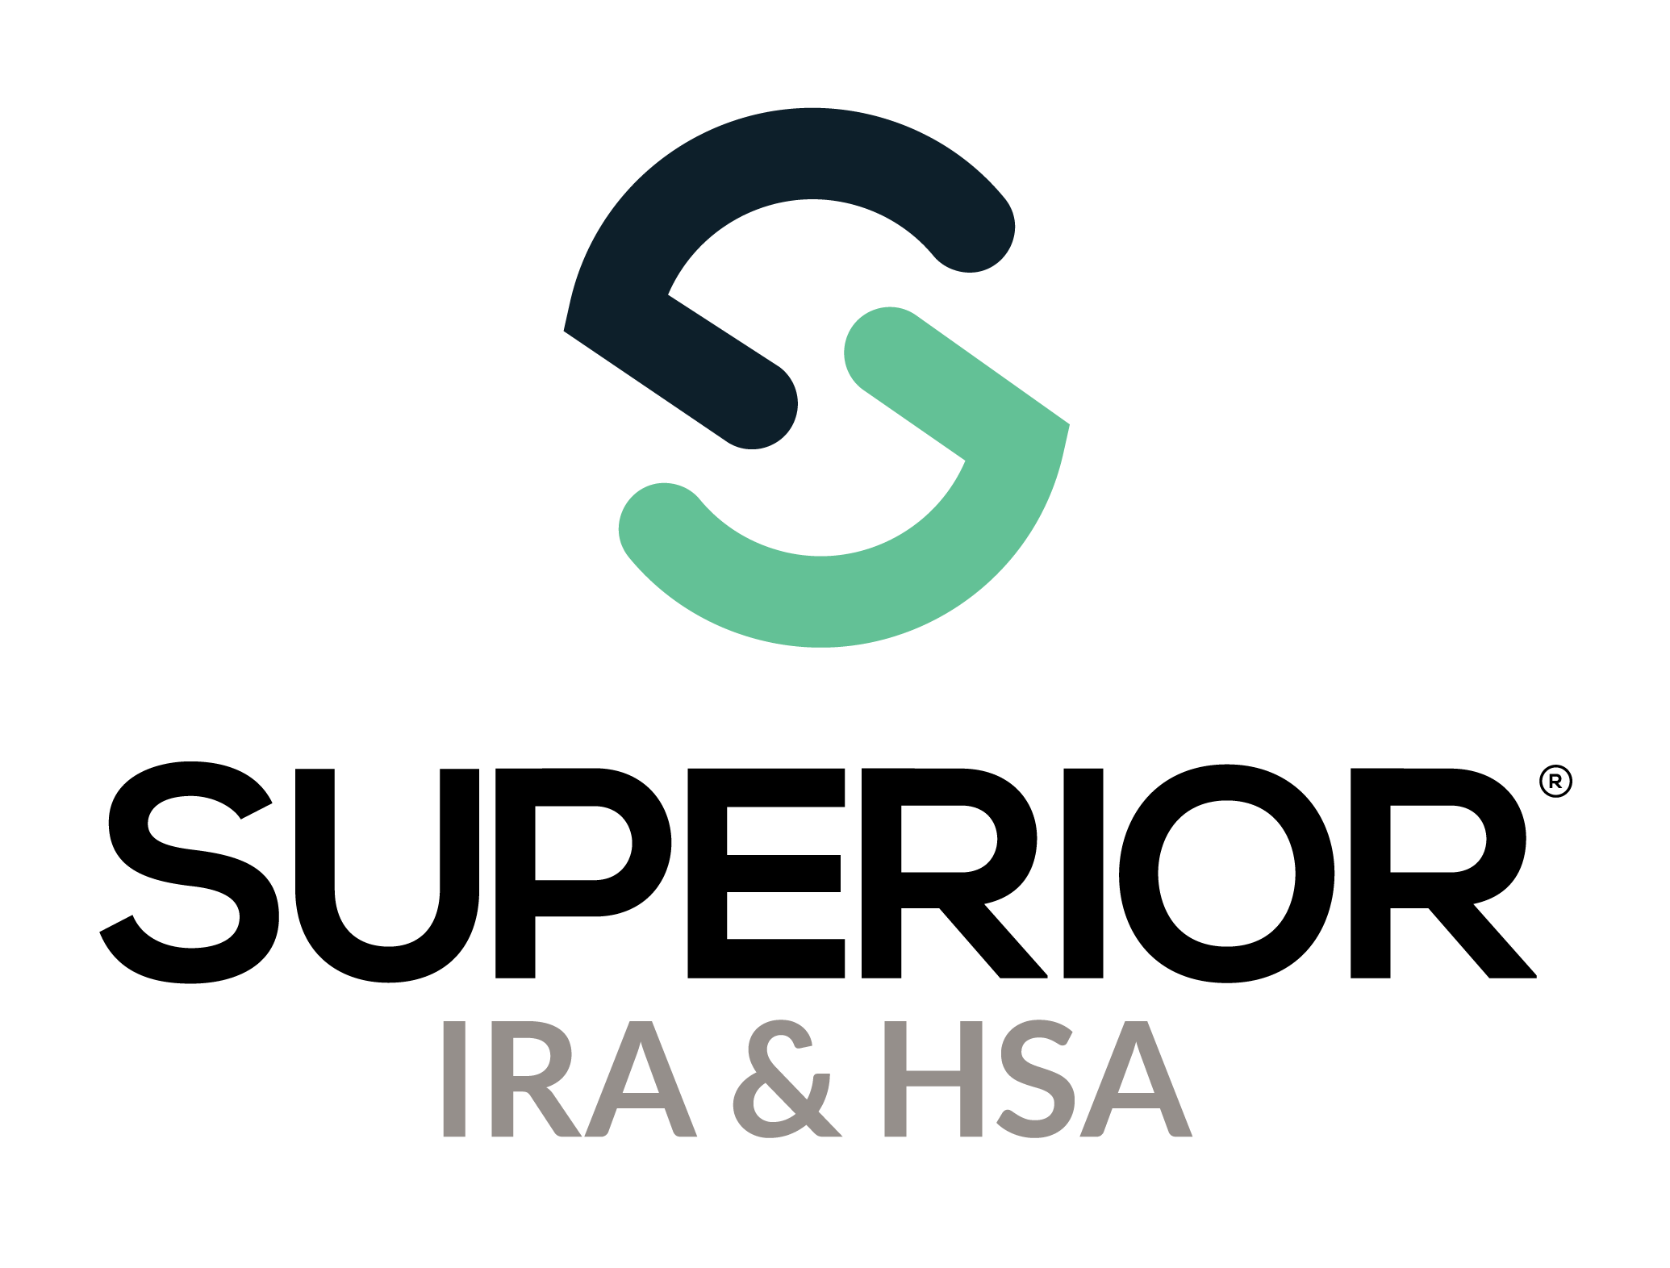
Submit Tax Form Corrections Training Guide

Superior IRA & HSA® and the Superior IRA & HSA logo are registered trademarks of Superior IRA & HSA, LLC.
Table of Contents
Active Year Tax Form Corrections 3
Submit 1099 (Distribution) Corrections 3
Submit 5498 (Deposit) Corrections 4
Submit 5498 (Fair Market Value) Corrections 5
Submit Name Change for Account Owner 6
Provide Tax Form to Account Owner 8
Prior Year Tax Form Corrections 9
Pending Tax Forms 11
Superior IRA & HSA Support 16
Chat 16
Call 16
Email 16
Help Center 16

Active Year Tax Form Corrections
If your organization discovers a tax form correction is needed after tax forms are already produced for the active (current) tax year, follow these steps to make the corrections within the Superior platform.

Submit 1099 (Distribution) Corrections
Transactions Administrators may make corrections at the account level:
- Search for the owner under the Account Search page and click the owner’s name to view the accounts.
- Edit distribution information under the Tax Forms >1099 Forms section or the Distributions section.

  - To edit under the Tax Forms section: Expand the Tax Forms>1099 section and click the Pencil icon to make edits as necessary and click Continue to save your changes.
    - Use this method if the incorrect distribution reason code was originally reported.
    - Edit the dollar amount of the Form 1099 created for the original distribution code and click Continue to save your changes.
    - Then, if applicable, add a new distribution under the Transactions>Distribute Money workflow to add the correct reason code.
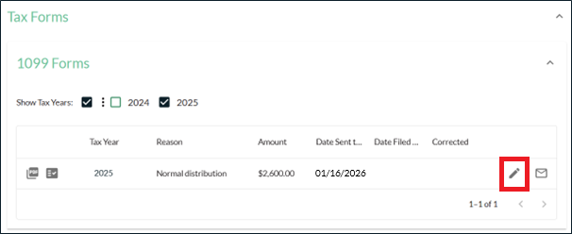

  - To edit under the Distributions section: Expand the Distributions section and click the Reason.
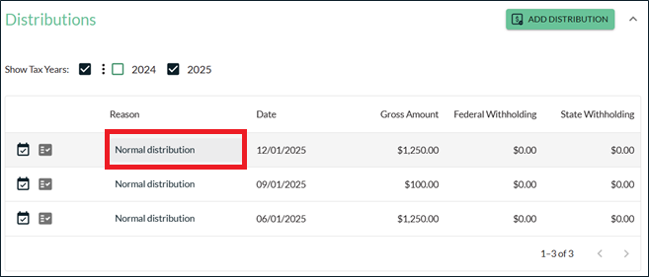
Then click Edit Details to make changes.
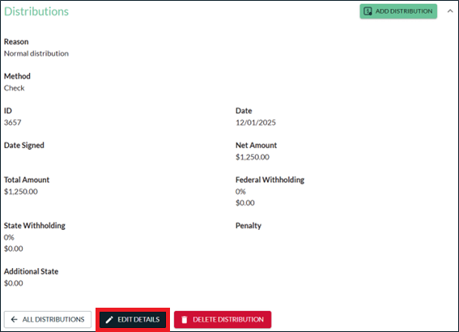

Submit 5498 (Deposit) Corrections
Transactions Administrators may make corrections at the account level:
- Search for the owner under the Account Search page and click the owner’s name to view the accounts.
- Edit deposit information under the Tax Forms >5498 Forms section or the Deposits section.

  - To edit under the Tax Forms section: Expand the Tax Forms>5498 section and click the Pencil icon to make edits as necessary and click Continue to save your changes.
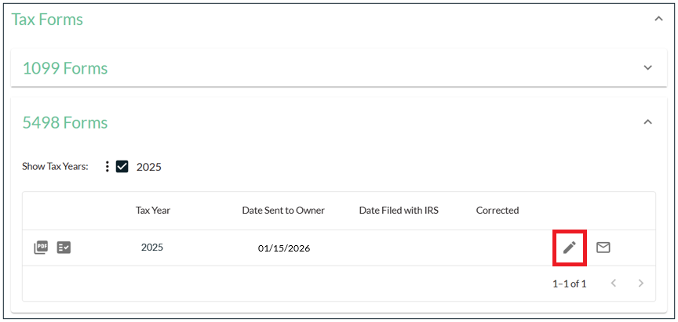
  - To edit under the Deposits section: Expand the Deposits section and click the Deposit Type. 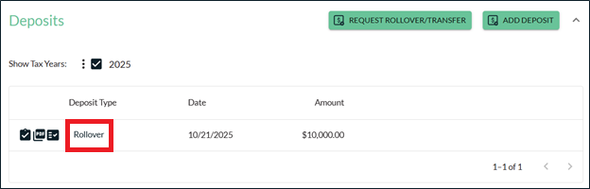

Then click Edit Deposit to make changes.
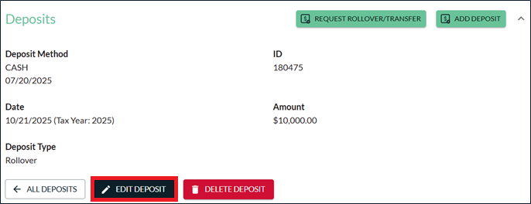

Submit 5498 (Fair Market Value) Corrections
Transactions Administrators may make corrections at the account level:
- Search for the owner under the Account Search page and click the owner’s name to view the accounts.
- Click the applicable account that needs to be updated.
- Expand the Fair Market Value (FMV) section under that account and click the Pencil icon next to Tax Year 2025. 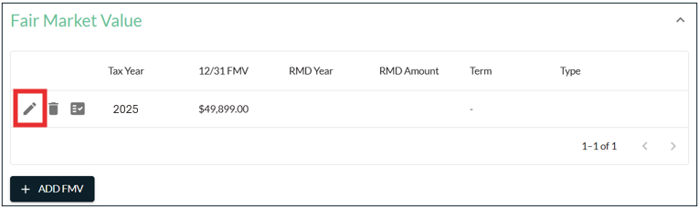

- Enter the correct 12/31/2025 FMV in the 12/31 Fair Market Value field and click Continue.
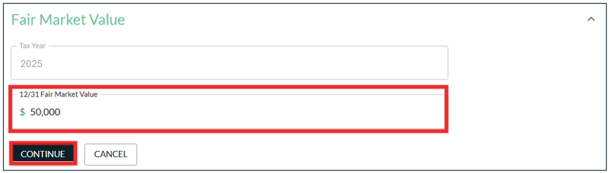

Submit Name Change for Account Owner
If a name change was made for an account owner that had an active (current) year tax form already produced/mailed, a corrected tax form will be generated, but it will require approval from a Tax Reporting user at your organization before Superior mails the corrected tax form and files it with the IRS.
These corrections require approval before mailing/filing a corrected tax form because the account owner may not always need a corrected tax form to be provided to them.
If a Transactions or Transactions Administrator updates the name of an account owner within the Superior platform that generates a corrected tax form for the active (current) tax year, an email notification will be sent to that user and any Tax Reporting user at the organization to let them know the update is pending approval.
Email to User Who Made the Update:
Subject: Active Year Tax Form Pending Approval
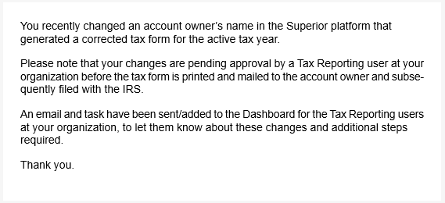

Email to Tax Reporting Users:
Subject: Action Required: Pending Active Year Tax Form Awaiting Approval
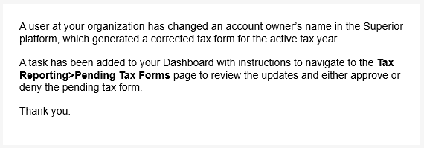
A task will also be added to the Dashboard to instruct Tax Reporting users to review and approve the pending active year tax form before Superior prints/mails the corrected tax form and files the correction with the IRS.
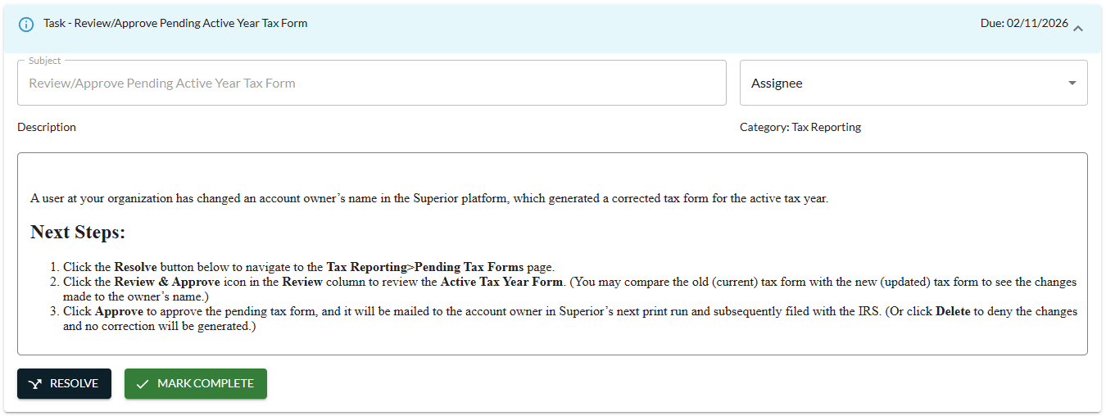
To complete the task, a Tax Reporting user must navigate to the Pending Tax Forms page. (Refer to the Pending Tax Forms section within this guide for steps to review and approve (or delete) these tax form corrections.)

Provide Tax Form to Account Owner
You may view corrected or new original tax forms immediately after updating any distribution, deposit, or FMV data (or upon a Tax Reporting user’s approval of any active tax year corrections made due to a name change).
Superior will print and mail the updated tax form to the account owner in our next tax form production run for that month, unless the following applies:
- If your organization chooses to print/provide the updated tax form to the account owner and indicates as such by taking these steps:
  - Click the Envelope icon next to the updated tax form.
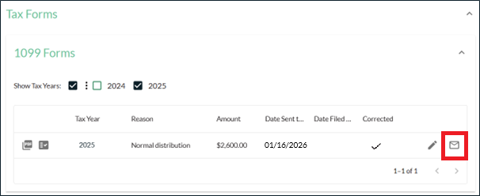

  - Enter the date your organization sent the updated tax form to the owner and click Acknowledge.
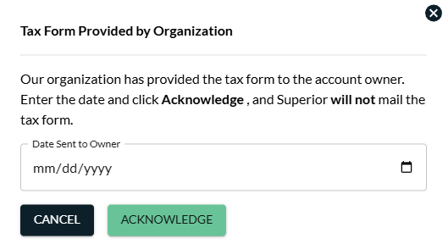

  - If indicated, Superior will only complete the information return filing for the updated tax form and will not mail the tax form to the account owner.

- If the account owner has opted out of paper delivery, your organization will be responsible for downloading an electronic copy of the updated tax form and providing it to the account owner through your online banking site. (This information will appear under the More Information section of the owner’s account, as outlined below.)

If “Yes” is listed in the Paper Delivery Opt-Out field, Superior will only complete the information return filing for the updated tax form and will not mail the tax form to the account owner.

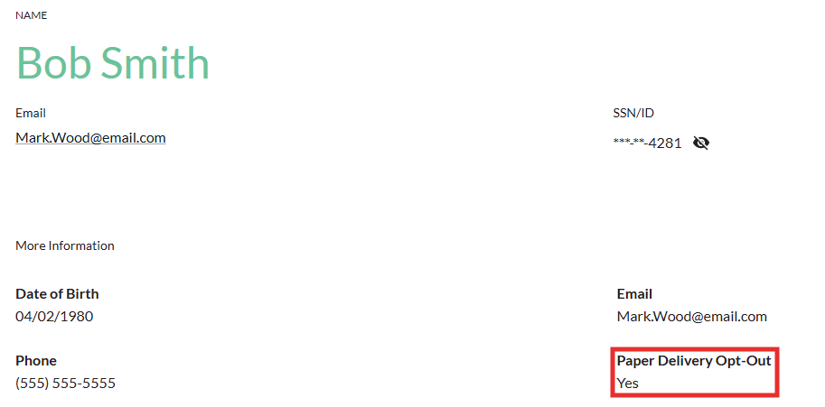

Prior Year Tax Form Corrections
A ”prior year tax form” includes any corrected or late original tax form that is generated after Superior submits the final IRS information return for that tax year on behalf of your organization (generally August 1st of the following year).
Superior will create corrected and late original tax forms and file them with the IRS on behalf of your organization only if we completed tax reporting for your organization for that tax year; however, your organization will be responsible for providing the updated tax form to the account owner upon approval from a Tax Reporting user at your organization.
If a Transactions Administrator follows the steps outlined in the previous sections to make a transactional change under an owner’s account in the Superior platform that generates a corrected or late original tax form for a prior tax year, an email notification will be sent to that user and any Tax Reporting user at the organization to let them know the update is pending approval.

Email to User Who Made the Update:
Subject: Prior Year Tax Form Pending Approval
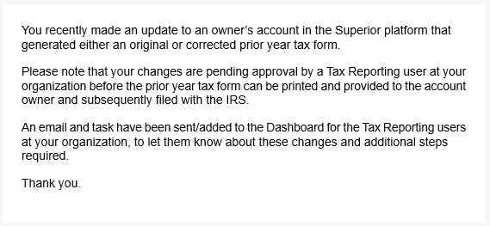
Email to Tax Reporting Users:
Subject: Action Required: Pending Prior Year Tax Form Awaiting Approval
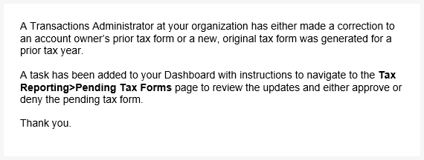

A task will also be added to the Dashboard to instruct Tax Reporting users to review and approve the pending prior year tax form before Superior files the tax form with the IRS.
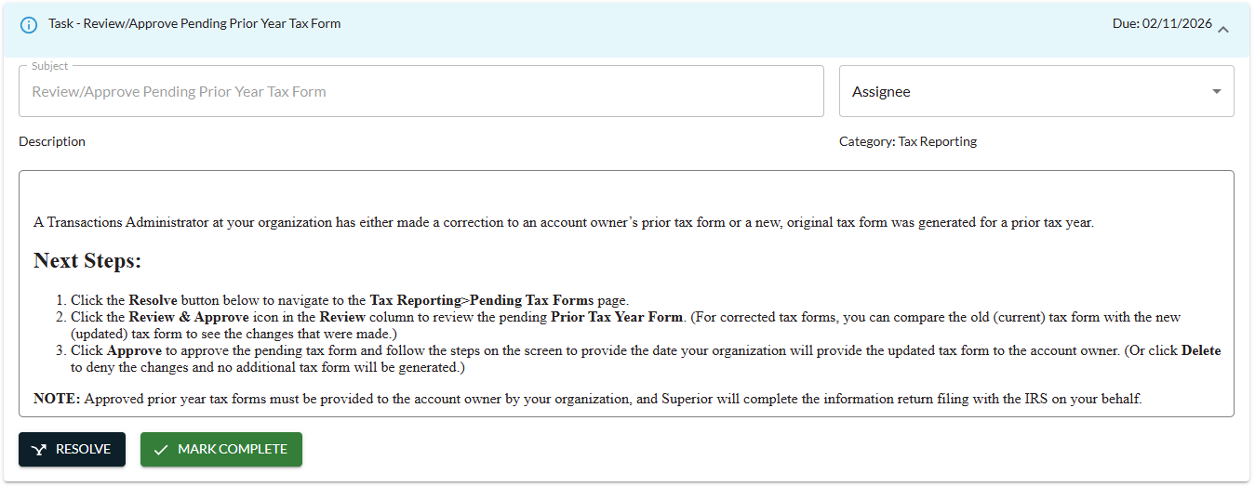
To complete the task, a Tax Reporting user must navigate to the Pending Tax Forms page, discussed next.

Pending Tax Forms
Tax Reporting users will navigate to the Tax Reporting>Pending Tax Forms page to review/approve pending tax form updates for the active (current) tax year (if a name change was made after a tax form was already mailed) or for a prior tax year.
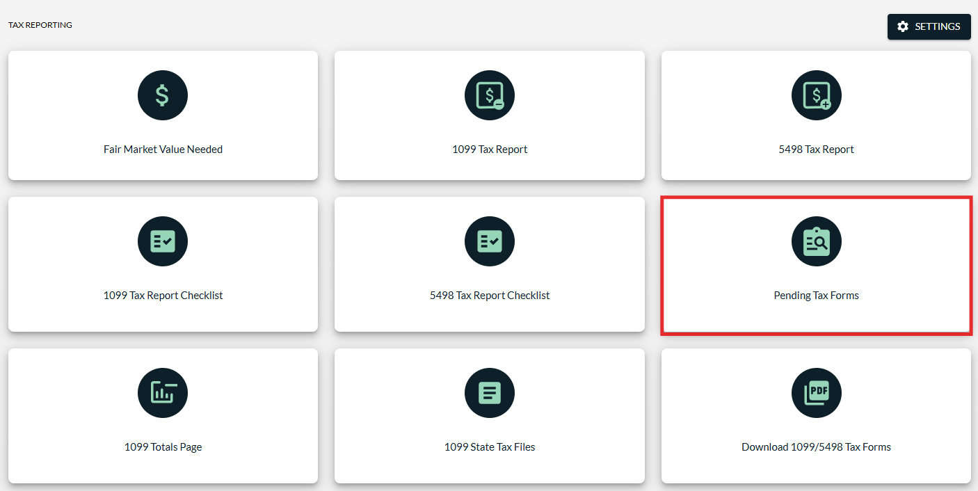

If tax forms are pending for review, a red circle will appear within the left navigation menu of the page and will include the number of pending tax forms awaiting review in one of the following sections:
- Active Tax Year 1099 Forms: Includes corrected Forms 1099 for the active tax year that were generated because an account owner’s name was changed in the platform.
- Active Tax Year 5498 Forms: Includes corrected Forms 5498 for the active tax year that were generated because an account owner’s name was changed in the platform.
- Prior Tax Year 1099 Forms: Includes corrected or new original Forms 1099 for a prior tax year that were generated because a transaction was added/updated for an account owner after the tax year was closed.
- Prior Tax Year 5498 Forms: Includes corrected or new original Forms 5498 for a prior tax year that were generated because a transaction was added/updated for an account owner after the tax year was closed.
Click the section that has pending forms awaiting approval to review and approve or deny the pending changes.
Then click the Review & Approve icon to review a pending tax form.
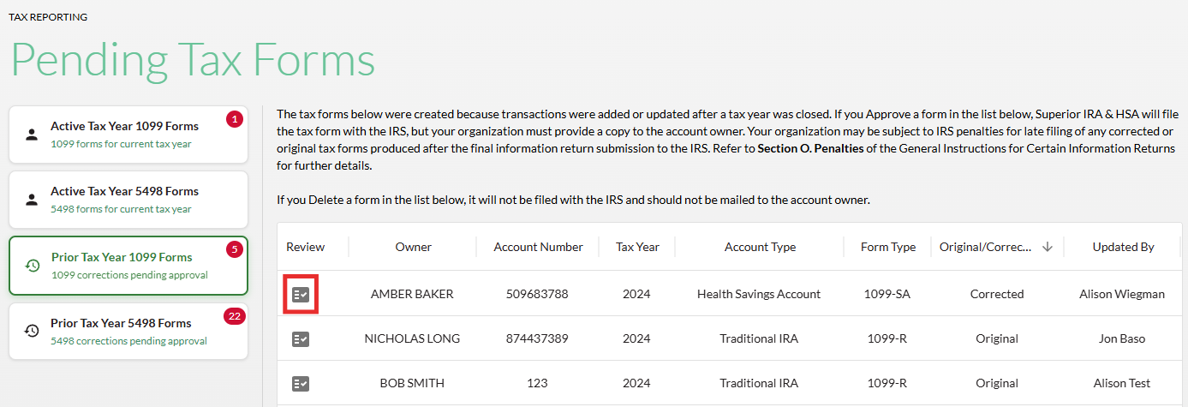

A Tax Form Details section will appear, where the user can compare the old (current) tax form with the new (updated) tax form if it was a correction (applicable to active and prior tax year forms), or just view the details of the tax form if it’s a new late, original form (only applicable to prior tax year forms).
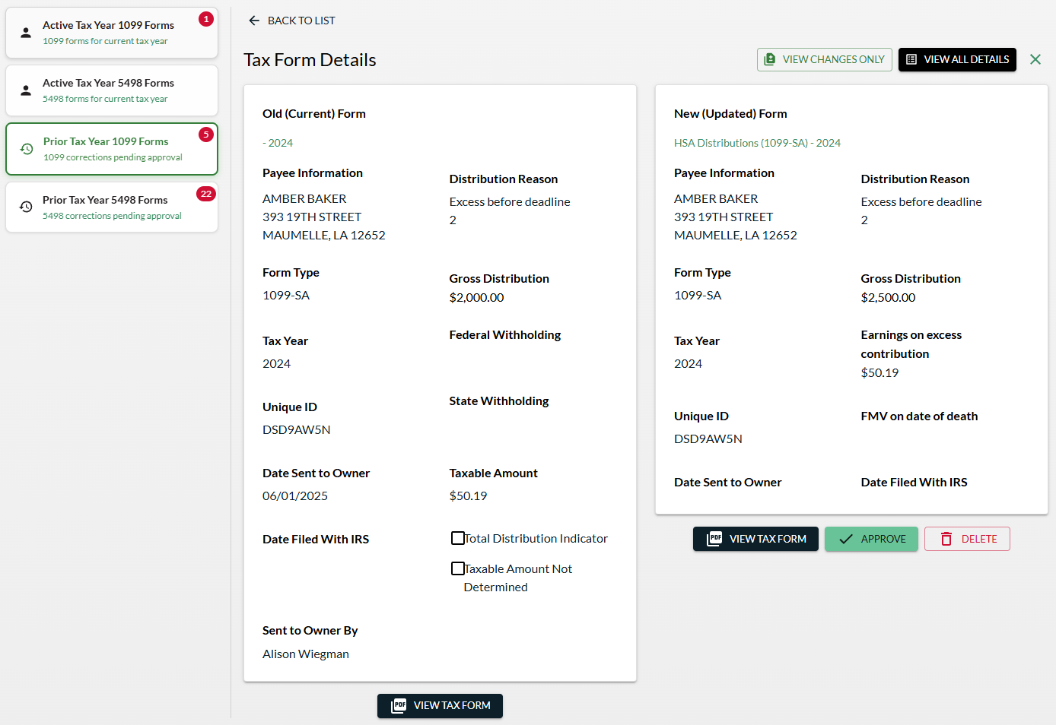
If the prior year (or active year) tax form is a correction to an original tax form, you can click the View Changes Only button in the upper right corner to view only the changes that were made from the original tax form.
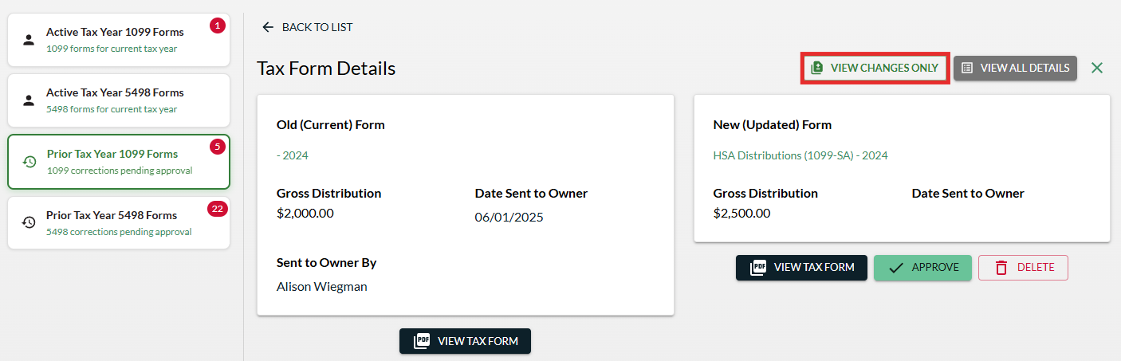
You may also click the View Tax Form button to view a copy of the old (current) tax form and a sample of the new (updated) tax form.
To deny a pending tax form:
- Click Delete to deny the changes if the pending tax form should not have been generated.

- The tax form will not be provided to the account owner, and Superior will not file any changes with the IRS.
To approve the pending tax form:
- Click Approve.


- If you approve an active tax year form:
  - The following success message will appear at the bottom of the page, and the corrected tax form will appear under the Tax Forms section of the owner’s account.

  - Superior will produce/mail the corrected tax form in the next tax form production run (unless your organization follows one of the steps in the Provide Tax Form to Account Owner section of this guide to indicate that you will send the corrected tax form to the owner).
  - Superior will also file the corrected tax form with the IRS.

- If you approve a prior tax year form:
  - A pop-up will appear to walk you through the approval process.
  - Click View Tax Form to review a sample copy of the tax form one more time and click Next.
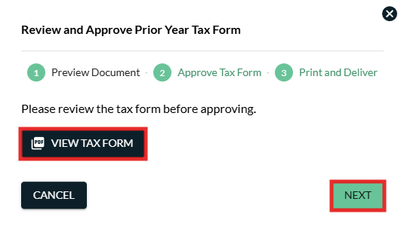

  - Enter the date your organization will provide the updated tax form to the account owner and click Approve. (Remember: Your organization must provide updated prior tax year forms to the account owner. Superior will not mail prior tax year forms on your behalf.)
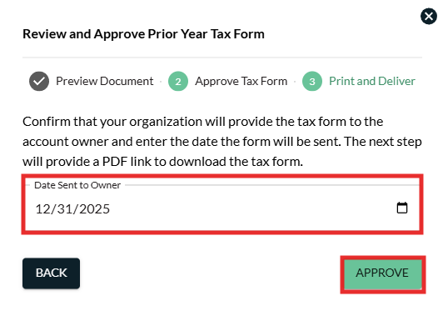

  - The following success message will appear at the bottom of the page, and the corrected tax form will appear under the Tax Forms section of the owner’s account.

  - Click View Tax Form to print the final copy of the approved prior year tax form and ensure your organization provides it to the account owner, then click Close.
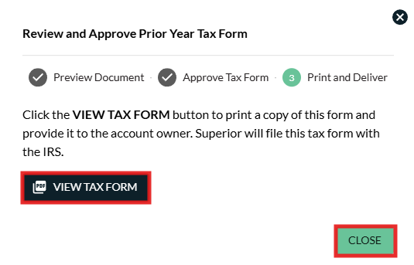

  - Superior will be notified of your approval and ensure the updated information return is filed with the IRS.

Superior IRA & HSA Support

Chat
Chat with us directly from the Superior IRA platform. The chat bubble appears in the lower right corner of every screen (unless you click the dots to the left of the chat bubble and move it).


Call
Call us at 888-470-4542, Option 1.

Email
Email us at support@superiorira.com.

Help Center
Search for your answer directly from the chat bubble.
- Click the Help tab at the bottom of the chat bubble screen.
- Enter a word to search for your answer within our Help Center.



