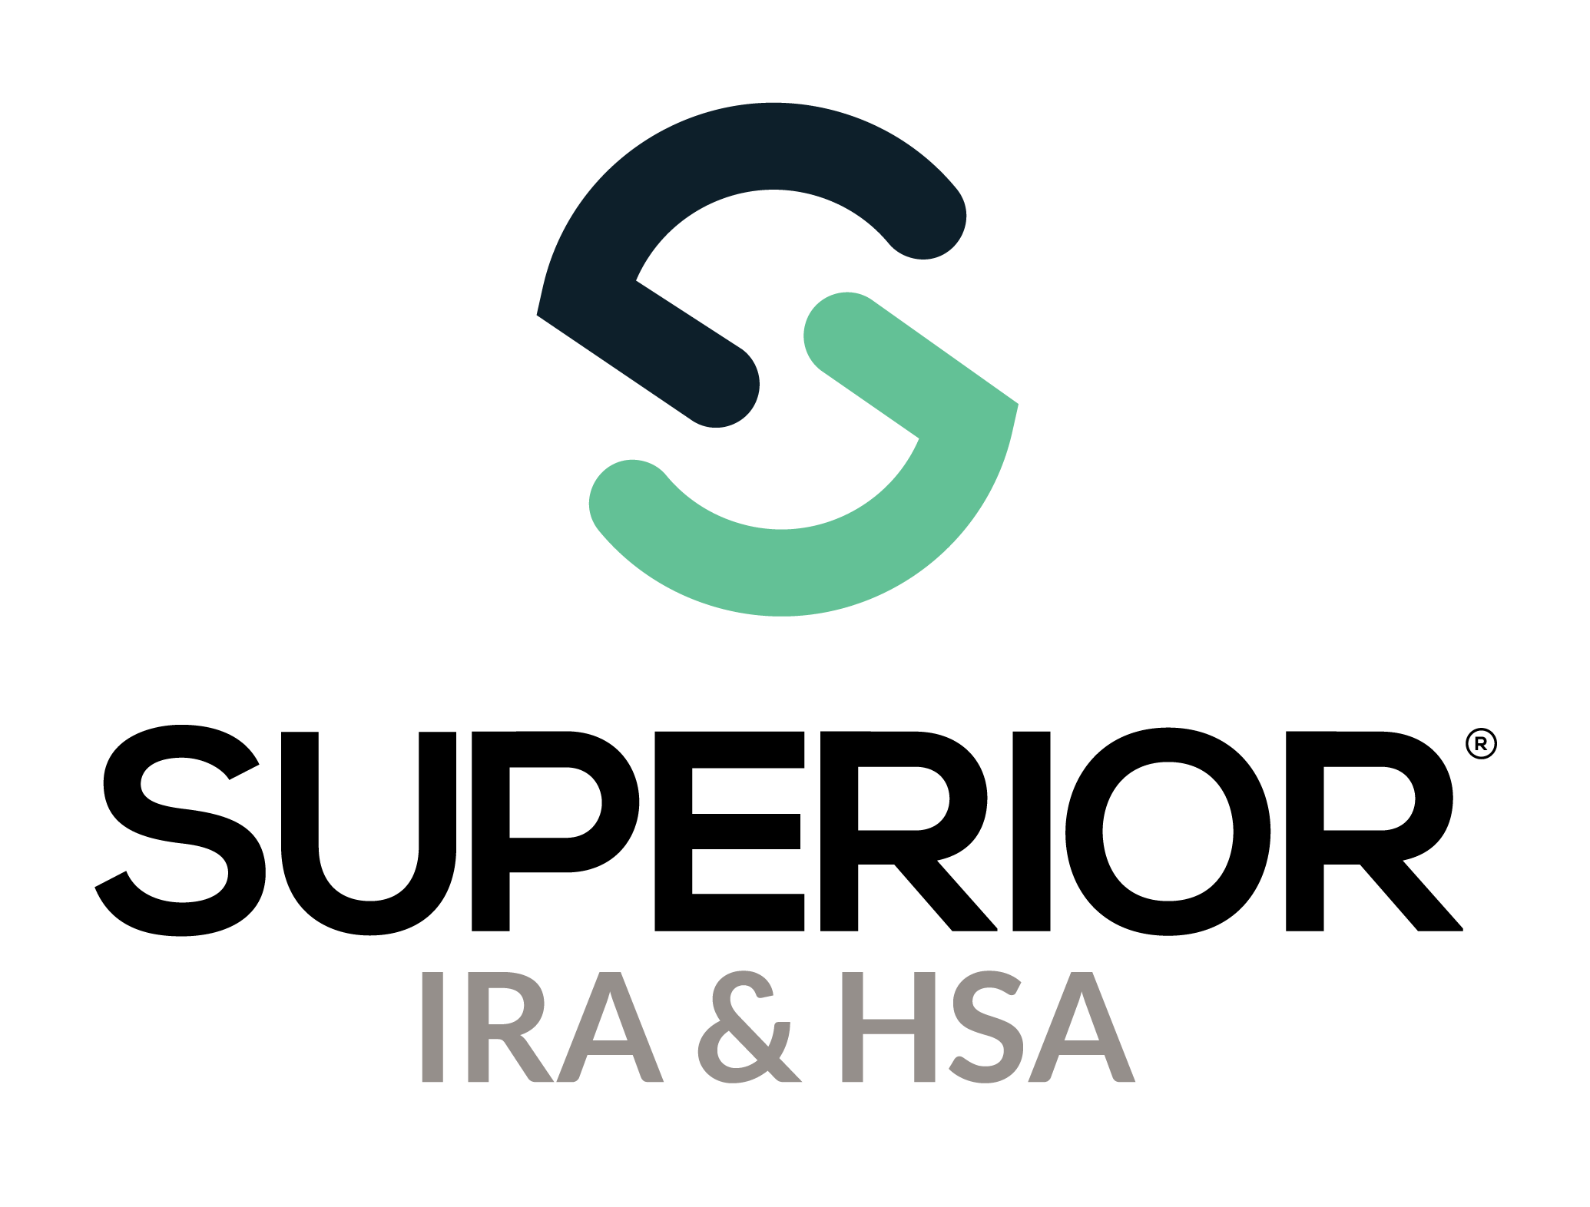
Submit Tax Form Corrections Training Guide

Superior IRA & HSA® and the Superior IRA & HSA logo are registered trademarks of Superior IRA & HSA, LLC.
Table of Contents
Current Year Tax Form Corrections 3
Submit 1099 (Distribution) Corrections 3
Submit 5498 (Deposit) Corrections 4
Submit 5498 (Fair Market Value) Corrections 5
Provide Tax Form to Account Owner 6
Prior Year Tax Form Corrections 8
Pending Prior Year Tax Forms 9
Superior IRA & HSA Support 13
Chat 13
Call 13
Email 13
Help Center 13

Current Year Tax Form Corrections
If your organization discovers a tax form correction is needed after tax forms are already produced for the current tax year, follow these steps to make the corrections within the Superior platform.

Submit 1099 (Distribution) Corrections
Transactions Administrators may make corrections at the account level:
- Search for the owner under the Account Search page and click the owner’s name to view the accounts.
- Edit distribution information under the Tax Forms >1099 Forms section or the Distributions section.

  - To edit under the Tax Forms section: Expand the Tax Forms>1099 section and click the Pencil icon to make edits as necessary and click Continue to save your changes.
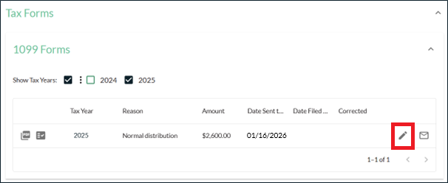

  - To edit under the Distributions section: Expand the Distributions section and click the Reason.
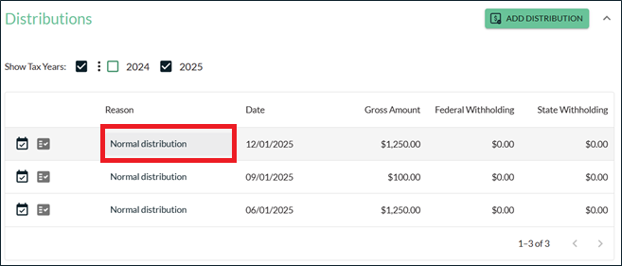

Then click Edit Details to make changes.
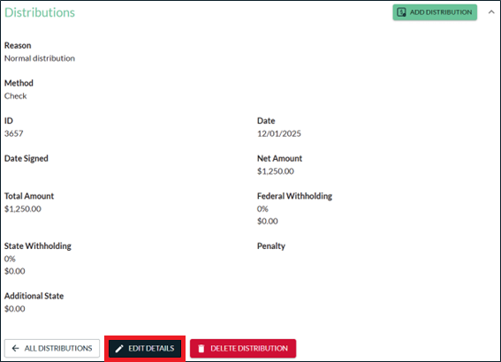

Submit 5498 (Deposit) Corrections
Transactions Administrators may make corrections at the account level:
- Search for the owner under the Account Search page and click the owner’s name to view the accounts.
- Edit deposit information under the Tax Forms >5498 Forms section or the Deposits section.

  - To edit under the Tax Forms section: Expand the Tax Forms>5498 section and click the Pencil icon to make edits as necessary and click Continue to save your changes.
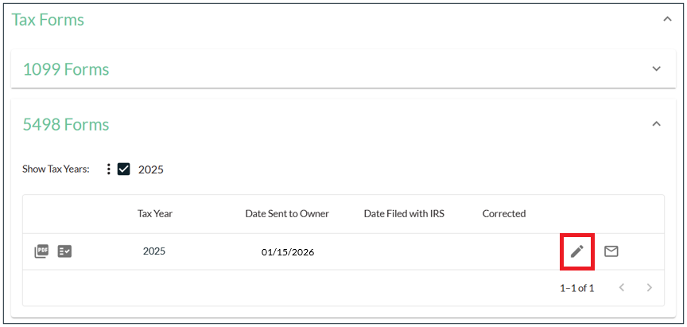
  - To edit under the Deposits section: Expand the Deposits section and click the Deposit Type. 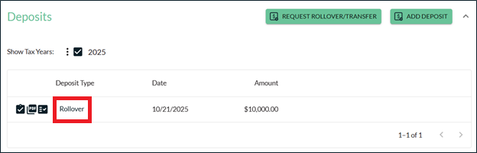

Then click Edit Deposit to make changes.
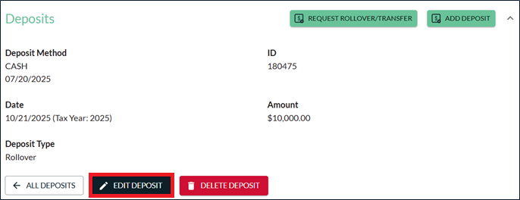

Submit 5498 (Fair Market Value) Corrections
Transactions Administrators may make corrections at the account level:
- Search for the owner under the Account Search page and click the owner’s name to view the accounts.
- Click the applicable account that needs to be updated.
- Expand the Fair Market Value (FMV) section under that account and click the Pencil icon next to Tax Year 2025. 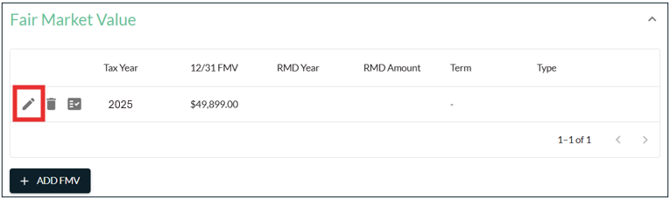

- Enter the correct 12/31/2025 FMV in the 12/31 Fair Market Value field and click Continue.
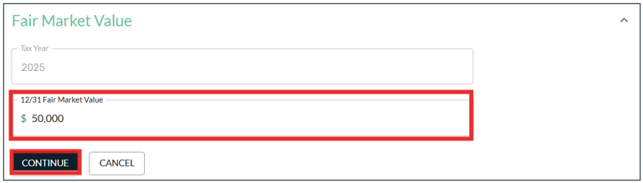

Provide Tax Form to Account Owner
You may view the corrected or new original tax forms immediately after updating any distribution, deposit, or FMV data.
Superior will print and mail the updated tax form to the account owner in our next tax form production run for that month, unless the following applies:
- If your organization chooses to print/provide the updated tax form to the account owner and indicates as such by taking these steps:
  - Click the Envelope icon next to the updated tax form.
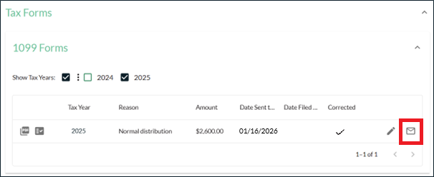
  - Enter the date your organization provided the updated tax form to the account owner and click Acknowledge.
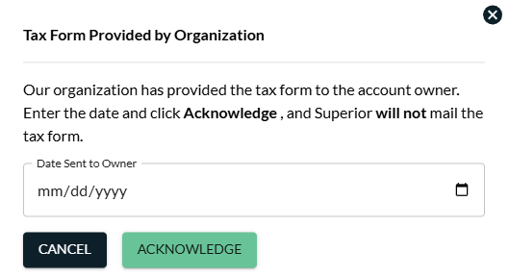
  - If indicated, Superior will only complete the information return filing for the updated tax form and will not mail the tax form to the account owner.
- If the account owner has opted out of paper delivery, your organization will be responsible for downloading an electronic copy of the updated tax form and providing it to the account owner through your online banking site. (This information will appear under the More Information section of the owner’s account, as outlined below.)

If “Yes” is listed in the Paper Delivery Opt-Out field, Superior will only complete the information return filing for the updated tax form and will not mail the tax form to the account owner.

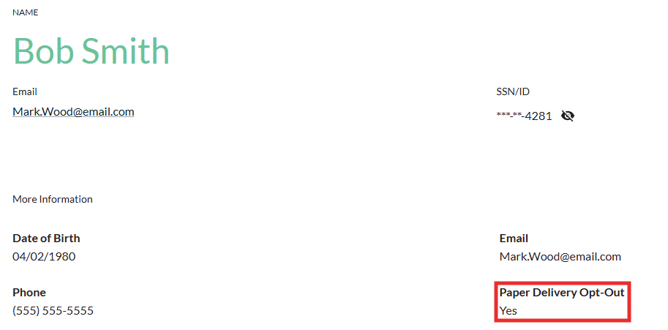

Prior Year Tax Form Corrections
A ”prior year tax form” includes any corrected or late original tax form that is generated after Superior submits the final IRS information return for that tax year on behalf of your organization (generally August 1st of the following year).
Superior will create corrected and late original tax forms and file them with the IRS on behalf of your organization only if we completed tax reporting for your organization for that tax year; however, your organization will be responsible for providing the updated tax form to the account owner upon approval from a Tax Reporting user at your organization.
If a Transactions Administrator follows the steps outlined in the previous section to make a change under an owner’s account in the Superior platform that generates a corrected or late original tax form for a prior tax year, an email notification will be sent to that user and any Tax Reporting user at the organization to let them know the update is pending approval.
Email to User Who Made the Update:
Subject: Prior Year Tax Form Pending Approval
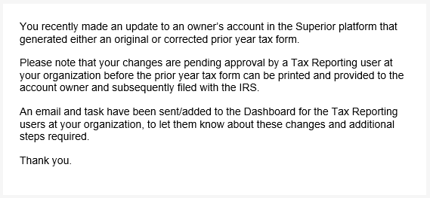
Email to Tax Reporting Users:
Subject: Action Required: Pending Prior Year Tax Form Awaiting Approval
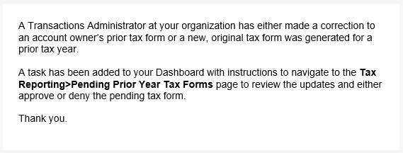
A task will also be added to the Dashboard to instruct Tax Reporting users to review and approve the pending prior year tax form before Superior files the tax form with the IRS.
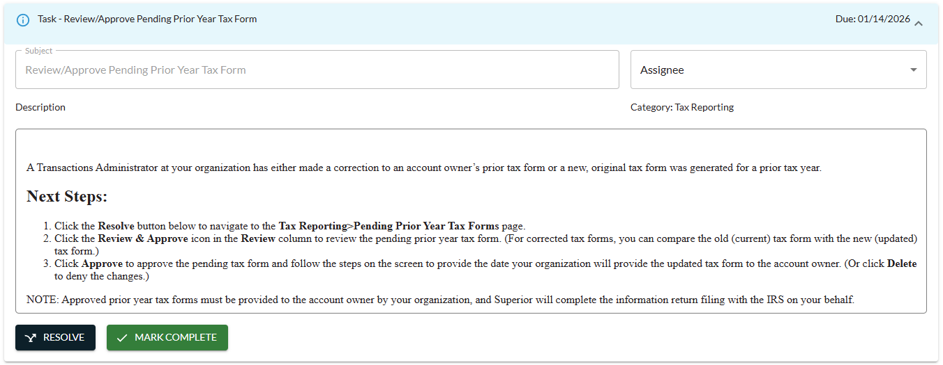
To complete the task, a Tax Reporting user must navigate to the Pending Prior Year Tax Forms page.

Pending Prior Year Tax Forms
Tax Reporting users will navigate to the Tax Reporting>Pending Prior Year Tax Forms page to review/approve pending tax form updates.
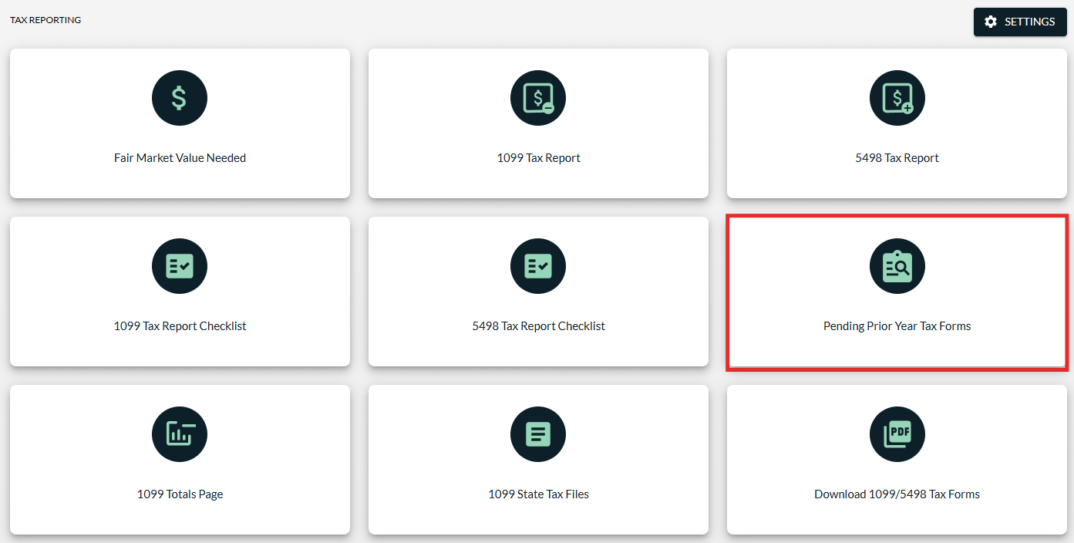

Click the Review & Approve icon to review a pending tax form.
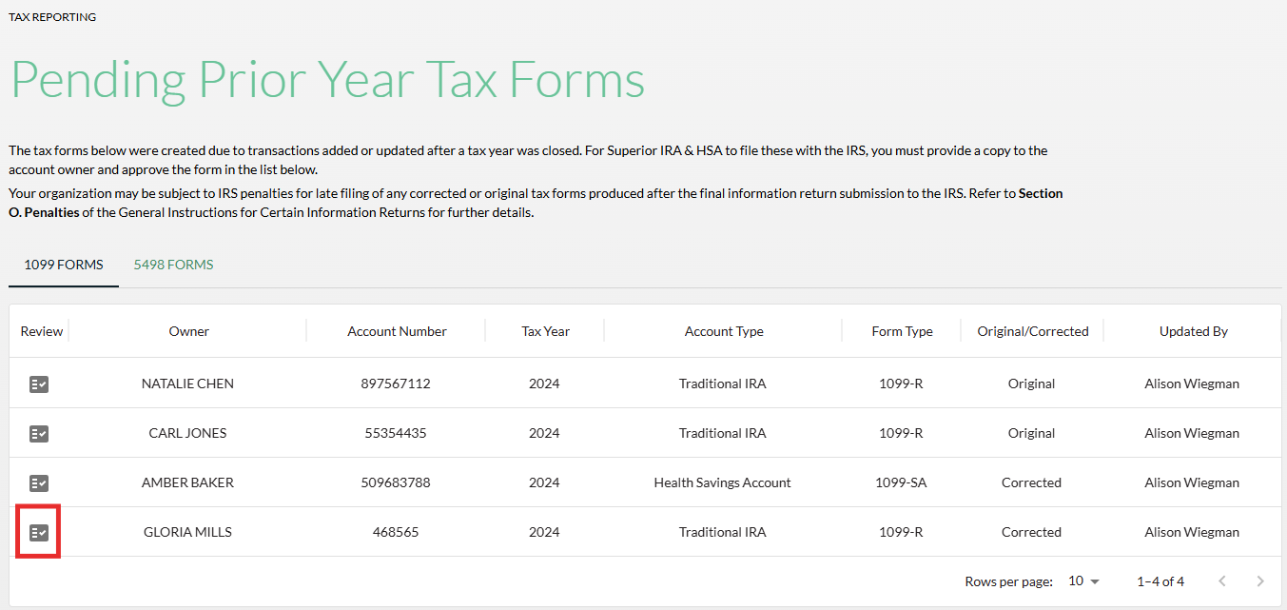
A Tax Form Details section will appear below the table, where the user can compare the old (current) tax form with the new (updated) tax form if it was a correction, or just view the details of the tax form if it’s a new late, original form.
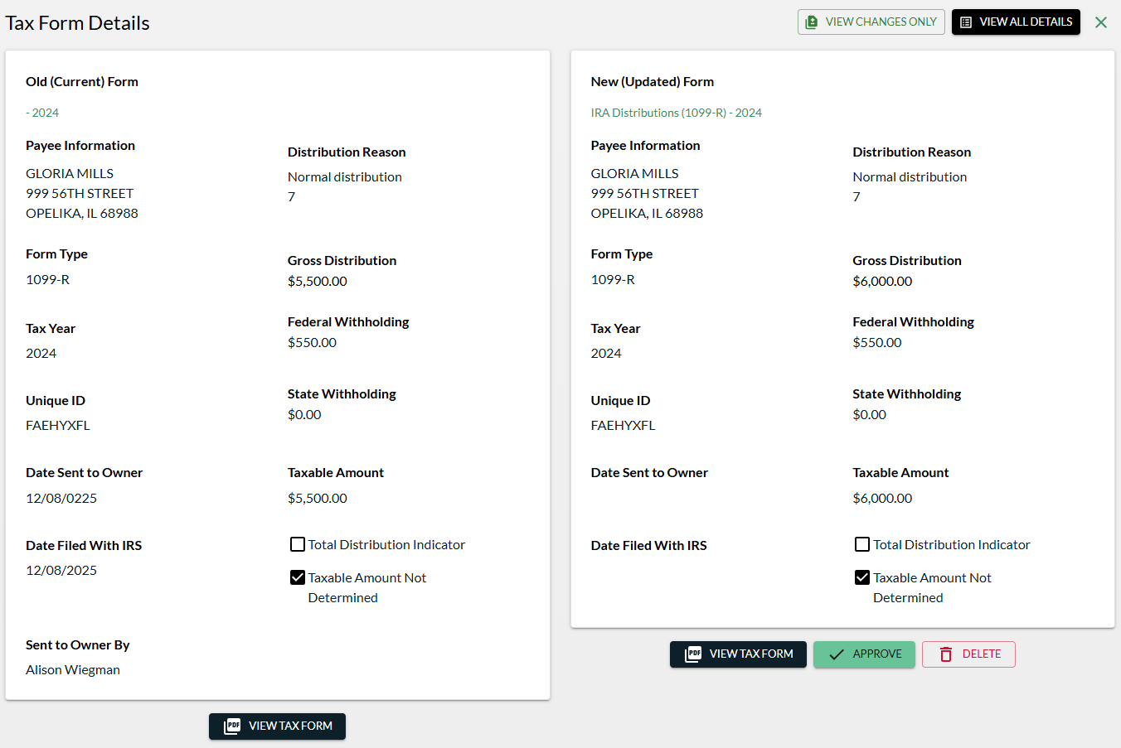
If the prior year tax form is a correction to an original tax form, you can click the View Changes Only button in the upper right corner to view only the changes that were made from the original tax form.
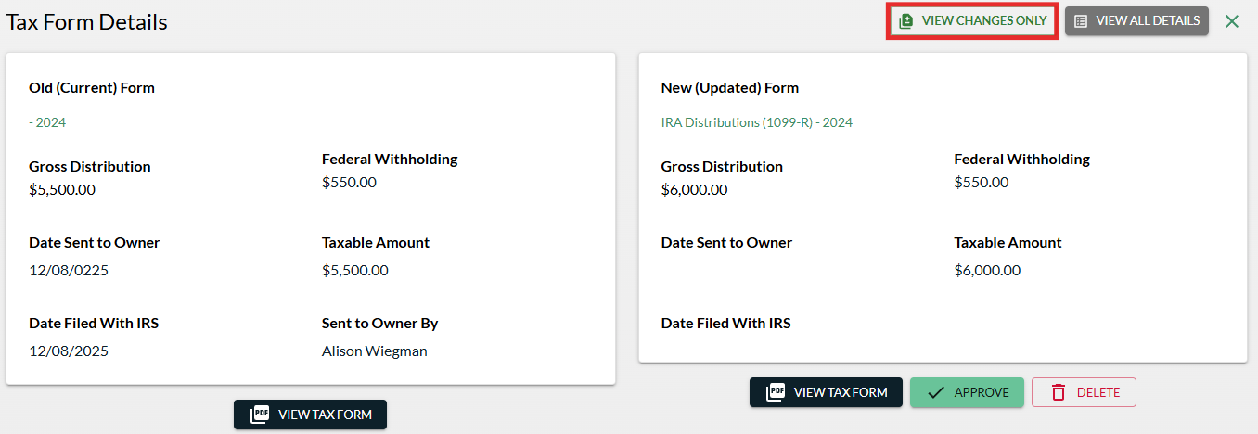
You may also click the View Tax Form button to view a sample copy of the new tax form.
To deny the pending prior year tax form:
- Click Delete to deny the changes if the pending tax form should not have been generated.

- The tax form will not be provided to the account owner, and Superior will not file any changes with the IRS.
To approve the pending prior year tax form:
- Click Approve.


- A pop-up will appear to walk you through the approval process.

  - Click View Tax Form to review a sample copy of the tax form one more time and click Next.
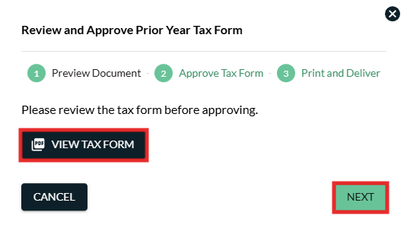
  - Enter the date your organization will provide the updated tax form to the account owner and click Approve.
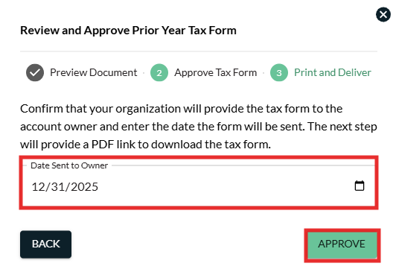

  - Click View Tax Form to print the final copy of the approved prior year tax form and ensure your organization provides it to the account owner, then click Close. (Superior will then be notified of the approval and ensure the updated information return is filed with the IRS.)
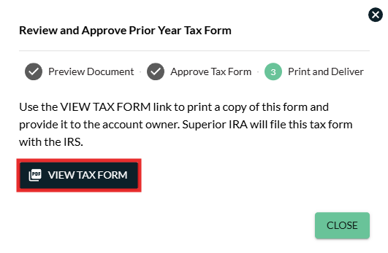

  - Upon approval, the new tax form will appear under the Tax Forms section of the owner’s account.

Superior IRA & HSA Support

Chat
Chat with us directly from the Superior IRA platform. The chat bubble appears in the lower right corner of every screen (unless you click the dots to the left of the chat bubble and move it).


Call
Call us at 888-470-4542, Option 1.

Email
Email us at support@superiorira.com.

Help Center
Search for your answer directly from the chat bubble.
- Click the Help tab at the bottom of the chat bubble screen.
- Enter a word to search for your answer within our Help Center.



