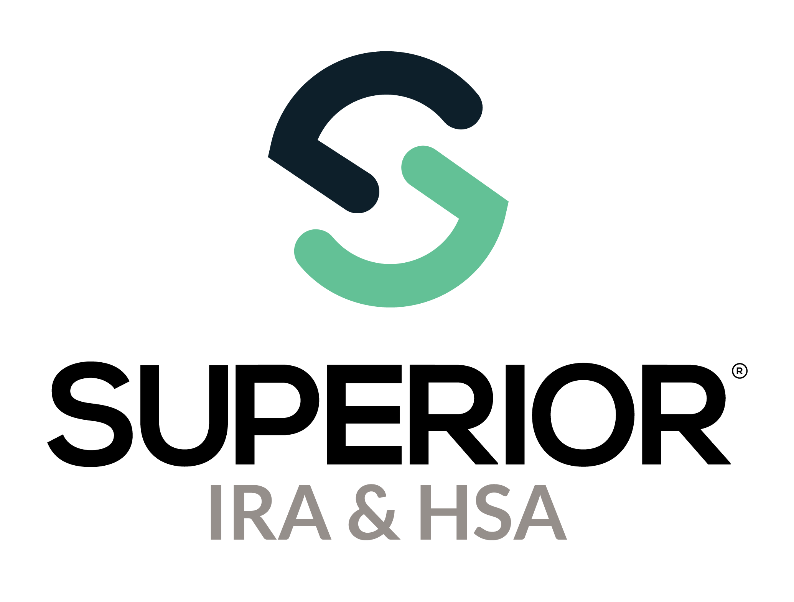
1099 State Tax Files Training Guide
(for State Reconciliation)

Superior IRA & HSA® and the Superior IRA & HSA logo are registered trademarks of Superior IRA & HSA, LLC.
Table of Contents
Download State Tax File for Reconciliation 3
Superior IRA & HSA Support 5
Chat 5
Call 5
Email 5
Help Center 5

Download State Tax File for Reconciliation
For details about reconciling your state withholding, review your state's Department of Revenue website.
If your financial organization requires a state tax file to reconcile your state withholding, follow the steps below to download this file.
- Click Tax Reporting from the left navigation menu. Then click 1099 State Tax Files.
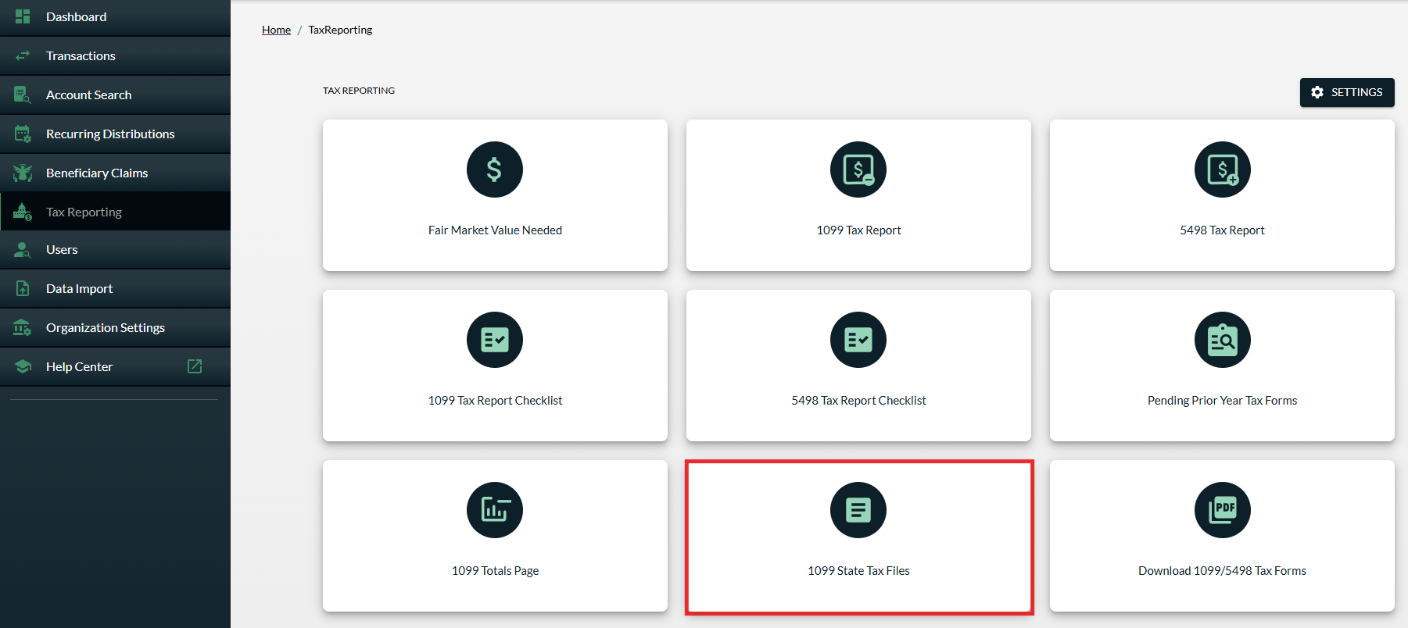

The top of the page will outline the states in which your organization withheld for state withholding and the total amounts withheld for that state.
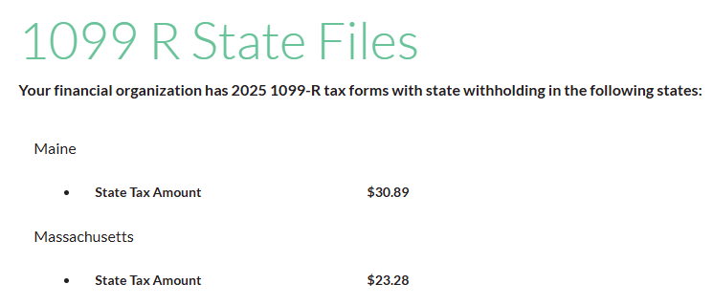

- Follow the steps on the page to download and retrieve your state's tax file.
  - 1099 Tax Form Type: The field will pre-fill with Form “1099-R”.


  - State: From the drop-down, select the state for which you would like to generate a state tax file.
  - Accounts to include: From the drop-down, select either Only withhold in this state or All owners with addresses in this state.
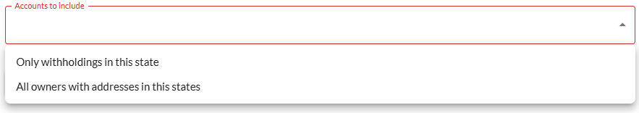
  - Click Create Tax File to download the state tax file after making your selections.
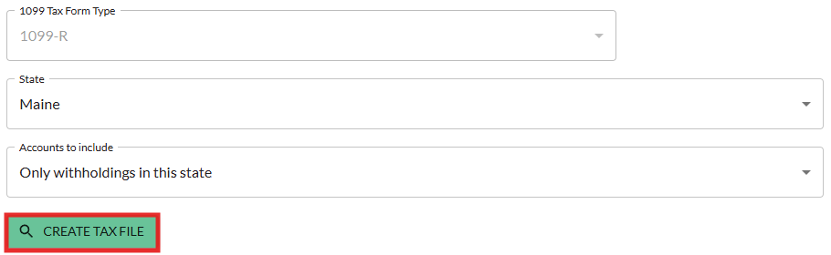

- The file will appear in your web browser downloads list when available. You may also view the downloaded state tax files under the 1099-R State Tax Files section of the page. Click on the file to download it to your computer.
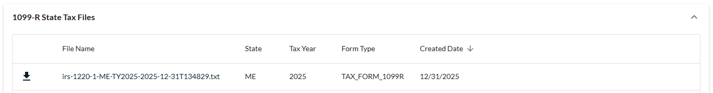

- Follow your state's reconciliation requirements to submit the electronic file to the state, if applicable.

NOTE: If your state requires additional columns or formatting that are not included in this state tax file, please let us know and we'll update our system for your state's rules if possible. Otherwise, your organization may need to update the file to include this data.

Superior IRA & HSA Support

Chat
Chat with us directly from the Superior IRA platform. The chat bubble appears in the lower right corner of every screen (unless you click the dots to the left of the chat bubble and move it).


Call
Call us at 888-470-4542, Option 1.

Email
Email us at support@superiorira.com.

Help Center
Search for your answer directly from the chat bubble.
- Click the Help tab at the bottom of the chat bubble screen.
- Enter a word to search for your answer within our Help Center.

