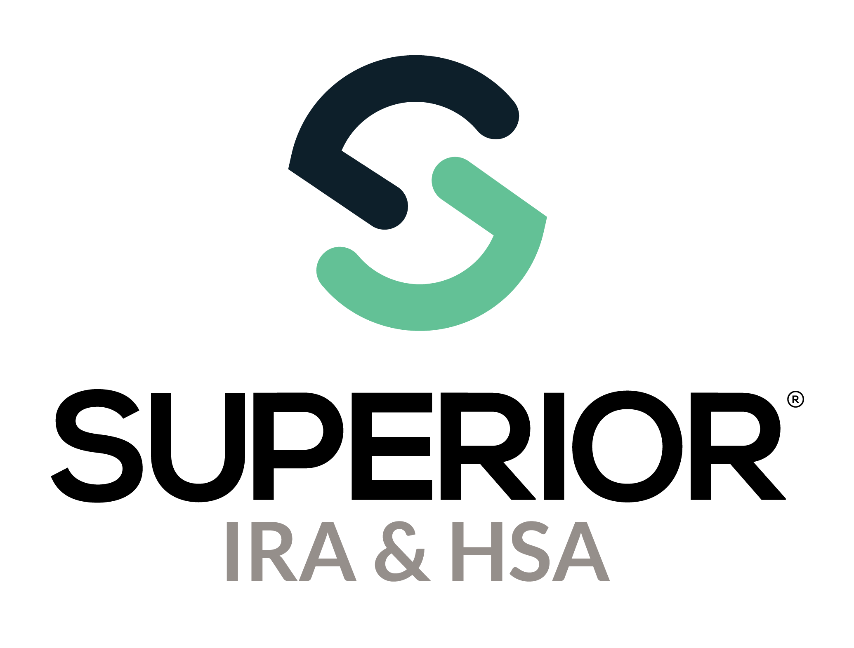
Recurring Distributions Page Training Guide

Superior IRA & HSA® and the Superior IRA & HSA logo are registered trademarks of Superior IRA & HSA, LLC.
Table of Contents
Recurring Distributions 3
Settings 4
Allowed Distribution Methods 4
RMD Notification Settings 5
Scheduled Distribution Settings 5
Scheduled Distributions 6
RMD Notifications 7
Withholding Notifications 8
RMD Summary 9
Recurring Distribution Schedules 10
Superior IRA & HSA Support 11
Chat 11
Call 11
Email 11
Help Center 11

Recurring Distributions
Users with a Recurring Distributions Administrator role have access to this section. (This page is not applicable if your organization is enrolled in Superior’s Silver solution. It is only applicable to Superior’s Green solution and Black solution.)
Select Recurring Distributions in the left navigation menu to view scheduled distributions, RMD notifications, withholding notifications (only applicable if enrolled in Superior’s Black solution), an RMD summary, and a list of all recurring distribution schedules.
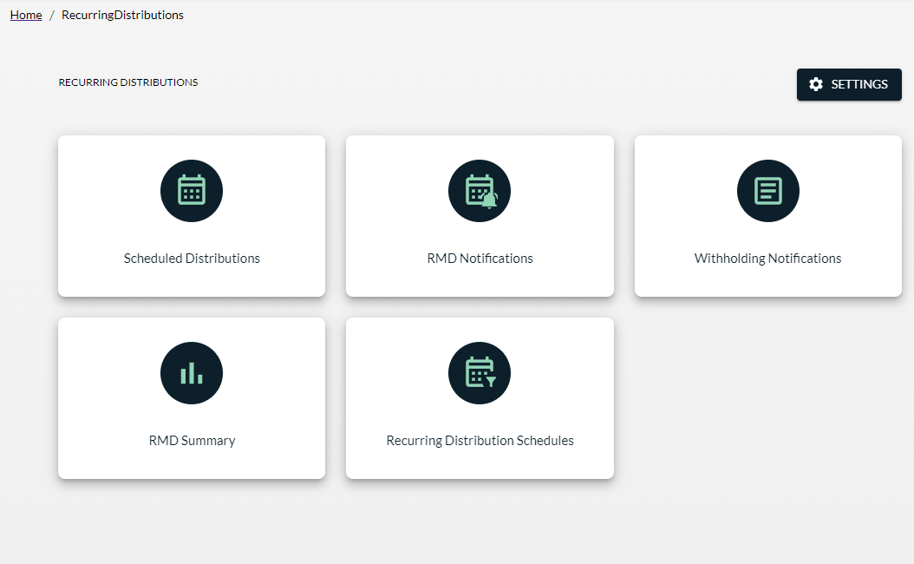

Settings
The Settings area is used to set your organization’s Allowed Distributions Methods, RMD Notification Settings (such as your default RMD option), and Scheduled Distribution Settings. Do not change these settings unless your role at your institution is to oversee the entire recurring distribution process.
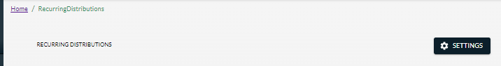

Allowed Distribution Methods
This section lets your organization manage the type of distribution methods displayed on the RMD Election forms sent to your account owners.
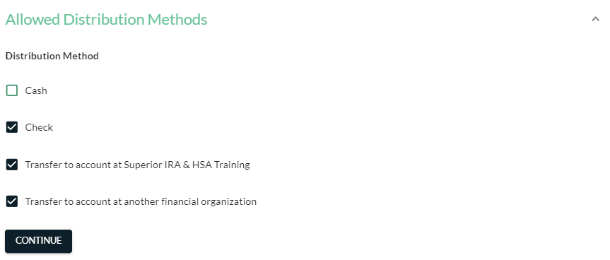

RMD Notification Settings
This section allows your organization to select how your account owners will be defaulted if they do not return their RMD Election forms, and how long they have to return those forms before they are defaulted.
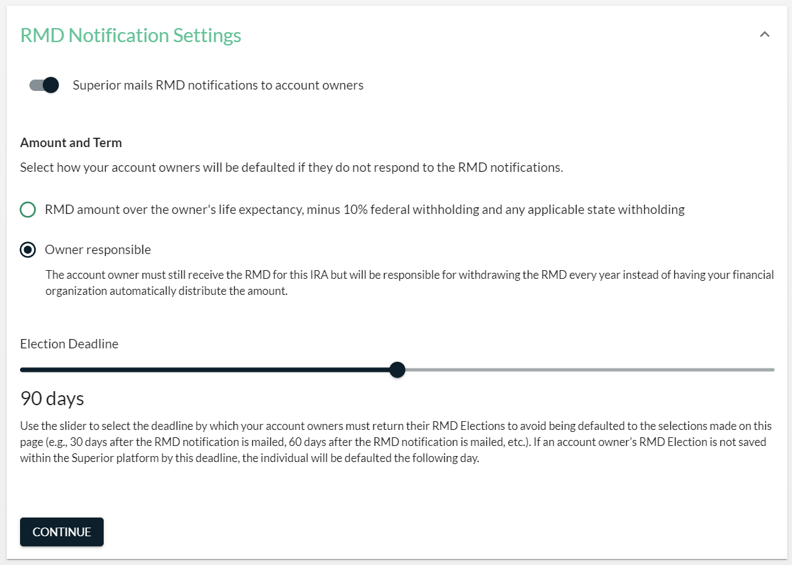

Scheduled Distribution Settings
This section allows you to enable or disable the following settings.
- Superior will automatically add the amounts of any scheduled distributions listed on the Scheduled Distributions report to the account owner’s account.
- Superior will mail your organization’s withholding notifications to your IRA owners set up to receive a scheduled distribution. (This setting is not editable if enrolled in Superior’s Green solution because Superior only completes withholding notifications for organization’s enrolled in the Black solution.)
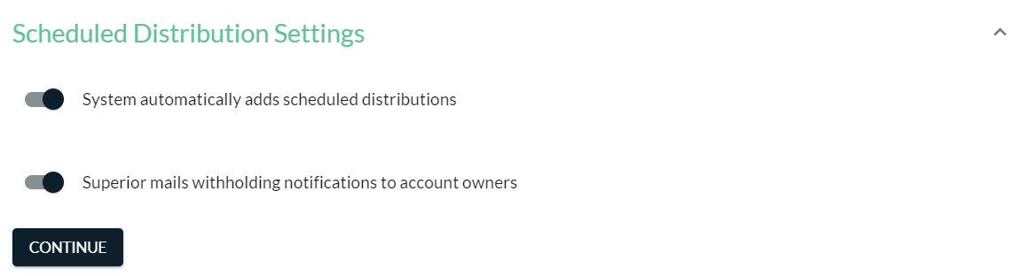

Scheduled Distributions
This section displays a list of the recurring distributions scheduled to be distributed during the date range selected.
- Choose the Start Date and End Date of the scheduled payments you want to view and click Search.
- Click Export to view a report of the data.
- Filter the list to view Completed or Pending statuses by clicking the appropriate option next to Filter by:
(Payments with a Completed status are those that should’ve already been distributed, and those with a Pending status have yet to be distributed.)
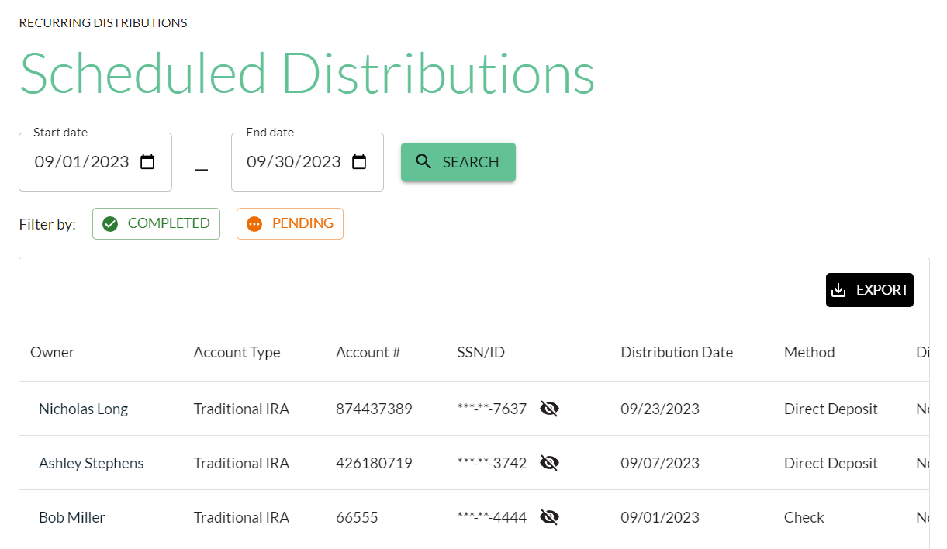

RMD Notifications
This section displays a list of the RMD notifications that were sent to your account owners who will
- attain age 73 in the current year, or
- attain age 74 or older and opened a new account with your organization in the current year.
One of the following statuses will appear on the report for your owners:
- Draft: The owner’s notification is created but Superior has not yet mailed the documents.
- Awaiting Election: The owner has not returned the election.
- Completed: Your organization has entered the owner’s election into the platform or the owner was defaulted to election because the Election Deadline has passed.
When you receive an RMD Election form back from an account owner, enter the election into the site by completing the Add Recurring Distribution workflow under the Transactions tab from the left navigation menu, or click the account owner’s name from the RMD Notifications list (shown below) to enter the Add Recurring Distribution workflow and add the election.
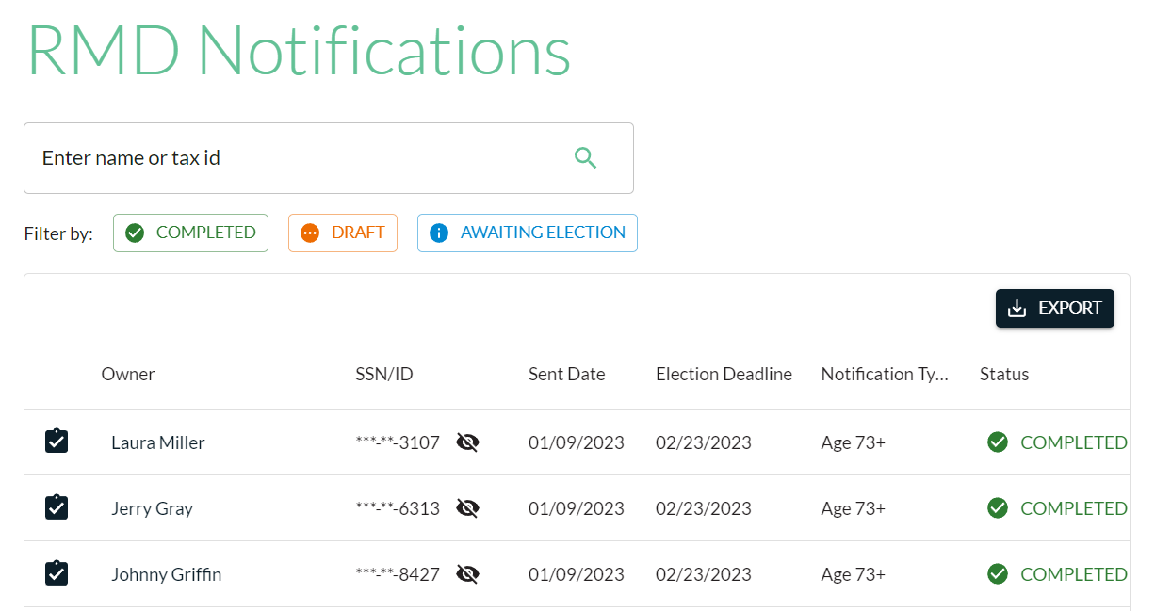

Withholding Notifications
This report is only available if your organization is enrolled in Superior’s Black solution.
Superior sends a withholding notice mailing twice a year to your account owners receiving scheduled payments.
- December notices are mailed to any owners scheduled to receive monthly, quarterly, or semi-annual payments, or annual payments during the upcoming months of January–June.
- June notices are mailed to any owners scheduled to receive semi-annual payments or annual payments during the upcoming months of July–December.
This section displays a list of the notices mailed to your account owners during the year.
- Select the month and click Search to view the account owners who were mailed a notice for that month.
- Edit the tax years to display in the report by checking (or unchecking) the Show Tax Years boxes, if applicable.
- Click the arrow next to an owner’s name to either
  - view the owner’s account, or
  - edit the owner’s withholding election upon receiving a completed withholding notification that the owner returned to your organization. (This directs you to the Edit Recurring Distribution workflow.)
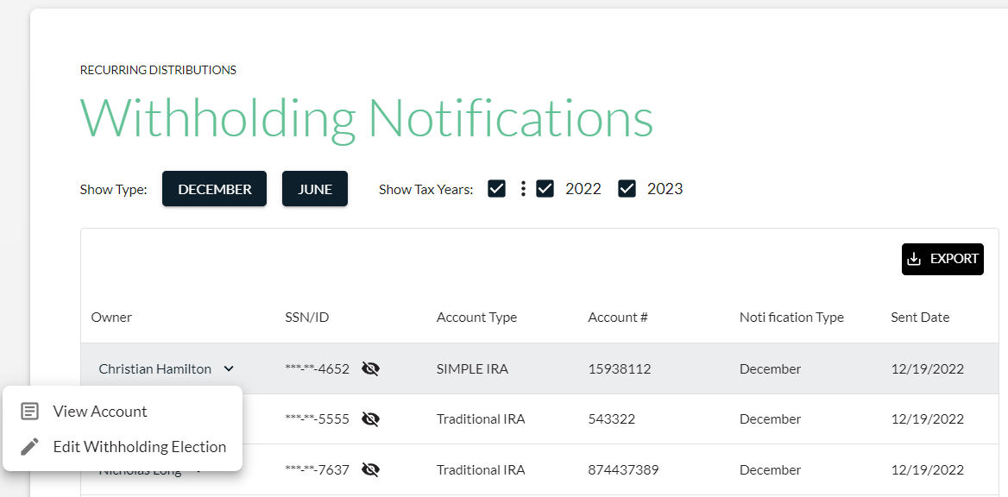

RMD Summary
The RMD Summary report displays the number of account owners ages 73 or older who have the following RMD elections added to the platform.

- Owner responsible: Account owners listed in this section have chosen not to have automatic distributions taken from their account.
- RMD amount: Account owners listed in this section have chosen to receive the amount of their RMD each year.
- Specific amount: Account owners listed in this section have chosen to receive a specific amount each year, rather than the amount of their RMD.
- No election: Account owners listed in this section do not yet have an election added to the platform and will be included in Superior’s next RMD notification mailing that occurs in February.
- Defaulted election: Account owners listed in this section did not return their RMD Election form to your organization by the Election Deadline selected under the Recurring Distributions>Settings page, so the defaulted election chosen on the Settings page was added to the owner’s account in the platform.

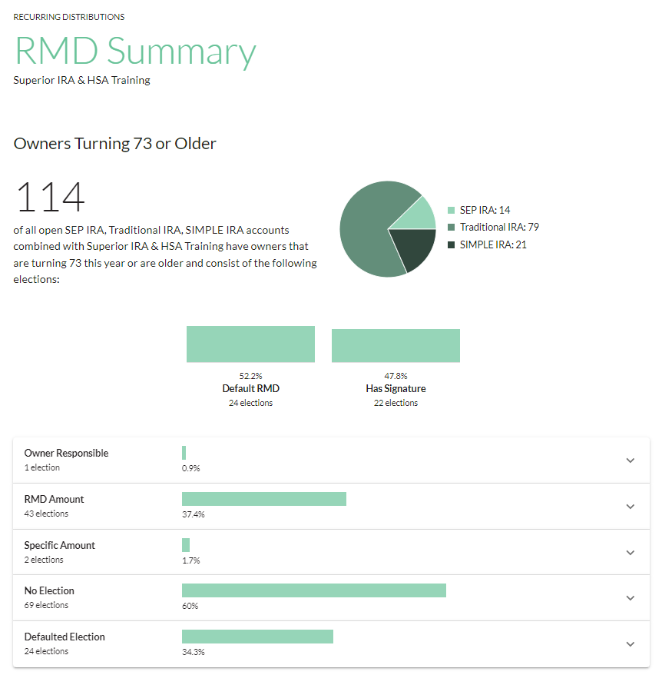
Click an election type to see the specific account owners set up with that election (or no election).

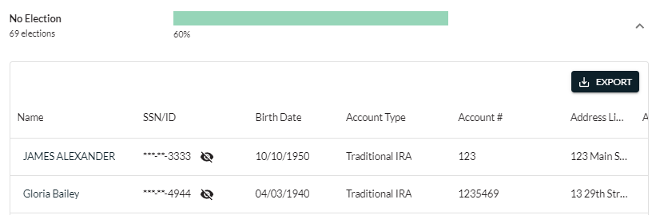

Recurring Distribution Schedules
This section displays a list of all recurring distribution schedules added to the site. You may search for a specific frequency by making one of the following selections from the Frequency filter.
- Annually
- Semi-Annually
- Quarterly
- Monthly
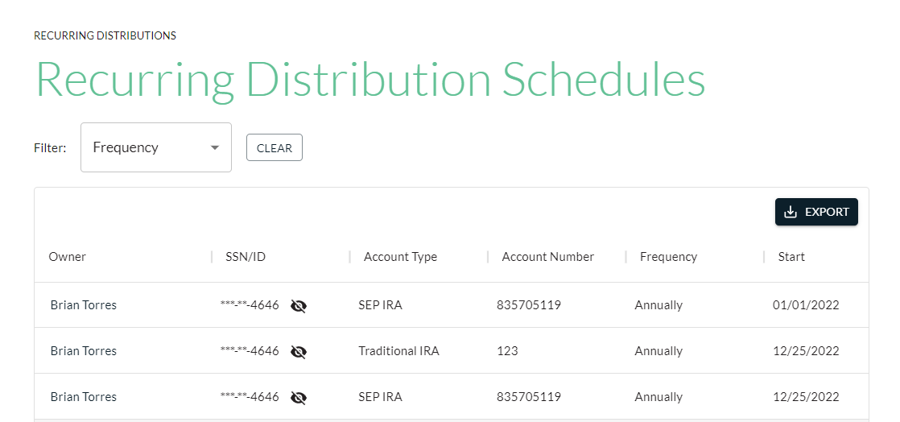

Superior IRA & HSA Support

Chat
Chat with us directly from the Superior IRA platform. The chat bubble appears in the lower right corner of every screen.


Call
Call us at 888-470-4542, Option 1.

Email
Email us at support@superiorira.com.

Help Center
Search for your answer directly from the chat bubble that appears in the lower right corner of every screen.
