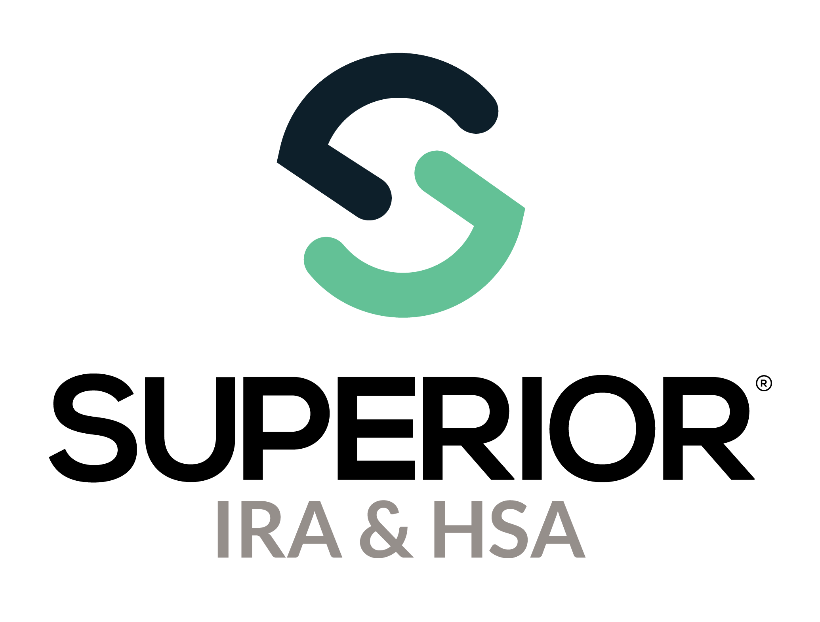
Organization Settings Page Training Guide

Superior IRA & HSA® and the Superior IRA & HSA logo are registered trademarks of Superior IRA & HSA, LLC.
Table of Contents
Organization Settings 3
Organization Information 4
Organization Esign Settings 6
Profile Options 7
Branch Information 8
State Withholding and Reporting 8
Transaction Settings 9
Distribution Code Descriptions 9
Transaction Workflow Settings 11
Workflow Permissions Settings 12
Investment Rates 13
Organization Branding 16
Organizational Documents 17
Superior IRA & HSA Support 18
Chat 18
Call 18
Email 18
Help Center 18

Organization Settings
Users with a Site Administrator role have access to this section. Select Organization Settings in the left navigation menu to view and edit your organization’s settings to ensure the site functions properly for your users.

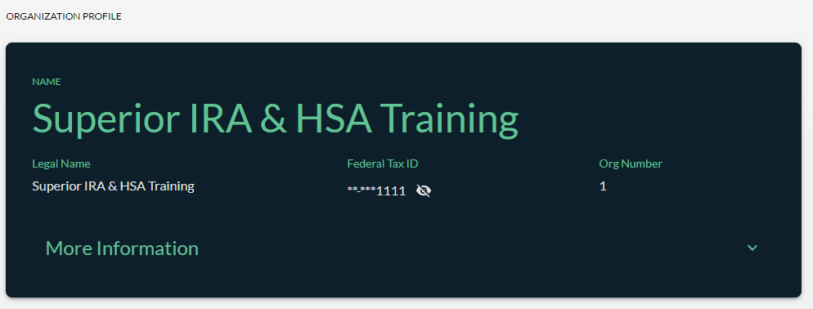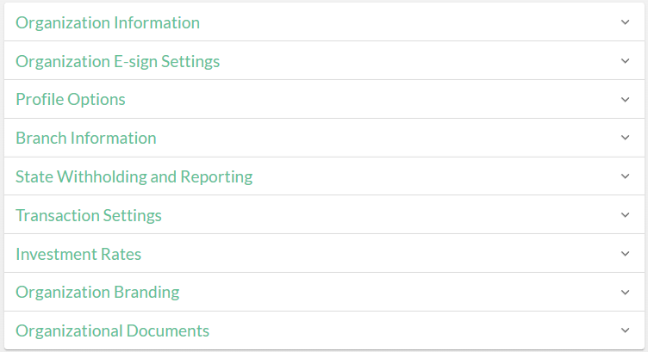

Organization Information
This section displays the following information for your organization.
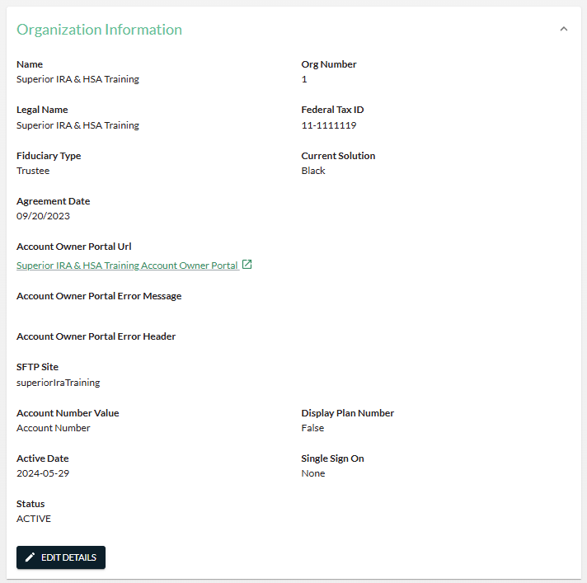
Click Edit Details to update any of the following applicable information. Click Continue to save your changes.
- Federal Tax ID – This is the federal tax ID assigned to your organization.
- Organization Name – This is your organization’s name as it will display on your completed transactional forms.

- Legal Name – (Legal name can only be updated by Superior.) This is your organization’s name as it displays on your Form 945 (to report backup withholding) and as it will display on tax forms produced by Superior IRA & HSA (if you’re on Superior’s Black solution).
- Fiduciary Type – This will display Custodian or Trustee and determines the agreements to populate for your organization when opening new accounts.
- Account Owner Info – Select if you prefer to have “account number” display throughout the site or “member number”, depending on if your organization is a bank or credit union.
  - Display Plan Number - Enable or disable the ability to display the “Plan Number” in addition to the Account Number or Member Number throughout the site. If the toggle is enabled (displays black, as shown below), any form produced by through a transaction workflow will reflect both the Account Number/Member Number and the Plan Number. If the toggle is disabled (displays gray), then the Plan Number will not display on generated forms.

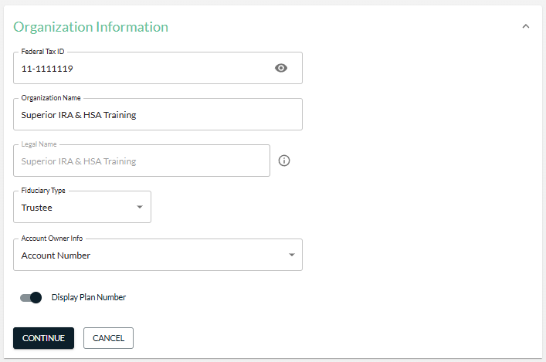

Organization Esign Settings
This section indicates if eSign functionality is enabled or disabled for your organization. You cannot enable this functionality if it is currently disabled. For more information about enabling eSign, contact our Sales Team.
If your organization uses eSign, a Site Administrator can expand the Advanced E-sign Settings section and double click an Index Field Name to edit a value.
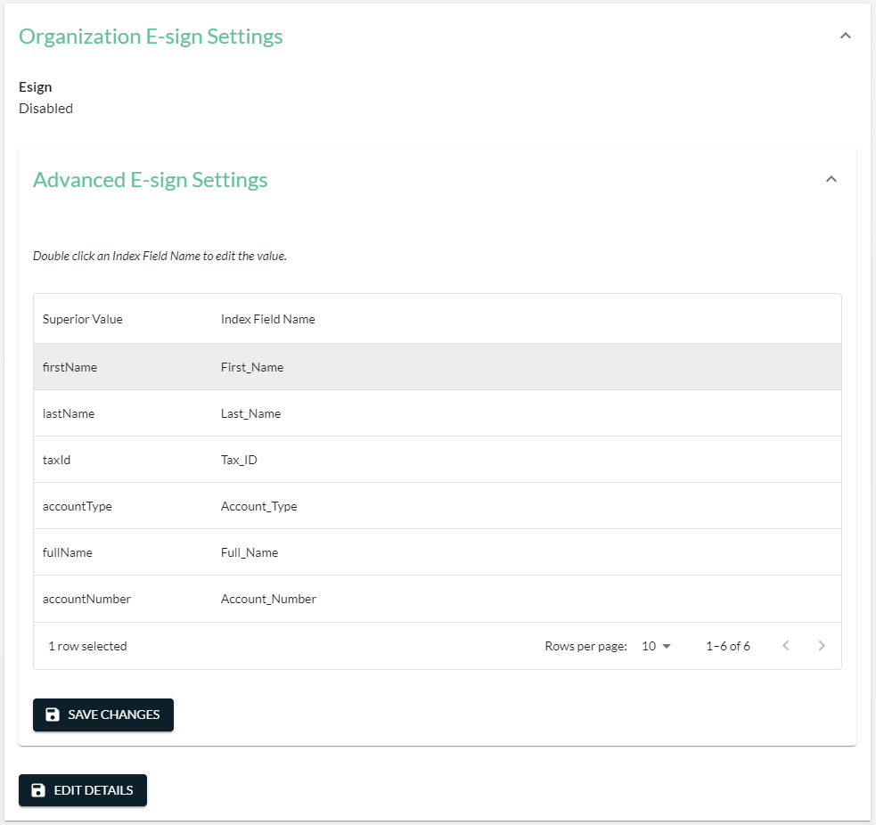

Profile Options
This section documents the account types supported by your organization. Changes by Site Administrators can be made at any time by simply updating the selection and clicking Continue.
If an account is not selected, it will not appear as an option to select within the Open New Account transaction workflow, but users will be able to complete the other transaction workflows if you have existing accounts of that account type established within the Superior platform.
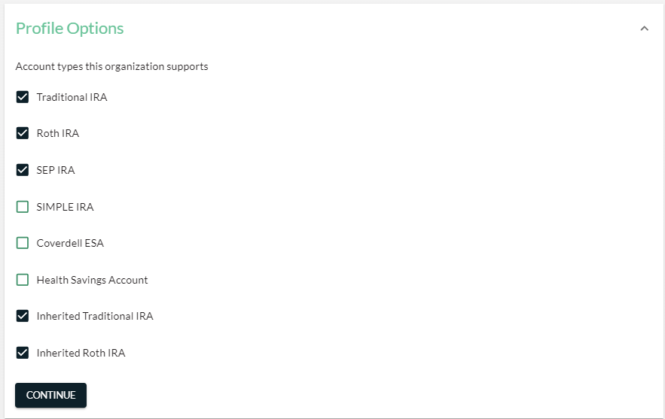

Branch Information
The different branches of your organization are stored in this section.
The branch indicated as your organization’s Primary Branch will be the information provided with your account owner mailings (i.e., branch address, phone number, and email address).
- Click + Add Branch to add a branch not listed in the table.
- Click the Pencil icon to edit information for an existing branch.
- Click the Delete icon to remove a branch.
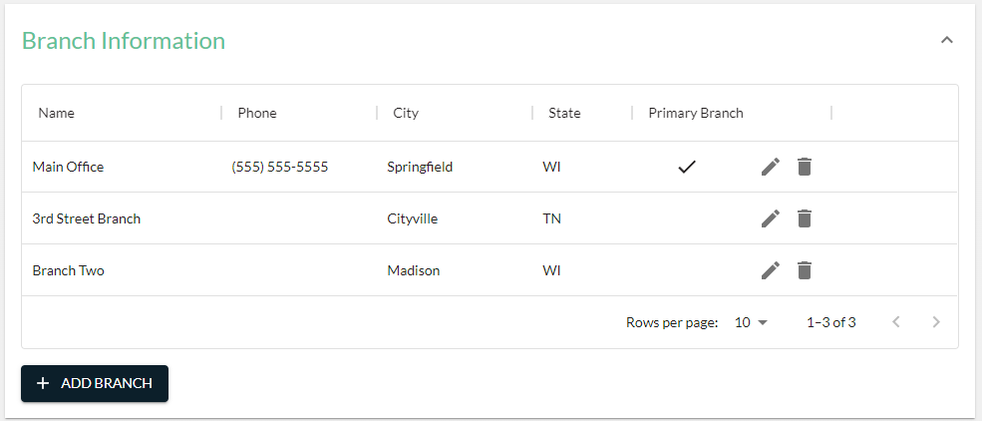

State Withholding and Reporting
In this section, indicate the states in which your organization conducts business, which is generally the states in which your organization has a physical presence. Also provide the following.
- The state tax ID
- Whether you support state withholding in that state
Take the following actions to edit this section.
- Click + Add State to add a state not listed in the table.
- Click the Pencil icon to edit information for an existing state.
- Click the Delete icon to remove a state.
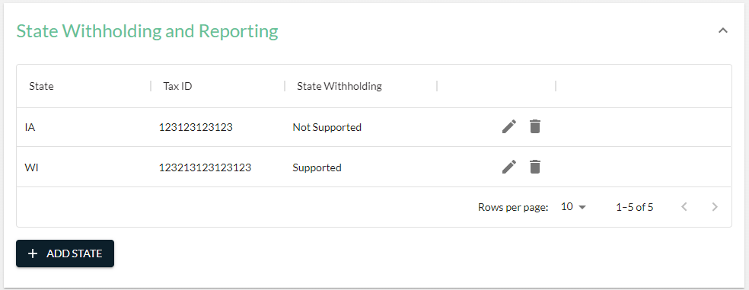

Transaction Settings
This section allows Site Administrators to add additional help text on the Distribution forms and manage additional settings available with the transaction workflows in the platform.

Distribution Code Descriptions
Expand this section to provide additional verbiage on the Superior Distribution forms if transactions codes used within your core system are different from the IRS code displayed on the printed form.
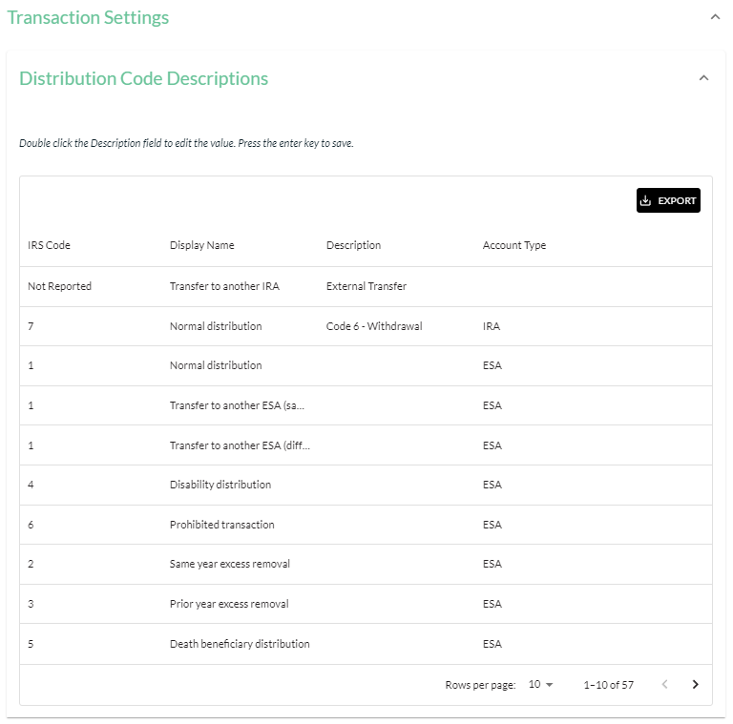

To add a description, follow these steps.
- Double click the Description column across from the applicable IRS Code.
- Enter the transaction code in the Description field.
- Click Enter on your keyboard to move to the next row.
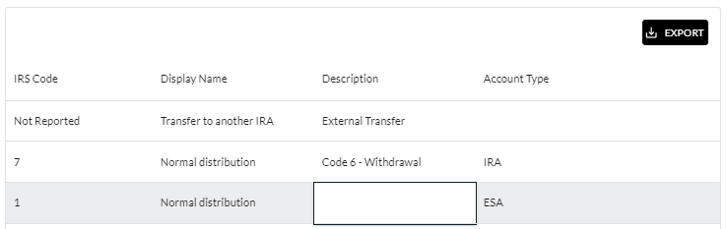
The description entered will appear in an Internal Reporting Code box below the IRS Code/Reason displayed on the Distribution form, as shown below.
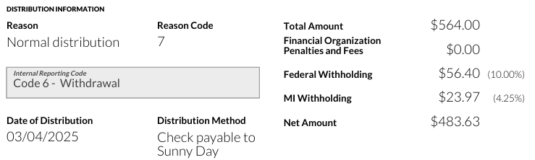
If no description is entered for an IRS Code in the Distribution Code Descriptions section, the Internal Reporting Code box will not appear on the printed form.

Transaction Workflow Settings
Expand this section to manage additional settings with the transaction workflows of the platform.
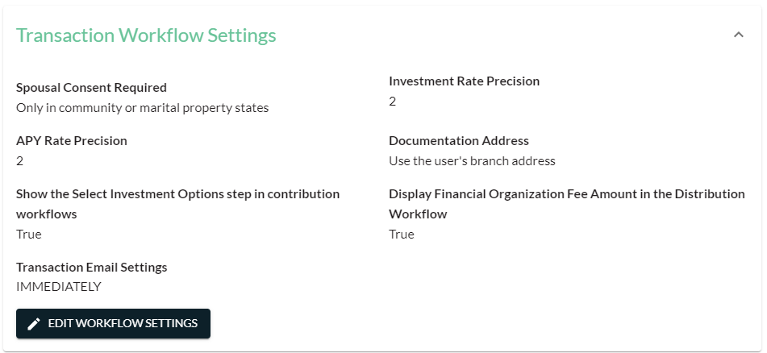
Click Edit Workflow Settings to edit the following information and click Continue to save your changes:
- Spousal Consent Required – Indicate if the Spousal Consent section on a New Account or Beneficiary Designation form will appear only when the account owner resides in a community or marital property state, or if it will always appear, regardless of the owner’s state residence.
- Investment Rate Precision – Enter the number of decimal places after the decimal point that is provided for your investment rates (e.g., enter “2” if your rates appear as 0.40; enter “3” if your rates appear as 0.400, etc.)
- APY Rate– Enter the number of decimal places after the decimal point that is provided for the annual percentage yield on your investments (e.g., enter “2” if your APY appears as 0.40; enter “3” if your APY appears as 0.400, etc.)
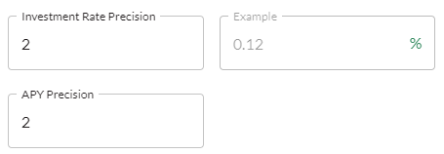
- Documentation Address – Select the financial organization address to appear on your forms. You may select to always display the primary branch address or the branch address for the specific user completing the transaction.
- Email Frequency (for Pending Transactions and Past Due Task Notifications) – Select how frequently you’d like staff to be notified about the following situations.
  - When Transactions Administrators will be notified that a transaction is awaiting review in the Pending Review section of the Dashboard.
  - When a user will be notified that a Task assigned to them on the Dashboard is past due.
You may select to receive these email notifications at one of the following frequencies.
- None: No email notifications will be sent
- Daily: A notification will be sent every day at 10:00 a.m. CT
- Weekly: A notification will be sent every Monday at 10:00 a.m. CT
- Immediately: A notification will be sent as soon as a transaction is added to the Pending Review section and as soon as a Task is past due.

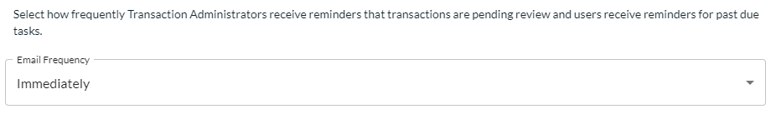
- Show the Select Investment Options step in contribution workflows – Enable or disable the ability to display the “Select Investment Options” step in the Open New Account/Deposit Money workflows. If the toggle is enabled (displays black, as shown below), then the user may either select the investment options to deposit assets into the IRA or the section may be skipped. If the toggle is disabled (displays gray), then the Select Investment Options section of the Open New Account and Deposit Money workflows does not display for the user to select.

- Display Financial Organization Fee Amount in the Distribution Workflow – Enable or disable the ability to display the Financial Organization Fee Amount field in the Distribute Money workflow. If the toggle is enabled (displays black, as shown below), then the user will see the option to enter any financial organization fees assessed on a distribution in the Distribute Money workflow. If the toggle is disabled (displays gray), then the Financial Organization Fee Amount field will not display in the Distribute Money workflow.


Workflow Permissions Settings
This section reflects the transaction workflows that your organization’s Transactions and Transactions Administrators can access. Changes by Site Administrators can be made at any time by simply updating the selection and clicking Continue.
If a transaction workflow is not selected, users will not be able to complete that transaction workflow within the Superior platform.
Please note that if any transaction workflows are disabled, you will need to log out of the platform and then log back in to have those transactions removed from the Transactions section of the platform.
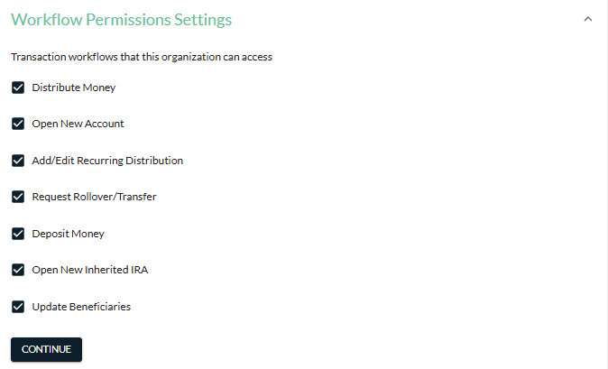

Investment Rates
This section tracks the current investments offered by your organization.
Take the following actions to edit this section.
- Click + Add Investment to add an investment not listed in the table.
- Click the Pencil icon to edit information for an existing investment.
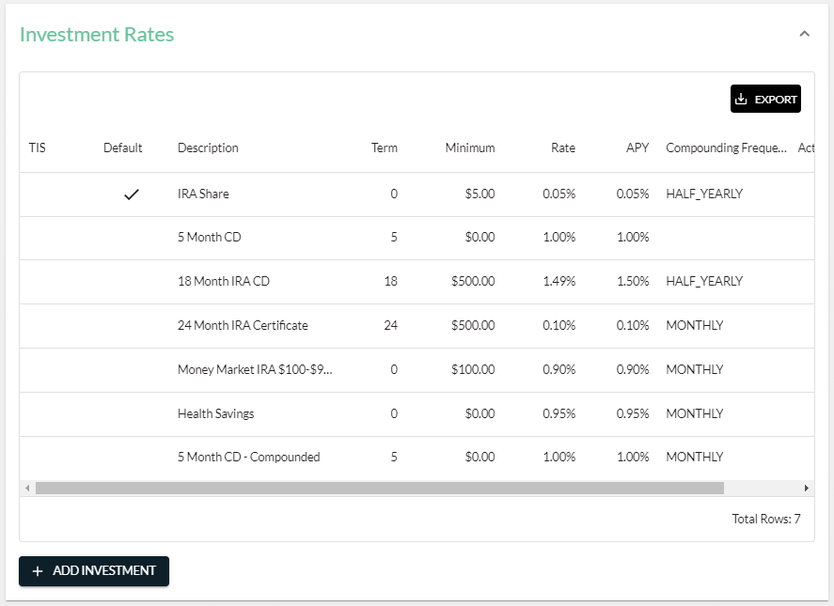
- Description – Provide the name of the investment.
- Term in Months – Enter the investment term, calculated in months. Enter “0” if there is no term.
- Minimum Investment – Enter the minimum amount required to select this investment.
- Interest Rate – Provide the rate for the investment.
- APY – Enter the annual percentage yield for the investment.
- Enrollment Fee – Enter the amount of the fee applied to select the investment, if applicable.
- Annual Fee – Provide the amount of the yearly fee charged for the investment, if applicable.
- Early Withdrawal Fee – Enter the fee (in number of days or months of interest or the dollar amount) for taking an early withdrawal before the investment matures.
- Early Withdrawal Option – Select the correct option to describe the number entered for the Early Withdrawal Fee—Days of Interest, Months of Interest, or Dollar Amount.
- Additional Fee – Provide the name of any additional fee assessed, if applicable.
- Additional Fee Amount – Enter the amount of the additional fee entered, if applicable.
- Compounding Frequency – Select if the interest on the investment is compounded yearly, half-yearly, quarterly, monthly, weekly, or daily.
- Active – Always check this box when adding a new investment. If editing an existing investment, you may uncheck this box to indicate that the investment is not currently offered at your organization.
- Default – Only check this box for your investment that offers the lowest interest rate. This default investment will be used to produce the financial disclosure for a new IRA if the user does not select an investment in which to make the initial deposit.
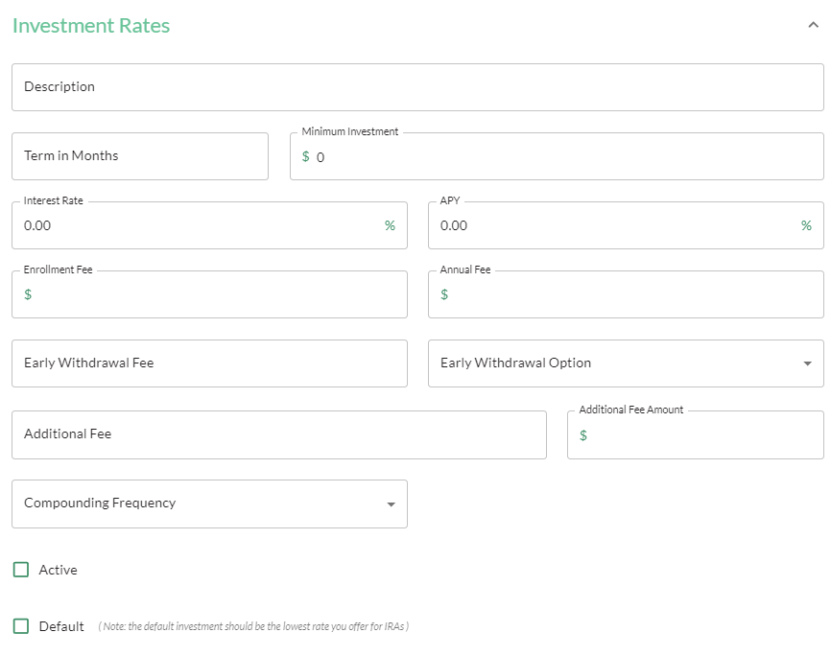

If your organization would like the truth-in-savings (TIS) document for a specific investment to print at the end of the Open New Account workflow when the investment is selected, you may also upload the TIS document applicable to that investment at the bottom of the investment section.
This section is optional. You have two options for uploading the TIS document:
- To upload the static TIS document, simply click Choose File or drag ‘n’ drop the TIS document into the applicable section and click Continue to save your changes to that investment. Any changes to the investment rates, APY, etc., must be updated under the Investment Rates section and a new TIS document must be uploaded.
- To upload a dynamic TIS document that will update any time changes are made to the investment information entered into Superior, enter the “Truth in Savings Document Mapping Fields” outlined on the page (and below) into the TIS document. Click Choose File or drag ‘n’ drop the mapped TIS document into the applicable section and click Continue to save your changes to that investment. Any changes made to the investment rates, APY, etc. under the Investment Rates section will automatically update the mapped TIS document for your organization.
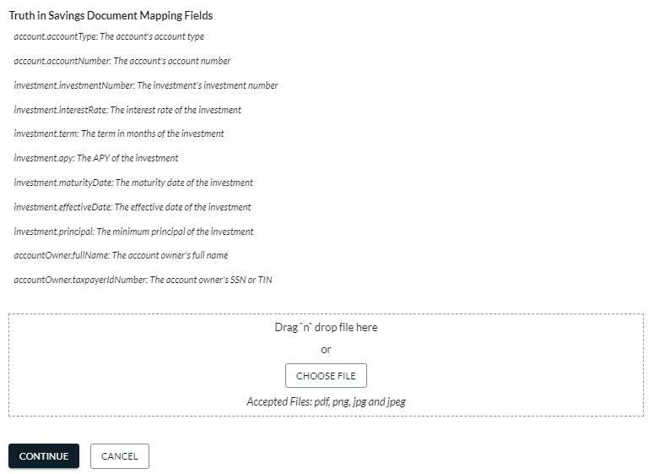

Organization Branding
Use this section to update your organization’s logo and primary color that are printed on the forms produced from the transaction workflows.
Note: Secondary Color, Primary Text Color, and Secondary Text Color are not applicable to the Superior platform. These colors will be customizable if your organization adds our Account Owner Portal. For more information about our Account Owner Portal, contact our Sales Team.
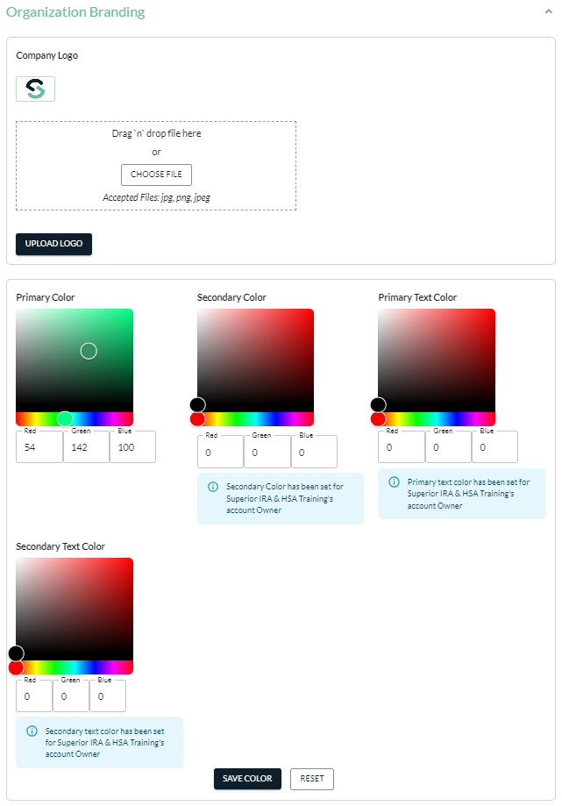

Organizational Documents
Use this section to securely exchange files with Superior IRA & HSA.
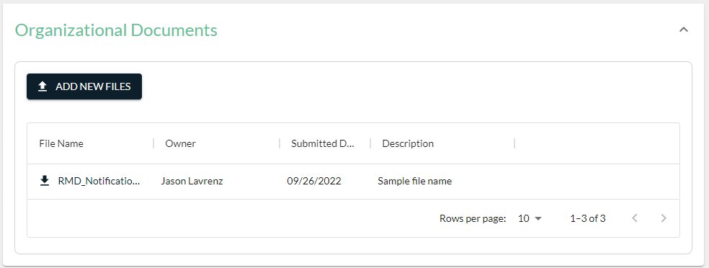
- Click the File Name of a document to view a file sent to your organization by Superior IRA & HSA.
- Click Add New Files to upload a document to Superior IRA & HSA.
- Drag ‘n’ drop the file into the specified location or click Choose File to select the file from a location on your computer. (You may upload multiple files at one time.)
- Click Upload Document(s).
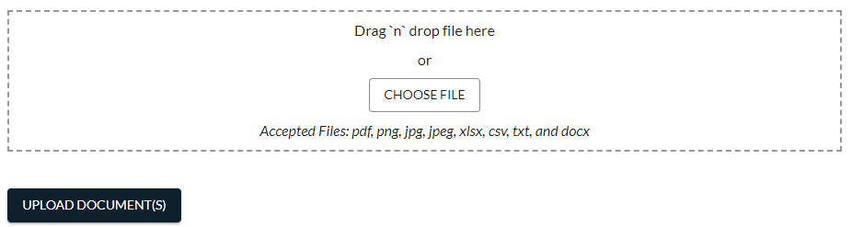
Superior IRA & HSA is notified when a document is uploaded to this section and will contact your organization if there are any questions.

Superior IRA & HSA Support

Chat
Chat with us directly from the Superior IRA platform. The chat bubble appears in the lower right corner of every screen.


Call
Call us at 888-470-4542, Option 1.

Email
Email us at support@superiorira.com.

Help Center
Search for your answer directly from the chat bubble that appears in the lower right corner of every screen.
