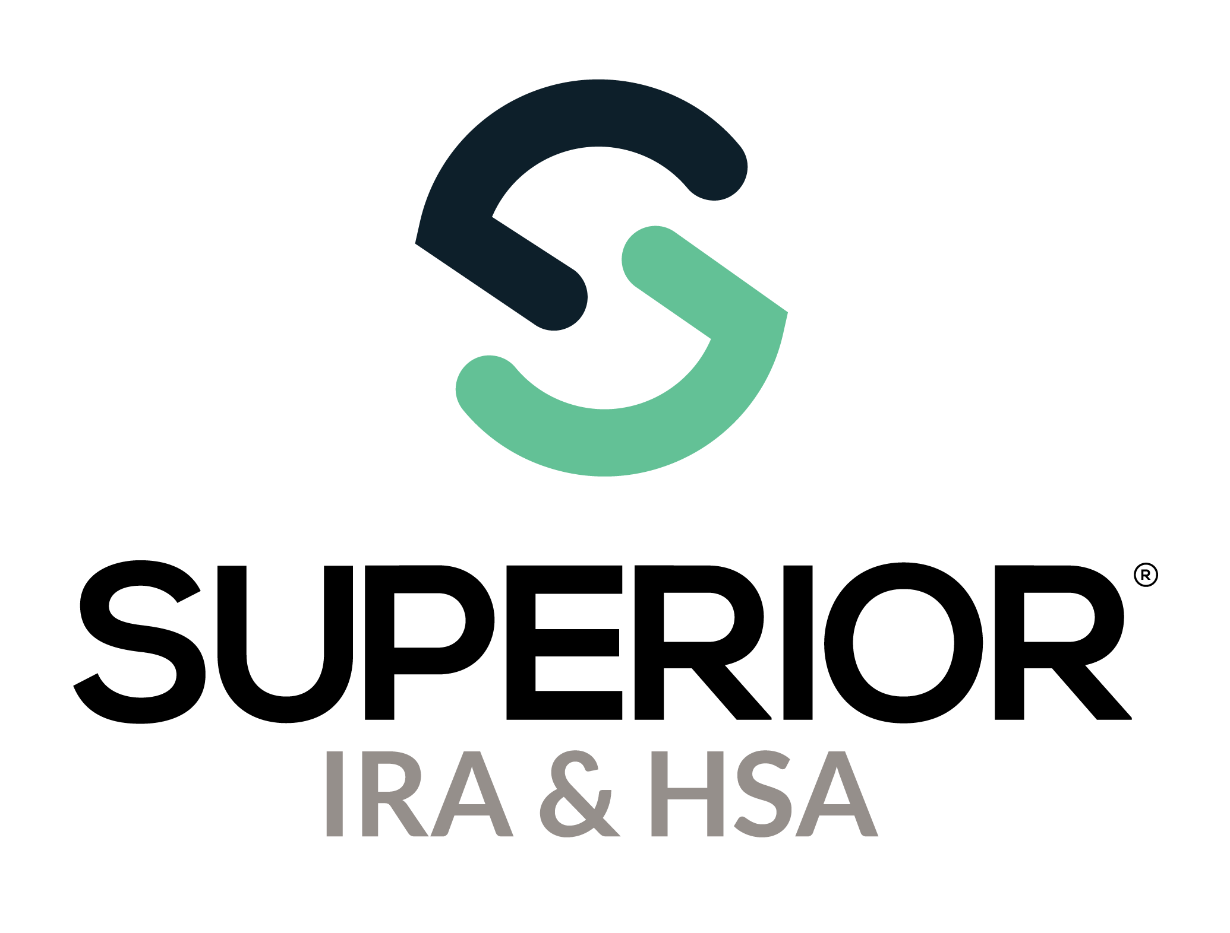
Login, Edit Profile, & Chat Bubble
Training Guide

Superior IRA & HSA® and the Superior IRA & HSA logo are registered trademarks of Superior IRA & HSA, LLC.
Table of Contents
New User Access and Verification 3
Logging In to Superior IRA 3
Editing Your Profile 4
Superior IRA & HSA Support 6
Chat 6
Call 6
Email 6
Help Center 6

New User Access and Verification
Your financial organization’s User Administrator(s) will set up all new users by navigating to the Users tab found in the left navigation menu. The Users tab is not accessible nor displayed for any other user role type.
If you are a User Administrator for your organization, review the Users Page Training Guide for instructions about adding users to the site.
After you are added to the system by the User Administrator, you will receive two emails from login@app.superiorira.com—one to verify your email address and the other to set up your password.

Logging In to Superior IRA
- Go directly to the login screen at https://app.superiorira.com/, or go to www.superiorira.com and click Login in the upper right corner of the screen.
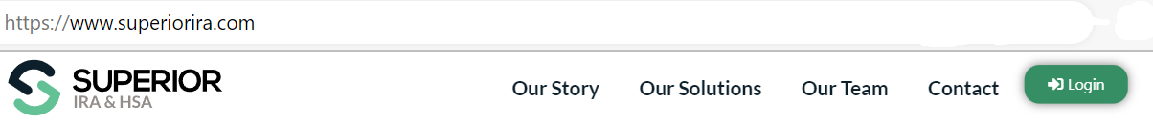
- Enter your email address and click Continue.
- Enter your password and click Continue.
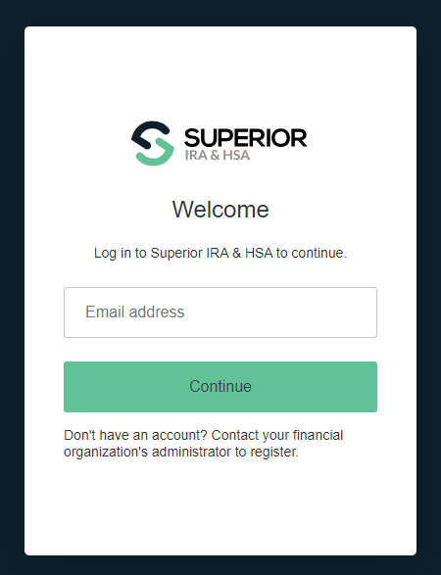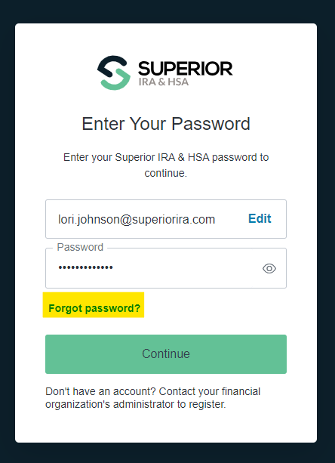
- Click Forgot password if you need to reset your password or contact your User Administrator to send you a reset password email. If reset, you’ll receive an email from login@app.superiorira.com to proceed with changing your password.

Editing Your Profile
Your profile consists of your first and last name, phone number, email address, job title, branch location, and notification preference.
All users may edit their user profile information, except for the email address used to establish their user account. If an email address needs to be changed for a user, a User Administrator must delete the account associated with the old email address and establish a new account for the user. Review the Users Page Training Guide for instructions about deleting/adding users to the site.
To edit your profile, take these steps after logging into the site.
- Click the Profile icon in the upper right corner.
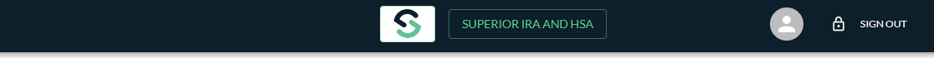
- Select Edit Profile.
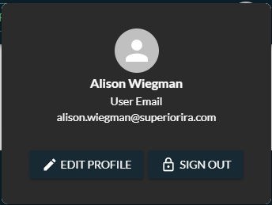
- Expand the Edit User Information section to edit any details and click Continue.

- Expand the Edit Role & Permissions section to edit your roles and permissions and click Continue. (Only available to User Administrators.)
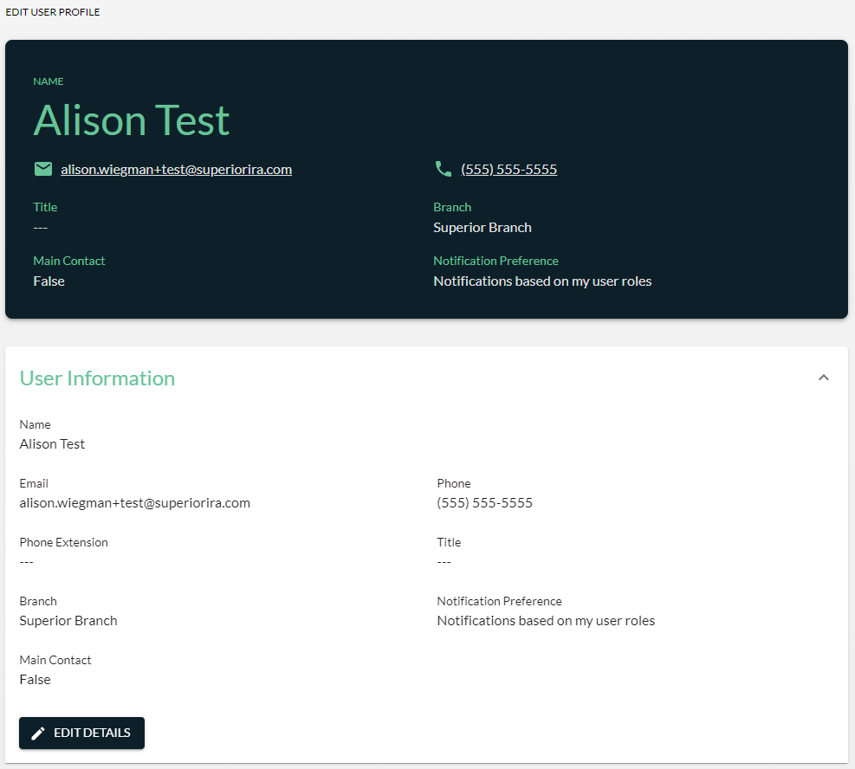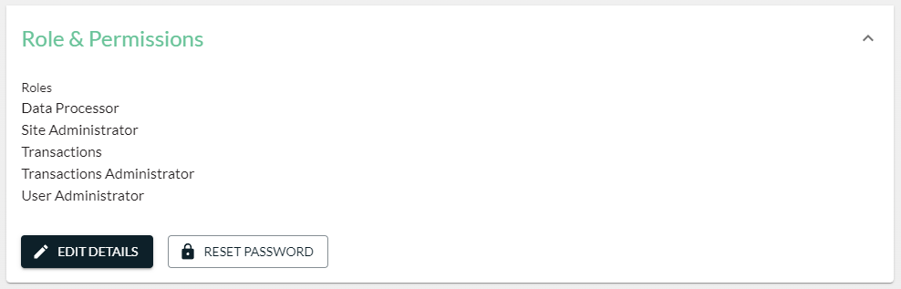

Superior IRA & HSA Support

Chat
Chat with us directly from the Superior IRA platform. The chat bubble appears in the lower right corner of every screen.


Call
Call us at 888-470-4542, Option 1.

Email
Email us at support@superiorira.com.

Help Center
Search for your answer directly from the chat bubble that appears in the lower right corner of every screen.
