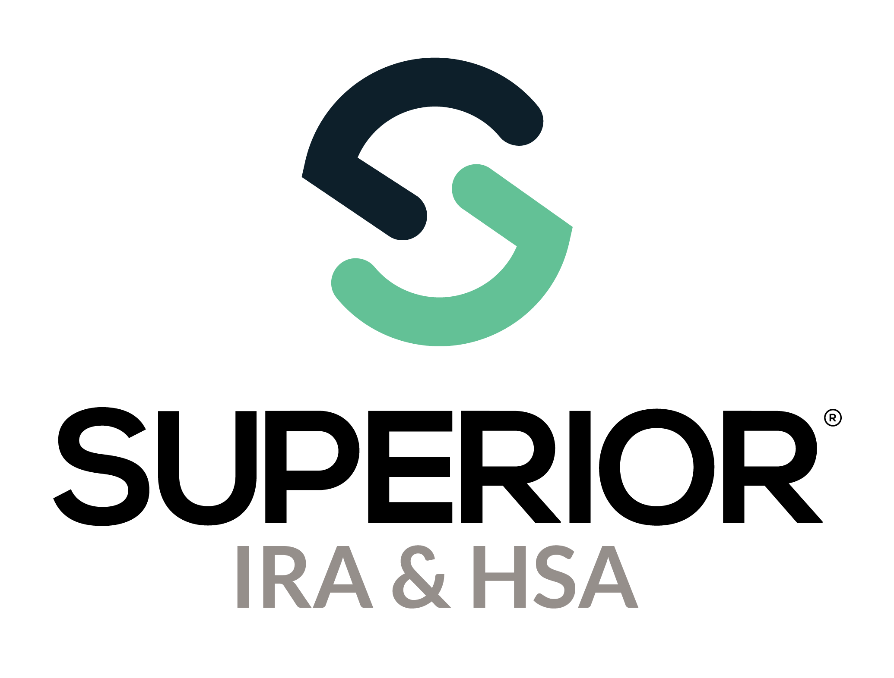
Download 1099/5498 Electronic Tax Forms Training Guide

Superior IRA & HSA® and the Superior IRA & HSA logo are registered trademarks of Superior IRA & HSA, LLC.
Table of Contents
Steps to Download Electronic Tax Forms 3
Establish an SFTP Site 3
Set Up Index File Settings 4
Retrieve Electronic Tax Forms 7
Superior IRA & HSA Support 9
Chat 9
Call 9
Email 9
Help Center 9

Steps to Download Electronic Tax Forms
If your organization wishes to download electronic copies of tax forms that you can upload to your online banking site, follow the steps within this guide.
- Establish a Secure File Transfer Protocol (SFTP) site
- Set up index file settings
- Retrieve electronic tax forms
Before providing only electronic tax forms to your account owners, refer to Section M. Statements to Recipients of the General Instructions for Certain Information Returns for the IRS consent requirements that must be obtained to utilize an alternative statement delivery method.

Establish an SFTP Site
To download/retrieve electronic .pdf copies of tax forms from the Superior platform, your organization must first establish an SFTP site with Superior.
Secure File Transfer Protocol (SFTP) is a method of file transfer used for sending sensitive files between connected systems. SFTP adds authentication and encryption to file transfers, allowing organizations to share files securely and meet regulatory compliance requirements for sensitive file data.
Superior utilizes SFTP connection to allow clients to send sensitive client information in a batch file to the platform as well as retrieve and download sensitive client information (such as .pdf copies of tax forms) from the platform for use on their online banking site.
To establish an SFTP connection, follow these steps:
- Determine the IP addresses that your organization will use to connect to Superior’s SFTP server.
- Securely email those IP addresses to support@superiorira.com, so we may whitelist them.
Superior will then set up your connection and send your organization the connection information and login credentials to access the SFTP site.

Upon establishing the SFTP site, the Download 1099/5498 Tax Forms icon will appear under the Tax Reporting page of the Superior platform.
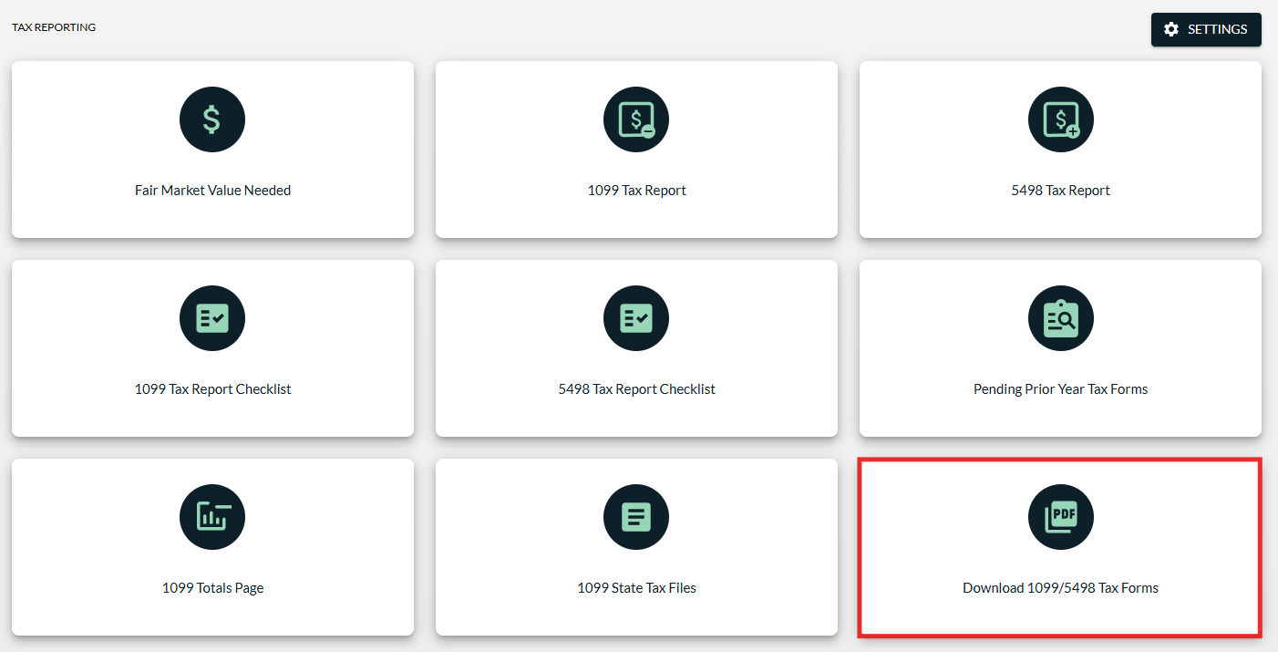

Set Up Index File Settings
Next, have your IT department establish your index file settings by following these steps.
NOTE: If you know what you would like to include in the index file, but need assistance in completing the one-time setup, you may email support@superiorira.com with the information that should be included in the index file, and we will work on setting it up for you.
- Click the Settings button under the Tax Reporting page.

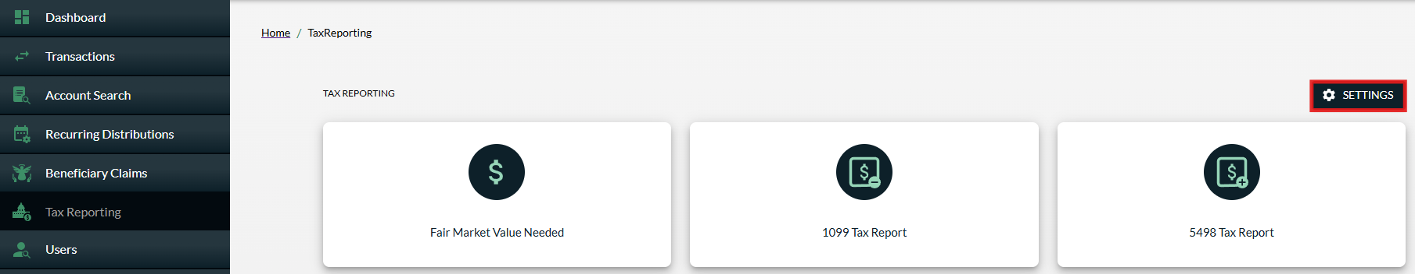

- Expand the Index File Settings section.

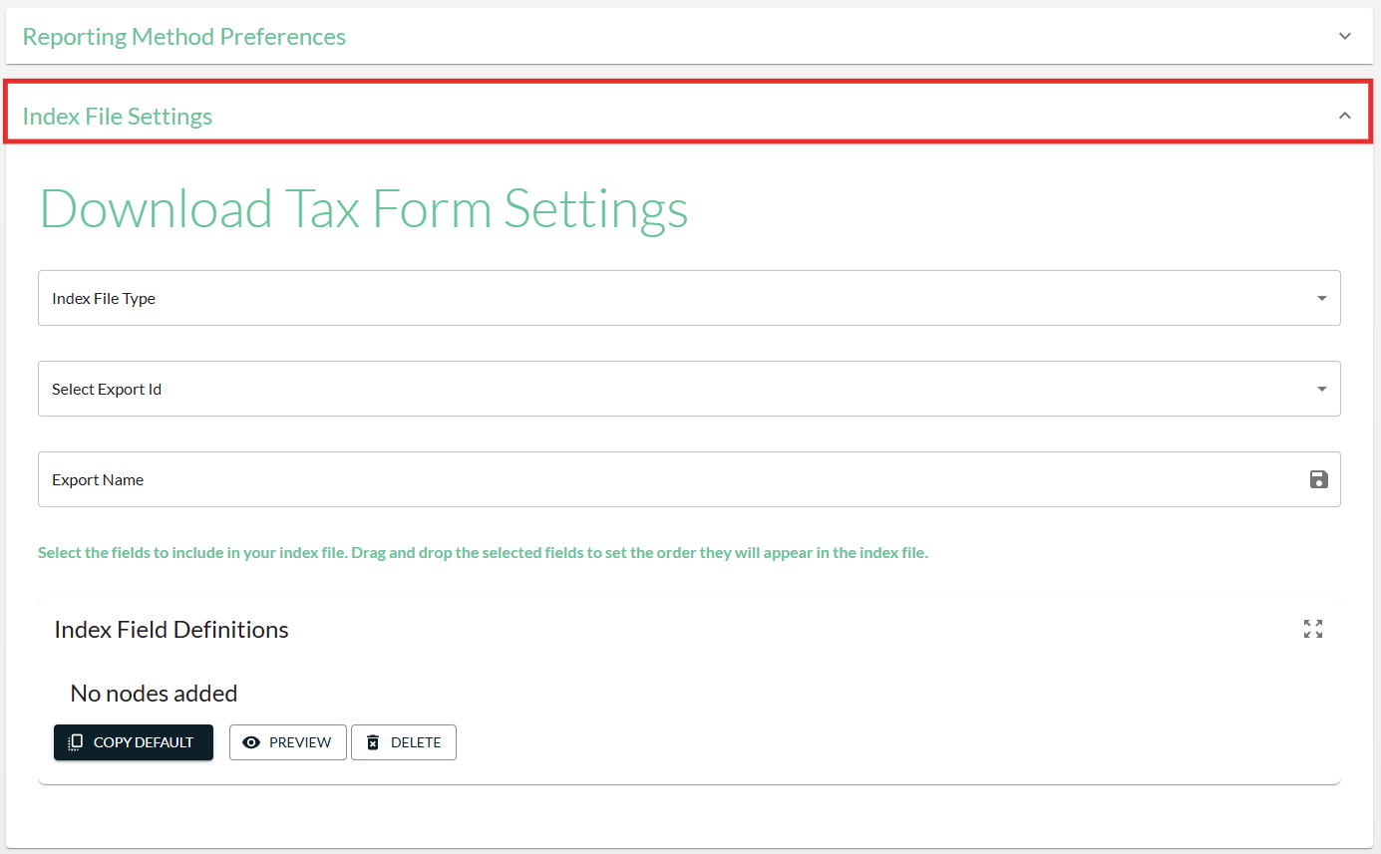

- Select the Index File Type you’d like provided with your electronic tax forms, so you can easily upload the .pdf copies to your online banking site—Text, Excel or XML. (Most index file types are text files. If your organization uses Synergy, you’ll select XML format.)
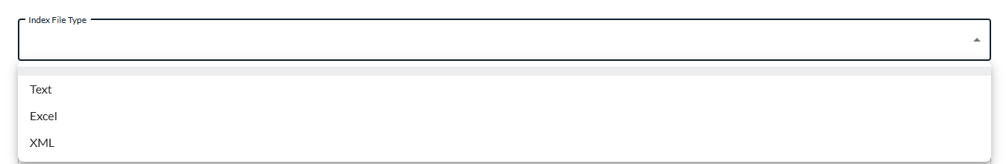

- Click the Copy Default button to copy over default settings.

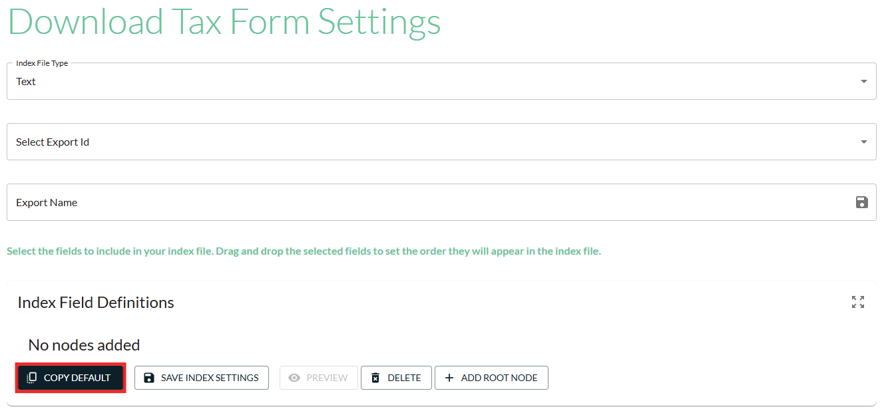

- After default settings are copied, a default Export Id name will appear. Enter a different title for this index file setting in the Export Name field and click the Save icon to update the Export Id name. (May only be necessary if you plan to use two separate index file settings for tax forms vs other notification mailings.)

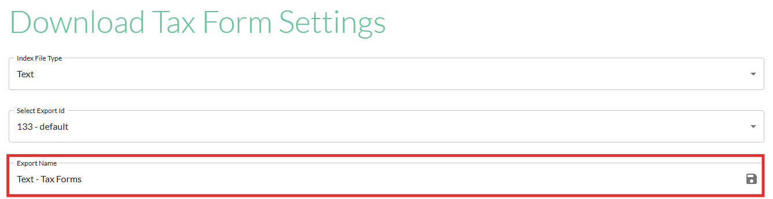

- From here, you may modify the basic file settings to fit your organization’s needs.
  - To edit the existing default fields that you want included in your index file:
    - Select the default field from the Select Fields drop-down.
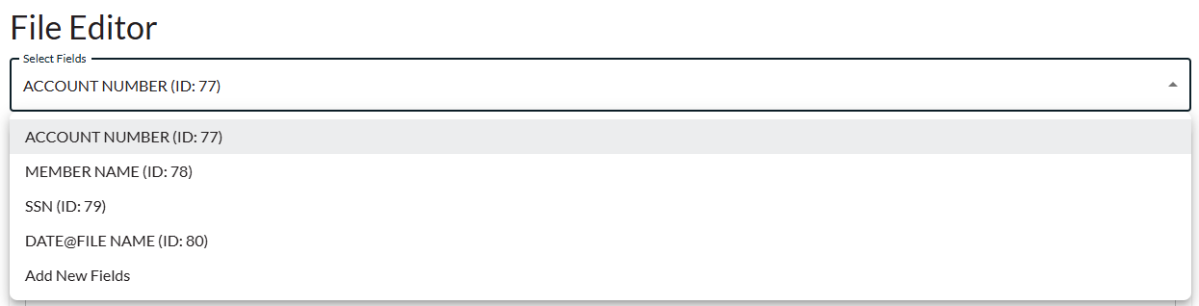
    - Update the Fields Name, if applicable.
    - Enter the Field Order in which you’d like that data to appear in the index file (1, 2, 3).
    - Provide the Field Delimiter to use to separate the data fields (| , ; ).
    - Continue with any remaining edits to the index file and click Save Index Settings to save your changes.

Retrieve Electronic Tax Forms
After your organization has an SFTP site established with Superior and your index file settings are established, you may download electronic copies of tax forms to upload to your online banking site.
Electronic tax forms can only be retrieved from the platform once your organization has approved tax form production, which is the final step in the tax reporting checklists. If your organization has not approved tax form production by clicking the Create Tax Forms button within the Approve Tax Form Production sections of the 1099/5498 Checklist, you will be unable to retrieve the electronic tax forms because they have not yet been created.
NOTE: The Create Tax Forms button should only be clicked after your organization has completed the checklist in its entirety. Clicking this button before reviewing and fixing any errors after uploading your tax file data (either with the 750 formatted file or a spreadsheet) could result in incorrect tax form production.
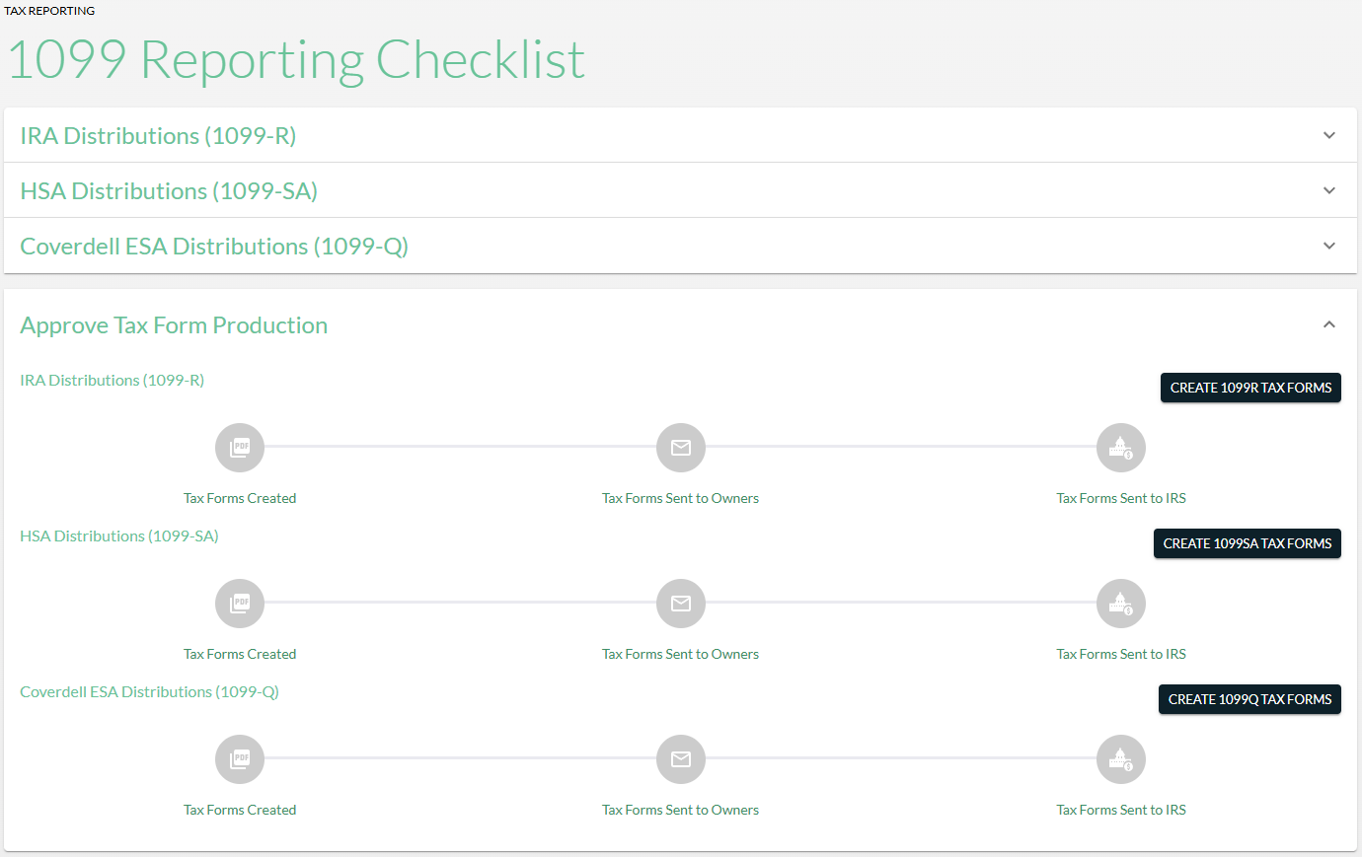

To download electronic copies of Forms 1099/5498:
- Click Tax Reporting.
- Click Download 1099/5498 Tax Forms.
- Enter the applicable information for the tax form you would like to retrieve.
  - Select the tax form from the Select Tax Form Type drop-down.
  - Choose the Tax Year.
  - Select the saved index file from the Select Export Id drop-down if your organization has more than one index file setting saved. Otherwise, only your sole saved index file setting will appear in this field.
  - If applicable, you can select to exclude forms sent before a certain date.
  - Click Create File.
  - Retrieve the index file/.pdfs from your SFTP site and upload to your online banking site.
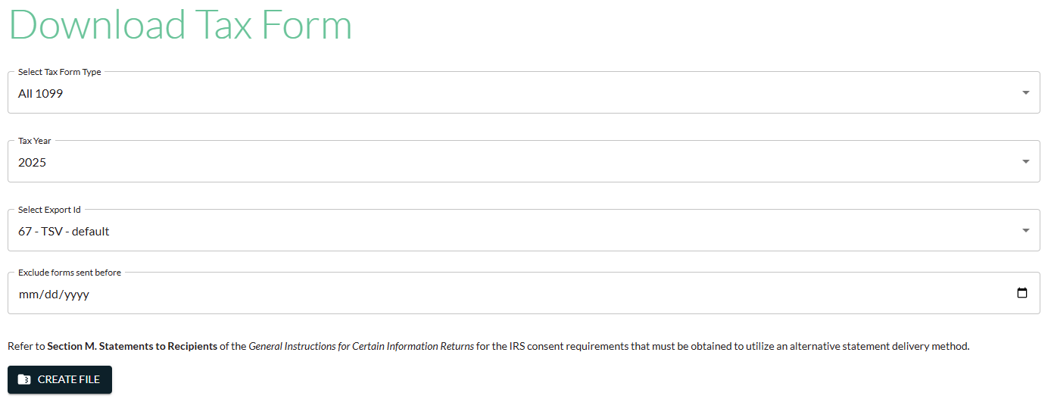

Superior IRA & HSA Support

Chat
Chat with us directly from the Superior IRA platform. The chat bubble appears in the lower right corner of every screen (unless you click the dots to the left of the chat bubble and move it).


Call
Call us at 888-470-4542, Option 1.

Email
Email us at support@superiorira.com.

Help Center
Search for your answer directly from the chat bubble.
- Click the Help tab at the bottom of the chat bubble screen.
- Enter a word to search for your answer within our Help Center.



