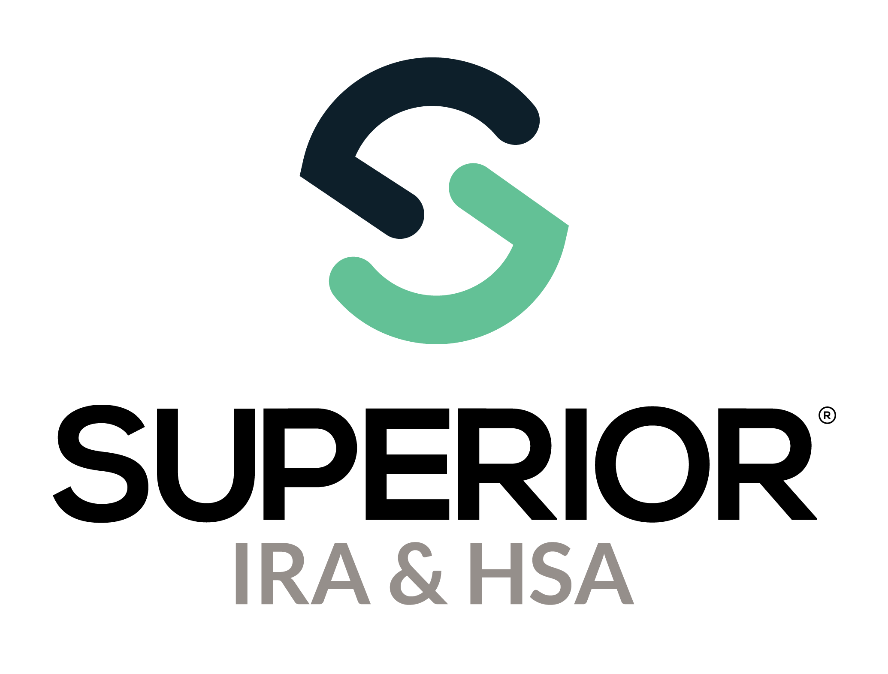
Data Import Page Training Guide

Superior IRA & HSA® and the Superior IRA & HSA logo are registered trademarks of Superior IRA & HSA, LLC.
Table of Contents
Data Import 3
Processing 7
Error 8
Completed 9
Superior IRA & HSA Support 10
Chat 10
Call 10
Email 10
Help Center 10

Data Import
Users with a Data Processor role have access to this section. Select Data Import in the left navigation menu to import data files for
- adding users,
- adding/updating accounts,
- updating account owner information,
- adding/updating deposits,
- adding/updating distributions,
- adding recurring distributions,
- adding/updating fair market values, or
- submitting 1099 or 5498 tax files (only applicable to Superior’s Black solution).

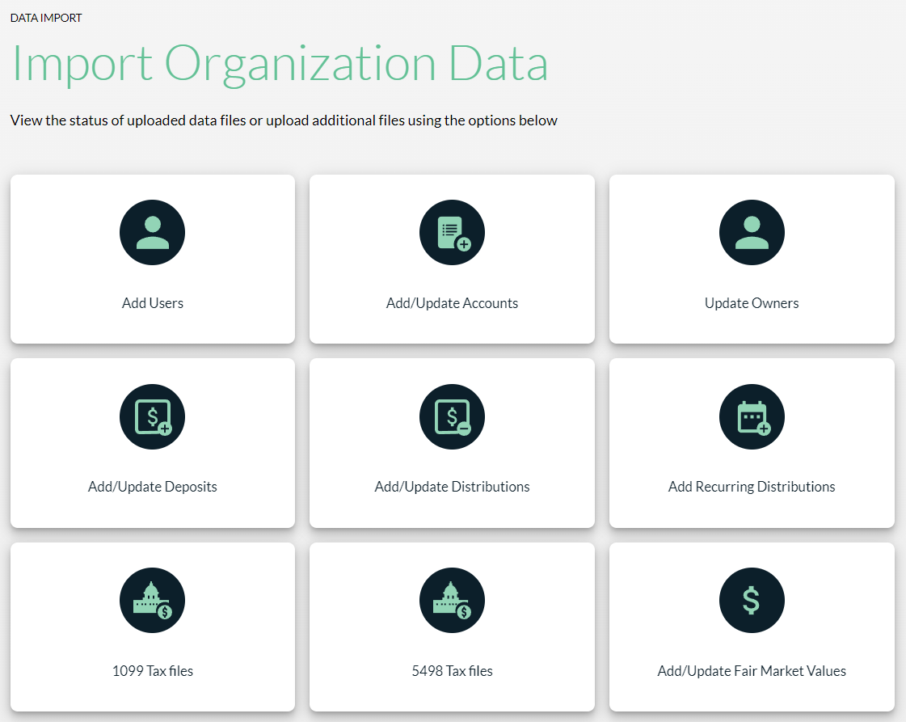

After selecting the data you plan to import to the site, click the applicable button in the upper right corner to import or update the information, as outlined below.

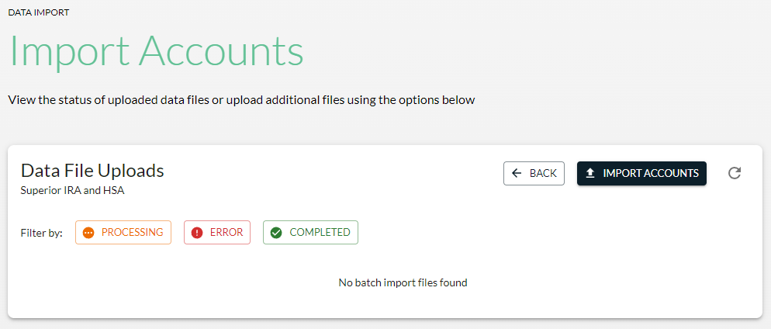

Follow the steps to upload your file or select the Click Here link to download a spreadsheet template to enter the data from your core system into the properly formatted template.
After entering your data into Superior’s template, upload the completed file in the Drag ‘n’ drop/Choose File section outlined below and click Continue.
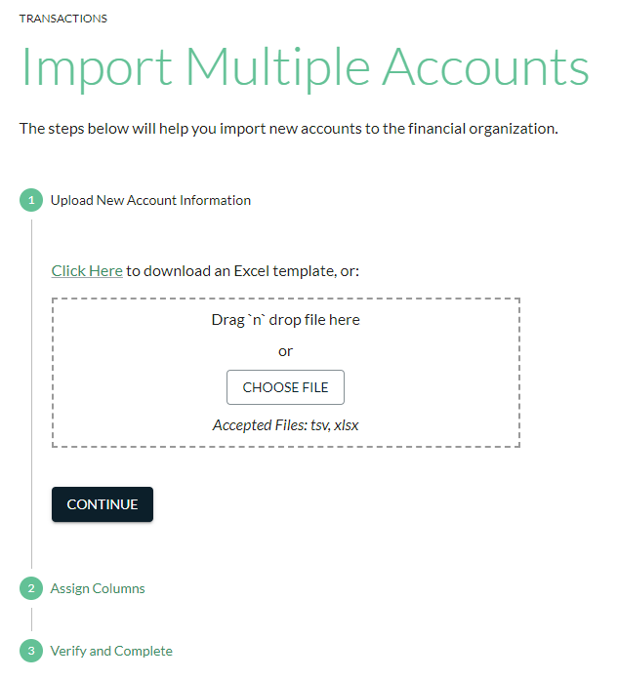

Confirm that the correct columns are assigned.
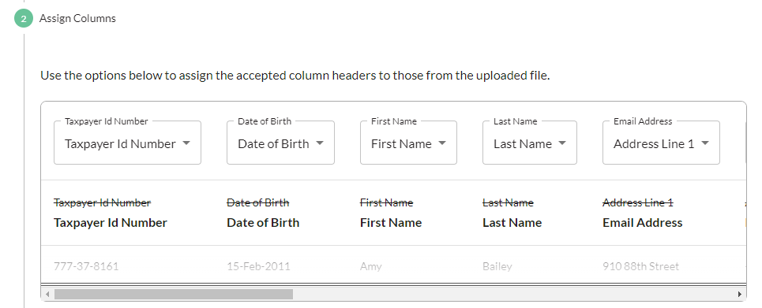
If a header does not match in a specific column, click the drop-down for that field and select the matching header.
For example, “Email Address,” listed below, is incorrectly matching to “Address Line 1”. Click the “Email Address” drop-down and select “Email Address” from the menu to match the email address header to the email address column within your file.
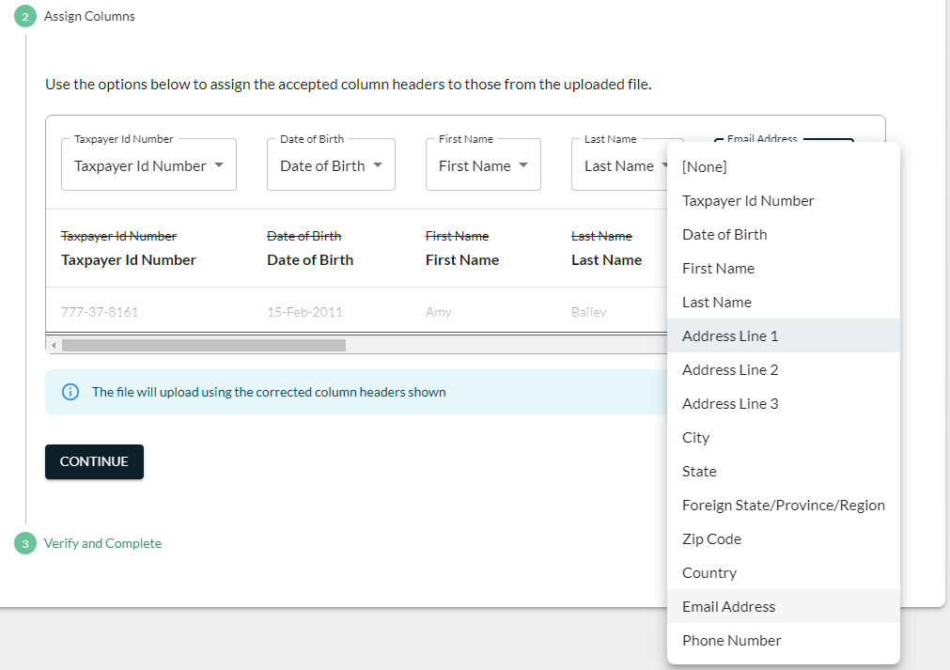

After all the columns are properly matched, check the box to confirm the information you’re uploading is accurate and click Continue to begin applying the data.
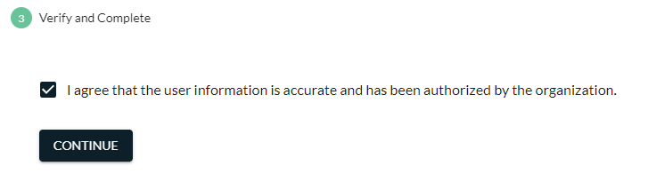
Upon verifying and completing the upload, the Data Import page will keep track of the file upload status.
- Processing – The file has been received and is being processed.
- Error – An error occurred with the file.
- Completed – The file has successfully applied to the site or marked completed after any errors were corrected at the account level.

Processing
The file will appear in an “orange” processing status if Superior is still applying the data to the platform. You’ll be able to track its progress within this section by seeing how many records have been created or updated.
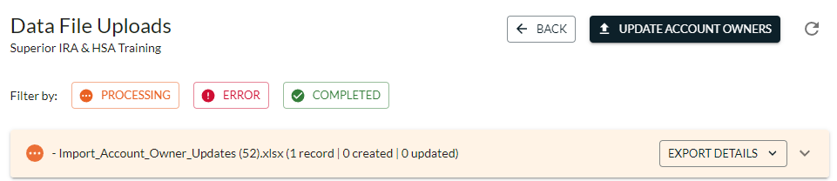

Error
The file will appear in a “red” error status if an error occurred during the file upload. If an error occurs, follow these steps:
- Click the file name to expand the error list.
- Click Download and Fix Errors to download the list of errors.
- Either update the errors at the account level under the Account Search or correct the errors on the spreadsheet and re-upload that file with the corrections.
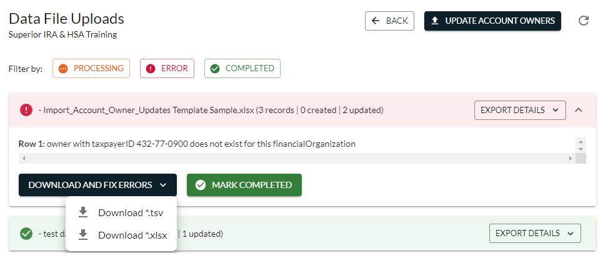

Completed
The file will appear in a “green” completed status if it has been successfully applied to the Superior platform, or the user clicked the Mark Completed button of a file that errored if corrections were made at the account level.
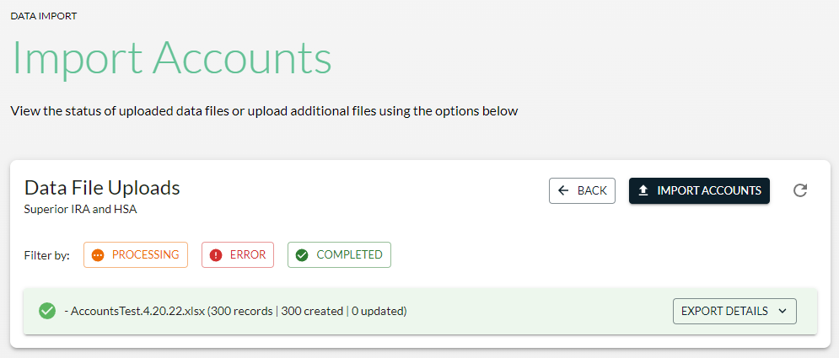
To download an audit record of the updates made to the Superior platform, click the Export Details button and select the file type to download those details--.tsv or .xlsx format.

Superior IRA & HSA Support

Chat
Chat with us directly from the Superior IRA platform. The chat bubble appears in the lower right corner of every screen.


Call
Call us at 888-470-4542, Option 1.

Email
Email us at support@superiorira.com.

Help Center
Search for your answer directly from the chat bubble that appears in the lower right corner of every screen.
