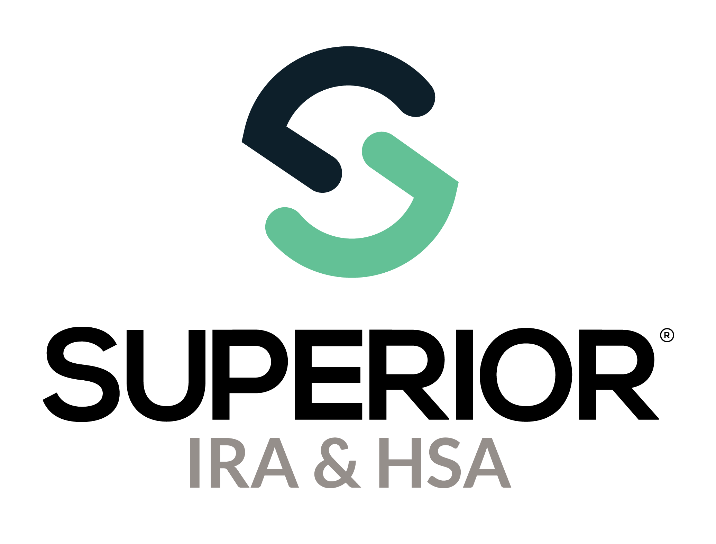
Dashboard Page Training Guide

Superior IRA & HSA® and the Superior IRA & HSA logo are registered trademarks of Superior IRA & HSA, LLC.

Table of Contents
Dashboard 3
Tasks 4
Pending Transactions 5
Draft 5
Awaiting Signature 6
Pending Review 7
Awaiting Transfer 7
Reports and Statistics 9
Accounts Summary 10
Distributions and Deposits 12
Fair Market Values 13
Audit Reports 13
Pending Transactions 14
Superior IRA & HSA Support 15
Chat 15
Call 15
Email 15
Help Center 15

Dashboard
The dashboard will appear upon logging into the site. You may access the dashboard at any time by selecting the Dashboard tab in the left navigation menu.

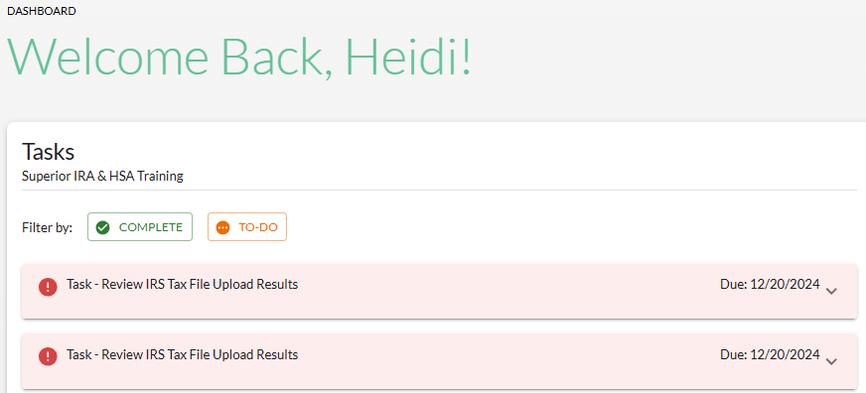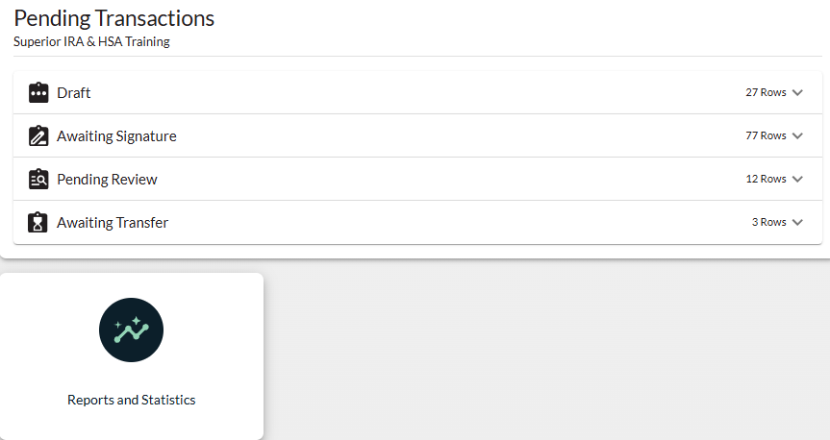

Tasks
Superior IRA & HSA will push out tasks for reminders and other communications to your organization. These tasks will be assigned to user roles as necessary. You may
- filter your tasks by Complete or To-Do;
- mark your tasks complete when finished (they will appear with a complete status on the dashboard); and
- reassign your tasks to other users at your financial organziation, by selecting another user listed under the Assignee drop down list; and
- click Mark Complete after a task has been completed to track your own progress (Superior is not notified when you complete a task).
If a Resolve button appears, the site will redirect you to the area within the platform where the task must be completed.
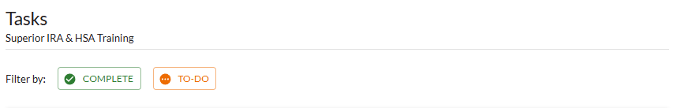

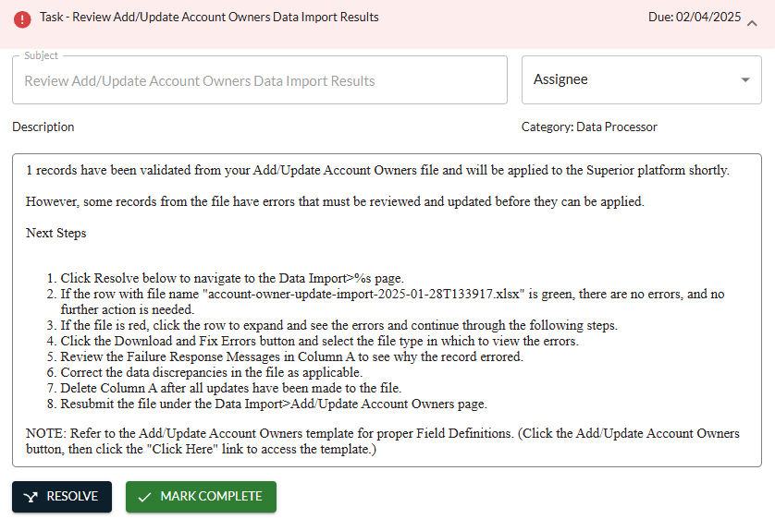

Pending Transactions
Pending transactions will appear on your dashboard if you have the Transactions or Transactions Administrator user role.
This section displays transactions that have been initiated in the system but are not yet completed because they were started and not finished, are awaiting a signature or transfer, or are pending review from a Transactions Administrator.

Draft
If you start a transaction and leave it before completion, you will be asked to Keep or Discard your progress or click Cancel to return and finish the workflow.
If you Discard the transaction, the workflow will close and not information will be saved to the platform.
If you Keep the transaction, it will appear in the Draft section of the dashboard. You may
- filter your drafts by any of the column headers;
- click the Type field of a transaction to finish completing the workflow; or
- click Discard to delete the draft.
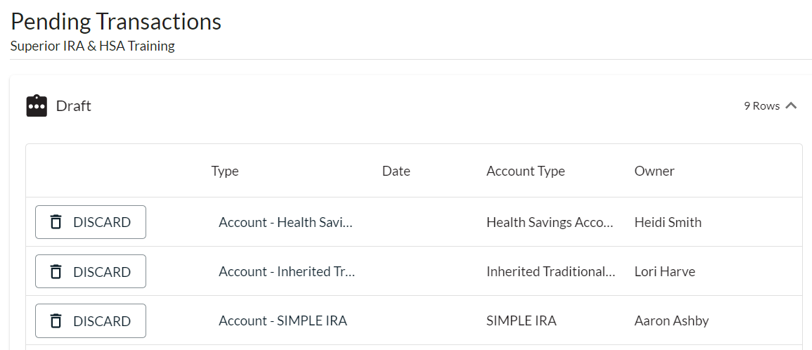
If you Discard the transaction, the workflow will close and no information will be saved to the platform.
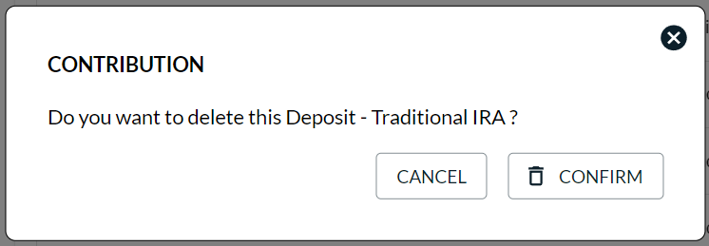

Awaiting Signature
If you complete a transaction up to the point of creating the PDF and navigate away from the workflow, you will be asked to Keep or Discard your progress or click Cancel to return and finish the workflow.
If you Discard the transaction, the workflow will close and no information will be saved to the platform.
If you Keep the transaction, it will appear in the Awaiting Signature section. You may
- filter the transactions by any of the column headers;
- click the Type field of the transaction awaiting signature to finish completing the workflow; or
- click Discard to delete the transaction.
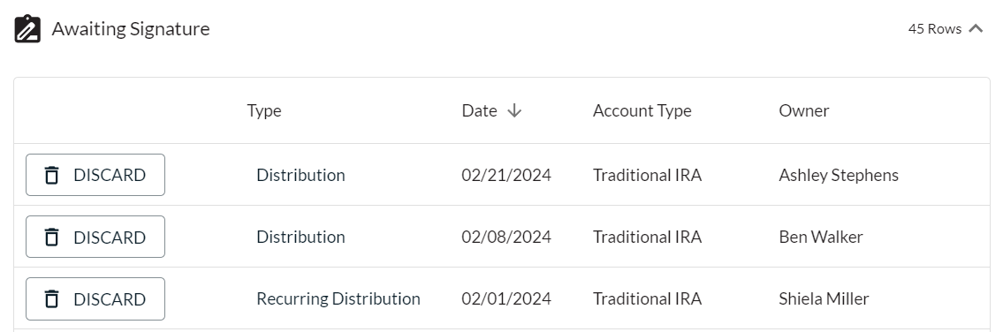
If you Discard the transaction, the workflow will close and no information will be saved to the platform.
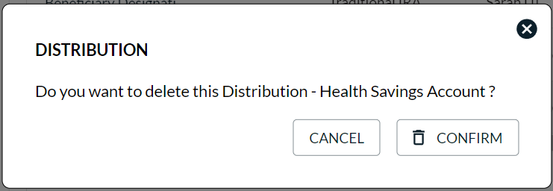

Pending Review
Any transactions completed by users that do not have the Transactions Administrator role assigned to them will appear in the Pending Review queue for review from a Transactions Administrator before being applied to the system. This queue is only viewable to Transactions Administrators.
Transactions Administrators may
- filter the transactions by any of the column headers; and
- take any of the following steps to review the transaction:
  - click the PDF icon to review the completed form, then click Done after it turns green;
  - click the Discard (trash can) icon to delete the transaction if it should not be applied;
  - click the Draft (arrow) icon to return the transaction to the Drafts section, so the user who submitted the transaction can update the document; or
  - click the Type field of the transaction to update and finish the completed workflow.
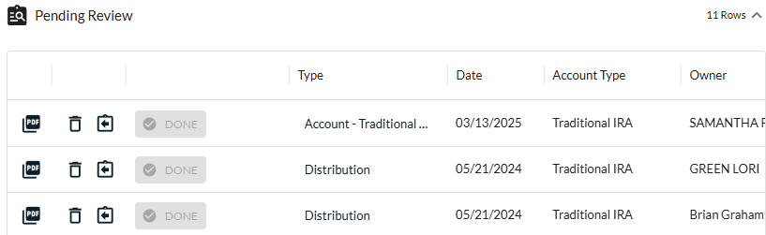

Awaiting Transfer
Whenever you complete the Request Rollover/Transfer workflow under the Transactions tab, the transaction will go into the Awaiting Transfer queue, pending completion until the money is received from the other financial organization.
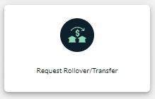

When you receive the money from the other organization, take these steps in the Awaiting Transfer section.
- Click Rollover/Transfer to open the specific transaction. (Only click Discard if the transaction will no longer be completed.)
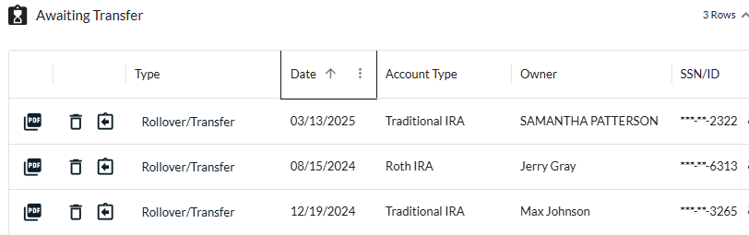
- Enter the amount of the rollover/transfer and the date assets were received. The account owner will not need to sign an additional document because a transfer/rollover request document was already signed, indicating which percentages to allocate to which investments.
- Click Submit to save the transaction.
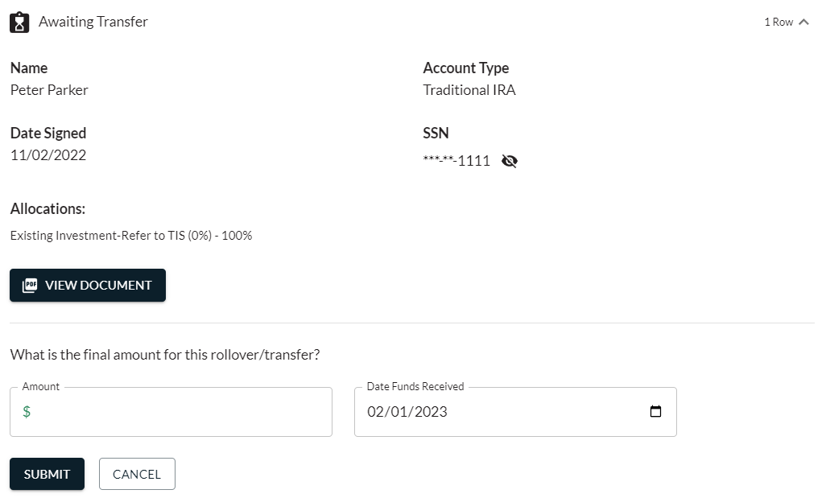

Reports and Statistics
The Reports and Statistics icon allows users to view the following reports for a certain time period of a specific tax year.
- Accounts Summary
- Distributions
- Deposits
- Fair Market Values
- Audit Reports
- Pending Transactions
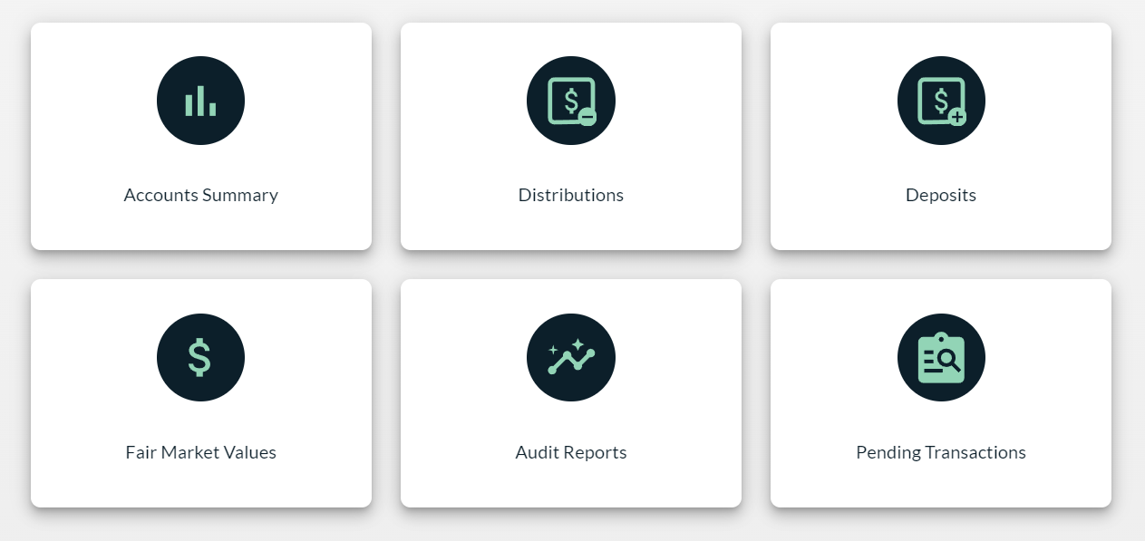

Accounts Summary
The Accounts Summary report displays a summary of all your accounts listed within the platform.
- Customize the report by selecting the date range to view the account activity.
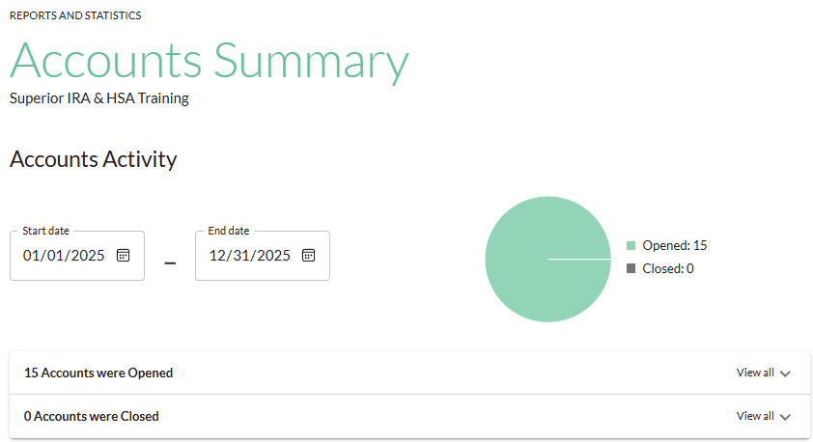
- View all accounts opened and closed during the date range.
- Click any listed account to view that specific account’s details.
- Click Export to review the list of accounts in a spreadsheet format.
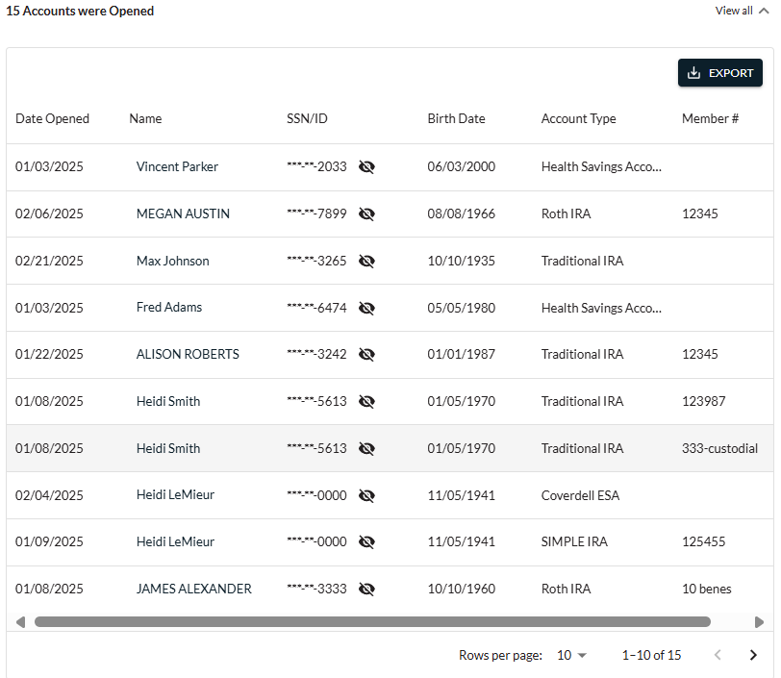
- Also view a summary of all currently open accounts within the platform.
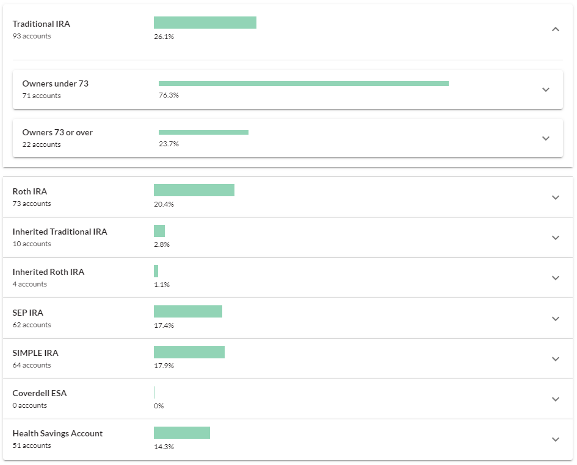

Distributions and Deposits
The Distributions and Deposits reports allow users to view a total report of the distributions or deposits made during a certain time period for specific account types.
- Select the Start date and End date to reflect the date range you wish to view.
- (For the Deposits report only) Select to view the Itemized or Totals version of the report.
  - Itemized: Displays all individual deposits added to the system.
  - Totals: Displays an aggregate total of all deposits of the same type added to the system, similar to how an account owner’s Form 5498 would appear.
- Select the specific account types you’d like to view, or leave the Show accounts field blank to view all account types.
- Click Search.
- Edit the tax years to display in the report by checking (or unchecking) the Show Tax Years boxes, if applicable.
- Click Export to create a .csv file of the report.
- Click any listed account to view that specific account’s details.
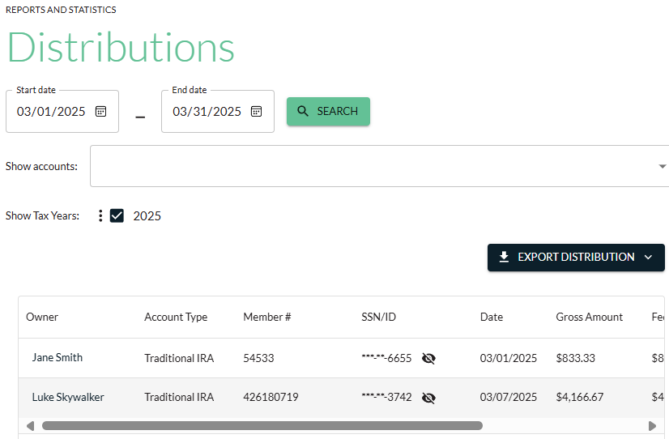

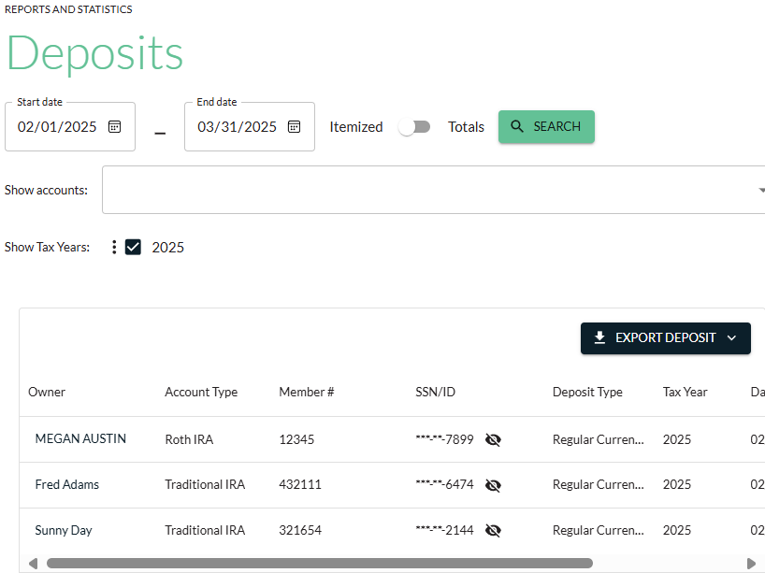

Fair Market Values
The Fair Market Values report allows you to view the December 31 account balances of the selected account types that have been entered into the platform. The report also includes an account owner’s RMD amount, if applicable.
- Select the tax year of the fair market value (FMV) you’d like to view.
- Select the specific account types you’d like to view, or leave the Show accounts field blank to view all account types.
- Select additional FMV filter options to only display accounts that have
  - $0 or no FMV listed in the site;
  - FMV listed in the site for the selected year;
  - Date of Death value listed for the selected year; or
  - Date of Death value listed for the current year.
- Click Search.
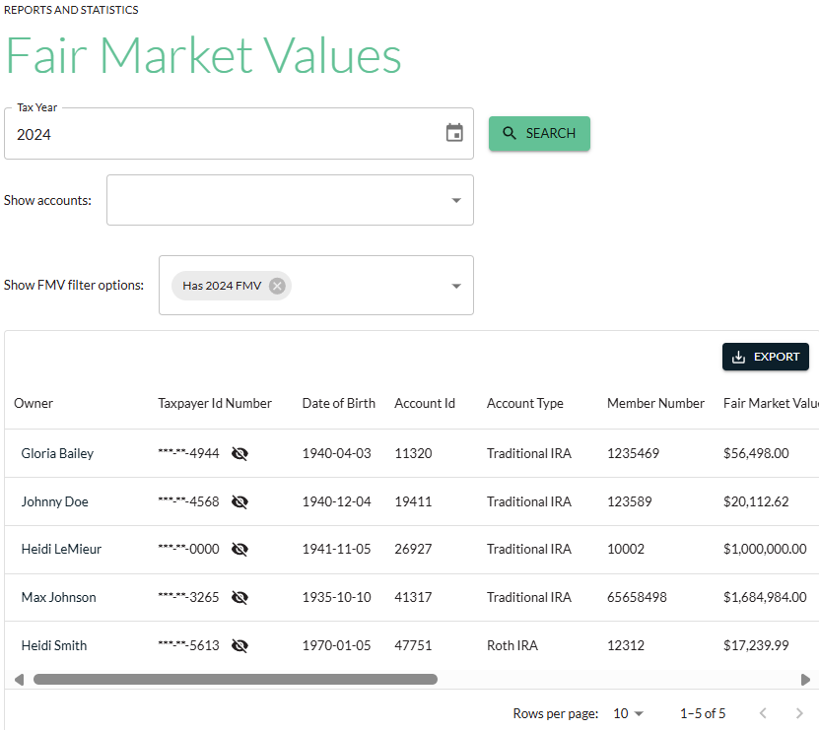

Audit Reports
The Audit Reports allow you to view an audit trail for the date range entered of any changes made to account owner information (i.e., name, taxpayer ID, date of birth, address) and which user made those changes.
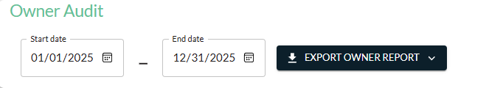

Pending Transactions
The Pending Transactions report provides a list of all transactions sitting in the Pending Review queue on the dashboard, awaiting review/approval from a user with the Transactions Administrator role.

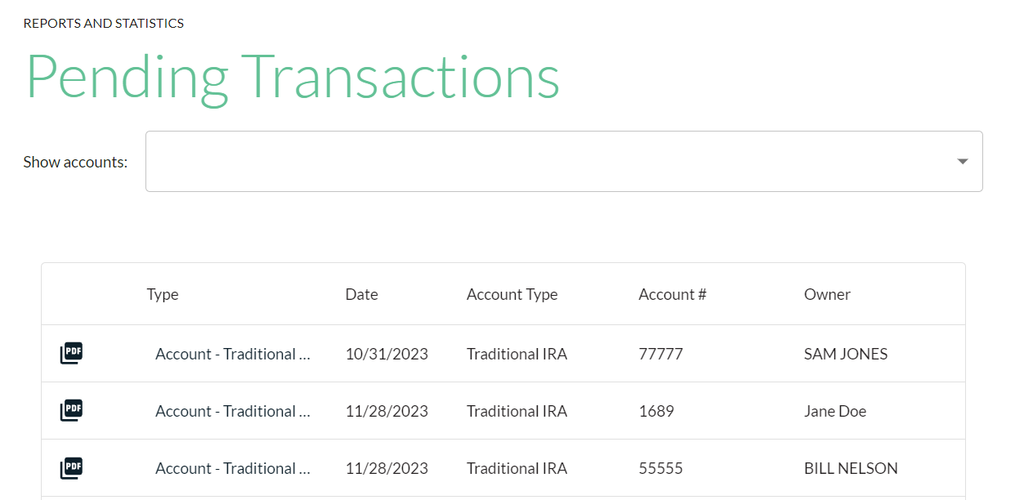

Superior IRA & HSA Support

Chat
Chat with us directly from the Superior IRA platform. The chat bubble appears in the lower right corner of every screen.


Call
Call us at 888-470-4542, Option 1.

Email
Email us at support@superiorira.com.

Help Center
Search for your answer directly from the chat bubble that appears in the lower right corner of every screen.
