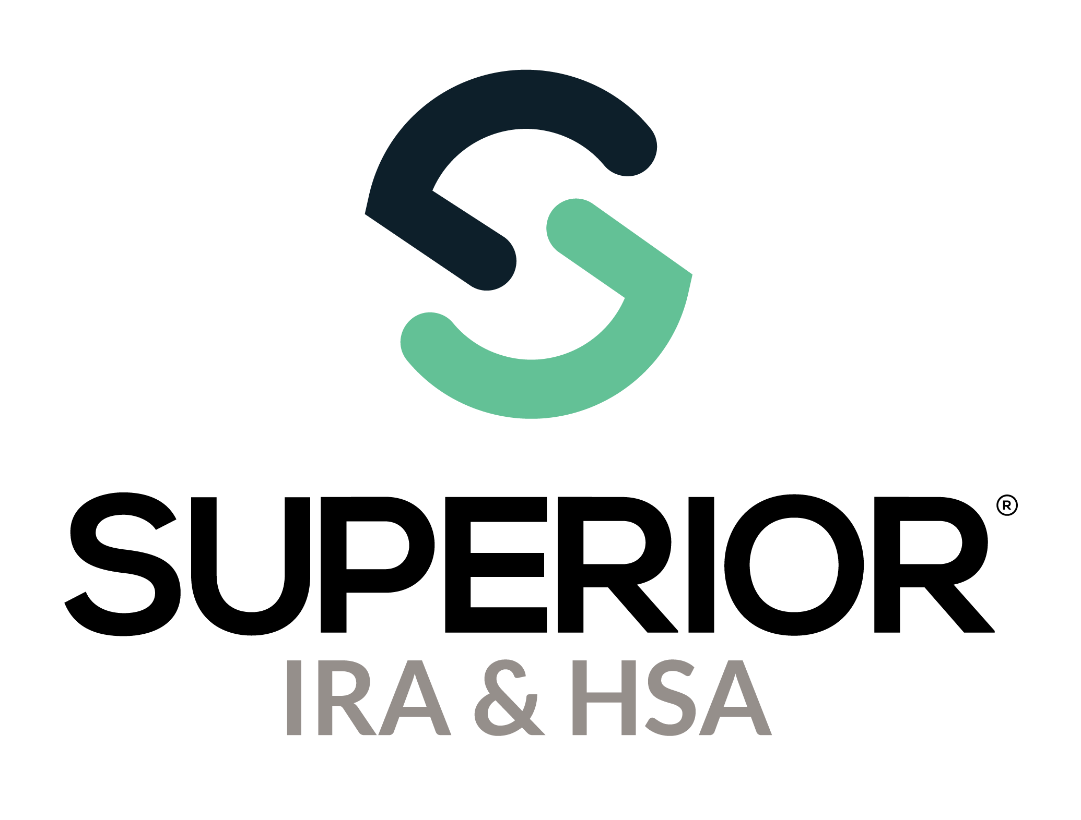
Dashboard Page Training Guide

Superior IRA & HSA® and the Superior IRA & HSA logo are registered trademarks of Superior IRA & HSA, LLC.

Table of Contents
Dashboard 3
Tasks 4
Pending Transactions 5
Draft 5
Awaiting Signature 6
Pending Review 7
Awaiting Transfer 7
Submitted by Owner 9
Reports and Statistics 11
Accounts Summary 12
Distributions and Deposits 14
Fair Market Values 15
Audit Reports 16
Pending Transactions 17
View All Tasks 18
Superior IRA & HSA Support 20
Chat 20
Call 20
Email 20
Help Center 20

Dashboard
The Dashboard will appear upon logging into the Superior platform. You may access the Dashboard at any time by selecting the Dashboard tab from the left navigation menu.
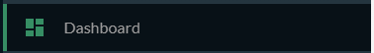
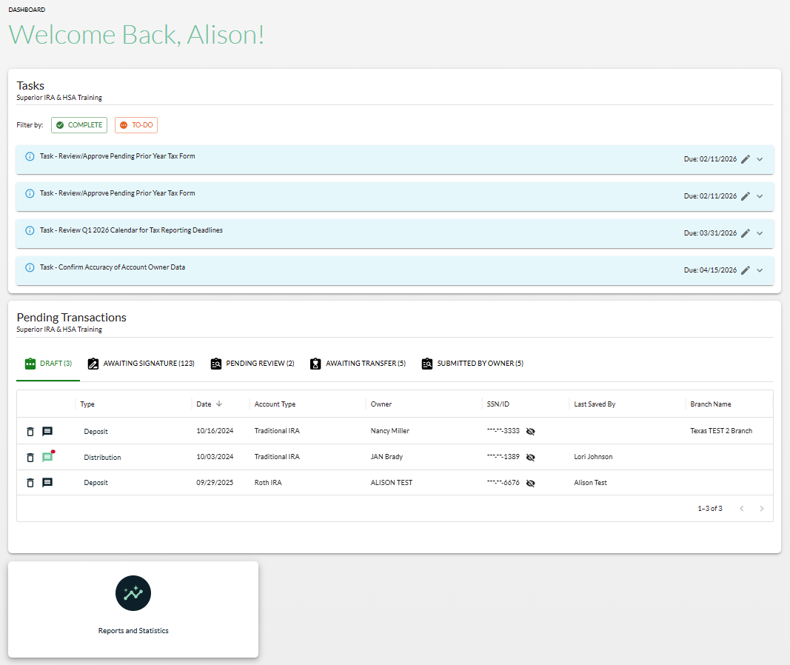

Tasks
Superior IRA & HSA will add tasks for reminders and other communications to your organization. These tasks will be assigned to user roles as necessary. (Tasks are never added for Transactions only users.)
You may
- filter your tasks by Complete or To-Do;
- mark your tasks complete when finished (they will appear with a complete status on the Dashboard);
- reassign your tasks to other users at your financial organziation, by selecting another user listed under the Assignee drop down list; and
- click Mark Complete after a task has been completed to track your own progress (Superior is not notified when you complete a task).
If a Resolve button appears and is clicked, the site will redirect you to the area within the platform where the task must be completed.
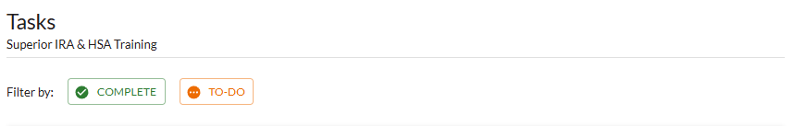
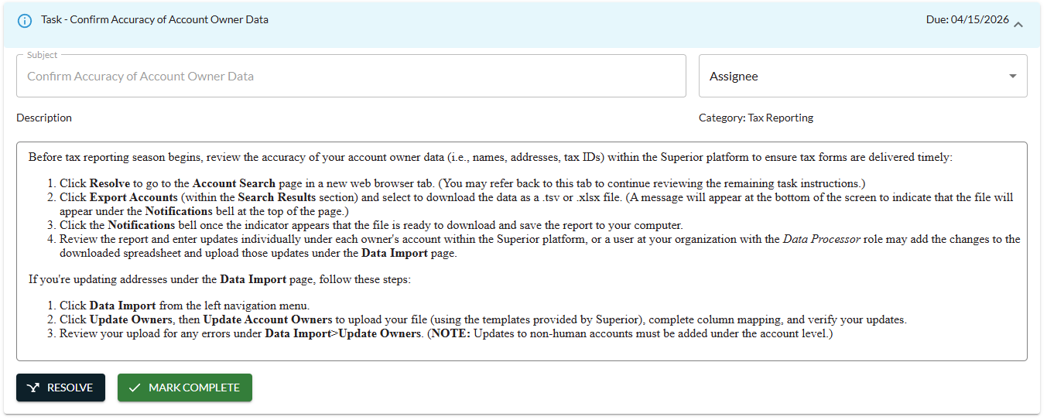

If you accidentally click Mark Complete when the task has not yet been completed, click Reopen to re-add the task to the Dashboard.
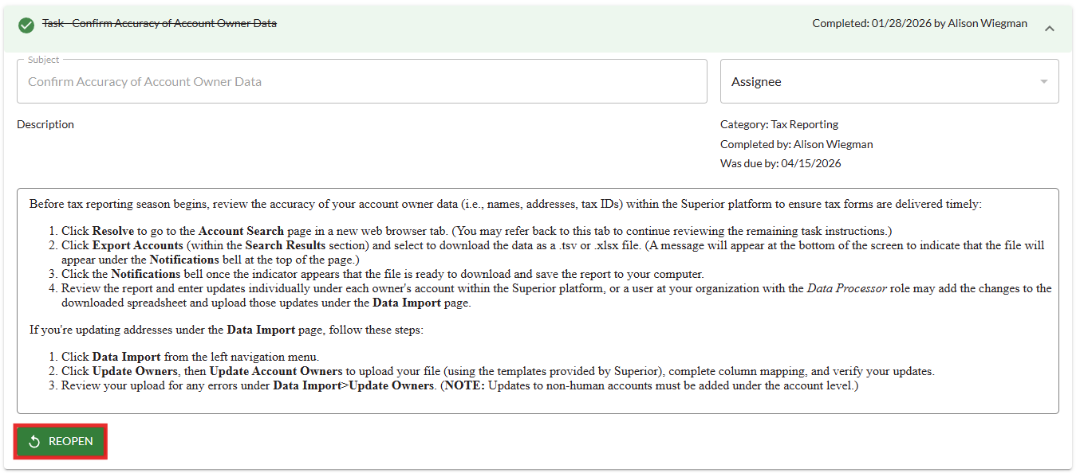

Pending Transactions
Pending transactions will appear on your Dashboard if you have the Transactions or Transactions Administrator user role.
This section displays transactions that have been initiated in the platform but are not yet completed because they were started and not finished, awaiting a signature or transfer, pending review from a Transactions Administrator, or pending review after being submitted by an account owner (only applicable if your organization uses Superior’s Account Owner Portal).

Draft
If you start a transaction and leave it before completion, you will be asked to Keep or Discard your progress or click Cancel to return and finish the workflow.
If you Discard the transaction, the workflow will close and no information will be saved to the platform.
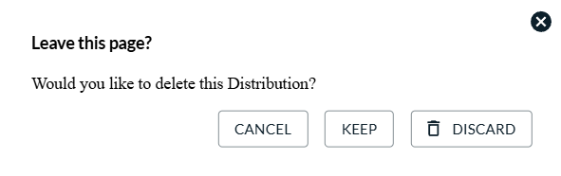

If you Keep the transaction, it will appear in the Draft section of the Dashboard. You may
- filter your drafts by any of the column headers;
- click the Type field of a transaction to finish completing the workflow;
- click the Discard (trash can) icon to delete the draft; or
- click the Comment icon to add a comment and/or view existing comments for a transaction.
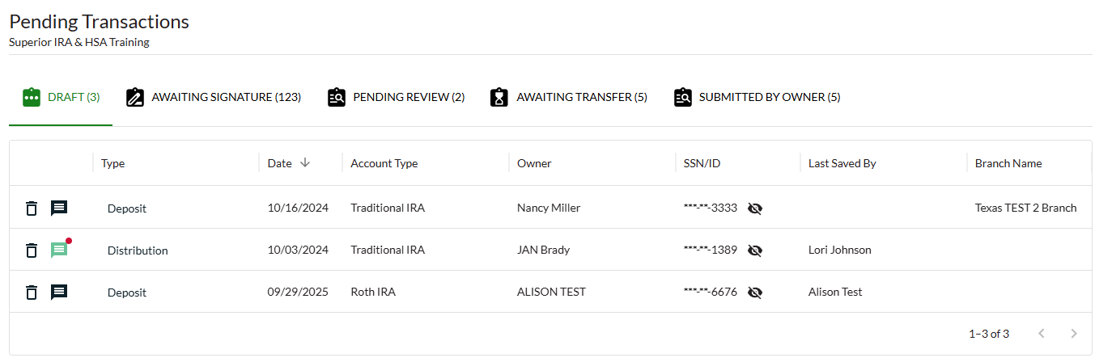

Awaiting Signature
If you complete a transaction up to the point of creating/viewing the PDF and navigate away from the workflow, you will be asked to Keep or Discard your progress or click Cancel to return and finish the workflow.
Again, if you Discard the transaction, the workflow will close and no information will be saved to the platform.
If you Keep the transaction, it will appear in the Awaiting Signature section. You may
- filter the transactions by any of the column headers;
- click the Type field of the transaction awaiting signature to finish completing the workflow;
- click the PDF icon to view the completed, unsigned form;
- click the Discard (trash can) icon to delete the transaction;
- click the Draft (back arrow) icon to return the transaction to the Drafts section; or
- click the Comment icon to add a comment and/or view existing comments for a transaction.

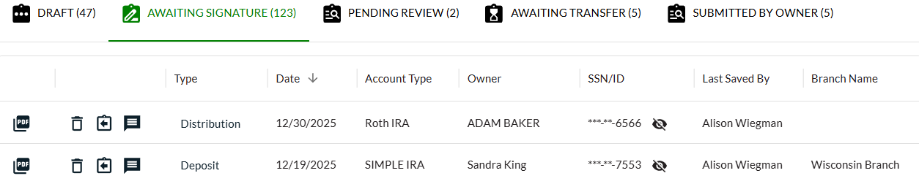

Pending Review
Any transactions completed by Transactions users will appear in the Pending Review queue for review from a Transactions Administrator before being applied to the platform. This queue is only viewable to Transactions Administrators.
Transactions Administrators may
- filter the transactions by any of the column headers; and
- take any of the following steps to review the transaction:
  - click the PDF icon to review the completed form, then click Done after it turns green;

  - click the Discard (trash can) icon to delete the transaction if it should not be applied;
  - click the Draft (back arrow) icon to return the transaction to the Drafts section, so the user who submitted the transaction can update the document;
  - click the Comment icon to add a comment and to view existing comments for a transaction; or
  - click the Type field of the transaction to edit the completed workflow before finishing and saving to the platform.

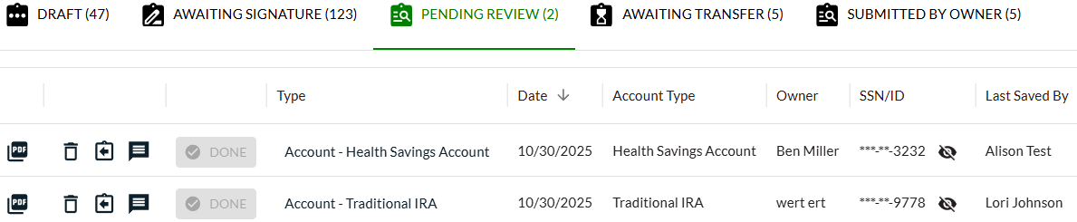

Awaiting Transfer
Whenever a user completes the Request Rollover/Transfer workflow under the Transactions tab, the transaction will go into the Awaiting Transfer queue, pending completion until the money is received from the other financial organization.
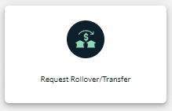

When you receive the money from the other organization, take these steps in the Awaiting Transfer section.
- Click the Type field of the Rollover/Transfer to open the specific transaction. (Only click Discard if the transaction will no longer be completed.)
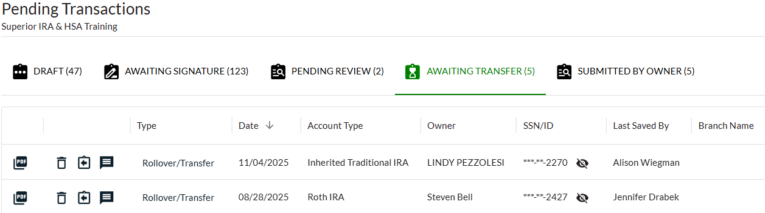
- Enter the amount of the rollover/transfer and the date assets were received. The account owner will not need to sign an additional document because a transfer/rollover request document was already signed, indicating which percentages to allocate to which investments. (You may click the View Document button to view the signed document.)
- Click Submit to save the transaction.
- The rollover or transfer deposit will save to the owner’s account in the platform.

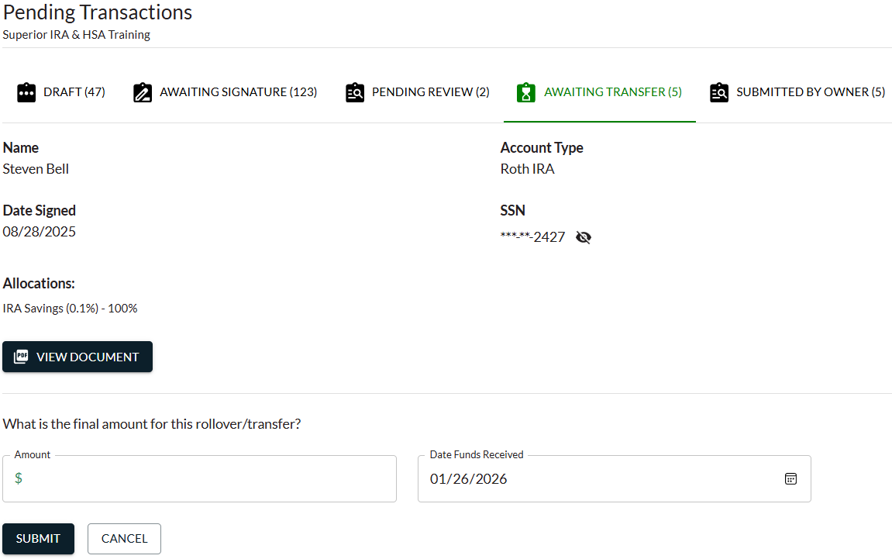

Submitted by Owner
If your organization uses Superior’s Account Owner Portal (additional fees apply if enrolled), whenever an account owner submits a transaction within the Account Owner Portal, the transaction will appear within the Submitted by Owner queue. This queue is only viewable to Transactions Administrators, if applicable for your organization.
Transactions Administrators may
- filter the transactions by any of the column headers; and
- take any of the following steps to delete or edit the transaction:
  - click the Discard (trash can) icon to delete the transaction if it should not be applied;
  - click the Draft (back arrow) icon to return the transaction to the Drafts section, so the account owner can review/update the document if needed; or
  - click the Comment icon to add a comment and to view existing comments for a transaction.; or
  - click the Review & Sign button of the transaction to review the completed and electronically signed document.
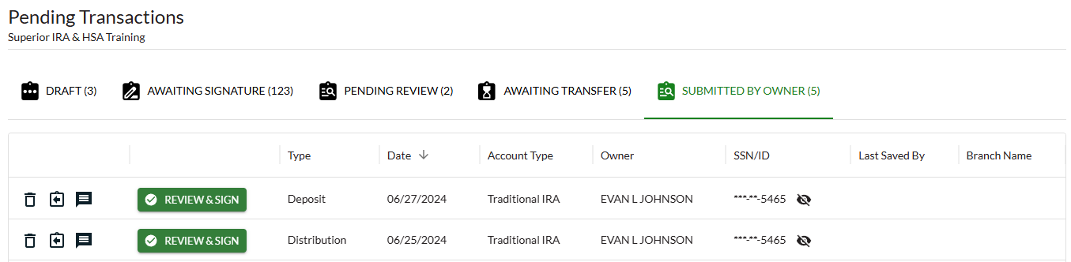
To review and approve the transaction:
- Click the Review & Sign button of the transaction.
- Click View PDF Document to review the completed and electronically signed document.
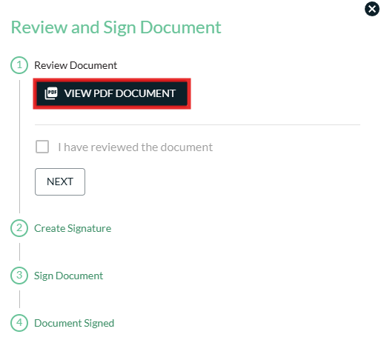

- Check the “I have reviewed the document” box and click Next.

- Click the Create Signature button to create your electronic signature (if one is not yet saved), type your name, and click Accept to save your signature. Then click Next.
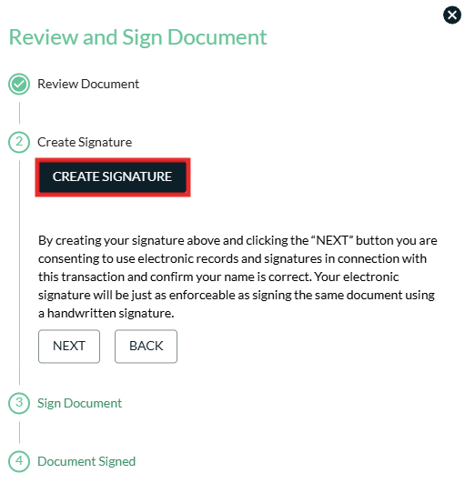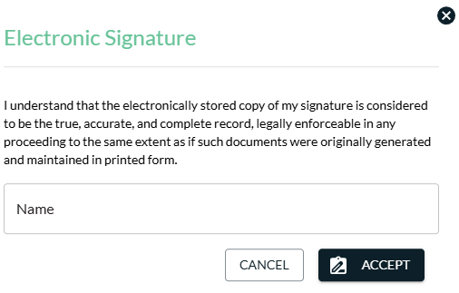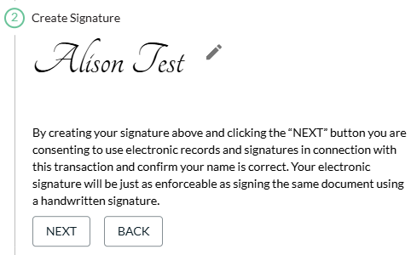

- Review the Electronic Signature Disclosure and Consent and click Sign Electronically to save the transaction to the platform.
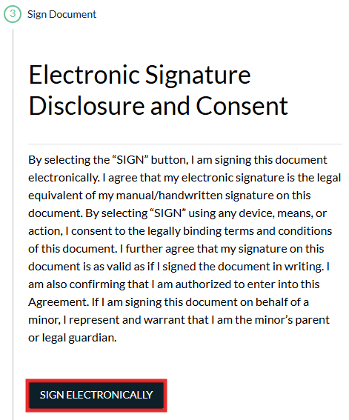

- Click View PDF Document to print/save the final, signed copy of the transaction and click Close.
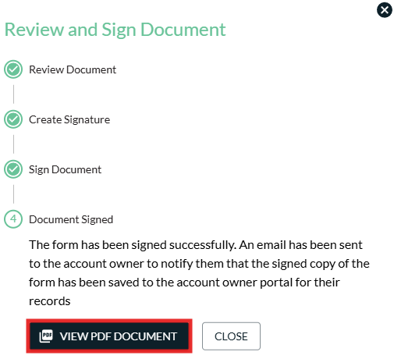

Reports and Statistics
The Reports and Statistics icon allows users to view the following reports for a certain time period of a specific tax year.
- Accounts Summary
- Distributions
- Deposits
- Fair Market Values
- Audit Reports
- Pending Transactions
- View All Tasks
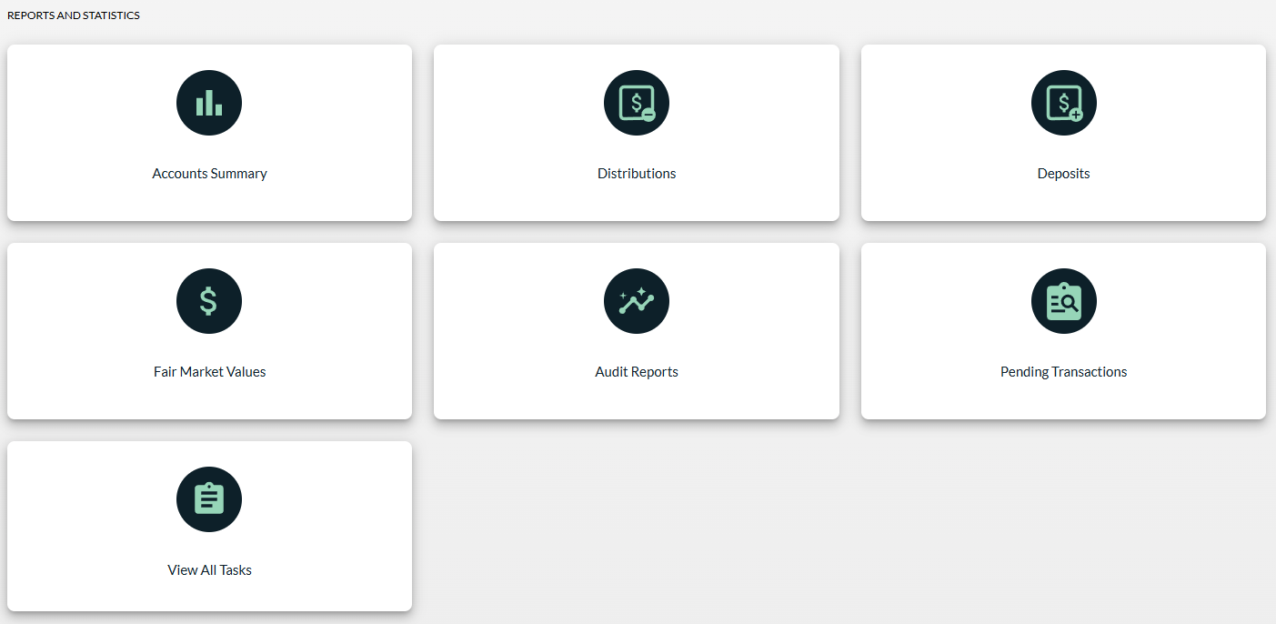

Accounts Summary
The Accounts Summary report displays a summary of all your accounts listed within the platform.
- Customize the report by selecting the date range to view the account activity.
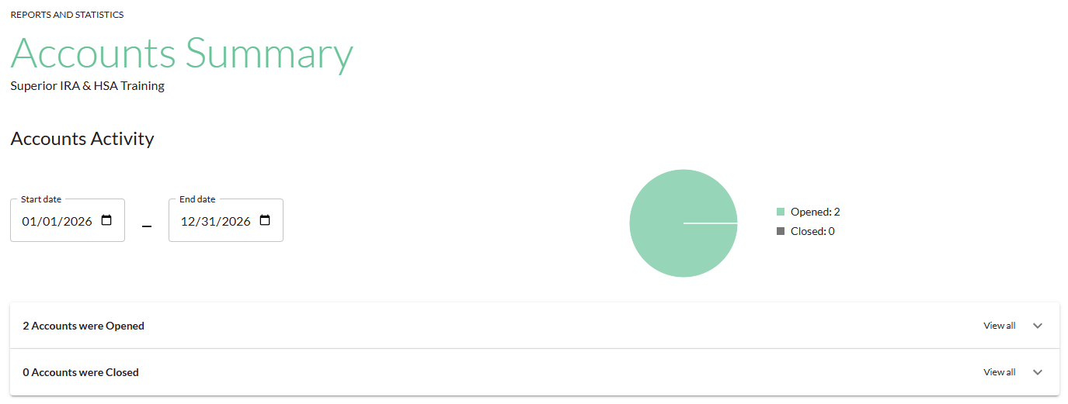
- View all accounts opened and closed during the date range.
- Click Export to review the list of accounts in a spreadsheet format.
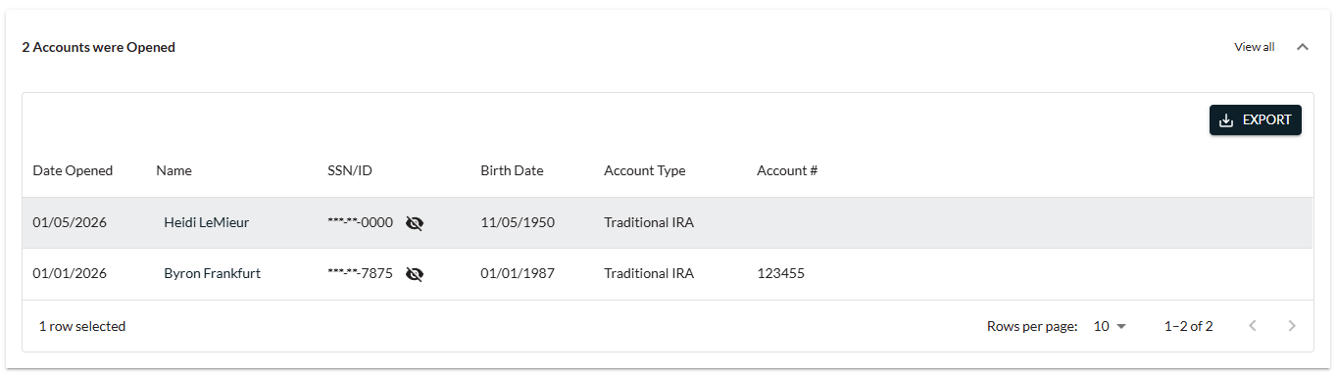

- Also view a summary of all currently open accounts within the platform.
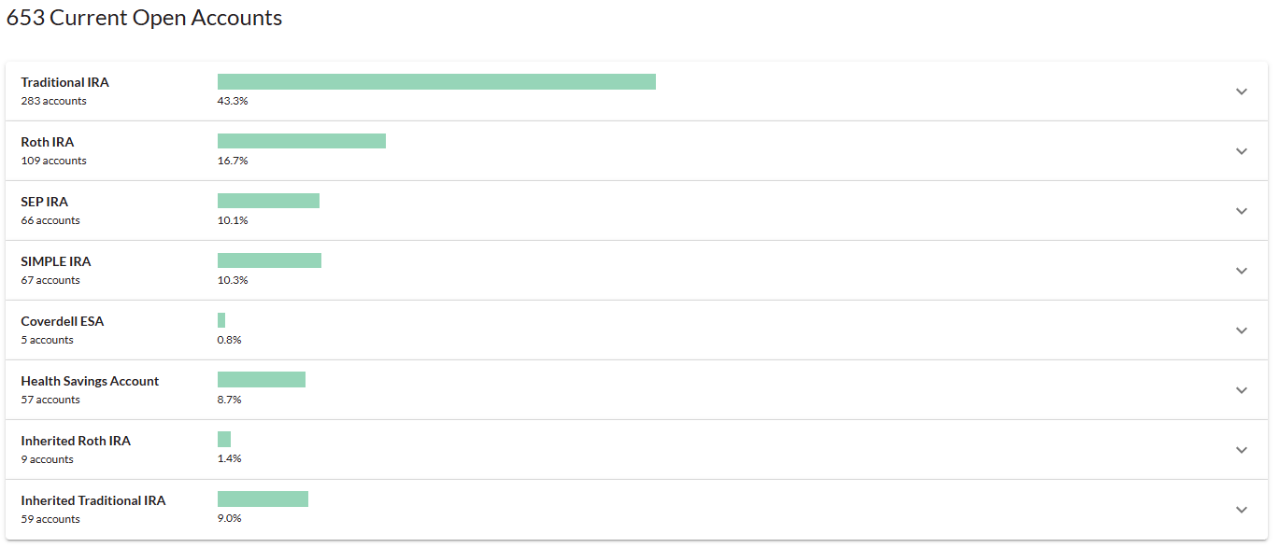
- Click a specific section to view additional subcategory, if applicable, and the account owners listed in each category.
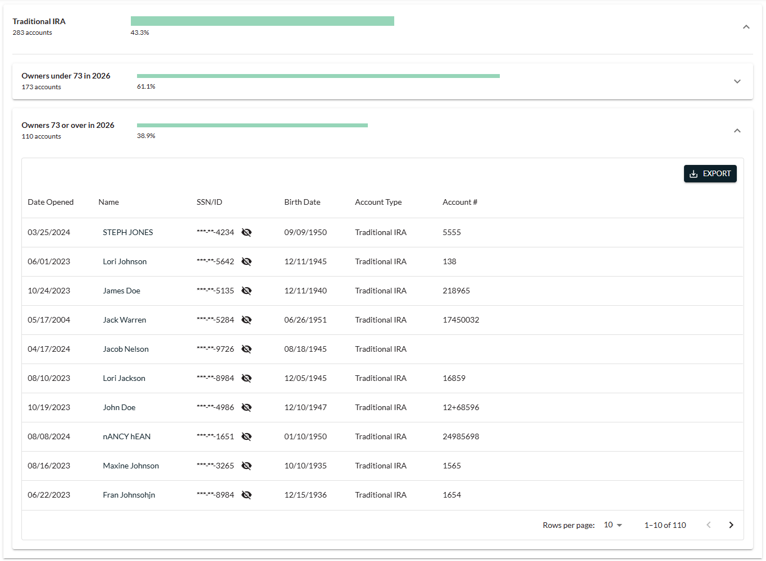

Distributions and Deposits
The Distributions and Deposits reports allow users to view a total report of the distributions or deposits made during a certain time period for specific account types.
- Update the Start date and End date to reflect the date range you wish to view.
- (For the Deposits report only) Select to view the Itemized or Totals version of the report.
  - Itemized: Displays all individual deposits added to the platform.
  - Totals: Displays an aggregate total of all deposits of the same type added to the platform, similar to how an account owner’s Form 5498 would appear.
- Select the specific account types you’d like to view, or leave the Show accounts field blank to view all account types.
- Click Search.
- Edit the tax years to display in the report by checking (or unchecking) the Show Tax Years boxes, if applicable.
- Click Export to create a .tsv or .xlsx file of the report.
- Click any listed account to view that specific account’s details.

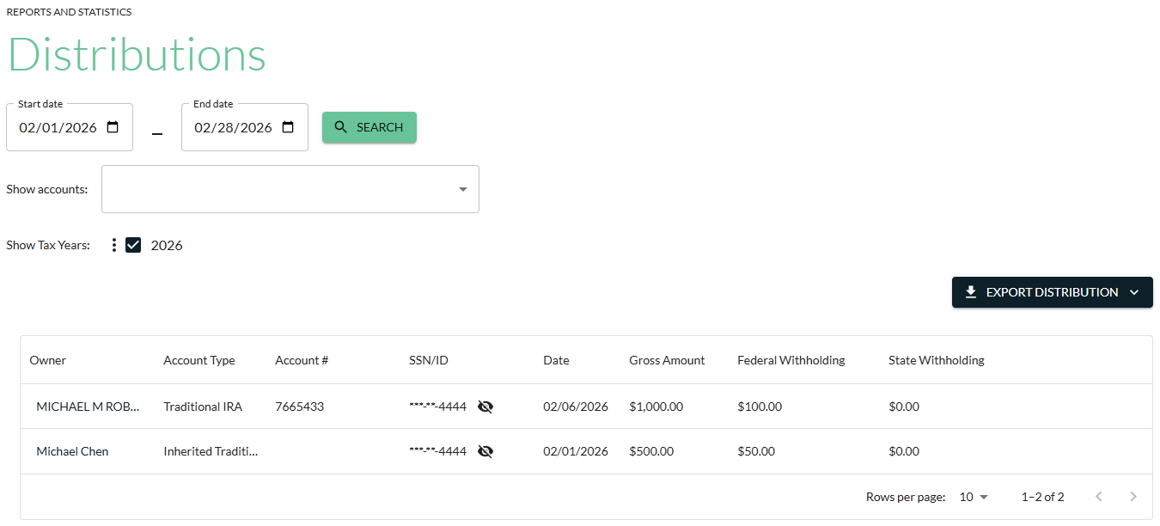
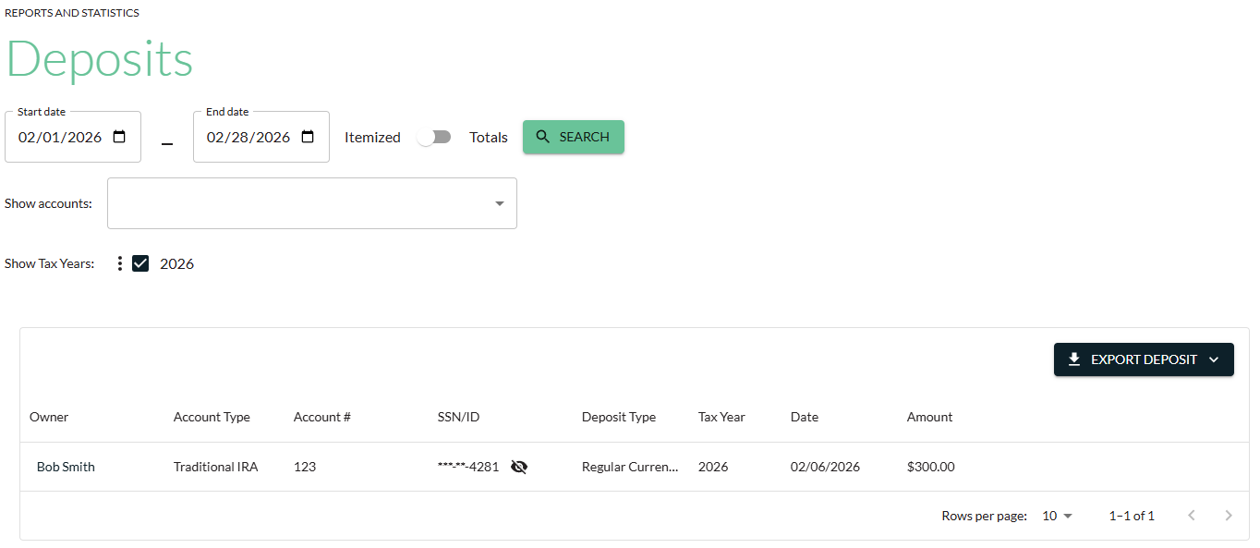

Fair Market Values
The Fair Market Values report allows you to view the December 31 account balances of the selected account types that have been entered into the platform. The report also includes an account owner’s RMD amount, if applicable.
- Select the tax year of the fair market value (FMV) you’d like to view.
- Select the specific account types you’d like to view, or leave the Show accounts field blank to view all account types.
- Select additional FMV filter options to only display accounts that have
  - $0 or no FMV listed in the platform; or
  - have an FMV listed in the platform for the selected year.
- Click Search.

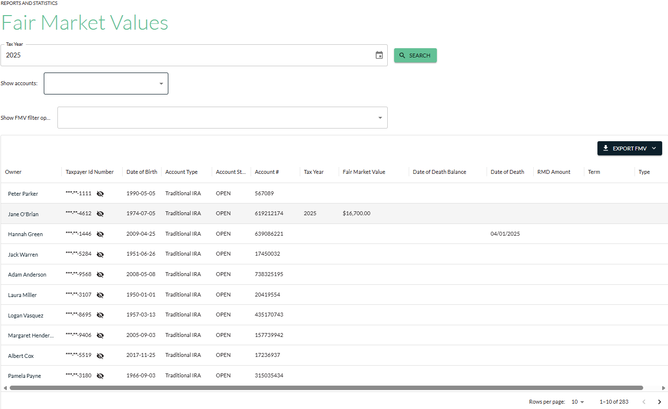

Audit Reports
The Audit Reports allow you to view an audit trail for the date range entered of any changes made to applicable information:
- Owner Audit: Account owner information (i.e., name, taxpayer IRA, date of birth, address)
- Account Audit: Account information (i.e., account number, account status, open/closed dates)
- FMV Audit: Fair market value (FMV) information under an account (i.e., adding/editing an FMV amount)
- Beneficiary Audit: Beneficiary information under an account (i.e., beneficiary designation updates)
- Deposit Audit: Deposit information under an account (i.e., adding/editing deposit amounts)
- Distribution Audit: Distribution information under an account (i.e., adding/editing distribution amounts)
- Recurring Distribution Audit: Recurring distribution information listed under an account (i.e., adding/editing recurring distributions)
- 1099 Tax Form Audit: 1099 tax forms listed under an account (i.e., adding/editing distribution information that updates a produced Form 1099)
- 5498 Tax Form Audit: 5498 tax forms listed under an account (i.e., editing/adding FMV or deposit information that updates a produced Form 5498)
- Account Owner Portal Signatures Audit: (If your organization has the Account Owner Portal) Transactions initiated and signed through the Account Owner Portal that were saved to the Superior platform

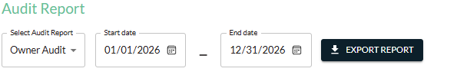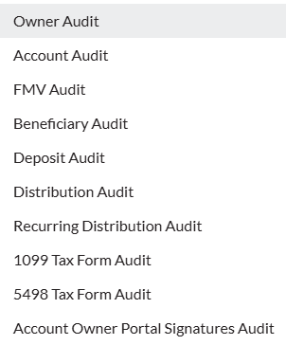

Pending Transactions
The Pending Transactions report provides a list of all transactions sitting in the Pending Review queue on the Dashboard, awaiting review/approval from a user with the Transactions Administrator role.
Because Transactions only users cannot see the Pending Review queue, this report allows these users to see a list of transactions that they’ve submitted that have yet to be reviewed/approved.

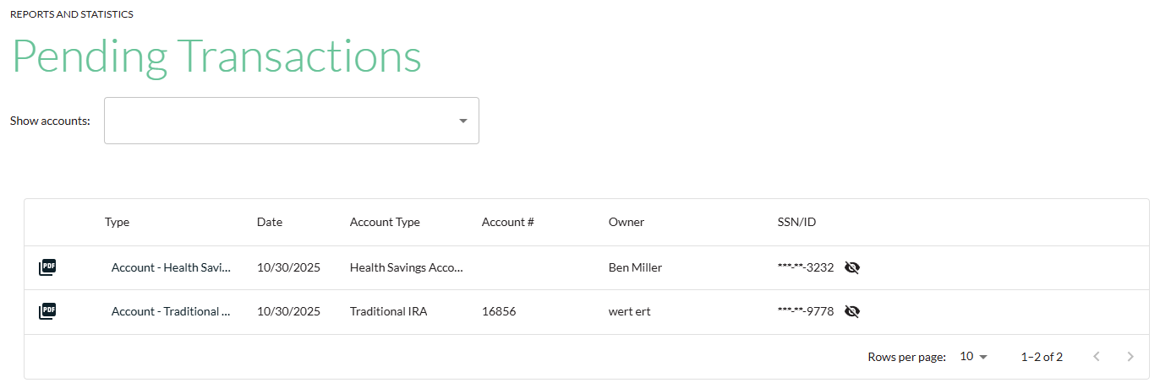

View All Tasks
The Review All Tasks report displays all tasks for your organization. This page allows users (except for Transactions users) to view completed and pending tasks for your organization if it matches that user’s roles/permissions, even if the user was not assigned the task.
Tasks may be viewed within a table or calendar format, as shown below and on the following page.
- Users may click a task within the table or calendar view to see the task details.
- Tasks may be assigned, reassigned, marked complete, or reopened if it was accidentally marked as completed.
Table View
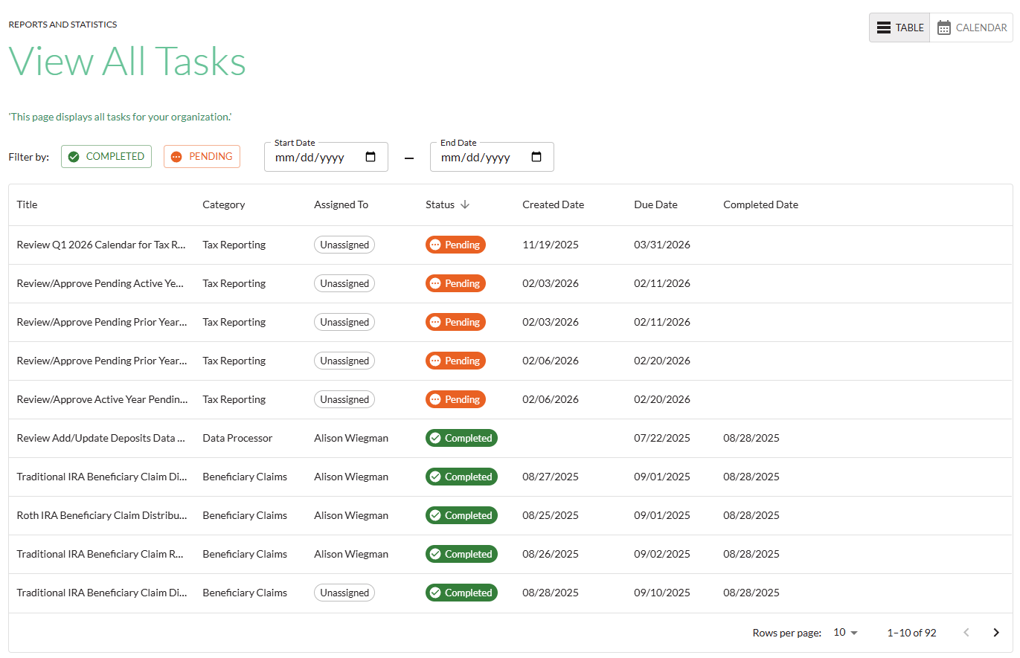

Calendar View
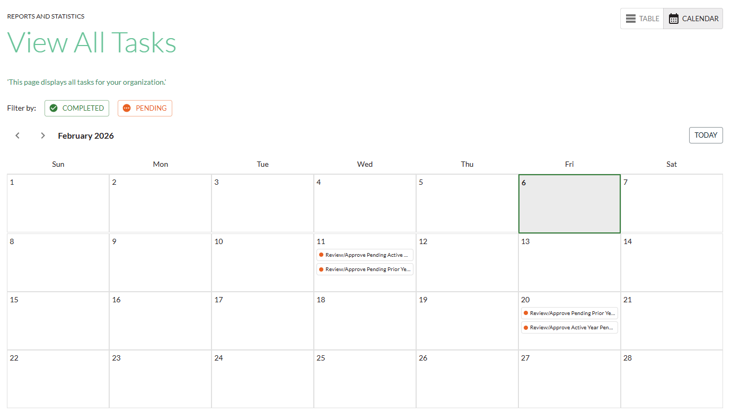

Superior IRA & HSA Support

Chat
Chat with us directly from the Superior IRA platform. The chat bubble appears in the lower right corner of every screen (unless you click the dots to the left of the chat bubble and move it).


Call
Call us at 888-470-4542, Option 1.

Email
Email us at support@superiorira.com.

Help Center
Search for your answer directly from the chat bubble.
- Click the Help tab at the bottom of the chat bubble screen.
- Enter a word to search for your answer within our Help Center.
