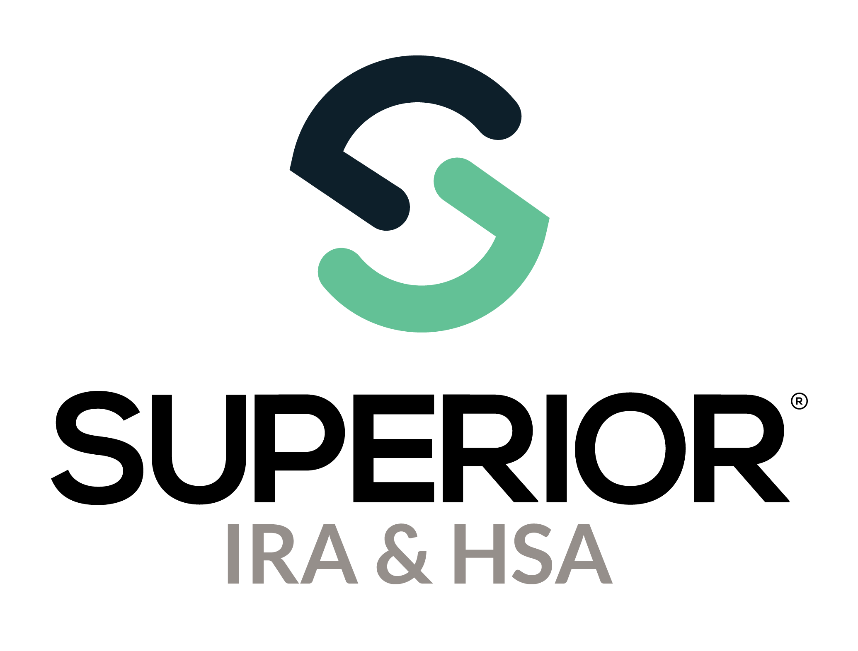
Beneficiary Claims Page Training Guide

Superior IRA & HSA® and the Superior IRA & HSA logo are registered trademarks of Superior IRA & HSA, LLC.
Table of Contents
Beneficiary Claims 3
Submit Beneficiary Claim 4
Provide Beneficiary Distribution Elections to Beneficiary(ies) 7
Upload Completed Beneficiary Distribution Elections 8
Await Disbursal Instructions from Superior 9
View Beneficiary Claims 9
Beneficiary Claim Information 11
Fair Market Value 13
Distributions 13
Uploaded Documents 13
Beneficiaries 14
Superior IRA & HSA Support 15
Chat 15
Call 15
Email 15
Help Center 15

Beneficiary Claims
Users with a Beneficiary Claims role have access to this section. (This page is not applicable if your organization is enrolled in Superior’s Silver solution. It is only applicable to Superior’s Green solution and Black solution.)
Please note that Superior will not process claims under the following circumstances (but we will assist your organization with any questions).
- If the claim was already started (in house or with previous vendor) before your organization’s go-live date with Superior.
- If the owner’s date of death was more than one year before your go-live date with Superior.
For instructions on processing claims that fall under these circumstances, click here to review Superior’s Beneficiary Claim Instructions.
For all other claims, follow the steps outlined within this guide to submit to Superior for processing.
Select Beneficiary Claims in the left navigation menu to submit and view beneficiary claims upon an account owner’s death.

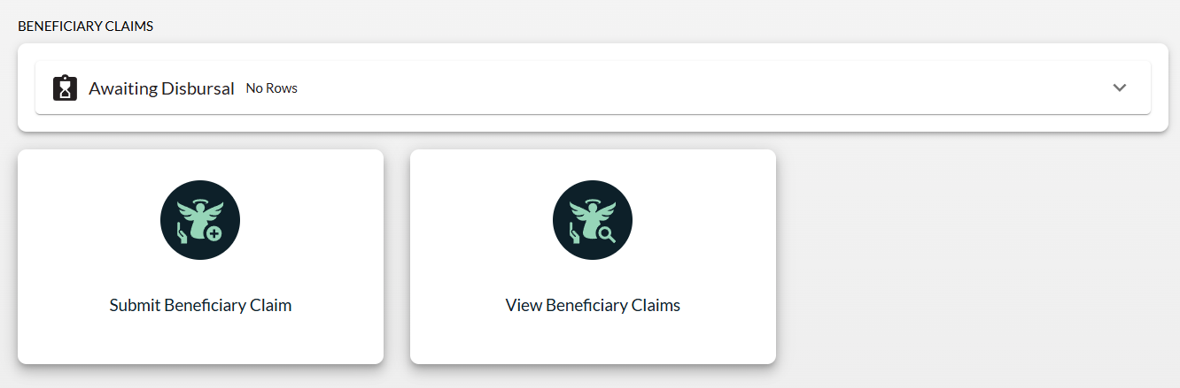

Submit Beneficiary Claim
Upon being notified of an account owner’s death and receiving a certified copy of the owner’s death certificate, click the Submit Beneficiary Claim icon to launch a workflow to upload the necessary documents to Superior IRA & HSA for processing.
A Required Documents Checklist will display on the right side of the workflow as a reminder of the documents/information needed to submit a claim. Refer to this checklist to ensure you provide the necessary documentation/information.
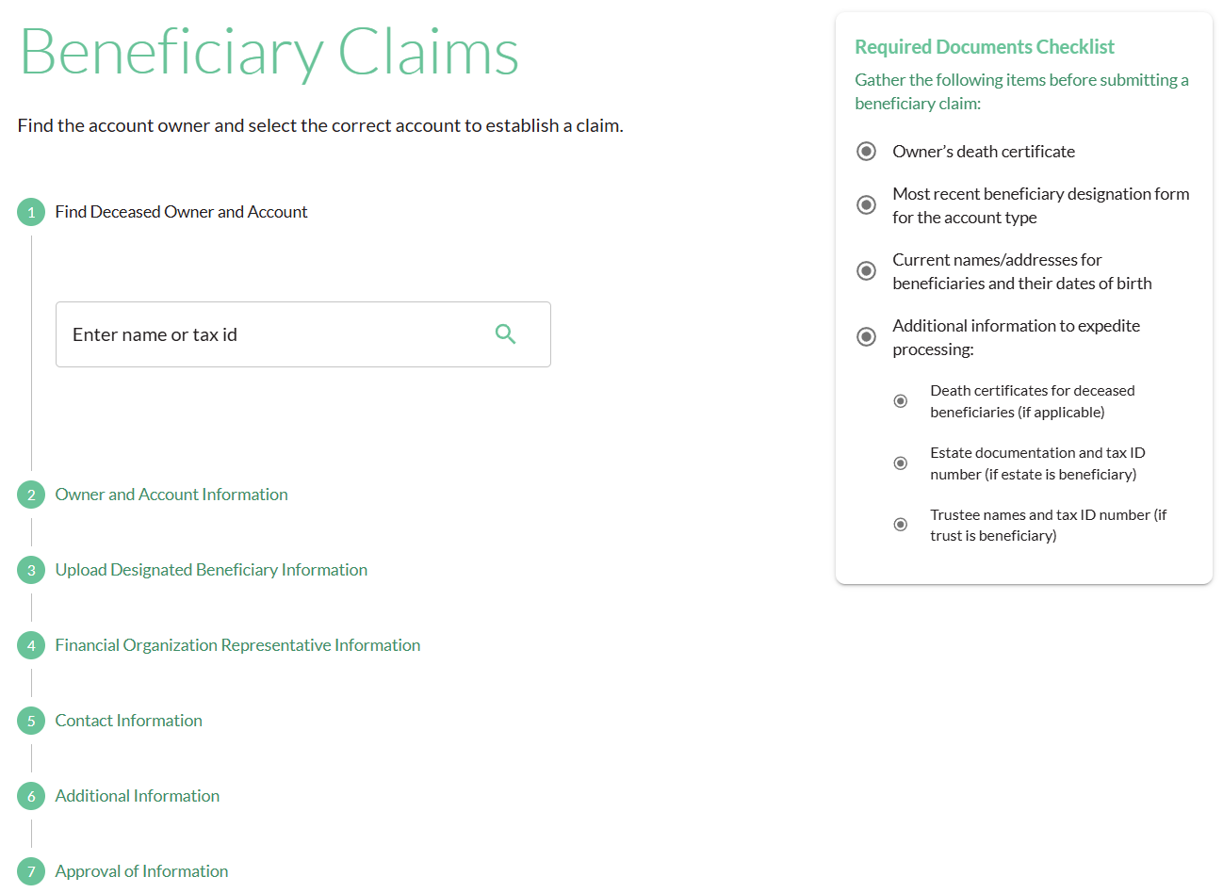

- Search for and select the deceased account owner for whom you are submitting a beneficiary claim.
- Enter the Owner’s Date of Death.
  - If the claim is being submitted for a Traditional, SEP, or SIMPLE IRA of a deceased account owner that has died after their required beginning date (which is April 1st of the year following the year in which they attained RMD age), you’ll be asked to reconcile the distributions currently listed in the Superior platform in the year of the owner’s death.
  - If the Reconcile Distributions section appears, simply add, remove, or edit the distributions listed to reflect the total amount distributed to the IRA owner before their death. This determines the remaining RMD in the year of death (if any) that must be distributed to the beneficiaries.
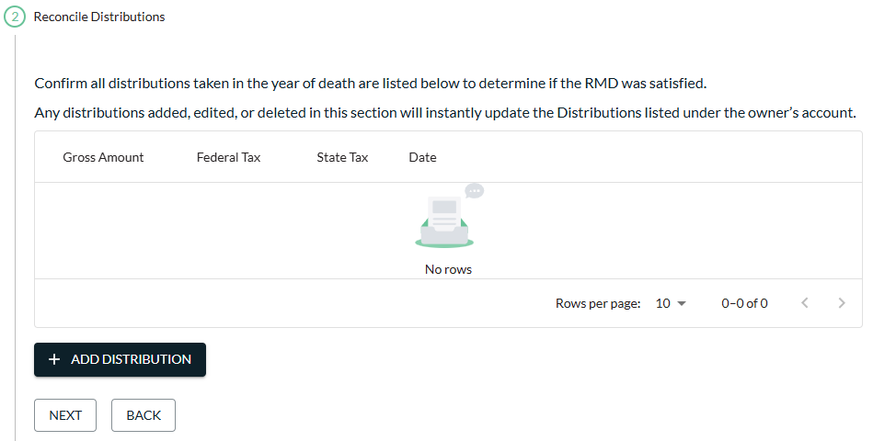

- Enter the Claims Amount (which is the Balance at Date of Death).
- Upload a copy of the owner’s death certificate by either dragging and dropping the document into the applicable section or by clicking Choose File to attach it from a specific file location.
- Attach the beneficiary designation form you have on file for the account.
  - If no form is on file, check the applicable box to indicate that no such designation is on file, and we will process the claim with the default beneficiaries.
  - If a beneficiary designation is uploaded within the workflow, an additional step to Verify Signature Authority will appear for your organization to confirm if the beneficiary designation form was signed by the account owner before death.
    - If you select “Yes” that the form was signed by the account owner, you may click Continue to proceed to the next section.
    - If you select “No” that the form was NOT signed by the account owner, you must check the applicable box to indicate if your organization verified or did not verify that the individual (i.e., Power of Attorney) had authority to sign on behalf of the account owner.

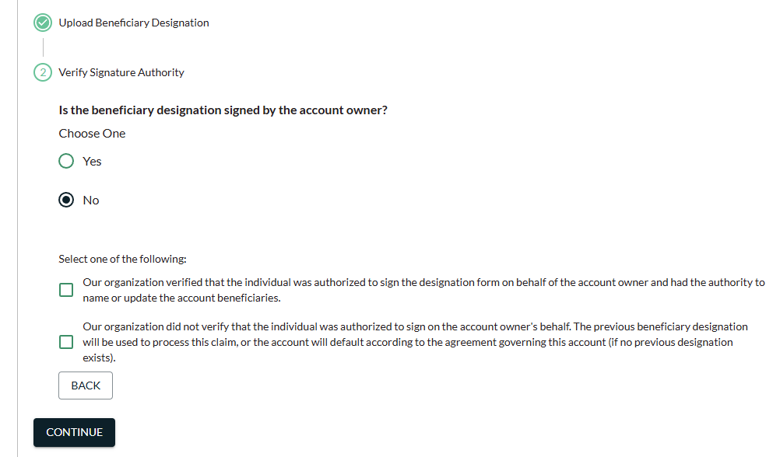

Remember: Review the form to ensure all beneficiary addresses are present and correct. In addition, make sure the beneficiary’s date of birth (DOB) is on the form. If a DOB or address needs to be provided to Superior or updated, please provide this information in the Additional Information section.

- Select your name from the Representative drop-down if it does not pre-populate in the Financial Organization Representative Information section.
- Enter information about the person who notified you of the owner’s death in the Contact Information section, along with the individual’s relationship to the deceased owner, their preferred contact method, and the details of that preferred contact method.
- Add any additional comments and/or upload additional documents (including descriptions of those documents) as applicable.
  - Include a list of updated beneficiary addresses if the information provided on the beneficiary designation is outdated.
  - Include the dates of birth for each beneficiary if not listed on the beneficiary designation form.
  - If any beneficiary named on the beneficiary designation form has also passed away, include a copy of that beneficiary’s death certificate.
  - If the beneficiary is a trust, provide a copy of the trust certification that includes the name(s) of the trustee(s).
- Check the applicable box to indicate that you understand the claim will be processed based on the information submitted and click Continue to submit the claim.
Superior will receive an automatic email notification when a new claim has been submitted and will begin processing the claim. When the forms are available to provide to the beneficiaries, Superior will notify your organization by adding a task to the Dashboard. If additional information is needed to process the claim, Superior will send an email requesting the information.

Provide Beneficiary Distribution Elections to Beneficiary(ies)
After Superior prepares the Beneficiary Distribution Elections (or any other necessary documentation) and uploads the documents to the claim, a task will be added to your Dashboard with instructions to view/print the documents and provide to the beneficiaries (or other steps will be provided if additional action is required by your organization).
Remember: Superior does not mail the documents to the beneficiaries on your behalf. It is your organization’s responsibility to provide the documents to the beneficiaries.
You will receive an email notification when the task has been added for your review.
Upon printing/providing the Beneficiary Distribution Elections to the beneficiaries, the user may click Mark Complete for the beneficiary claim task.
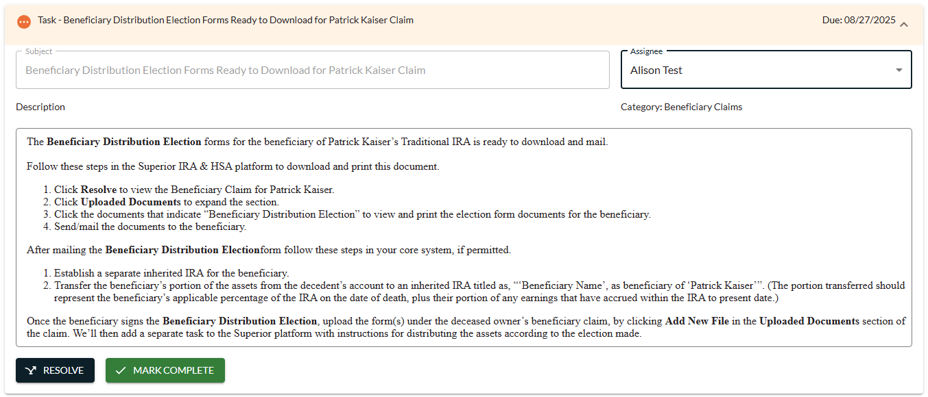

Upload Completed Beneficiary Distribution Elections
Once a beneficiary has completed a Beneficiary Distribution Election, your organization will upload the completed/signed document to the Upload Documents section.
- Click Add New File.
- Select Completed Beneficiary Distribution Election from the Document Type drop-down.
- Drag ‘n’ drop the signed election into the applicable section or click Choose File to locate the path of where the document is saved on your computer.
- Enter a brief description of the document.
- Click Upload Document.
Superior will receive an automatic email notification when a new document is uploaded to the claim and disbursal instructions will be provided to your organization upon our review.
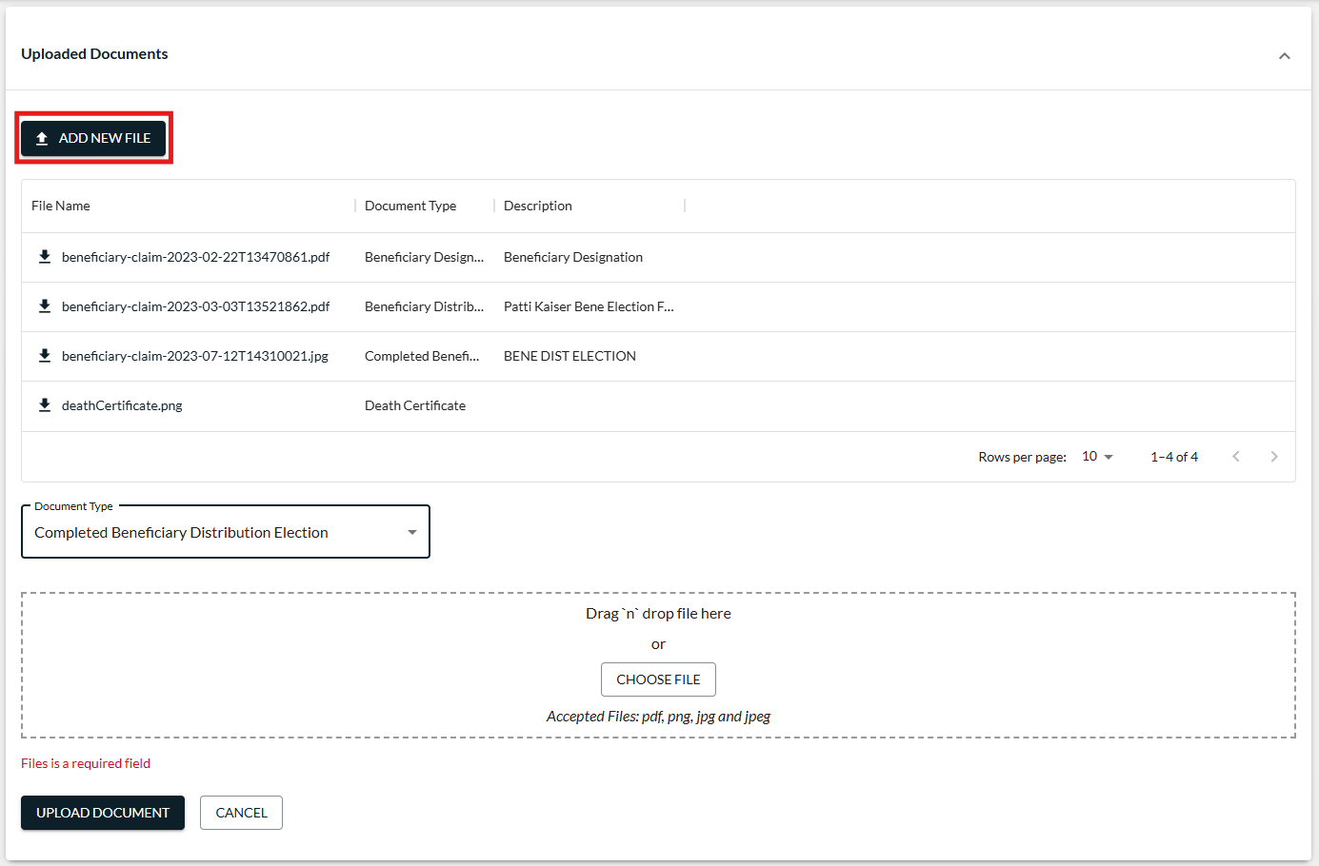

Await Disbursal Instructions from Superior
We’ll review the completed beneficiary distribution election and if everything appears correctly, we will add another task to your Dashboard with instructions of how to distribute the IRA assets to the beneficiary from your core system and how to log the distribution in Superior for reporting purposes.
If there is more than one beneficiary, you’ll receive separate tasks for each beneficiary after their election is uploaded and reviewed by Superior.
In some instances, you may receive more than one task for the same beneficiary (e.g., a spouse elects to transfer the assets to their own IRA and must also satisfy the owner’s year-of-death RMD before the transfer).
After all Beneficiary Distribution Elections are received from the beneficiaries, uploaded to the claim, and processed by Superior, Superior will update the claim status from Awaiting Election to Completed and the deceased owner’s account will be closed within the platform.

View Beneficiary Claims
Use this page to view the status of any beneficiary claims that your organization has either started to complete and hasn’t yet submitted (Pending) or has already submitted for processing.
The following statuses may appear. Expand the Status Definitions on the right side of the page to view detailed explanations of each status.
- Pending – Claim is started but not yet submitted to Superior IRA & HSA for processing
- Submitted for Processing – Claim has been submitted to Superior IRA & HSA for processing
- Awaiting Additional Info – Additional information is needed from either your organization or the contact/beneficiary of the claim before claim processing can resume
- Awaiting Election – The Beneficiary Distribution Election has been uploaded to the claim for your organization to print and provide to the named beneficiary(ies)
- Completed – Your organization has uploaded the completed Beneficiary Distribution Election back to the claim and Superior IRA & HSA has added a task to the Dashboard with instructions for your organization to distribute the money to the beneficiaries
- Processed by Client– Claims that will not be processed by Superior either because the date of the owner’s death is more than one year before your organization’s go-live date, the claim was already submitted/processed by your prior vendor, or your organization paid the assets to the beneficiary(ies) prior to Superior reviewing the claim. If a claim is updated to Processed by Client, Superior will email your organization explaining why the status was changed.
Expand each status to view the claims within that section.

Search for a deceased owner in the Search by… field to locate the status of that owner’s claim.
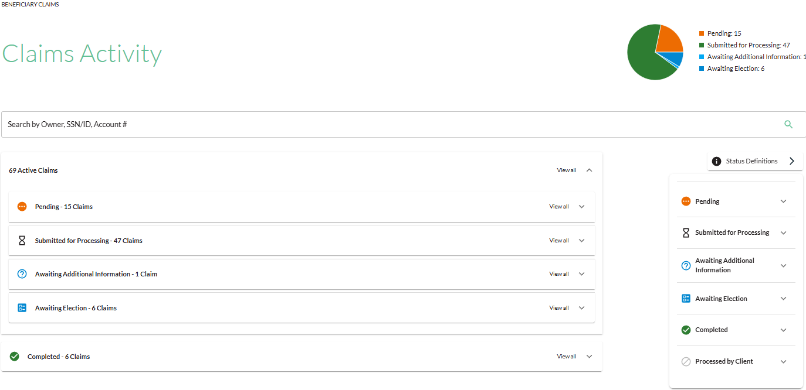
Users may click the deceased owner’s name within a specific section to view the beneficiary claim for that account.
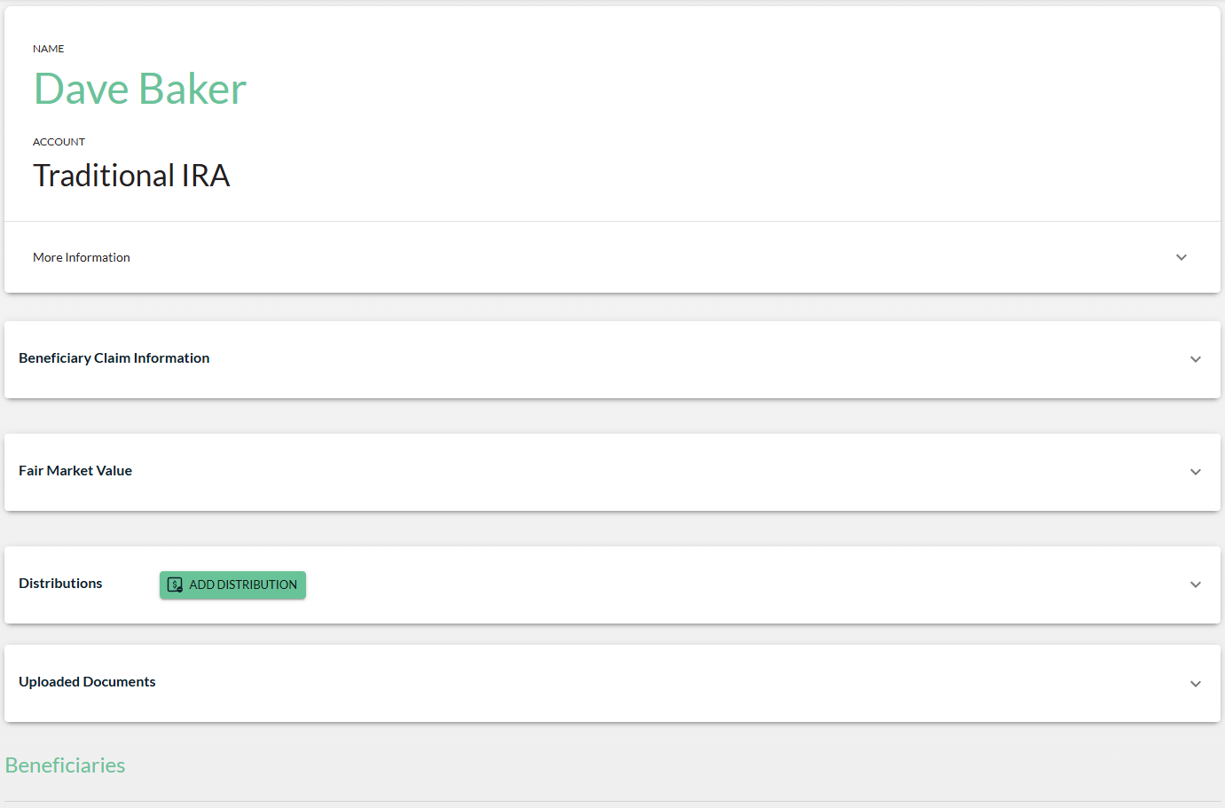

Beneficiary Claim Information
The Beneficiary Claim Information section displays the data that was entered by the financial organization user when the claim was submitted.
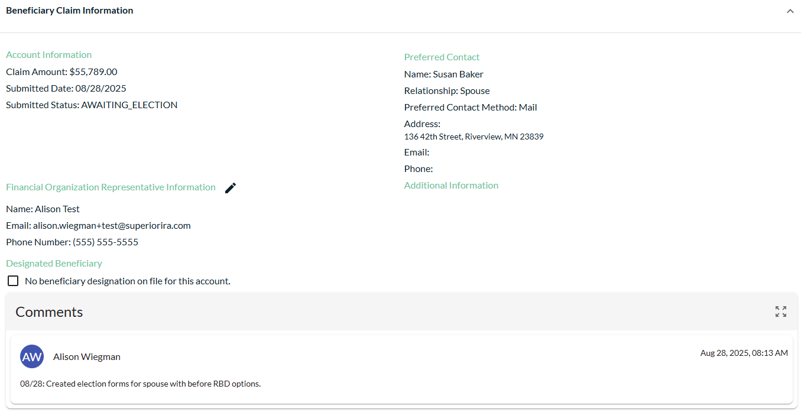
The Comments section allows your organization to notify Superior of additional details related to a beneficiary claim or to review comments added by a Superior representative. Any comments added by your organization will send an automatic email notification to the Superior beneficiary claims team.
Click the Add icon to add a new comment if one does not yet exist under the claim.
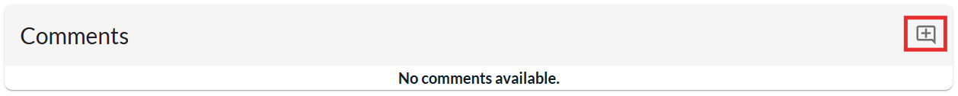
Or click the Expand icon in the Comments section to view all existing comments under a claim.
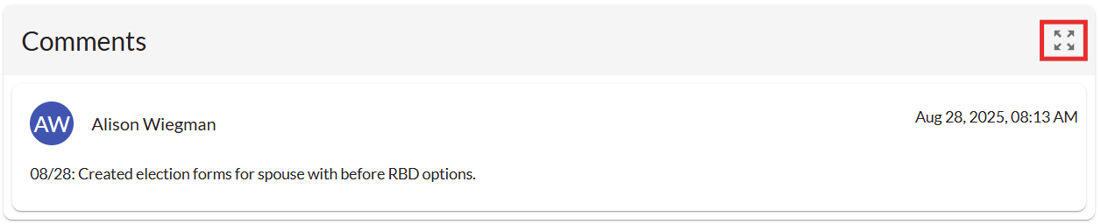

- To add a new comment: Type your comment in the Add a comment… section and click the submit arrow.
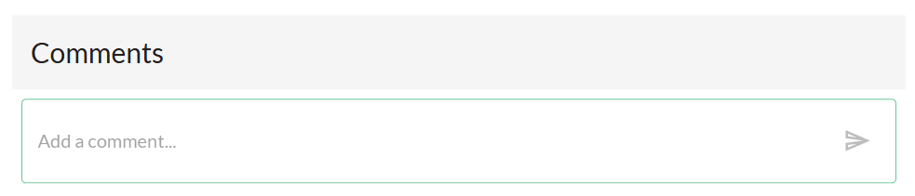
- To edit an existing comment: Click the “three dots” next to the applicable comment. Select Update to make your edits and click the Save icon to save your changes. (You may only edit your own comments.)
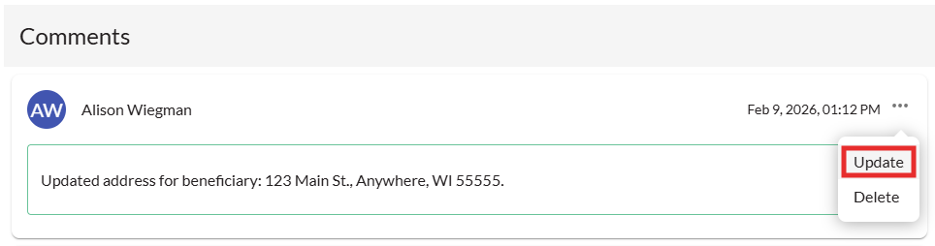
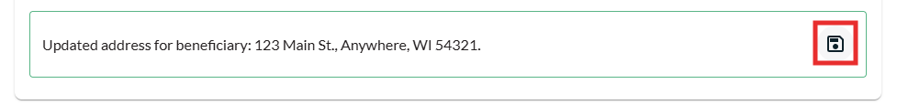

- To delete an existing comment: Click the “three dots” next to the applicable comment and select Delete to remove your comment. (You may only delete your own comments.)
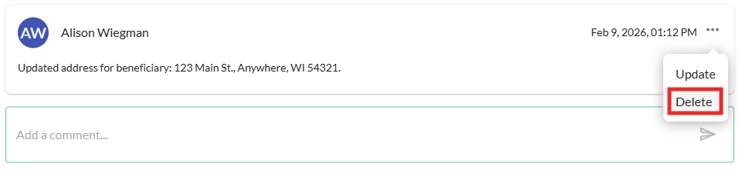

Fair Market Value
The Fair Market Value section displays the date-of-death balance provided by your organization, as well as the current/prior year RMDs for the IRA owner, if applicable.
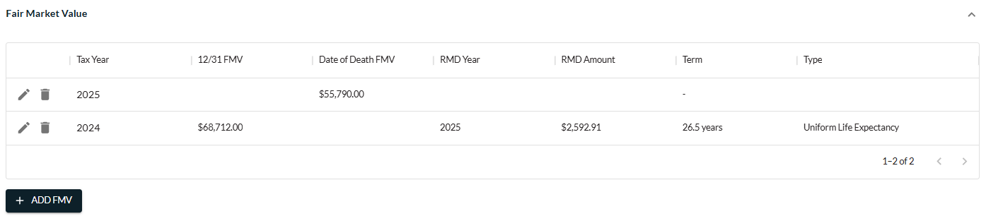

Distributions
The Distributions section displays the distributions taken from the deceased owner’s account, as provided by your organization when submitting the beneficiary claim.
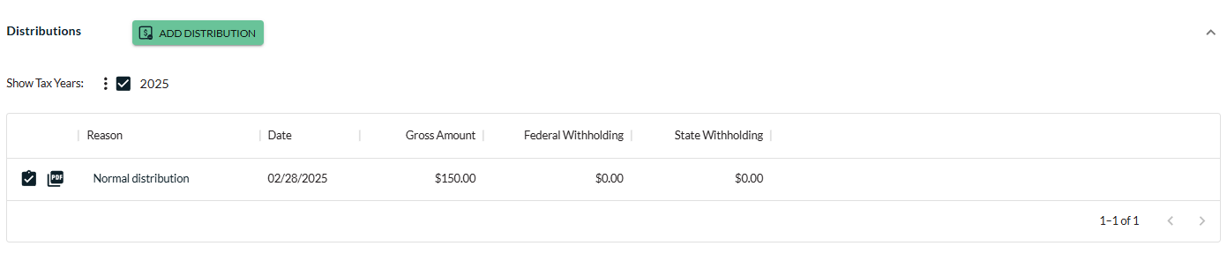

Uploaded Documents
The Uploaded Documents section displays the documents that were submitted with the claim and any additional documents that were uploaded by Superior or your financial organization, including the Beneficiary Distribution Elections for each beneficiary that your organization must print and provide to the applicable beneficiaries.
- View/download a document by clicking the File Name for the document.
- Upload additional documents by clicking the Add New File icon.
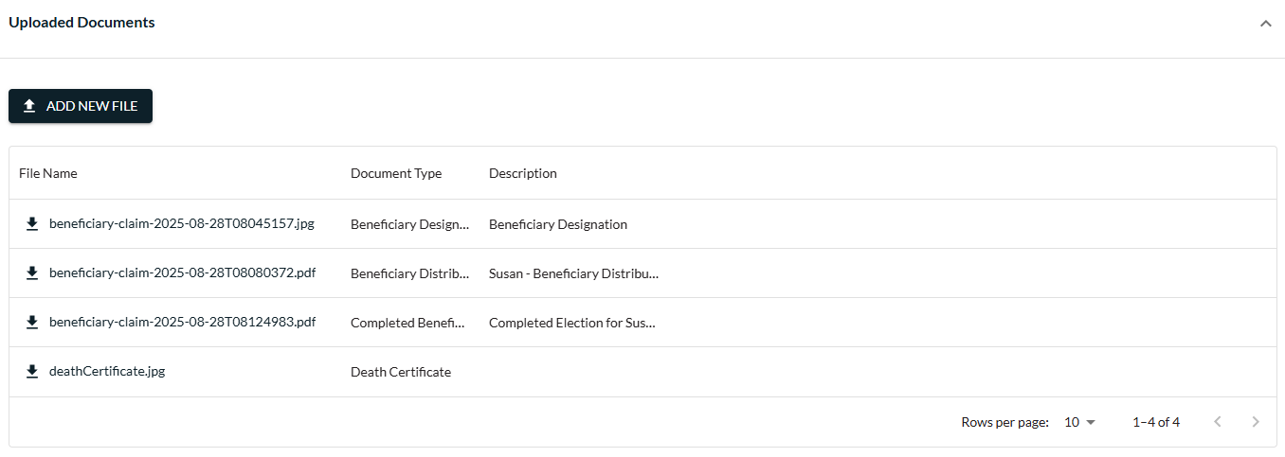

Beneficiaries
The Beneficiaries section displays the beneficiaries of the account. When Superior determines the beneficiaries upon reviewing the documentation submitted by your organization, the beneficiaries will appear under the claim with a separate “card” in the Beneficiaries section.
Click a card to view more details about the beneficiary such as
- Date of birth
- SSN/ID
- Address
- Relationship to deceased owner
- Percentage of account designated
- Distribution option selected on their completed Beneficiary Distribution Election form (after it’s been received/processed by Superior)
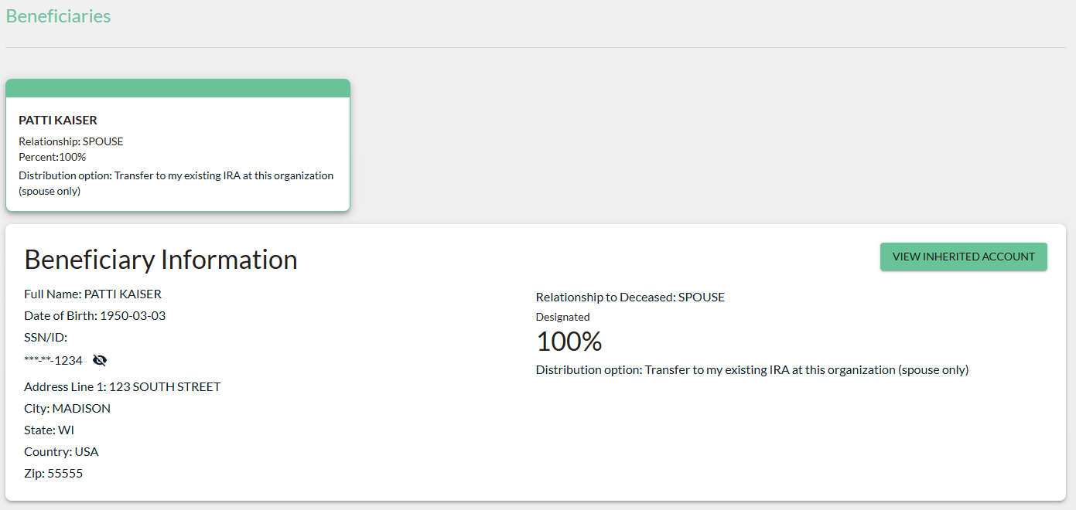

Superior IRA & HSA Support

Chat
Chat with us directly from the Superior IRA platform. The chat bubble appears in the lower right corner of every screen (unless you click the dots to the left of the chat bubble and move it).


Call
Call us at 888-470-4542, Option 1.

Email
Email us at support@superiorira.com.

Help Center
Search for your answer directly from the chat bubble.
- Click the Help tab at the bottom of the chat bubble screen.
- Enter a word to search for your answer within our Help Center.

