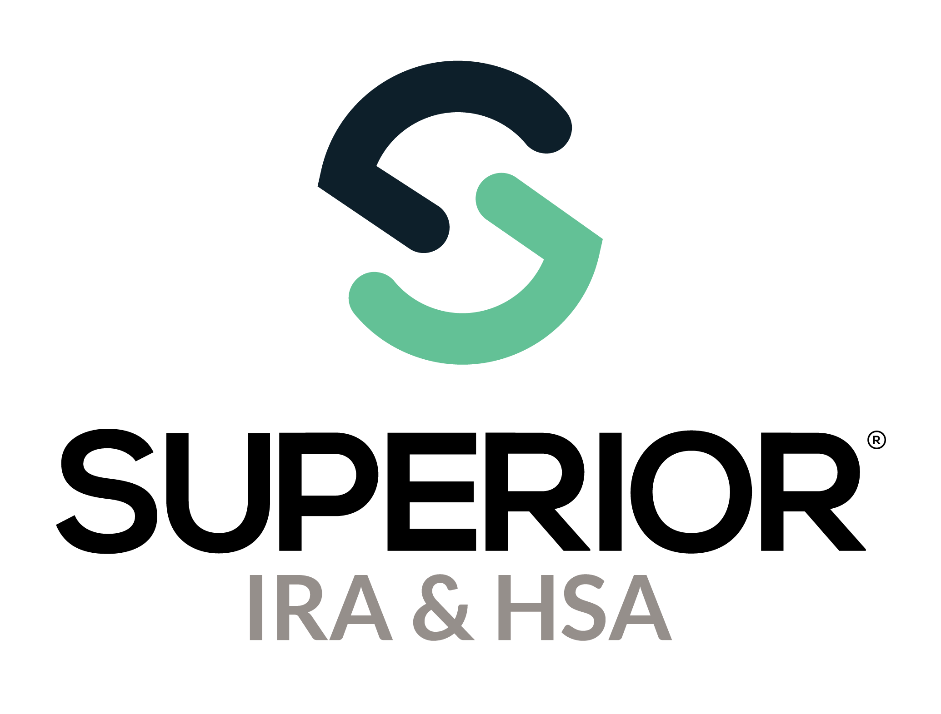
Account Search Page Training Guide

Superior IRA & HSA® and the Superior IRA & HSA logo are registered trademarks of Superior IRA & HSA, LLC.
Table of Contents
Account Search 3
Superior IRA & HSA Support 13
Chat 13
Call 13
Email 13
Help Center 13

Account Search
The Account Search page is accessible if you have the Transactions or Transactions Administrator user role. Select Account Search from the left navigation menu to look for existing account owners within your financial organization.
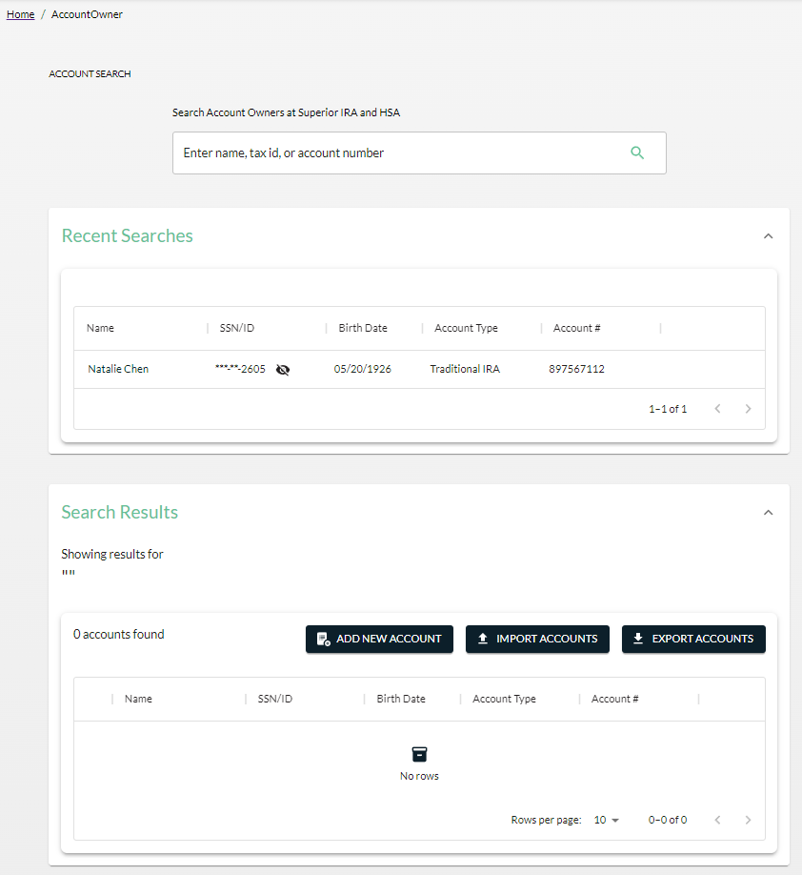

- Enter in an asterisk to pull up all owner accounts at your organization.
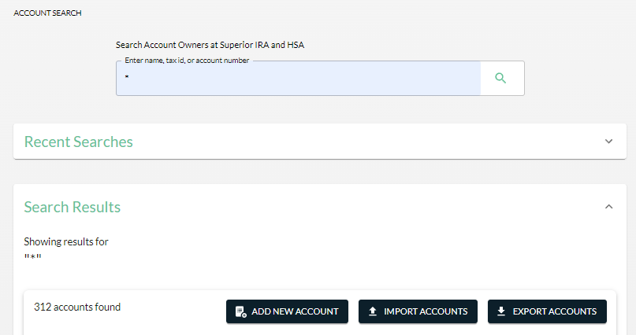
- Click Add New Account to navigate to the Open New Account workflow.
- Select Import Accounts to add accounts by uploading data files.
- Select Export Accounts to produce a report showing the account information that appears in your Search Results.
- Recent searches you have made during your current login are displayed to easily navigate back to those accounts by clicking on the account owner’s name.
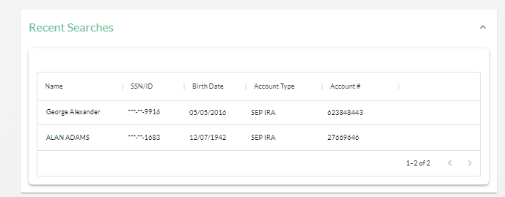

To search for an account owner and the details/transactions listed under the account, follow these steps.
- Enter the first name, last name, full name, part of the name, full SSN, part of the SSN, or account number for the specific account owner.
- All search results will be displayed after searching.
- Click the account owner’s name to view the account details.
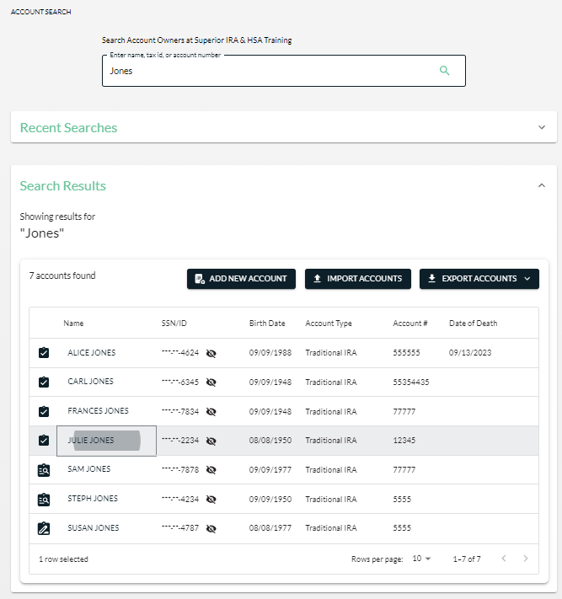

- If the account owner owns more than one account (or IRA plan), each account type will display under the individual’s name.

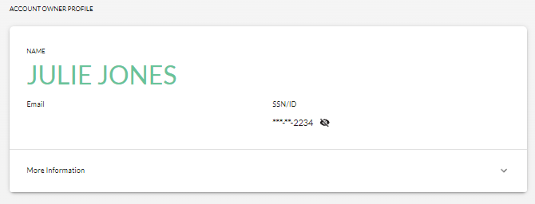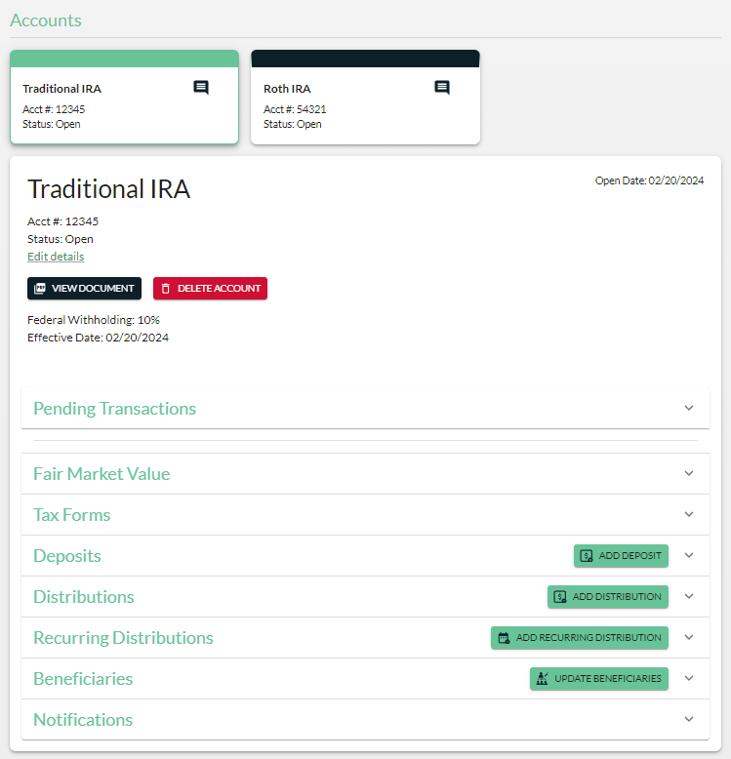

- Click the More information section under the owner’s name to expand and/or edit the account owner details.
  - Any user with the Transactions role may click Edit Details and update the information listed in this section.
  - Only users with the Site Administrator role may click Delete Owner to delete the account owner. (An account owner may only be deleted if no transactions appear under any accounts listed for the account owner.)
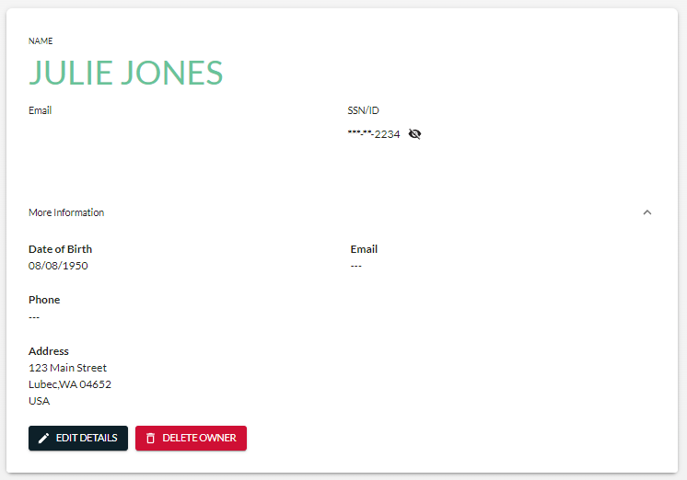
- Click a specific account card to view the details of that account. (The account will be highlighted green if selected.)
  - Any user with the Transactions role may click the Edit details link under the account to update the account number or account status (open vs. closed).
  - Only users with the Site Administrator role may click Delete Account to delete the account within Superior. (An account may only be deleted if no transactions appear under the account.)
  - Click View Document to view the document created to open the account. (If an error message appears, this account was opened before your organization moved to the Superior platform.)
  - The most recent federal withholding election on file for the account and the effective date of that election appear under the account details.
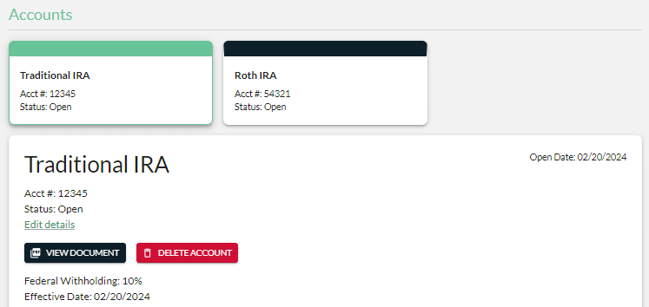
- Expand the Pending Transactions section to view any transaction workflows for the account that are sitting in one of the four Pending Transaction queues on the Dashboard—Drafts, Awaiting Signature, Pending Review, or Awaiting Transfer.
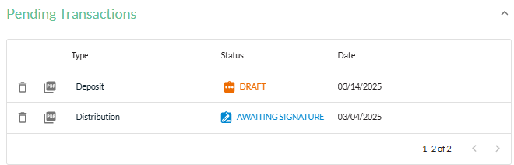
- Expand the Fair Market Value section to view an account’s fair market value (12/31 balance) and current year required minimum distribution (RMD) amount.
  - Only users with the Transactions Administrator role may edit, delete, or add an FMV to the account within Superior.
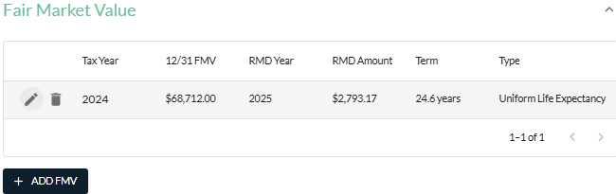
- Expand the Tax Forms section to view tax forms produced by Superior for the specific account. (This section is only applicable if your organization is enrolled in Superior’s Black solution and Superior completes tax reporting on your organization’s behalf. It is not applicable if your organization is enrolled in Superior’s Green solution or Silver solution.)
  - Click the PDF icon to view a copy of the tax form produced for this account.
  - Only users with the Transactions Administrator role may click the Pencil icon to edit a tax form to issue a corrected statement.
  - Users may print corrected tax forms immediately after an edit is made. (Superior will also mail a copy of the corrected tax form to the account owner, unless you direct us not to by clicking the Envelope icon.)
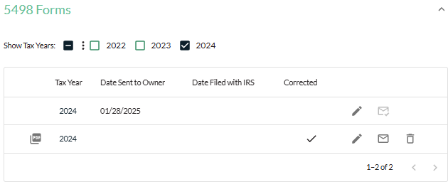

- Expand the Deposits section to view any deposits added to Superior for the specific account.
  - Click Add Deposit in the upper right corner of the section to enter the Deposit Money workflow and add any missing deposits.
  - Click the PDF icon to view a copy of the form produced for this transaction.
  - Click the Deposit Type (e.g., Regular Current Year) to view the transaction details.
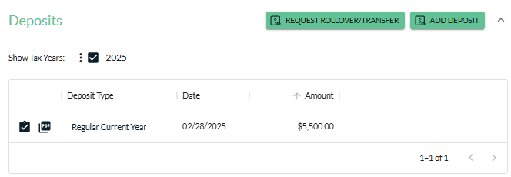
  - Only users with the Transactions Administrator role may click Edit Deposit to make changes to the transaction or click Delete Deposit to remove it from the platform.
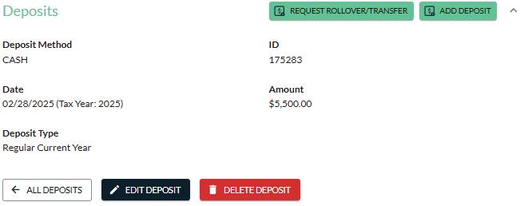
- Expand the Distributions section to view any distributions added to Superior for the specific account.
  - Click Add Distribution in the upper right corner of the section to enter the Distribute Money workflow and add any missing distributions.
  - Click the PDF icon to view a copy of the form produced for this transaction.
  - Click the Reason (e.g., Normal distribution) to view the transaction details.
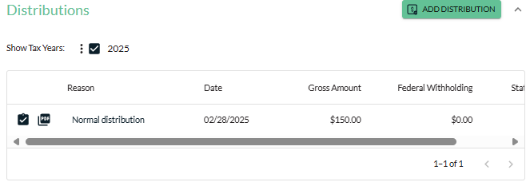

  - Only users with the Transactions Administrator role may click Edit Details to make changes to the transaction or click Delete Distribution to remove it from the platform.
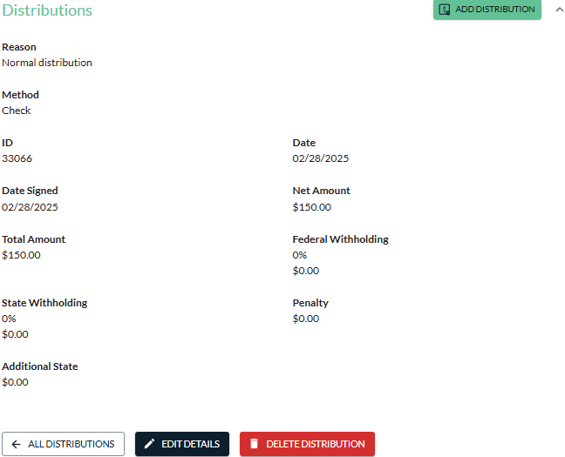
- Expand the Recurring Distributions section to view an account owner’s recurring distribution election if they are set up to receive automatic distributions (or are of RMD age and have chosen to be “owner responsible”).
  - Click Edit Recurring Distribution in the upper right corner of the section to enter the Edit Recurring Distribution workflow and make changes to the account owner’s existing election.
  - Click Add Recurring Distribution in the upper right corner of the section to enter the Add Recurring Distribution workflow and add a new election to the owner’s account.
  - Click the PDF icon to view a copy of the form produced for this transaction.
  - Click the Type (e.g., RMD) to view the recurring distribution election details.
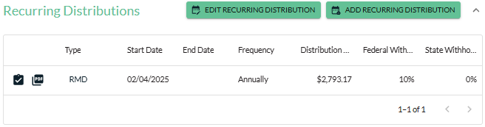

  - Only users with the Transactions Administrator role may click Edit Details to make changes to Start date/End date, Distribution Status, or Distribution Method listed for the election without printed a form to be signed by the account owner. (If your organization is enrolled in Superior’s Silver solution, only the Distribution Method is editable from this page.)
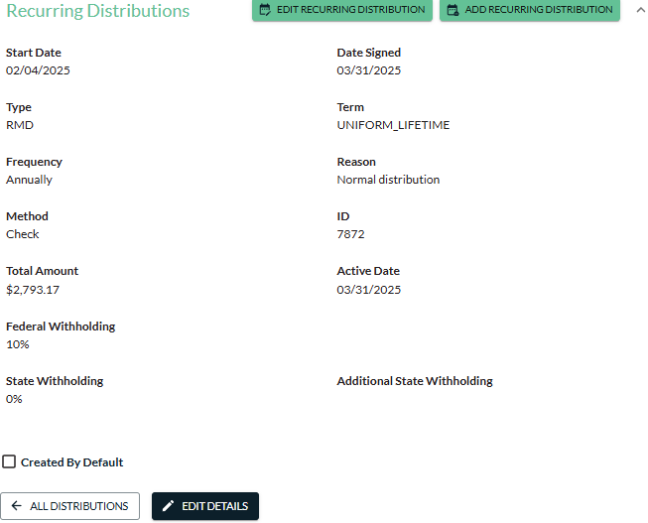
- Expand the Beneficiaries section to view an account owner’s beneficiaries for the account (if they were added to the platform).
  - Click Update Beneficiaries in the upper right corner of the section to enter the Update Beneficiaries workflow and make changes to the account owner’s existing beneficiary designation.
  - Click View Document to view a copy of the form produced for this transaction.
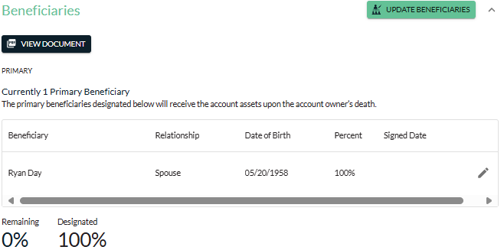
- Expand the Notifications section to view any notifications Superior mailed on behalf of your organization to the account owner regarding the specific account.
  - Click the PDF icon to view a copy of the notification mailed to the account owner.
    - Withholding Notification: Sent to account owners set up to receive a recurring distribution; notifies owners of their current withholding rate and always them to change their election. (This section is not applicable if your organization is enrolled in Superior’s Silver solution.)
    - RMD Notification: Sent to account owners of RMD age who do not yet have a recurring distribution set up in Superior; allows owners to make an RMD election. (Applicable if your organization is enrolled in Superior’s Green or Black solutions.)
    - Amendment Notification: (Optional) Sent to account owners if your organization elects to have Superior send an amendment mailing on your behalf (i.e., due to forms vendor change or legislative updates). (Applicable to all Superior solutions if you have elected to have Superior mail the amendment on your organization’s behalf.)
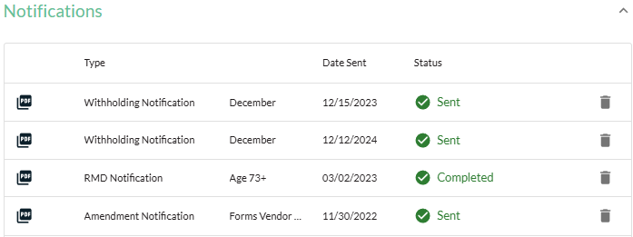
- Expand the Beneficiary Claim Information section (if applicable) to view information related to the beneficiary claim submitted by your organization for the owner’s account upon their death. (This section is not applicable if your organization is enrolled in Superior’s Silver solution.)
  - Only users with the Beneficiary Claims role may click View Claim in the upper right corner of the section to view every detail of the beneficiary claim, along with any documents submitted by your organization or created by Superior.
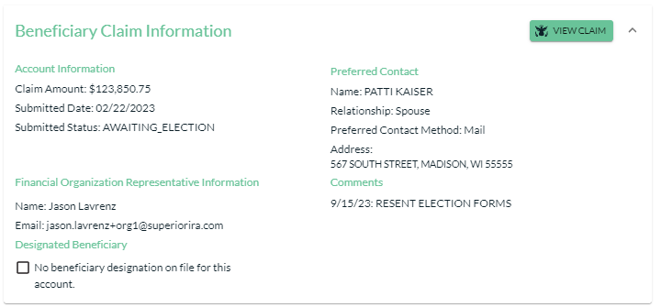

Superior IRA & HSA Support

Chat
Chat with us directly from the Superior IRA platform. The chat bubble appears in the lower right corner of every screen.


Call
Call us at 888-470-4542, Option 1.

Email
Email us at support@superiorira.com.

Help Center
Search for your answer directly from the chat bubble that appears in the lower right corner of every screen.
