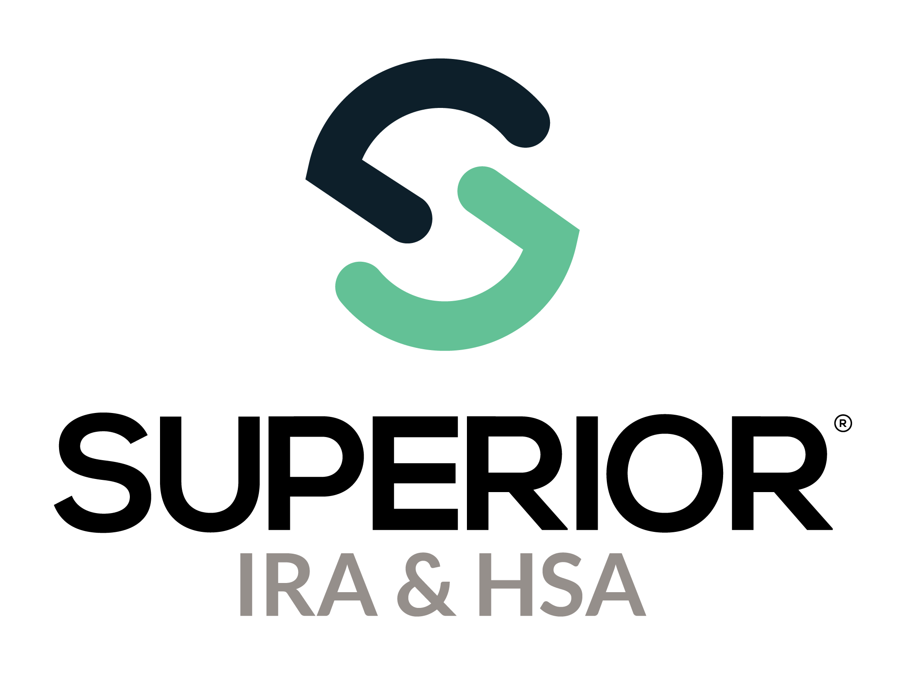
Account Owner Portal Training Guide
For Organizations and Account Owners

Superior IRA & HSA® and the Superior IRA & HSA logo are registered trademarks of Superior IRA & HSA, LLC.

Table of Contents
Financial Organization Guide 3
Organization Settings 3
Profile Options 3
Transaction Settings>Workflow Permissions Settings 4
Account Owner Access 6
Pending Submitted by Owner Transactions 7
Saving PDF Certificates for Auditing Purposes 11
Troubleshooting 11
Marketing 12
Sample Owner Email (for Organizations with IRAs & HSAs) 12
Account Owner Guide 13
Account Log In 13
Completing Transactions 17
Add Deposit 17
Request Rollover/Transfer 20
Distributions 23
Update Beneficiaries 29
Review and Sign Document 31
Tax Forms 35
Notifications 36

Financial Organization Guide
The Account Owner Portal provides IRA and HSA owners online access to their accounts that are housed on the Superior platform. Account owners can complete transactional forms, view account history, and retrieve copies of current and previous year tax forms if allowed by your financial organization.
A link to the portal will be provided by Superior IRA & HSA after the initial setup. You can add this link to your website or your online banking platform. Contact Superior if you have changes that need to be made to the branding or verbiage used on the screens after your implementation has ended.

Organization Settings
Under the Organization Settings page from the left navigation menu of the Superior platform, users with the Site Administrator role can configure which accounts may be opened by account owners within the Account Owner Portal and additional workflow permissions.

Profile Options
Navigate to the Organization Settings>Profile Options section to indicate if account owners should have access to open the applicable new accounts within the Account Owner Portal.
- To allow account owners to open a new account type, check the Allow account owner portal users to open new <AccountType> accounts box and click the Continue button.
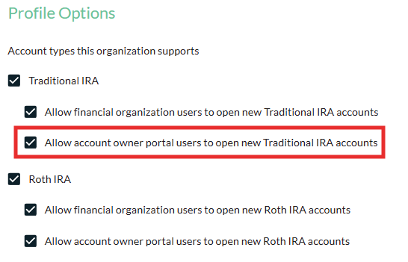

- To remove the option from the Account Owner Portal for account owners to open a specific account type, uncheck the applicable Allow account owner portal users to open new <AccountType> accounts box and click the Continue button.
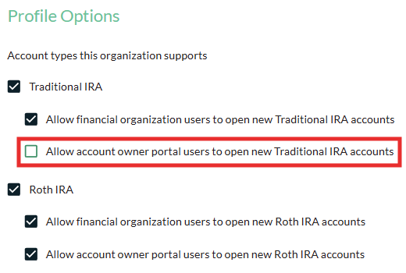

Transaction Settings>Workflow Permissions Settings
Navigate to the Organization Settings>Transaction Settings>Workflow Permissions Settings section to configure the following workflows you’d like to be accessible to your account owners within the Account Owner Portal.
- Distribute Money workflow
- Open New Account workflow
- Add/Edit Recurring Distribution workflows
- Request Rollover/Transfer workflow
- Deposit Money workflow
- Open New Inherited IRA workflow
- Update Beneficiaries workflow
To enable a workflow within the Account Owner Portal, check the box that has “(Account Owner Portal)” next to it, as shown below, and click the Save Settings button. (Uncheck the box if you do not want your account owners to access that workflow within the Account Owner Portal.)
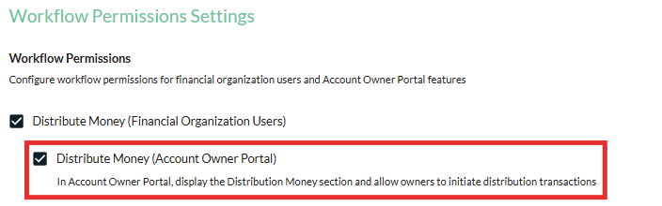

You may also configure the following additional sections your account owners may or may not access under their accounts within the portal:
- Pending Transactions
- Fair Market Value
- Tax Forms
- Notifications
To enable a section so that it appears within the Account Owner Portal, check the applicable box next to that section, as shown below, and click the Save Settings button. (Uncheck the box if you do not want your account owners to be able to view that section under their account within the Account Owner Portal.)
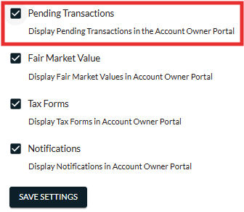

Account Owner Access
The email address for your account owners must be stored under the owner’s record within the Superior platform and needs to be unique for each owner if that owner wants to access the Account Owner Portal.
To add or update an email address for your owners:
- A user with the Data Processor role may use the Update Owners file under the Data Import>Update Owners page to import a file with updated email addresses; or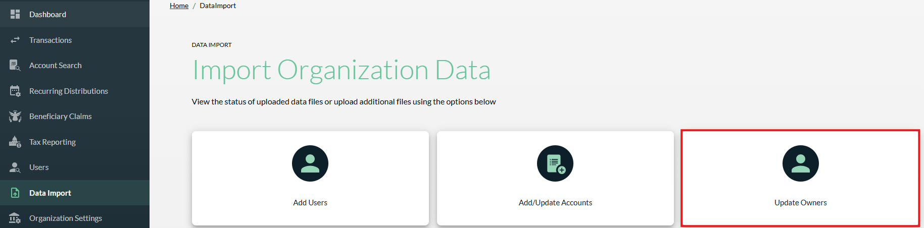

- A user with a Transactions or Transactions Administrator role may search for the owner under the Account Search page, expand the More Information section, and click the Edit Details button to update an owner’s email address. Click Continue to save your changes.
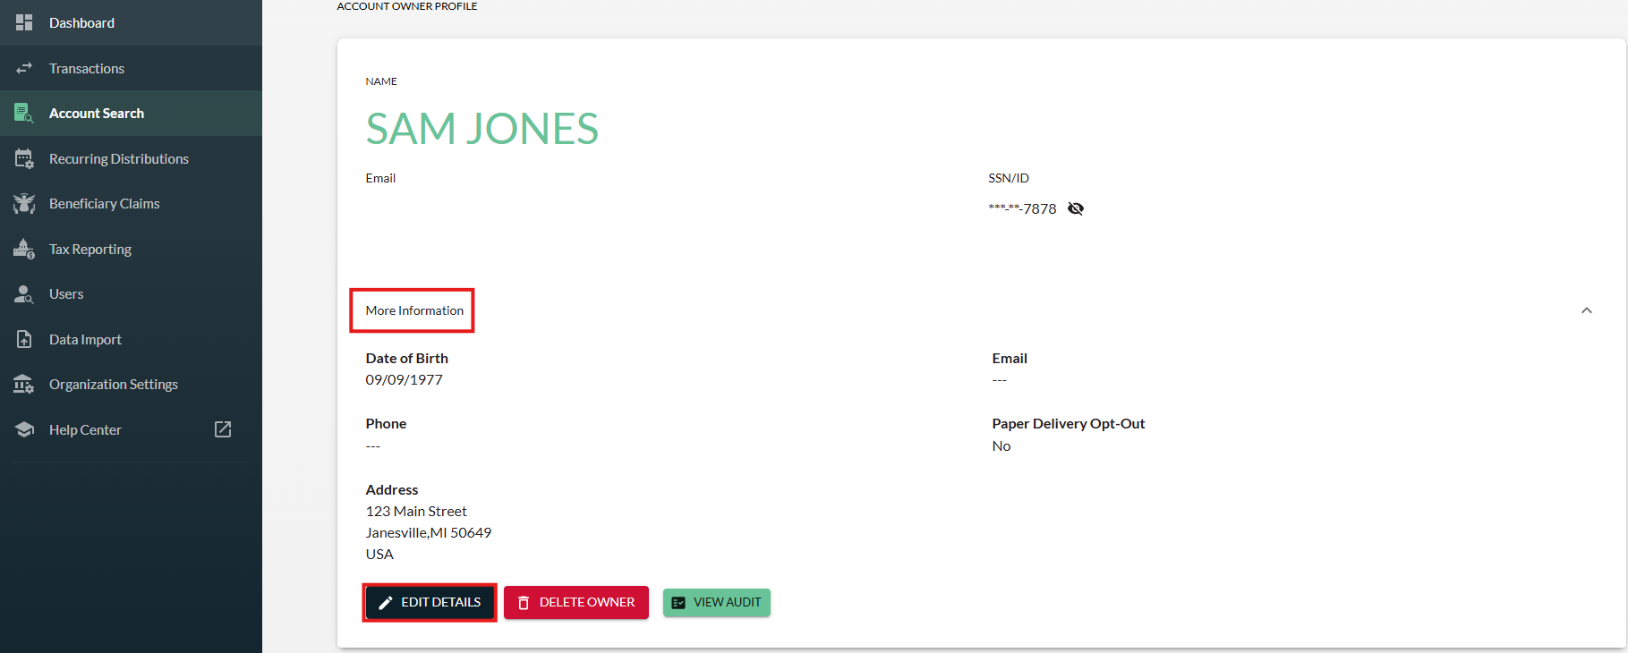

Pending Submitted by Owner Transactions
Transaction Administrator users in the Superior platform will receive an email notification when an owner completes a transactional form in the Account Owner Portal (according to the Transaction Email Settings selected under the Organization Settings>Transaction Settings>Transaction Workflow Settings section).
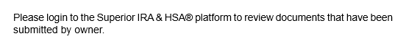
Follow these steps to review/approve the submitted transaction:
- Log into the Superior platform and the form will be located under the Submitted by Owner queue of the Pending Transactions section of the Dashboard.
- Click the Submitted by Owner queue to view these transactions.
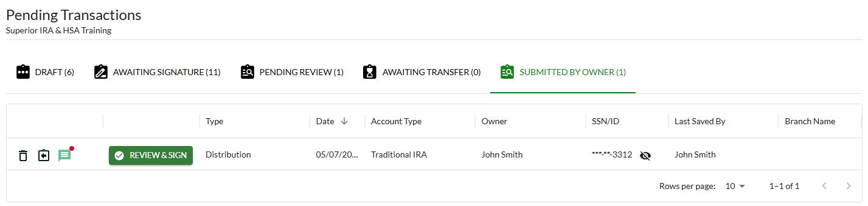

- If an account owner left a comment within the transaction workflow, the Comments icon () will be highlighted green, and a red dot will appear next to it if the comment has not yet been read by the logged in representative.
  - Click the Comments icon to read the owner’s message.
  - NOTE: Any comments added by your organization representatives cannot be viewed by the account owner and are for internal reference only at your organization.
- If an organization representative spoke with the account owner and determined a change must be made to the transaction before approving it, you may click the Draft icon () next to the transaction to send it back to the Pending Transactions section of the owner’s account, so the owner can retrieve, edit, and resubmit for approval.
- If the transaction is completed incorrectly and should not be approved, click the Discard icon () next to the transaction to remove it. (NOTE: A notification is not sent to the account owner when a transaction is denied by your organization, so an organization representative must contact the owner to let them know.)

- Click the Review & Sign button next to the submitted document to view the PDF document, provide the employee’s signature, and approve the transaction.
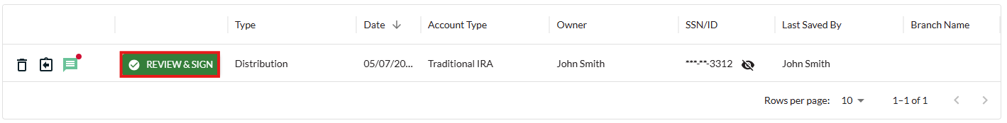

- A pop-up window appears. Click View PDF Document to review the completed transaction.
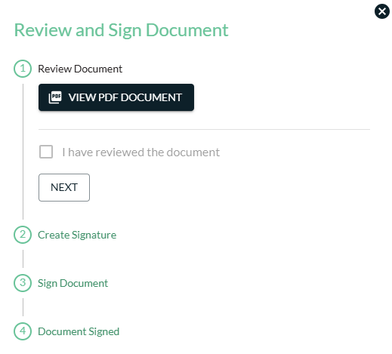

- If the transaction is completed correctly and can be processed, check the box to confirm the document has been reviewed and click Next.
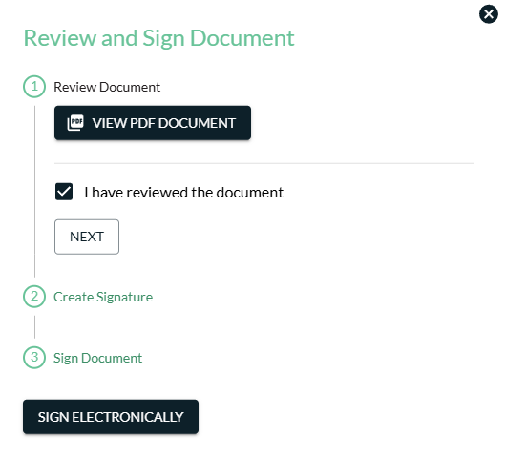

- If the employee reviewing the transaction has not yet created approved a transaction submitted by an owner:
  - Click Create Signature to create a signature.
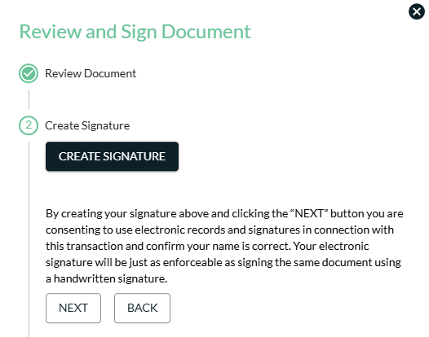

  - Enter the name of the employee reviewing the document and click Accept to confirm the electronic signature. Then click Next to continue.
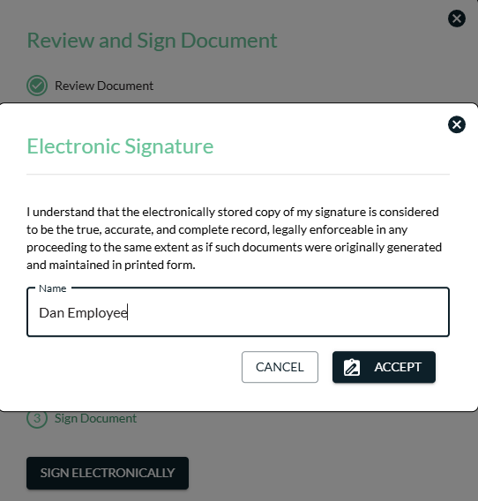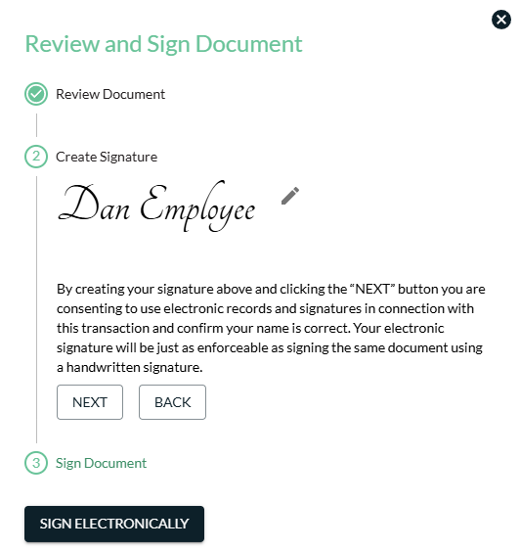

- If the employee reviewing the transaction has already created a signature:
  - Review the saved signature in the Create Signature section. (Click the Pencil icon to make edits to the signature, if needed.)
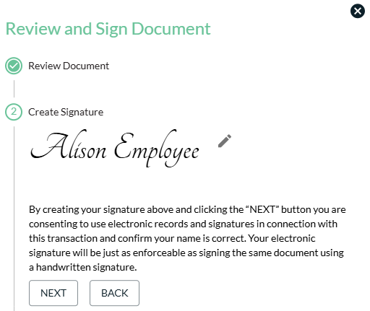

  - Click Next to continue.

- Review the Electronic Signature and Disclosure and Consent section and click Sign Electronically to finish processing the transaction. The employee’s electronic signature will be applied to the document.
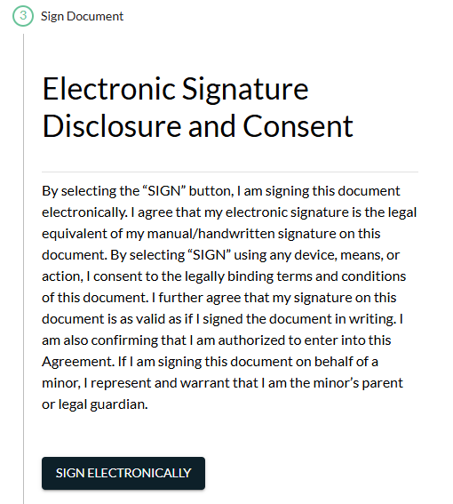

- Click View PDF Document to review/save the electronically signed transaction, which will include the account owner’s and the employee’s signatures. Click Close once completed.
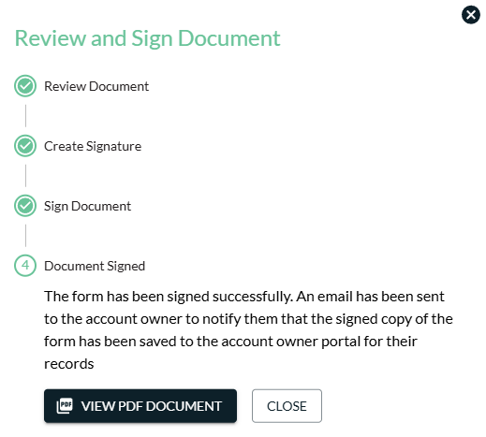

- The completed/signed transaction will save to the Superior platform and Account Owner Portal, and an email will be sent to the account owner to confirm that your organization has processed the transaction and that a signed copy is available for the owner to view within the Account Owner Portal.
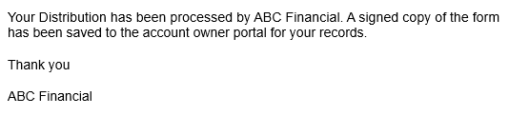

Saving PDF Certificates for Auditing Purposes
PDF copies of forms electronically signed through the Account Owner Portal contain certificates to confirm, validate, and secure for auditing purposes:
- Save a copy of the signed PDF.
- Open the saved PDF and click Signature Panel in the upper right corner of the Adobe document to view further details about the validity of the electronic signatures.
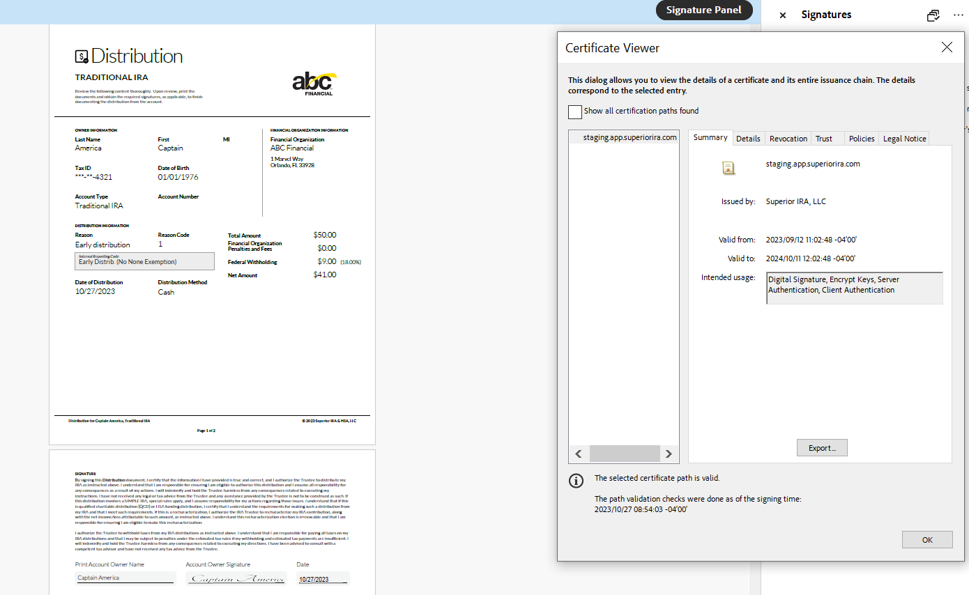

Troubleshooting
Owner receives an error after the identity verification page: The owner’s Social Security number, date of birth, or name entered during the verification process does not match the record within the Superior platform. The owner either entered the information incorrectly or the data within Superior is incorrect and needs to be updated by a financial organization employee.
Owner receives a black screen after entering their verification code: Either the owner does not have an owner record within the Superior platform, the email address entered does not match the email listed under the account in the Superior platform, or the owner is using the same email address that is currently listed for another account owner within the Superior platform (which is not allowed as each email address must be unique to each owner).
Owner is locked out: If the verification code is entered incorrectly three times, the owner will be locked out. Contact Superior to unlock the account.

Marketing
We recommend announcing the launch of your Account Owner Portal to your account owners. Consider using a variation of this sample notification:

Sample Owner Email (for Organizations with IRAs & HSAs)
Dear Account Owner,
We are pleased to announce the launch of our new IRA & HSA Account Owner portal. The portal gives you direct, online access to perform certain IRA & HSA transactions using this simple and user-friendly system. Here are examples of transactions you can request via the portal:
- Open a new IRA or HSA account
- Request a rollover or transfer from another institution to our financial organization
- Add a deposit to your account
- Take a distribution from your account
- Set up automatic distributions to be taken from your IRA
- Update your IRA or HSA beneficiaries
You also have access to these great features within the Account Owner Portal:
- Receive notifications via email when transactions have been processed
- View your signed forms within the portal
- View electronic copies of IRA & HSA tax forms and notifications sent to you regarding your account
- Access the December 31st fair market value (FMV) of your IRA, and if applicable, the amount of your required minimum distribution (RMD) for the current year
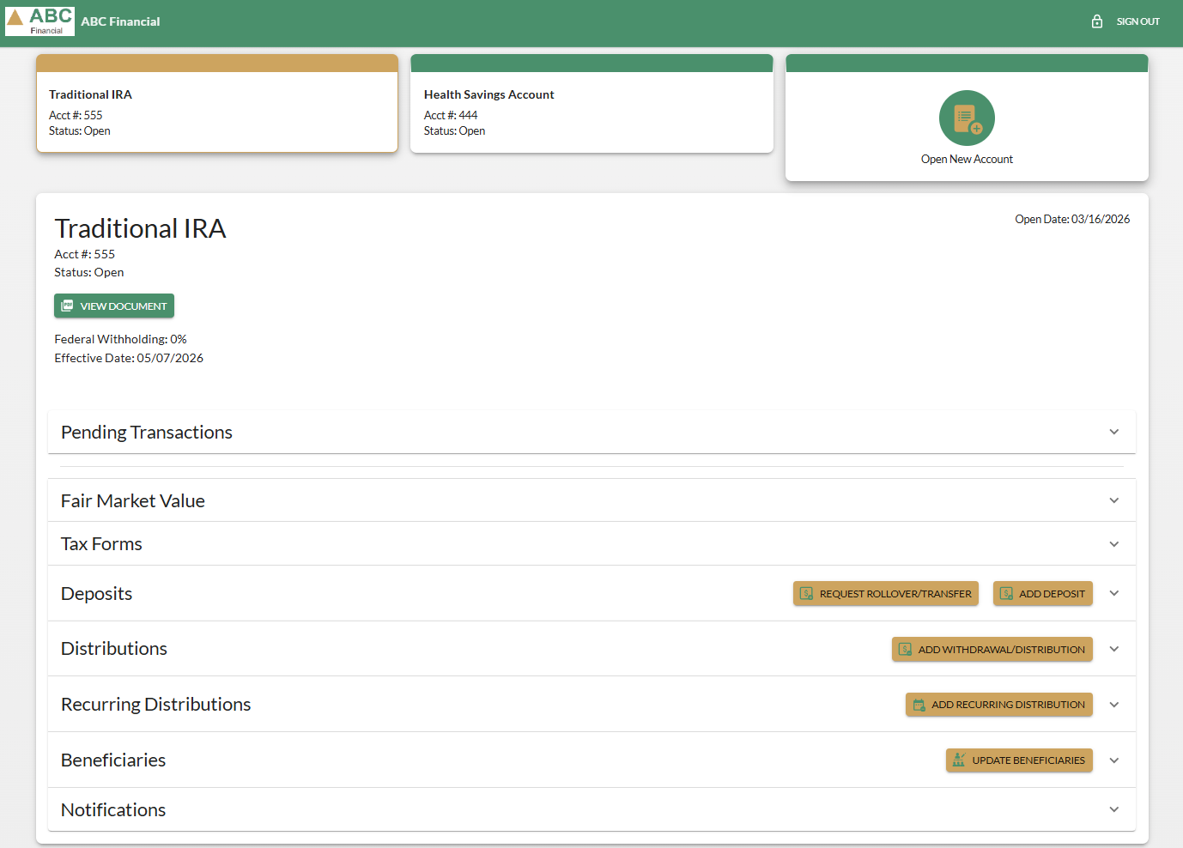
Giving you 24/7 online access to these features is just another way that our financial organization is adding functionality for valued account owners like you. Click here to get started: <INSERT ACCOUNT OWNER PORTAL LINK>.

Account Owner Guide

Account Log In
- Enter the email address associated with your account and click Continue.
NOTE: The email address entered must match the email address associated with your account. If you have any issues with your account, please don't hesitate to contact us by calling our financial organization.
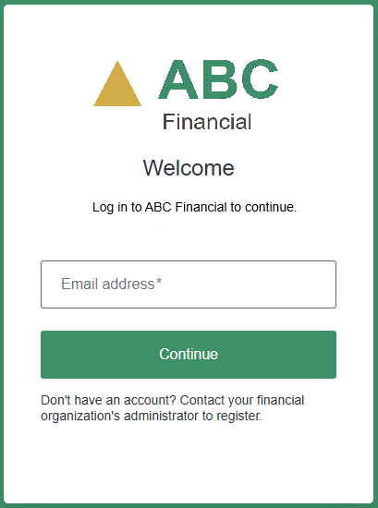
- A verification code will be sent to your email. Enter the verification code and click Continue.
  - You have three minutes to enter the verification code before it expires.
  - If you do not receive the email with the code or your code has expired, click the Resend link found below the Continue button to have another one sent.

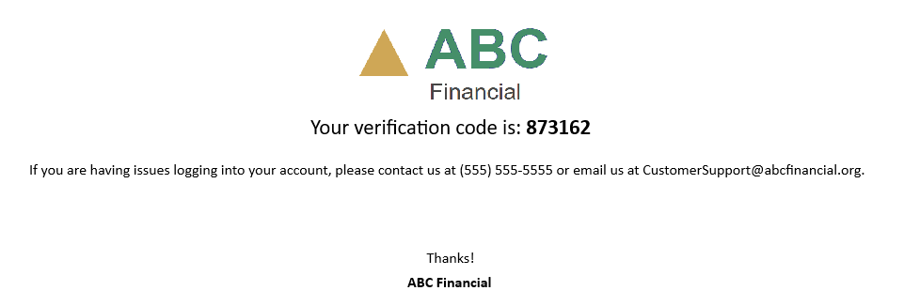
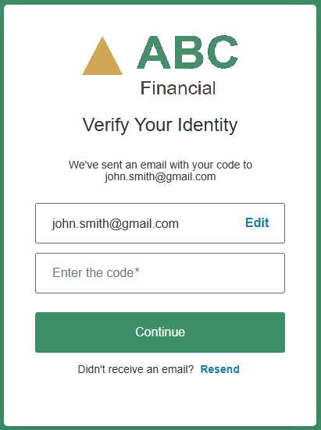

- If this is your first time logging in, authorize the application to access your account profile and email by clicking Accept.
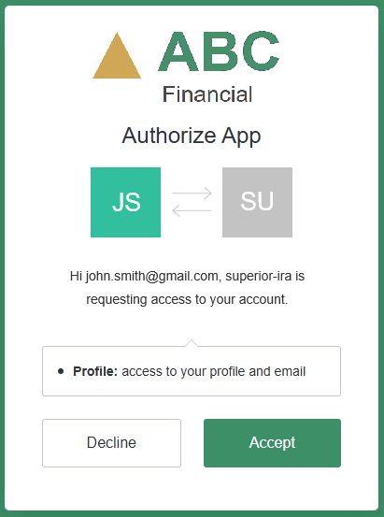

- You will be asked to verify your identity by entering the following information and clicking Verify:
- Last Name
- Birth Date
- SSN

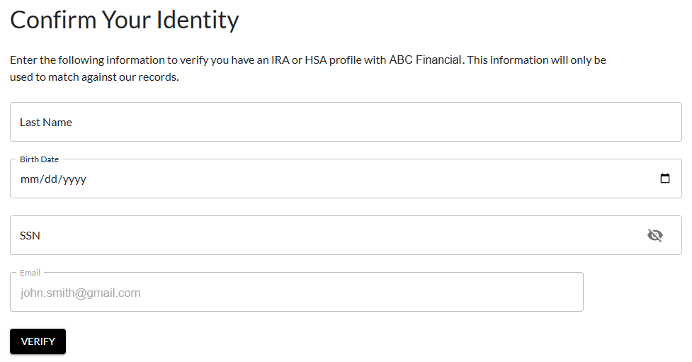

- Click an applicable account to view the details and/or start a transaction. (If you only have one account, you still need to click on it to view the account details). To open a new IRA or HSA account, click Open New Account.

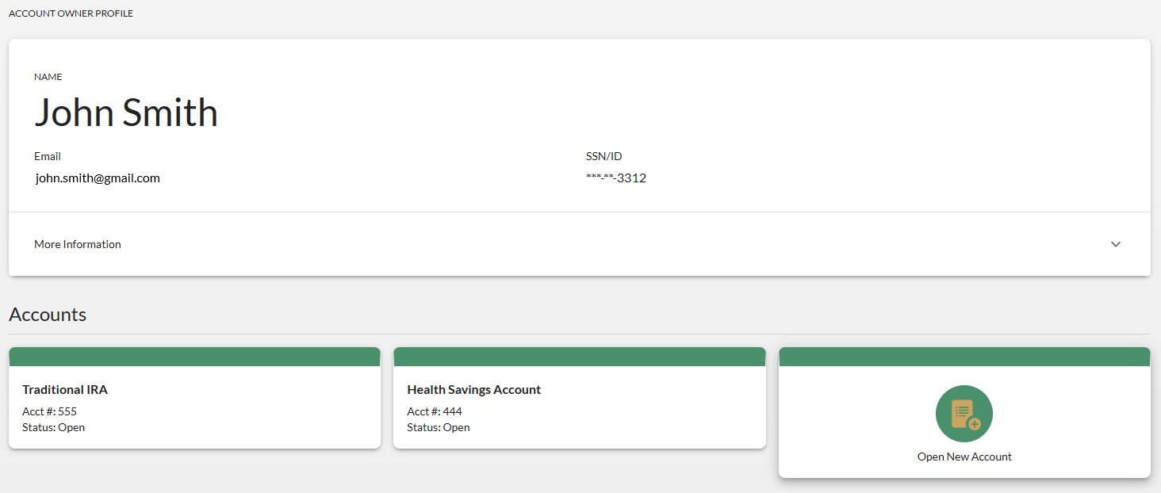

- When viewing an account, you can expand each section to see additional details. Use the buttons located on the right side of each section to initiate a transaction.

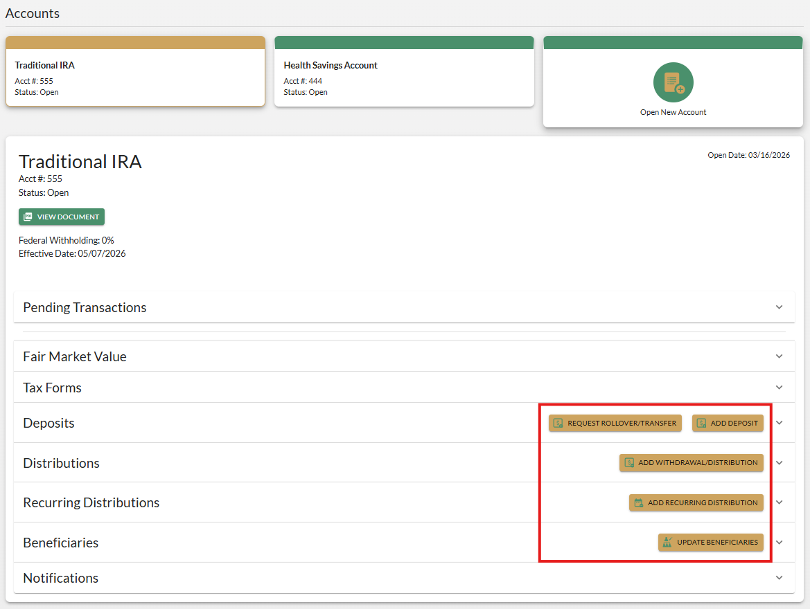

Completing Transactions
To complete a transaction, navigate to and expand the applicable section (i.e., Deposits, Distributions, etc.) and select the appropriate button—Add Deposit or Add Withdrawal/Distribution to complete that workflow.
NOTE: The Account Owner Portal is not used to move existing money within your IRA or HSA to a different investment within the same IRA/HSA. Please contact our financial organization directly if you’re interested in completing this type of transaction.

Add Deposit
To add a deposit to your existing IRA or HSA:
- Click Add Deposit under the Deposits section of the applicable account.
- Enter the deposit date, choose the deposit method, and click Next.
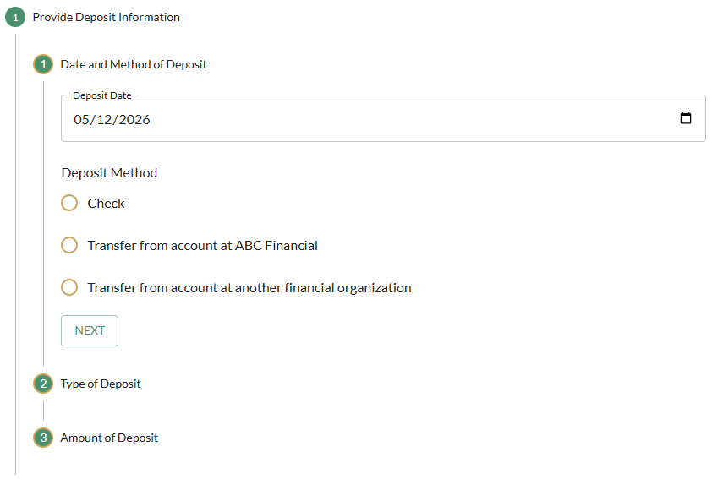
- Depending on the selection, additional fields may appear (i.e., Check Payable To and Date on Check fields, Select where the money came from if moving assets from an existing account at our organization, etc.). Any reference to “Account Owner” refers to you as the account owner of the IRA or HSA.

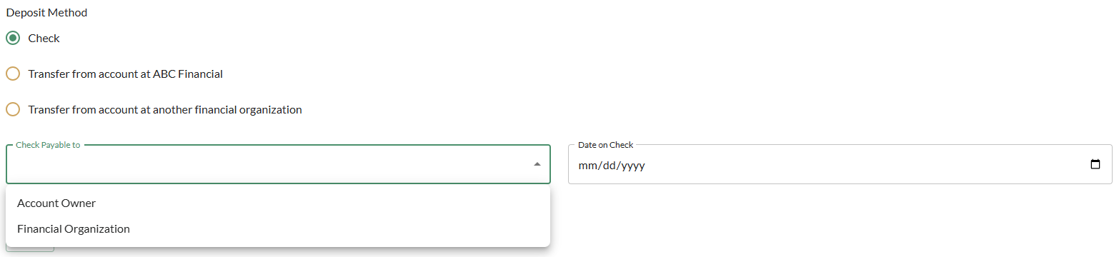

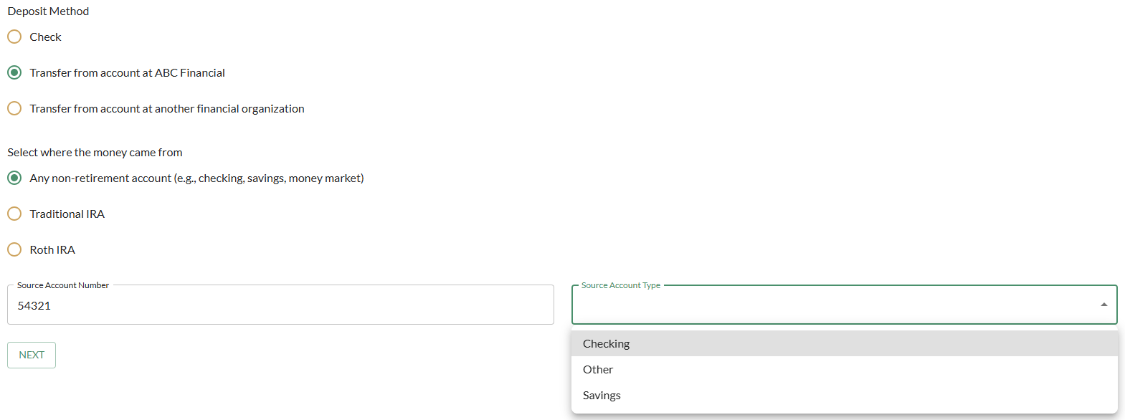

- Select the type of deposit being made to your IRA/HSA and click Next. (Click the Show more deposit types toggle to display additional options.) Depending on the selection, additional fields may appear.

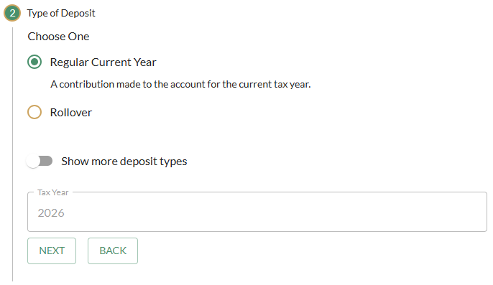

- Enter the amount of the deposit and click Continue. (NOTE: The indicator on the right side of the screen outlining the remaining amount you’re allowed to contribute for the tax year may not be accurate if there are pending transactions you’ve submitted that are still awaiting approval by our financial organization staff. For an accurate value of the remaining contribution amount, contact our organization or review your account information on our online banking site.)

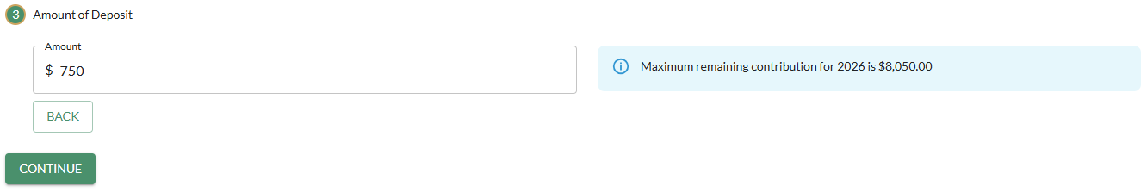
- Click Allocate Assets to select the investments into which you wish to deposit your money. (Or click Skip if you only have one investment within your account.) If you Allocate Assets, select the investment option by entering the amount allocated to each investment type and click Continue.

NOTE: All investments available at our organization will appear within the menu if you click Allocate Assets. Make sure to select the specific investment you currently have your assets invested in at our organization, or if you select a new investment, you must meet the requirements for opening that new investment.

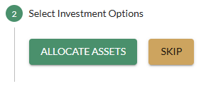

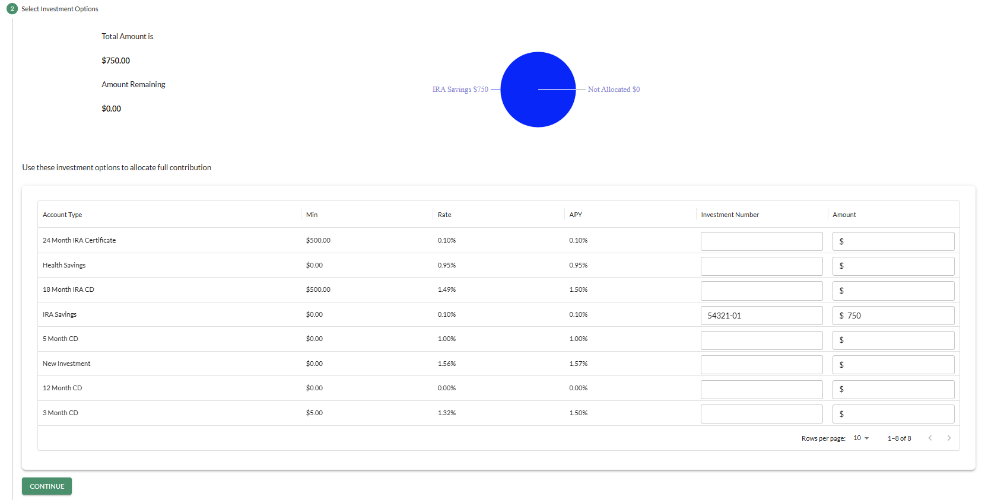

- Review and sign the document by completing the steps outlined in the Review and Sign Document section of this guide

Request Rollover/Transfer
A transfer is when you request to move an IRA or HSA from another institution to the same account type at our financial organization. This is completed via a “transfer” of assets. A signed transfer form needs to be completed and mailed to your current IRA/HSA institution.
A rollover is for qualified plan assets to be rolled over to an IRA. This money can come from a 401k plan, 403b plan, a pension, etc. In most cases, the plan administrator will provide you with certain documentation to complete for the rollover to occur instead of completing this type of request within the Account Owner Portal.
To create a document to send to another financial organization where you currently hold IRA or HSA assets and request that they transfer or directly rollover those assets to an IRA/HSA held at our organization, follow the steps below.
NOTE: If you do not already have the appropriate IRA (TRAD, ROTH, or HSA) set up, a new account must be opened at our financial organization before completing the rollover/transfer request form.
- Click Request Rollover/Transfer under the Deposits section of the applicable account.
- Select the account type currently held at the other financial organization, enter the other organization’s information in the applicable fields, and click Continue.

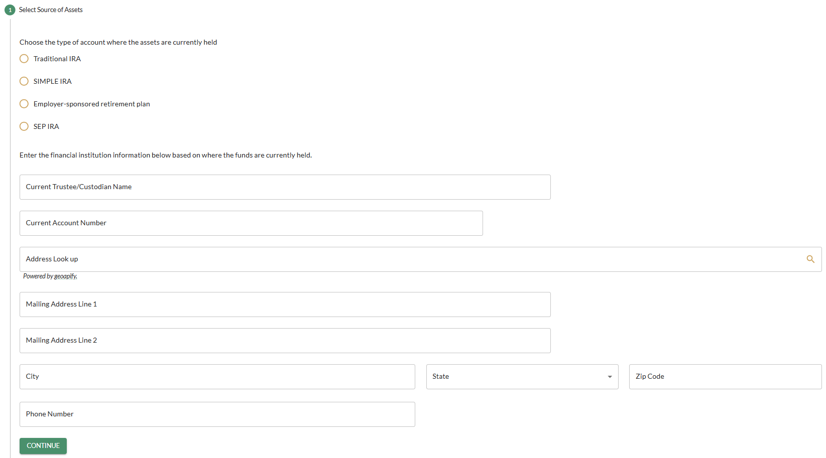

- Select your relationship to the current owner who holds the account assets at the other institution, and provide information in the additional fields that appear, if applicable. Click Continue.

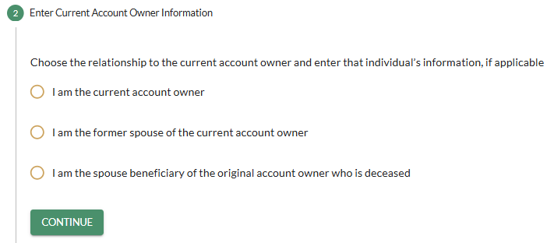

- Provide the transfer/rollover instructions, as shown below. (Additional fields may appear depending on your selections made.) Include any additional details about the transaction, if necessary.
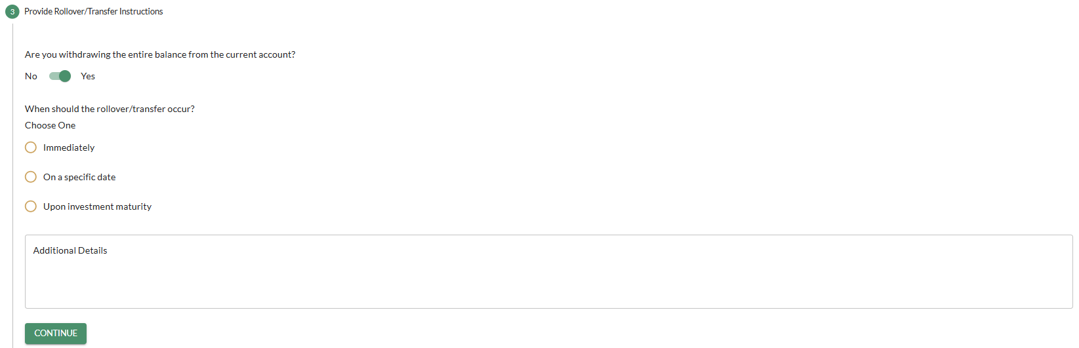

- Select the investments into which you wish to deposit your money into your IRA/HSA at our financial organization and click Continue.

NOTE: All investments available at our organization will appear within the menu. Make sure to select the specific investment you currently have your assets invested in at our organization (if applicable), or if you select a new investment, you must meet the requirements for opening that new investment.

  - If you are withdrawing the entire balance from your current IRA/HSA at another institution, you must enter the percentage to deposit into each investment selected.
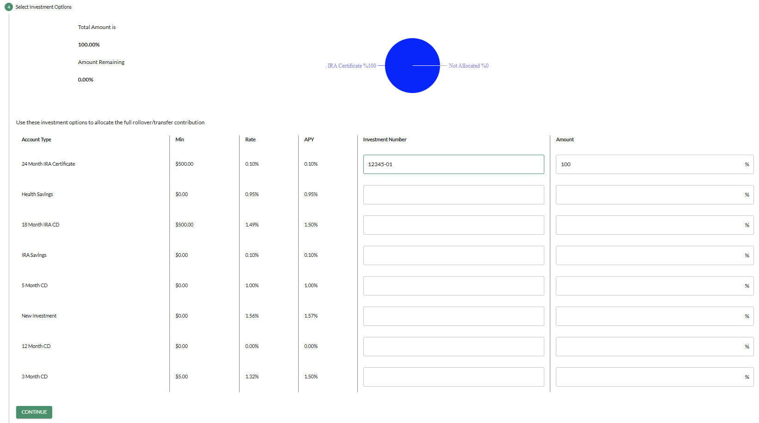

  - If you are only withdrawing a specific amount from your current IRA/HSA at another institution, you must enter the specific amount to deposit into each investment selected.
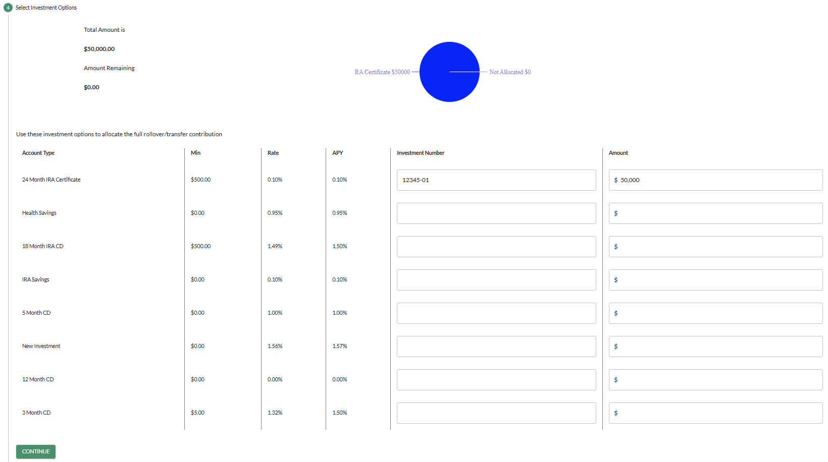

- Review and sign the document by completing the steps outlined in the Review and Sign Document section of this guide.

Distributions
To add a withdraw money from your existing IRA or HSA:
- Click Add Withdrawal/Distribution under the Distributions section of the applicable account.
- Enter the Distribution Date (the date on which you’d like the distribution to occur) and click Next.
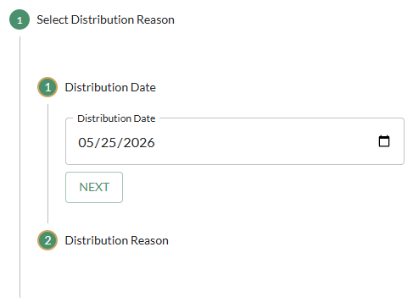
- Select the distribution reason and click Continue. Only the distributions reasons applicable to your age are listed, and the most common selections are displayed automatically in the workflow. If the correct selection is not listed, click Show more reasons to view additional, less common options.
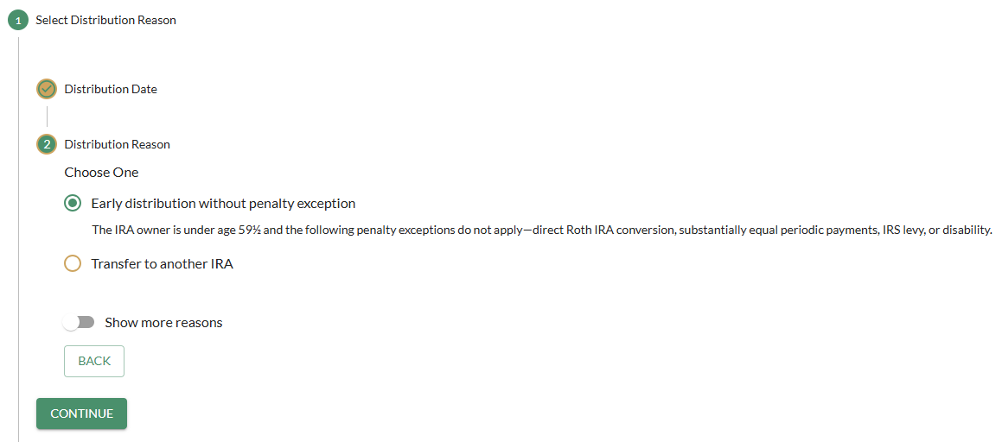

- Enter the amount of the distribution (total or net) and click Next. (Select “total” to enter the entire amount of the distribution leaving the account before any tax withholding or financial organization penalties are assessed. Or select “net” to enter the amount you want to receive after any tax withholding or organization penalties are assessed.)
  - Ignore the Financial Organization Fee Amount field.
  - If the entire account is being distributed and will close the entire IRA plan, indicate as such in this section by clicking the Distribute the entire balance and close the plan toggle.
NOTE: A Distribution Summary will appear on the right side of the screen as you begin to enter data in this section.
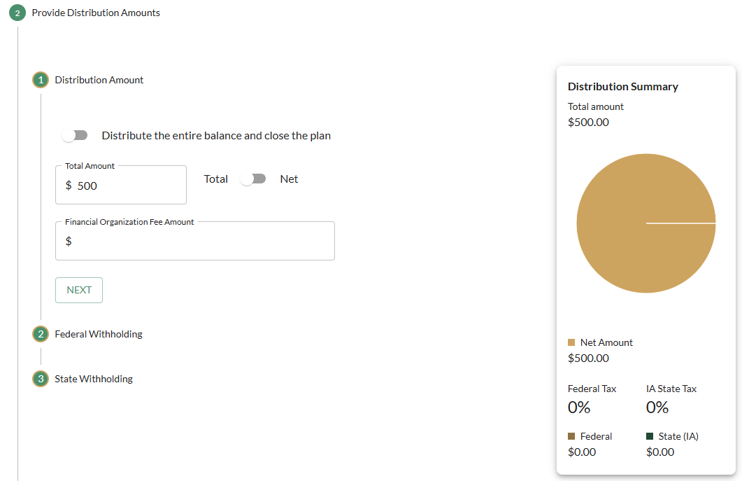

- Select your federal withholding election by choosing to withhold based on your current election on file, withholding a different rate, or selecting to not withhold.
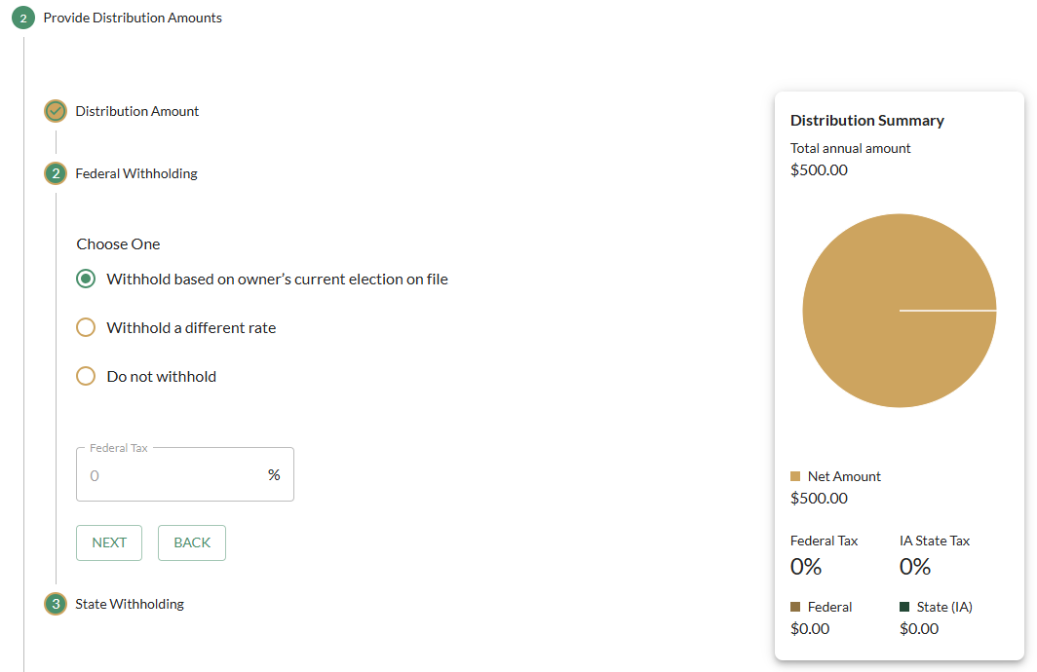

- Select your state withholding elections, if applicable. (This section will not appear if state withholding is not accepted by our financial organization.)
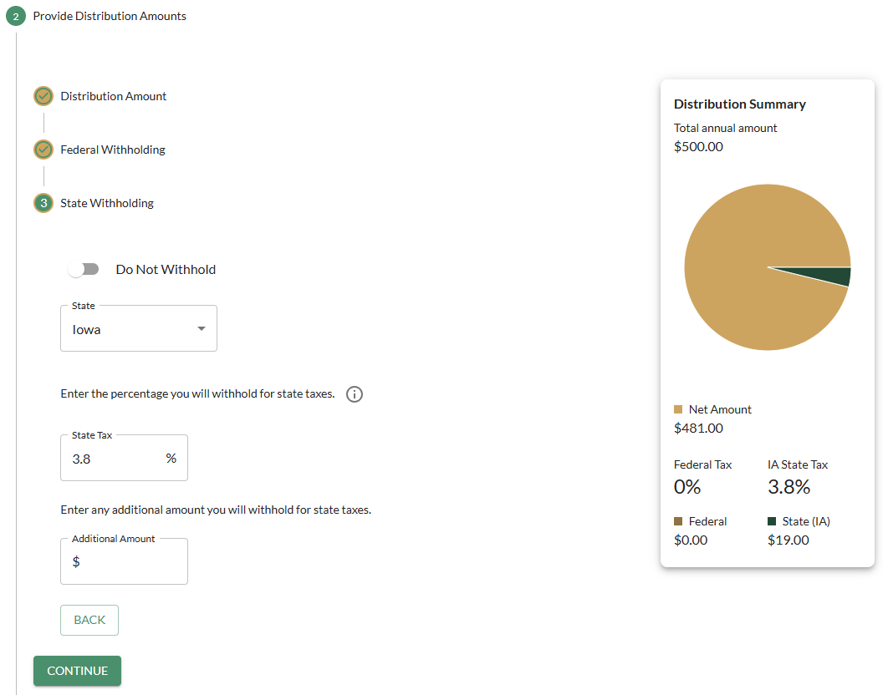

- Select the distribution method from the options provided. Depending on the selection, additional fields may appear. Then click Continue.
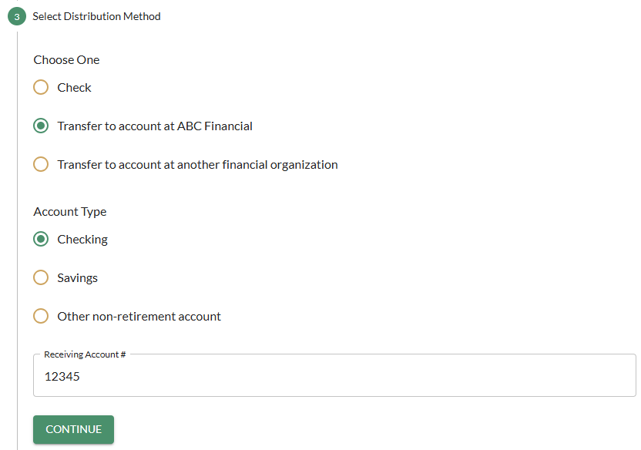
- Click Enter Assets to select the investments from which you wish to take your money. (Or click Skip if you only have one investment within your account.) If you Enter Assets, select the investment option by entering the amount to be taken from each investment type and click Continue.

NOTE: All investments available at our organization will appear within the menu if you click Enter Assets. Make sure to select the specific investment you currently have your assets invested in at our organization.

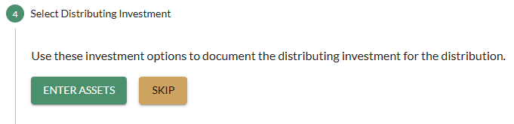
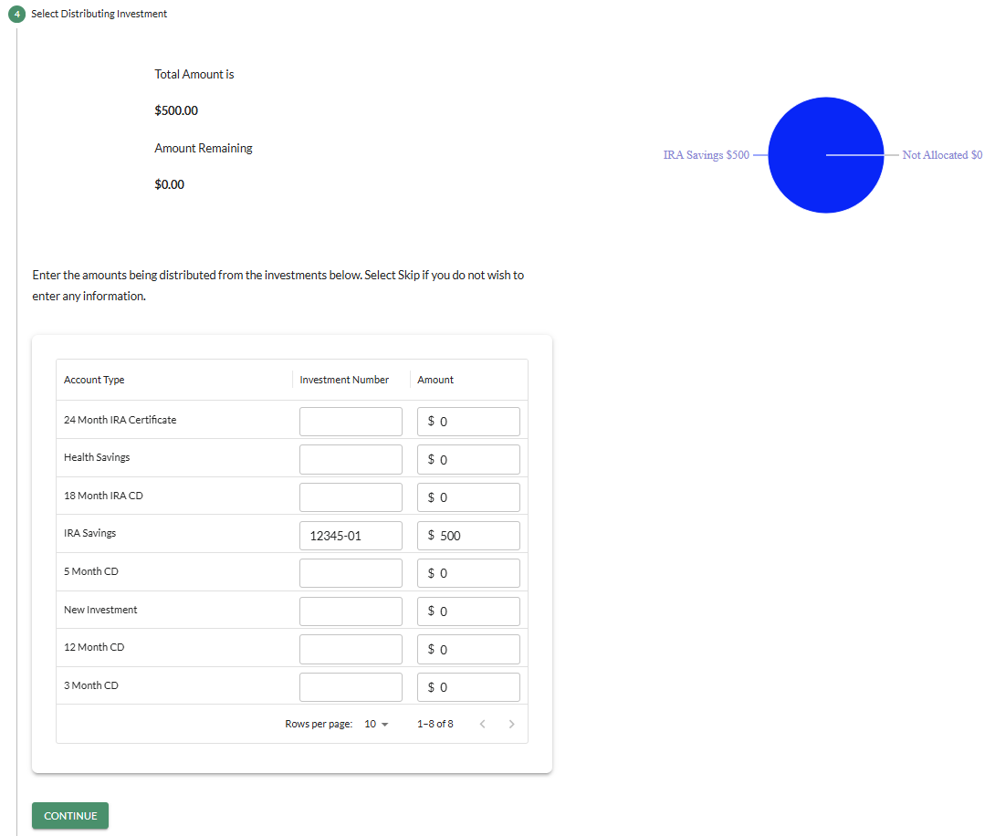

- Review and sign the document by completing the steps outlined in the Review and Sign Document section of this guide.

Update Beneficiaries
To add or update the beneficiaries designated for your existing IRA or HSA:
- Click Update Beneficiaries under the Beneficiaries section of the applicable account.
- Click Add Beneficiary in the Name Primary Beneficiaries section to add a new beneficiary or click the Pencil icon next to an existing beneficiary to make changes.
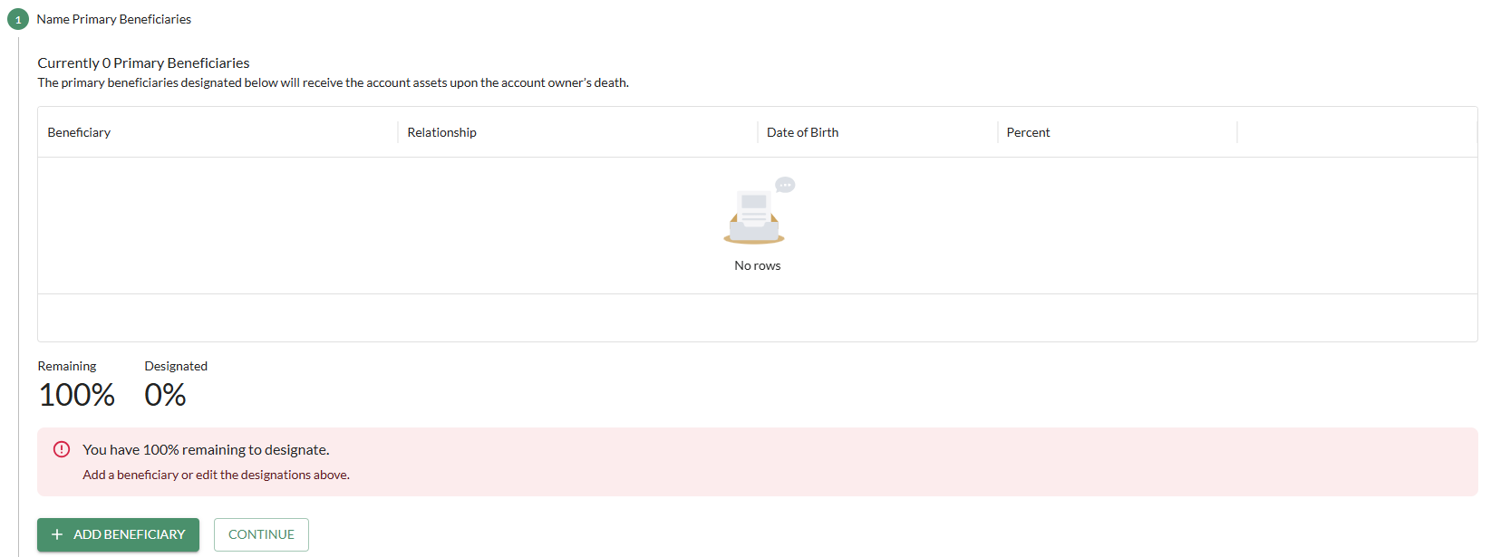

- Select the Relationship of the named beneficiary in relation to you (i.e., spouse, child, estate, etc.), the beneficiary’s name or title, date of birth (if applicable), SSN or Tax ID number, address, and percentage entitled. Click Continue to save that beneficiary’s information.
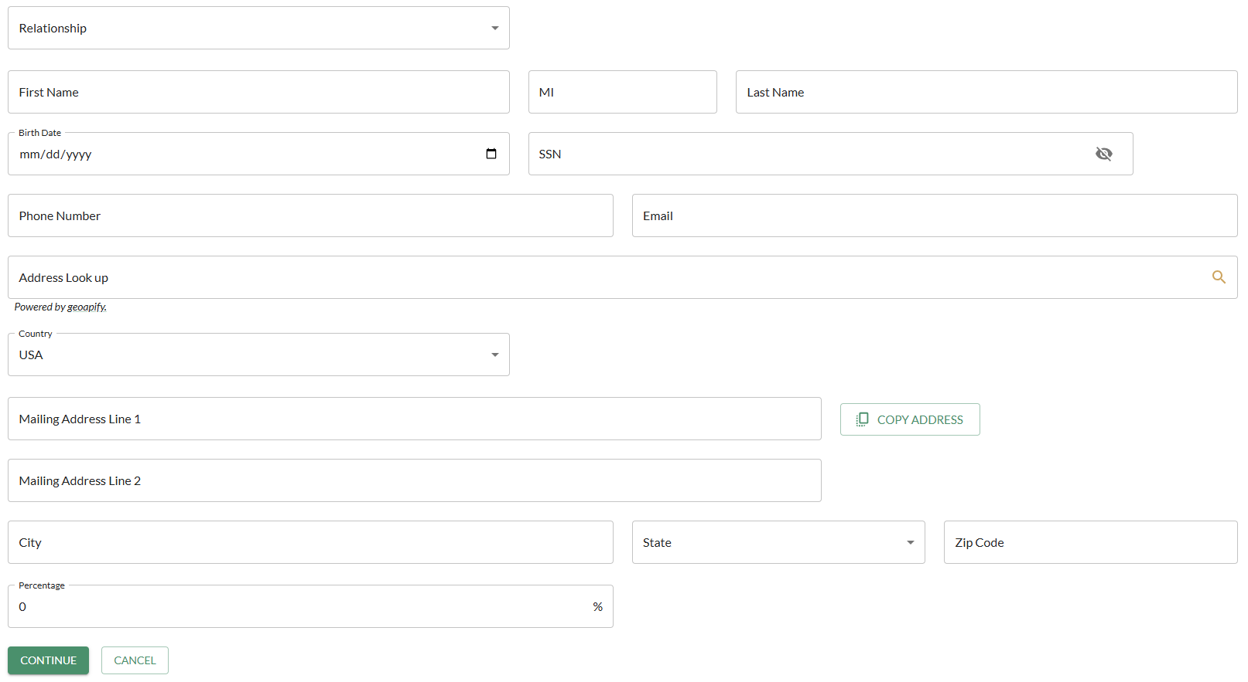

- Click Add Beneficiary to add additional primary beneficiaries, if needed, or click Continue after all primary beneficiary information is added and the total percentage designated equals 100%.
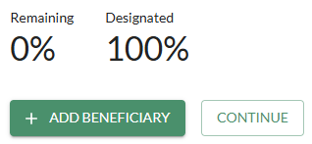

- Click Add Beneficiaries in the Name Contingent Beneficiaries section to designate contingent beneficiaries or click Skip if you do not wish to make this designation at this time. (If you choose to add contingent beneficiaries, follow the same steps previously outlined for your primary beneficiary designation.)
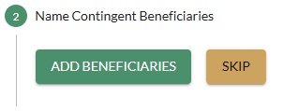

- Review and sign the document by completing the steps outlined in the Review and Sign Document section of this guide.

Review and Sign Document
When you reach the Review and Sign Document section of a transaction workflow, follow these steps:
- Click View PDF Document to review the form in a new tab and confirm everything appears correctly
- If accurate, return to the previous tab, check the “I have reviewed the document” box, and click Next.
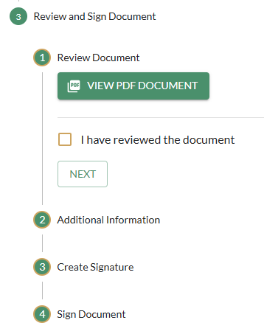
- (Optional) Provide additional comments for our financial organization staff, if necessary and click Save Comment. Or click Skip.
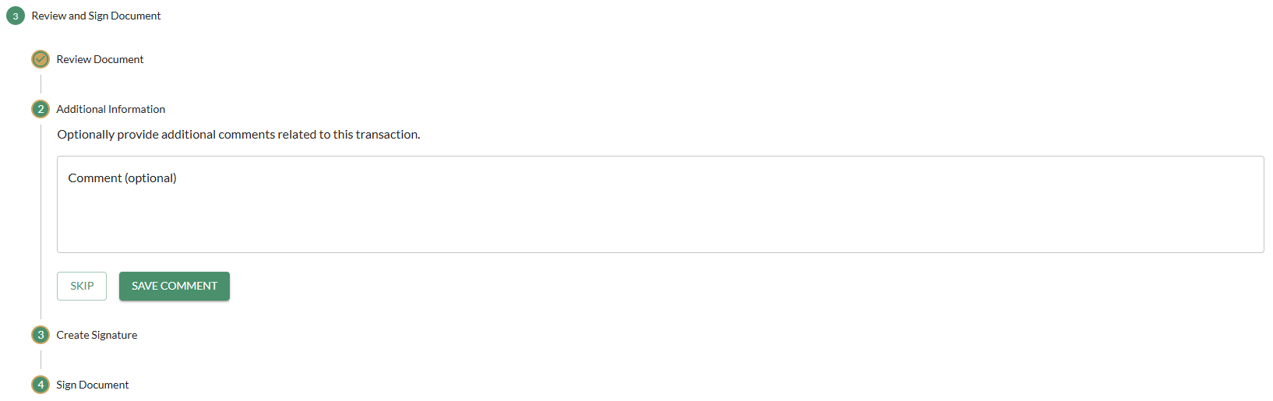

- If you have not yet created an electronic signature for a transaction within the Account Owner Portal:
  - Click Create Signature to create your electronic signature.
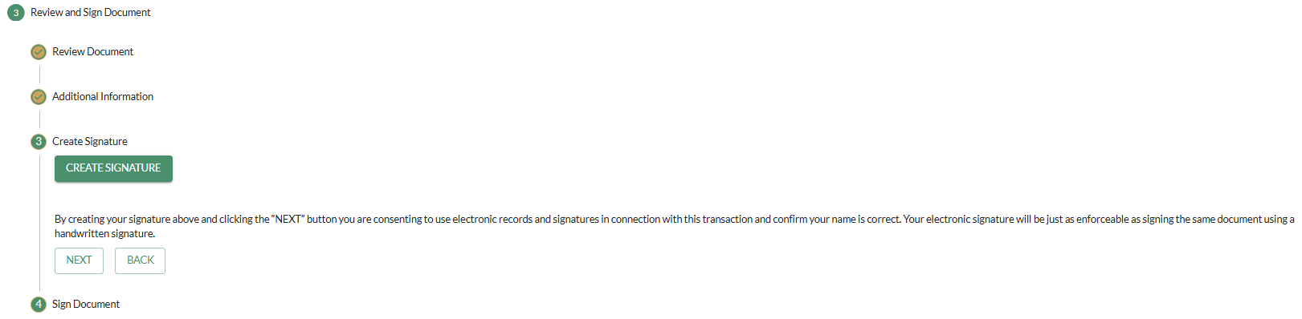

  - Type your name within the pop-up window to create your signature for the first time and click Accept to confirm the electronic signature.
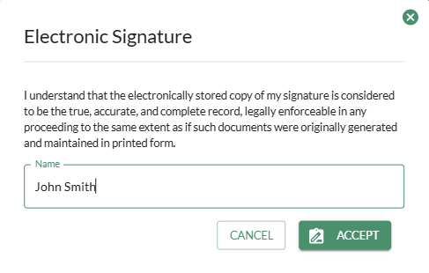

  - Your captured electronic signature will appear in the Create Signature section. Click Next to continue. (This is only required once. The next time a form is created, your saved electronic signature will appear.)
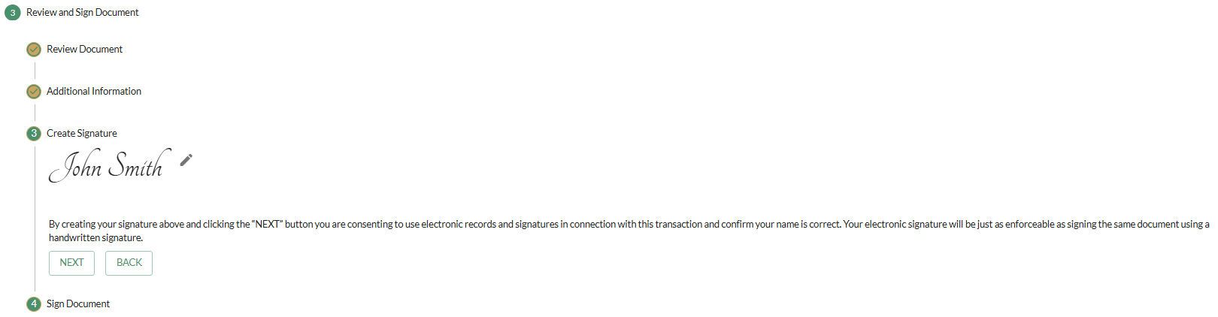

- If have already created an electronic signature for a previous transaction within the Account Owner Portal:
  - Review the saved signature in the Create Signature section. (Click the Pencil icon to make edits to the signature, if needed.)
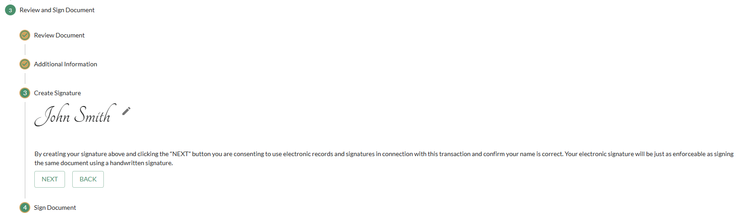

  - Click Next to continue.

- Review the Electronic Signature and Disclosure and Consent section and click Sign Electronically to accept and consent to the disclosures and finish processing the transaction. Your electronic signature will be applied to the form.
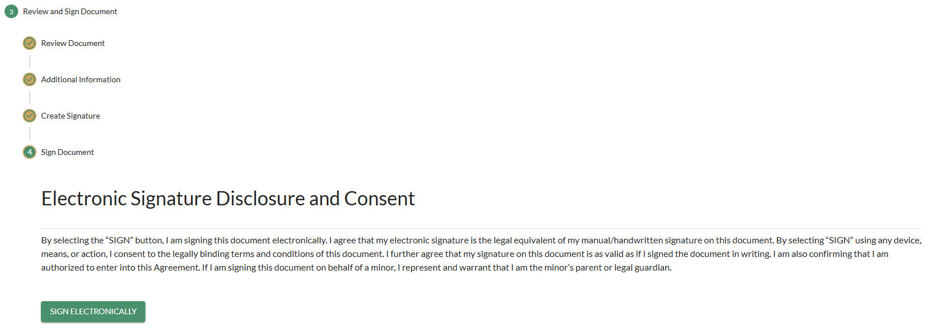

- The following message will appear to confirm your form has been electronically signed and submitted to our financial organization for review/processing.
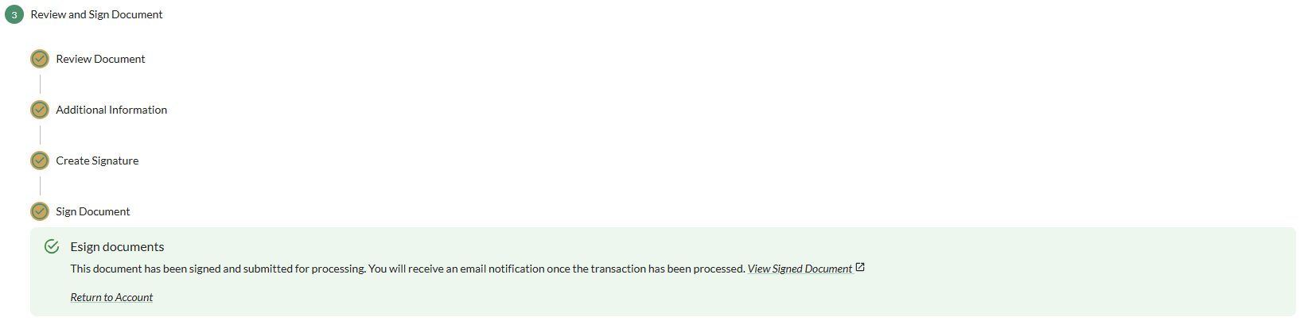

  - Click the View Signed Document link to view your electronically signed form (example below) in a new browser tab. NOTE: The form will not yet include our financial organization’s signature until the document is reviewed/approved.
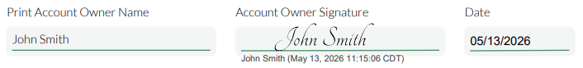

  - Click the Return to Account link to navigate back to your account within the portal or close the browser to exit the portal.

- Your submitted transaction will appear under your applicable account within the Account Owner Portal.
  - If the transaction is not yet approved, it will appear under the Pending Transactions section of the owner’s account.
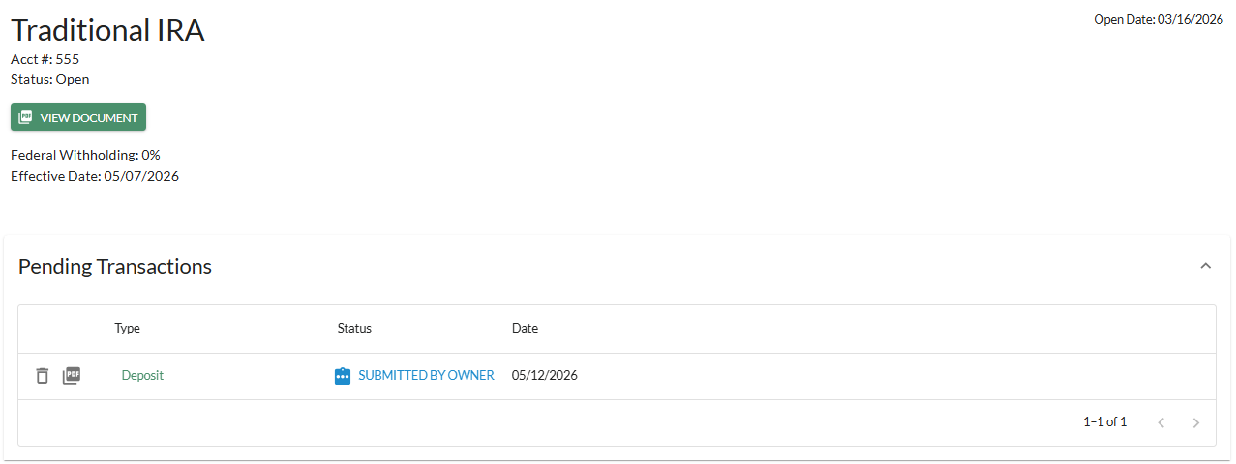

  - After the transaction has been reviewed/approved by our financial organization staff:

    - You’ll receive an email notification to confirm the transaction has been processed. 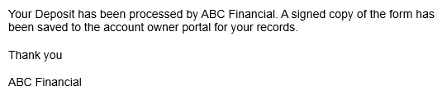

    - The transaction will move to the applicable section under your account (i.e., Deposits, Distributions, etc.). Click the PDF icon next to the transaction to view the final, signed document.
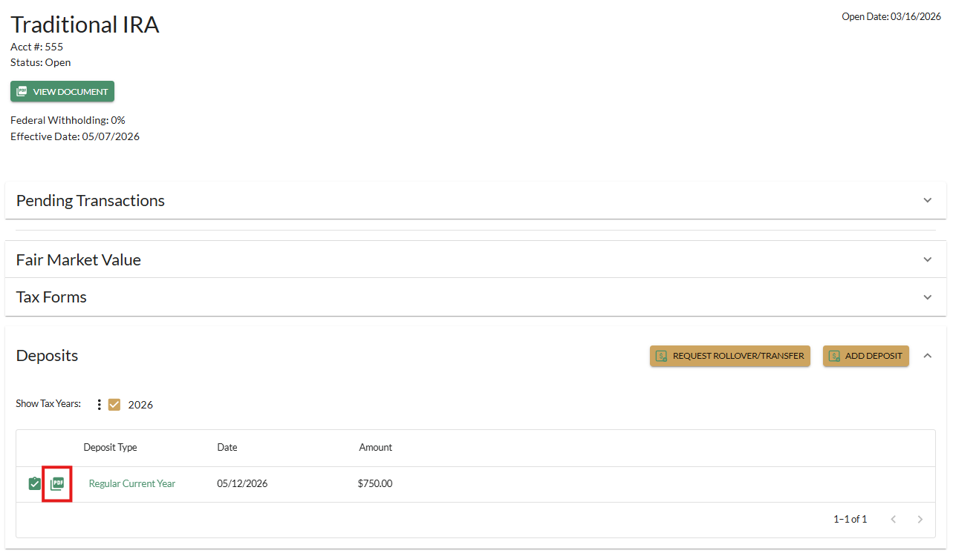

Tax Forms
To view electronic copies of tax forms reported for an applicable account:
- Expand the Tax Forms section under that account.
- Expand the 1099 Forms section to view distributions reported for the account.
- Expand the 5498 Forms section to view contributions reported for the account (and end of year balances, or fair market values, if it’s for an IRA or HSA).
- Click the PDF icon to view/download a copy of the tax form.

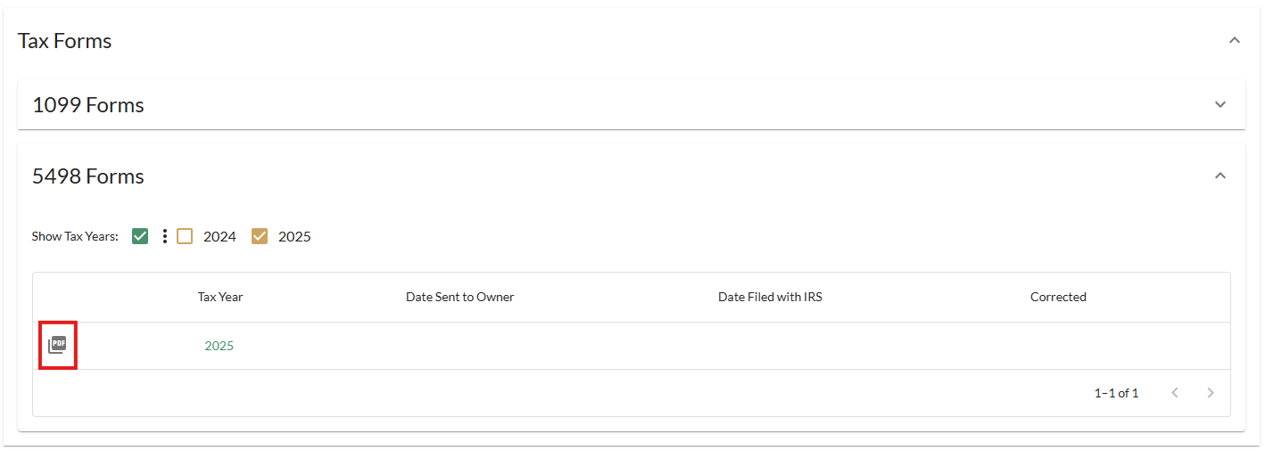

Notifications
To view electronic copies of notifications our organization may have mailed to you regarding your IRA or HSA:
- Expand the Notifications section under that account.
- Click the PDF icon to view/download a copy of the specific notification.
